**COS10011 Creating Web Applications**

**UI Testing Tools Report**

**Name: Nicholas Ting Tiew Leong**

**ID: 102767857**

**Table of Contents**

1.0 Selenium 2

1.1 Screenshot of Selenium 3

1.2 Link of Selenium 4

2.0 Cucumber 4

2.1 Screenshot of Cucumber 5

2.2 Link of Cucumber 5

3.0 Comparison 5

# 1.0 Selenium

Selenium Integrated Development Environment (IDE) is the simplest framework in the Selenium suite and is the easiest one to learn. It is a Firefox plugin that users can install as easily as they can with other plugins. However, because of its simplicity, Selenium IDE should only be used as a prototyping tool. If the users desire to create a more advanced test case, the users will need to use either Selenium RC or WebDriver. It is also a free automation testing suite of tools used for only testing web applications. There is no need to feel disappointed or upset due to the fact that it only helps in testing web applications because various other software have got the users covered. There are many tools available for testing desktop and mobile applications, such as IBM’s RFI, HP’s QPI, Appium and many more. However, the aim of this Selenium tutorial is to make you understand the testing of dynamic web applications and why Selenium is the best for it. Most programmers and developers use Selenium to build website applications and test them anytime. One of the biggest and popular advantages of Selenium is its flexibility. Any individual who creates web programs can use Selenium to test the code and applications. Furthermore, professionals can debug and perform visual regression tests as per the requirements of the website or code.

## 1.1 Screenshot of Selenium



## 1.2 Link of Selenium

<<https://intellipaat.com/blog/tutorial/selenium-tutorial/introduction/>>

# 2.0 Cucumber

A cucumber is a tool based on Behavior Driven Development (BDD) framework which is used to write acceptance tests for the web application. It allows automation of functional validation in easily readable and understandable format (like plain English) to Business Analysts, Developers, Testers, and many more. Cucumber feature files can serve as a good document for all. There are many other tools like JBehave which also support BDD framework. Initially, Cucumber was implemented in Ruby and then extended to Java framework. Both the tools support native JUnit. Behavior Driven Development is an extension of Test Driven Development and it is used to test the system rather than testing the particular piece of code. Cucumber can be used along with Selenium, Watir, and Capybara. Cucumber supports many other languages like Perl, PHP, Python, Net etc.

## 2.1 Screenshot of Cucumber

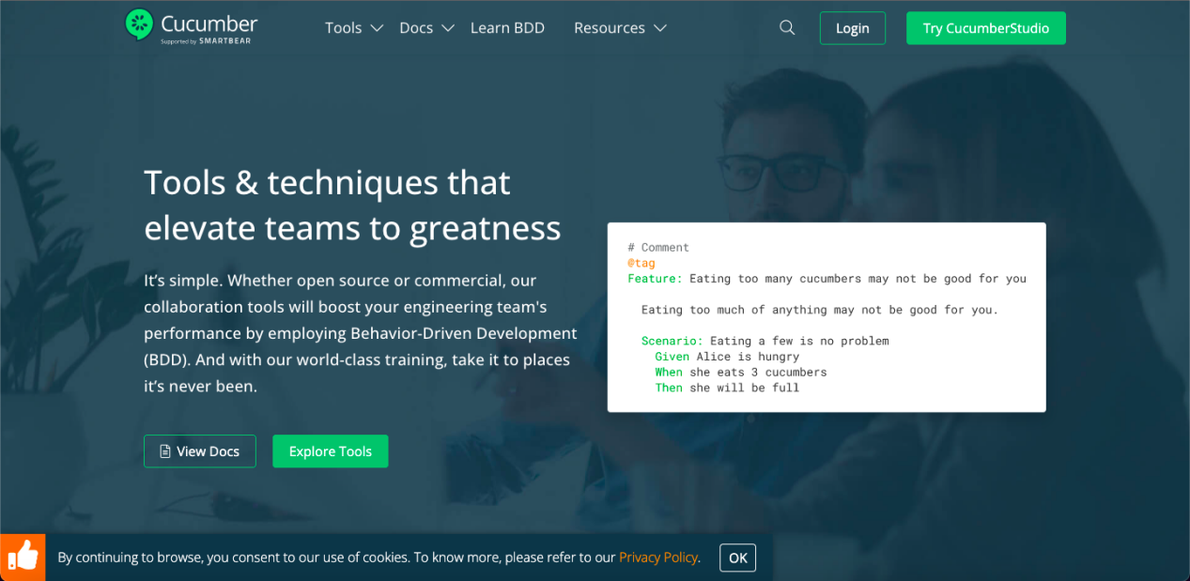

## 2.2 Link of Cucumber

<<https://cucumber.io/>>

# 3.0 Comparison

|  |  |  |
| --- | --- | --- |
|  | Selenium | Cucumber |
| Advantages | Easy to install and use. | Does not require licensing. |
| Provides excellent support for extensions. | Easy to maintain and is scalable. |
| Easy to understand & developed a test script. | Increases the reusability of important steps. |
| Provides excellent support for extensions. | Easily configured with IDEs like Eclipse. |
| Debugging by displaying the information and error messages. | Promotes teamwork since each individual in the team can contribute. |
| Disadvantages | Does not support error handling and database testing. | Requires Maintenance of a Second Testing Environment |
| Looping and conditional statements are not allowed. | Routing Causes Cognitive Strain |
| Cannot be used in iPhone and Android applications testing. | Increased Wordiness |
| Does not support iterations and conditional operations. | Breaks text editors |
| Supports only the html language. | Syntactically Discourages Code Reuse |