1
e. accuracy
[1] 0.6853767 0.6740522 0.6046283 0.6932546 0.6878385 0.7055638 0.6937469
[8] 0.6824225 0.6740522 0.6755293
f.
output
[1] "nnode"
[1] 3392
[1] 0.6780990 0.6736990 0.6732302 0.6610408 0.5986873 0.6661978 0.6066573
[8] 0.6732302 0.6666667 0.6845441
[1] 0.6780990 0.6810387 0.6732302 0.6610408 0.5986873 0.6661978 0.6066573
[8] 0.6732302 0.6666667 0.6845441
[1] 0.6780990 0.6810387 0.6952474 0.6610408 0.5986873 0.6661978 0.6066573
[8] 0.6732302 0.6666667 0.6845441
[1] 0.6780990 0.6810387 0.6952474 0.6727095 0.5986873 0.6661978 0.6066573
[8] 0.6732302 0.6666667 0.6845441
[1] 0.6780990 0.6810387 0.6952474 0.6727095 0.6883880 0.6661978 0.6066573
[8] 0.6732302 0.6666667 0.6845441
[1] 0.6780990 0.6810387 0.6952474 0.6727095 0.6883880 0.6771191 0.6066573
[8] 0.6732302 0.6666667 0.6845441
[1] 0.6780990 0.6810387 0.6952474 0.6727095 0.6883880 0.6771191 0.6810387
[8] 0.6732302 0.6666667 0.6845441
[1] 0.6780990 0.6810387 0.6952474 0.6727095 0.6883880 0.6771191 0.6810387
[8] 0.6565409 0.6666667 0.6845441
[1] 0.6780990 0.6810387 0.6952474 0.6727095 0.6883880 0.6771191 0.6810387
[8] 0.6565409 0.6746693 0.6845441
[1] 0.6780990 0.6810387 0.6952474 0.6727095 0.6883880 0.6771191 0.6810387
[8] 0.6565409 0.6746693 0.6114650
[1] "nnode"
[1] 6204
[1] 0.6733301 0.6810387 0.6952474 0.6727095 0.6883880 0.6771191 0.6810387
[8] 0.6565409 0.6746693 0.6114650
[1] 0.6733301 0.6811312 0.6952474 0.6727095 0.6883880 0.6771191 0.6810387
[8] 0.6565409 0.6746693 0.6114650
[1] 0.6733301 0.6811312 0.6913701 0.6727095 0.6883880 0.6771191 0.6810387
[8] 0.6565409 0.6746693 0.6114650
[1] 0.6733301 0.6811312 0.6913701 0.6821063 0.6883880 0.6771191 0.6810387
[8] 0.6565409 0.6746693 0.6114650
[1] 0.6733301 0.6811312 0.6913701 0.6821063 0.6645539 0.6771191 0.6810387
[8] 0.6565409 0.6746693 0.6114650
[1] 0.6733301 0.6811312 0.6913701 0.6821063 0.6645539 0.6816187 0.6810387
[8] 0.6565409 0.6746693 0.6114650
[1] 0.6733301 0.6811312 0.6913701 0.6821063 0.6645539 0.6816187 0.6889322
[8] 0.6565409 0.6746693 0.6114650
[1] 0.6733301 0.6811312 0.6913701 0.6821063 0.6645539 0.6816187 0.6889322
[8] 0.6738176 0.6746693 0.6114650
[1] 0.6733301 0.6811312 0.6913701 0.6821063 0.6645539 0.6816187 0.6889322
[8] 0.6738176 0.6879571 0.6114650
[1] 0.6733301 0.6811312 0.6913701 0.6821063 0.6645539 0.6816187 0.6889322
[8] 0.6738176 0.6879571 0.6786933
[1] "nnode"
[1] 25389
[1] 0.6704173 0.6811312 0.6913701 0.6821063 0.6645539 0.6816187 0.6889322
[8] 0.6738176 0.6879571 0.6786933
[1] 0.6704173 0.6610408 0.6913701 0.6821063 0.6645539 0.6816187 0.6889322
[8] 0.6738176 0.6879571 0.6786933
[1] 0.6704173 0.6610408 0.6591655 0.6821063 0.6645539 0.6816187 0.6889322
[8] 0.6738176 0.6879571 0.6786933
[1] 0.6704173 0.6610408 0.6591655 0.6661978 0.6645539 0.6816187 0.6889322
[8] 0.6738176 0.6879571 0.6786933
[1] 0.6704173 0.6610408 0.6591655 0.6661978 0.6671355 0.6816187 0.6889322
[8] 0.6738176 0.6879571 0.6786933
[1] 0.6704173 0.6610408 0.6591655 0.6661978 0.6671355 0.6085326 0.6889322
[8] 0.6738176 0.6879571 0.6786933
[1] 0.6704173 0.6610408 0.6591655 0.6661978 0.6671355 0.6085326 0.6765120
[8] 0.6738176 0.6879571 0.6786933
[1] 0.6704173 0.6610408 0.6591655 0.6661978 0.6671355 0.6085326 0.6765120
[8] 0.5972808 0.6879571 0.6786933
[1] 0.6704173 0.6610408 0.6591655 0.6661978 0.6671355 0.6085326 0.6765120
[8] 0.5972808 0.6038444 0.6786933
[1] 0.6704173 0.6610408 0.6591655 0.6661978 0.6671355 0.6085326 0.6765120
[8] 0.5972808 0.6038444 0.6699484
[1] "nnode"
[1] 46276
[1] 0.6354724 0.6610408 0.6591655 0.6661978 0.6671355 0.6085326 0.6765120
[8] 0.5972808 0.6038444 0.6699484
[1] 0.6354724 0.6238859 0.6591655 0.6661978 0.6671355 0.6085326 0.6765120
[8] 0.5972808 0.6038444 0.6699484
[1] 0.6354724 0.6238859 0.6595365 0.6661978 0.6671355 0.6085326 0.6765120
[8] 0.5972808 0.6038444 0.6699484
[1] 0.6354724 0.6238859 0.6595365 0.5940285 0.6671355 0.6085326 0.6765120
[8] 0.5972808 0.6038444 0.6699484
[1] 0.6354724 0.6238859 0.6595365 0.5940285 0.6613191 0.6085326 0.6765120
[8] 0.5972808 0.6038444 0.6699484
[1] 0.6354724 0.6238859 0.6595365 0.5940285 0.6613191 0.6225490 0.6765120
[8] 0.5972808 0.6038444 0.6699484
[1] 0.6354724 0.6238859 0.6595365 0.5940285 0.6613191 0.6225490 0.6336898
[8] 0.5972808 0.6038444 0.6699484
[1] 0.6354724 0.6238859 0.6595365 0.5940285 0.6613191 0.6225490 0.6336898
[8] 0.6350267 0.6038444 0.6699484
[1] 0.6354724 0.6238859 0.6595365 0.5940285 0.6613191 0.6225490 0.6336898
[8] 0.6350267 0.6359180 0.6699484
[1] 0.6354724 0.6238859 0.6595365 0.5940285 0.6613191 0.6225490 0.6336898
[8] 0.6350267 0.6359180 0.6519608

accuracy decrease with number of noise.
Number of nodes constructed, and path length of parse increase with number of noise.

2
a.i. two bimodal distributions, which are mixure of two uniform distributions, whose regions are not overlapping or cross could be seperate linearly with optimal
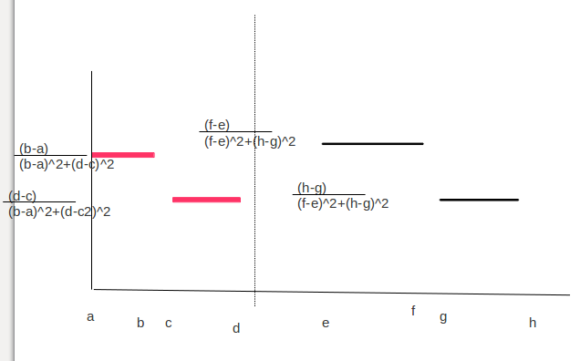

a.ii two normal distributions with means close to each other could not be seperate linearly. for example, two data set which could not pass two-sample t-test.
Plot of x<-rnorm(1000,m=50,sd=10); y<-rnorm(1000,m=51,sd=10)
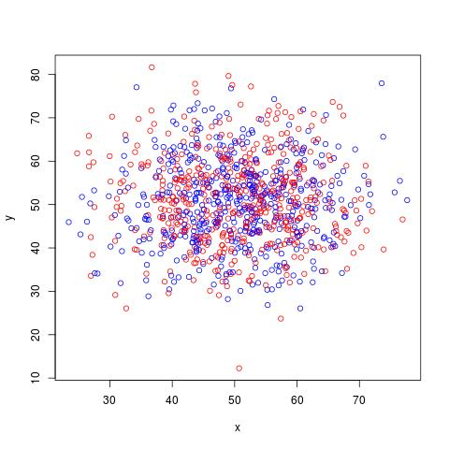

b. for a decision region Ri and x1, x2 in it
there exit k , such that
g_k(x1) > g_l(x1)
g_k(x_2) >g_l(x_2)
for all l
we will prove
g_k(λx1 + (1 − λ)x2 )> g_l(λx1 + (1 − λ)x2 )
for all l

g_k(λx1 + (1 − λ)x2 )=W(λx1 + (1 − λ)x2)+ wk0 =W(λ(x1-x2) + x2)+ wk0
=W(λ(x1-x2) +λwk0-λwk0 + x2)+ wk0= λ(Wx1+wk0) - λ(Wx2+wk0) + Wx2+wk0
=λ(Wx1+wk0)+(1-λ)(Wx2+wk0)
=λ *g_k(x1)+(1-λ) *g_k(x2)
( because g_k(x1)> g_l(x1) g_k(x_2) >g_l(x_2), 0<λ <1, 0<1-λ<1, for all l )
>λ *g_l(x1)+(1-λ) *g_l(x2)

this imply that all points on a line connecting two points in the set are in the set.

