1.
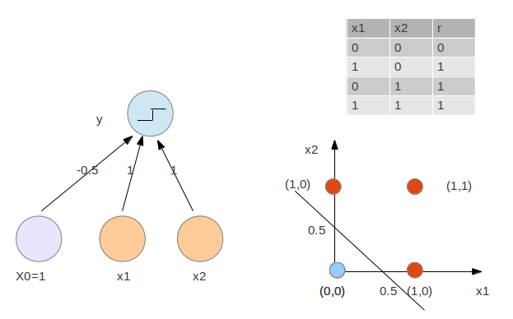
2.
(e) epoch from 1:100
black for train accuracy, red for test accuracy
with H=20, n=0.1
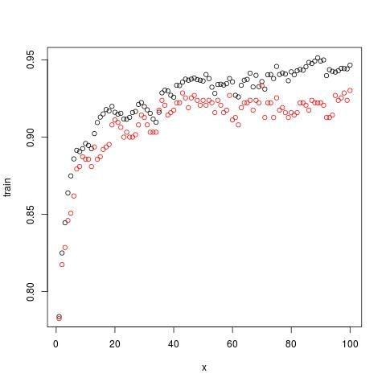

choose epoch=50
(f_n)
x is epoch from 1:50
circles is training accuracy, solid points are test accuracy
H=20
n=c(0.01, 0.1, 0.3) from top to bottom
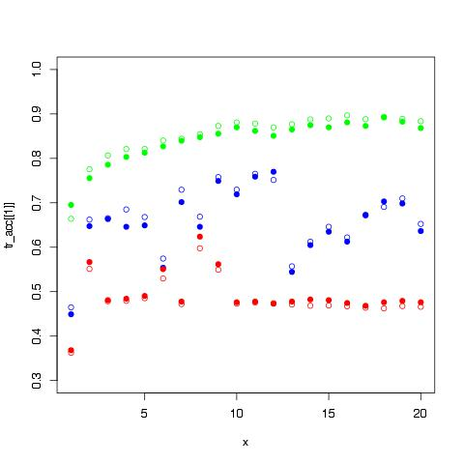

increase n increase both accuracy and, smooth the curve
choose n=0.01
(f_h)
x is epoch from 1:50
circles is training accuracy, solid points are test accuracy
H=c(5,20,40,100) from bottom to top, green for 100, blue for 40
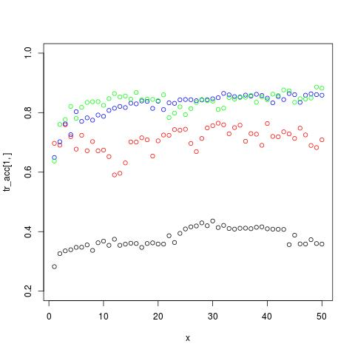
n=0.1
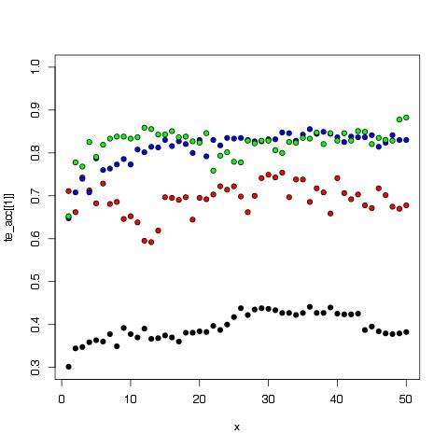
choose H=40

2.(g)
[1] 1 1 1 1 1 1 1 1 1 1 1 1 1 1 1 1 1 7 1 1 1 1 1 1
[25] 1 1 1 1 1 1 1 1 1 1 1 1 1 1 1 1 1 1 3 1 1 1 1 1
[49] 1 1 1 1 1 1 1 1 1 1 1 1 1 1 1 1 1 1 1 1 1 1 1 1
[73] 1 1 1 1 1 1 1 1 1 1 1 1 1 1 3 1 1 5 1 1 1 7 1 1
[97] 1 1 1 1 1 1 1 1 1 1 1 1 1 1 1 1 1 1 1 1 1 1 1 3
[121] 1 5 1 1 1 1 1 1 1 1 1 1 1 1 1 1 1 1 1 1 7 1 1 1
[145] 1 1 1 1 1 1 1 1 1 2 2 2 2 2 2 2 2 2 2 2 8 2 2 2
[169] 2 2 2 2 2 2 2 2 2 2 2 2 2 2 2 2 2 2 2 2 2 2 2 2
[193] 2 2 2 2 2 2 2 6 2 2 2 2 2 2 9 2 2 2 2 2 2 2 2 2
[217] 2 2 2 2 2 2 2 2 2 2 2 2 2 2 2 2 1 2 2 2 2 2 2 2
[241] 2 2 2 2 2 2 2 2 2 2 2 2 2 2 2 2 2 2 2 2 7 8 2 2
[265] 2 2 6 2 2 2 2 2 2 2 2 2 2 2 2 2 2 2 2 2 3 2 2 2
[289] 2 2 2 2 2 2 2 2 2 2 2 2 2 2 2 2 2 2 2 2 2 2 3 4
[313] 3 3 3 3 3 3 3 3 3 3 3 4 3 3 3 4 3 3 3 3 3 3 3 3
[337] 3 3 3 4 3 3 3 4 8 3 3 3 3 3 3 1 4 4 3 3 3 3 3 3
[361] 3 3 3 3 3 3 3 6 3 4 3 4 3 3 3 3 3 3 3 3 3 3 3 3
[385] 3 3 1 3 3 3 3 3 3 3 3 7 3 3 3 3 3 3 4 1 3 3 3 3
[409] 3 3 3 3 3 3 3 3 3 3 3 3 3 6 3 3 3 3 3 3 3 3 3 3
[433] 3 4 3 3 7 3 3 3 3 3 3 1 3 3 3 3 3 3 3 3 3 3 4 3
[457] 3 3 3 4 7 3 3 3 4 3 3 3 3 3 3 4 4 4 4 4 4 4 4 4
[481] 4 4 4 4 4 4 4 4 4 4 4 5 4 4 4 4 4 4 4 4 4 4 4 4
[505] 4 4 4 4 4 4 4 4 4 4 4 4 4 4 4 4 4 4 4 4 4 4 4 4
[529] 4 4 4 1 1 4 4 4 4 4 4 4 4 4 4 4 4 4 4 4 4 4 4 4
[553] 4 4 4 4 4 4 4 4 4 4 4 4 4 4 4 4 4 4 4 4 4 4 4 4
[577] 5 4 4 4 4 4 4 4 4 4 4 4 4 4 4 4 4 4 4 4 4 4 4 4
[601] 5 4 4 4 4 4 5 4 6 4 4 4 4 4 4 4 4 4 4 5 4 5 5 5
[625] 5 5 5 5 5 5 5 5 5 5 5 5 5 5 5 5 5 5 5 5 5 5 9 5
[649] 5 5 5 5 5 5 5 5 5 5 5 5 5 5 5 5 5 4 5 5 5 5 5 5
[673] 4 5 5 5 1 5 5 5 5 5 5 5 5 5 5 5 5 5 5 5 5 5 5 5
[697] 9 5 5 5 5 5 5 5 5 5 5 4 5 5 5 5 5 9 9 5 5 5 5 5
[721] 5 5 5 5 5 5 6 4 5 5 5 5 9 5 5 5 5 5 5 5 5 5 5 9
[745] 5 5 5 5 5 5 5 5 5 5 5 5 3 5 5 5 5 5 5 5 2 5 5 5
[769] 5 5 5 9 5 5 5 5 5 6 6 6 6 4 6 6 6 6 6 6 6 6 5 6
[793] 6 6 6 6 6 5 6 6 6 6 6 6 6 6 6 3 6 6 6 6 9 6 6 6
[817] 6 6 6 6 6 6 6 6 6 6 6 6 6 6 6 6 6 6 6 6 6 6 6 6
[841] 6 6 6 6 6 6 6 6 6 6 6 6 6 6 6 6 6 6 6 6 6 6 6 6
[865] 6 6 6 6 6 6 6 6 6 6 6 6 6 6 6 6 6 6 6 5 6 6 6 6
[889] 6 6 6 6 6 6 6 6 6 6 6 6 6 6 6 6 6 6 6 3 6 6 6 6
[913] 6 6 6 6 6 6 3 6 6 6 6 6 6 6 6 6 6 6 3 6 6 6 5 6
[937] 6 7 7 7 7 7 7 7 7 7 7 7 7 7 7 7 7 7 7 7 7 7 7 6
[961] 7 7 7 7 7 7 7 7 7 7 7 7 7 7 7 7 7 7 7 7 7 7 7 7
[985] 7 7 7 7 7 7 7 7 7 7 7 7 7 7 7 7 7 5 7 7 7 7 7 7
[1009] 7 7 7 7 7 7 7 7 7 7 5 7 7 7 7 7 7 7 7 7 7 7 7 7
[1033] 7 7 7 7 7 7 7 7 7 7 7 7 7 7 7 7 7 7 7 7 3 7 7 7
[1057] 7 7 7 7 7 7 7 7 7 7 7 7 1 7 7 7 7 7 7 9 7 7 7 7
[1081] 7 3 7 7 7 7 7 7 8 8 8 8 8 8 8 8 8 9 8 8 7 8 8 8
[1105] 8 8 8 8 8 8 8 8 8 8 8 8 8 8 8 8 8 8 8 8 8 8 8 8
[1129] 9 8 8 8 8 8 8 8 8 8 8 8 8 8 8 8 8 8 8 8 8 8 8 8
[1153] 8 8 8 8 8 8 8 8 8 8 8 8 8 8 8 8 8 8 8 8 8 8 8 8
[1177] 8 8 8 8 8 8 8 8 8 8 8 8 8 8 8 8 8 8 8 3 8 8 8 8
[1201] 8 8 8 8 8 8 8 8 8 8 8 8 8 8 8 8 8 8 8 8 8 8 8 3
[1225] 8 8 8 8 8 8 8 8 8 8 8 8 8 8 8 8 8 8 8 8 8 8 8 9
[1249] 9 9 9 9 9 1 9 9 9 9 9 9 9 9 11 9 9 9 9 9 9 9 9 9
[1273] 9 9 9 9 9 9 9 9 9 9 9 9 9 9 9 9 9 9 9 9 9 9 9 9
[1297] 9 9 9 9 9 9 9 9 9 9 9 9 9 9 9 9 9 9 9 9 9 9 9 9
[1321] 9 9 9 9 9 9 9 9 9 9 9 9 9 9 9 9 9 9 9 9 9 9 9 9
[1345] 9 9 4 9 9 9 9 9 9 9 9 9 9 9 9 9 9 9 9 9 9 9 5 9
[1369] 9 9 9 9 9 9 9 9 9 9 9 9 9 9 9 9 9 9 9 9 8 9 9 9
[1393] 9 9 9 9 9 9 9 10 10 10 10 10 10 10 10 10 10 10 10 10 8 10 10 10
[1417] 10 4 10 10 10 10 10 10 4 10 10 1 10 10 10 10 10 10 10 10 10 10 10 10
[1441] 10 10 10 10 10 10 10 10 10 10 10 10 4 10 10 10 10 10 10 10 10 4 10 10
[1465] 10 10 10 10 10 10 10 10 10 10 10 10 10 10 7 10 10 10 10 10 4 10 10 10
[1489] 10 10 10 10 10 10 4 4 10 8 10 10 10 10 10 10 10 10 4 10 10 10 10 10
[1513] 10 10 10 10 10 10 10 10 10 10 10 10 3 4 10 2 10 10 10 10 10 10 10 10
[1537] 10 10 10 10 10 10 10 10 10 10 10 10 10 10 4 10 10 10 10 11 11 11 11 11
[1561] 11 11 1 11 11 11 1 11 11 11 11 11 11 11 11 11 11 11 11 11 11 11 11 11
[1585] 11 11 11 11 11 11 11 11 11 11 11 11 11 11 11 11 11 11 11 11 11 11 11 11
[1609] 11 11 11 11 11 11 11 11 11 11 11 11 11 11 11 11 11 11 11 11 11 11 1 11
[1633] 11 11 11 11 11 11 11 11 11 11 11 11 11 11 11 11 11 11 11 11 11 11 11 11
[1657] 11 11 11 11 11 11 11 11 11 11 11 11 11 11 11 11 11 11 11 11 11 11 11 11
[1681] 11 11 11 11 11 3 11 11 11 11 11 11 11 11 11 11 11 11 11 11 11 11 11 11
[1705] 11 11 11 11 11 11 11 11 11

3.(a)
Minimize margin 1/2||w||^2
Minimize soft error C ∑ξ (t)
s.t. r (t) (wx(t) + w0) ≥ 1-ξ(t) ,
ξ(t)>0 for all x(t)
Lp = 1/2||w||^2+ C ∑ξ( t) − ∑α (t) (r(t) (w x( t) + w 0 ) − 1 + ξ (t)) −∑ μ (t)ξ (t)
minimize w, w0, ξ (t)
maximize α (t)
∂Lp /∂w =0 => w=∑ α( t) r (t )x(t)
∂Lp /∂w0 =0 => ∑α (t )r (t) = 0
∂Lp /∂ξ(t) =0 ⇒ C −α (t) − μ(t) = 0
plug back to Lp maximize α(t)
Ld=− ∑∑ α(t)α(s)r(t) r(s) x (t)(t)x(t) + ∑ α (t)
subject to ∑ α (t)r(t) = 0 and 0 ≤ α (t) ≤ C ,
with KKT condition
α(t) {r (t) (wx(t) + b) − 1 + ξi } = 0
u(t)ξ(t) = 0
or
αi = 0 r (t) (w x(t) + w0) ≥ 1
αi = C r(t) (wx(t) + w0) ≤ 1
0 < αi < C r(t) (w x (t)+ w0) = 1

3(b).

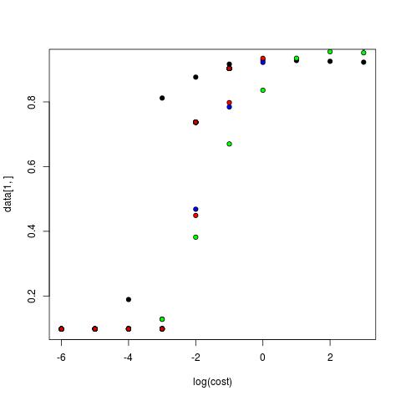

accuracy increase with cost because when cost is low we do not pay much penety to data voilate margin
linear is sufficient for classification with cost greater than 10^-3
polynomials doesn't show better(worse) then linear
radial doesn't show better(worse) then linear
so, data are linear seperatable

