2.
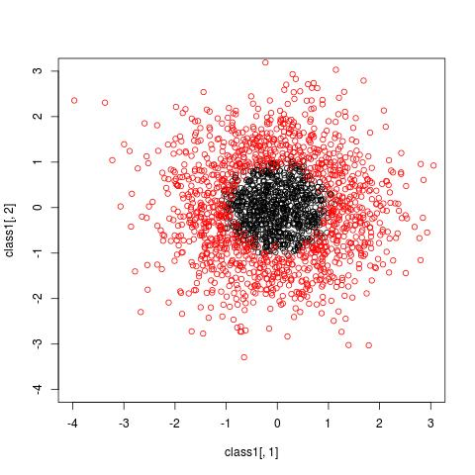

black for +1, red for -1, linear function is not a good choice for a classifier

3.
- train accuracy for combined model against iteration
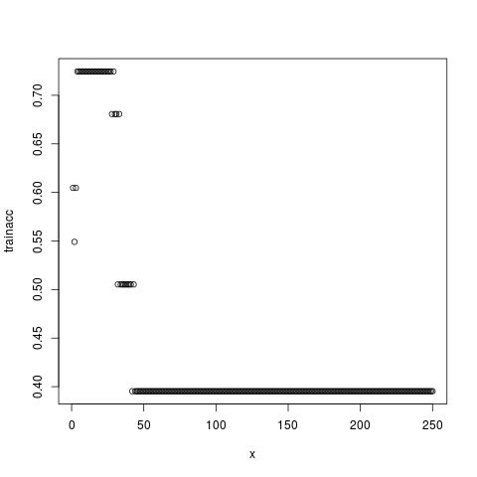

4.
- test accuracy (with sign(H(x)))
[1] 0.3969849 0.3969849 0.6030151 0.3969849 0.3969849 0.3969849 0.6030151
[8] 0.6030151 0.6030151 0.6030151
mean(testacc)
[1] 0.5
- confusion matrix
[[1]]
[,1] [,2]
[1,] 79 0
[2,] 120 0

[[2]]
[,1] [,2]
[1,] 0 79
[2,] 0 120

[[3]]
[,1] [,2]
[1,] 79 0
[2,] 120 0

[[4]]
[,1] [,2]
[1,] 79 0
[2,] 120 0

[[5]]
[,1] [,2]
[1,] 79 0
[2,] 120 0

[[6]]
[,1] [,2]
[1,] 79 0
[2,] 120 0

[[7]]
[,1] [,2]
[1,] 79 0
[2,] 120 0

[[8]]
[,1] [,2]
[1,] 0 79
[2,] 0 120

[[9]]
[,1] [,2]
[1,] 79 0
[2,] 120 0

[[10]]
[,1] [,2]
[1,] 79 0
[2,] 120 0

- precision and recalls
> precisions1
[1] 0.3969849 NaN 0.3969849 0.3969849 0.3969849 0.3969849 0.3969849
[8] NaN 0.3969849 0.3969849
> precisions2
[1] NaN 0.6030151 NaN NaN NaN NaN NaN
[8] 0.6030151 NaN NaN

> recalls1
[1] 1 0 1 1 1 1 1 0 1 1
> recalls2
[1] 0 1 0 0 0 0 0 1 0 0

- ROC curves
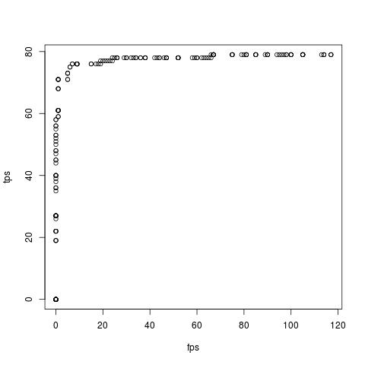

choose threshold at turning point instead of sign(H) to increase accuracy

