Navie Bayes Classifier with PCA and EM
Xiyu Xie

I . Description of Algorithm

- I Naïve Bayes[1]

A naive Bayes classifier is a simple probabilistic classifier for data with more than one features. It rest on the strong assumption that the presence (or absence) of a particular feature of a class is unrelated to the presence (or absence) of any other feature, given the class variable[1].

Say we have data with n features, F1...Fn. We want to estimate the its class label. That is a is a conditional probability of class given features.

Using Bayes' theorem, we get

Ignore divisor, we only care about

which can be rewritten as follows

Applying the assumption that each feature is conditionally independent of every other feature for given the class . This means that
for ,
and so the joint model can be expressed as
equation 1

I.II Parameter Estimation[2][1]

Parameters for P(C) and P(F_i| C) are estimated by maximum likelihood[2].
In general, maximum likelihood selects values of the model parameters that produce a distribution that gives the observed data the greatest probability[2].
Suppose there is a sample x1, x2, ..., xn of n independent and identically distributed observations, coming from a distribution with an unknown probability density function f0 = f(·| θ0). The joint density function for all observations is

By considering the observed values x1, x2, ..., xn to be fixed "parameters" of this function, whereas θ will be the function's variable and allowed to vary freely; this function will be called the likelihood:

In practice it is often more convenient to work with the logarithm of the likelihood function, called the log-likelihood:

The method of maximum likelihood estimates θ0 by finding a value of θ that maximizes .

Result of MLE is in consist with our common sense
P(C)= (number of samples in the class) / (total number of samples)).
To estimate the parameters for a feature's distribution, we assume they follow a normal distribution with parameters mean and variance , which are respresent by the sample mean and variance within a given class. And the probability of a value of feature is calculated by:

equation 2

I.III PCA

Because naïve bayes is based on the strong assumption that features are independent, it performance bad when this assumption not meet. Principal component analysis (PCA) is need in preprocessing in this case. In principal, this method will map a set of possibly correlated features into a set of values of linearly uncorrelated variables. PCA can be done by eigenvalue decomposition of a data covariance (or correlation) matrix[3]. The resulting the principal components are order by the value of their variance.
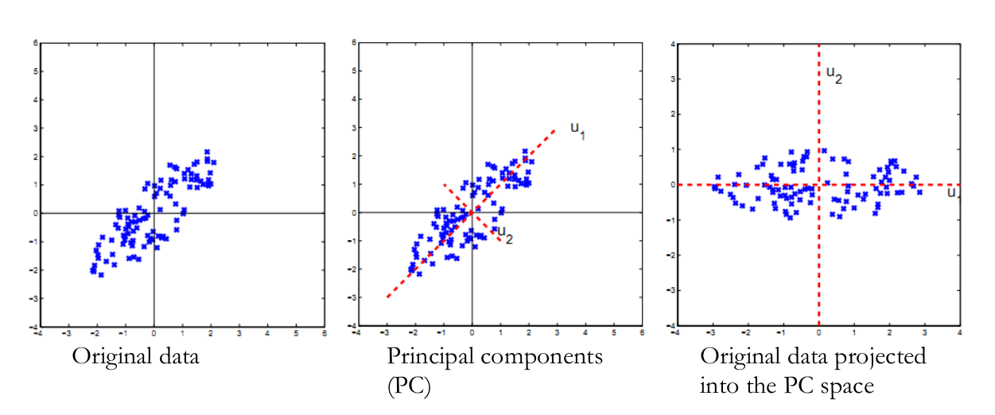
As PCA is calculated by the variance of features, it is influenced by the scale of data

Figure 1. Data with two correlated features show as x and y.
First component is map to vector u1, which has the largest variance. Then values are map to vector u2 to get the second component. u1 and u2 are vertical to each other, so components are independent.

I. IV EM

As show before, parameter estimation for naïve bayes is based on the assumption that it follows one normal distribution. There are cases it may follow a mixture model, as demonstrate by the old faithful eruption data.

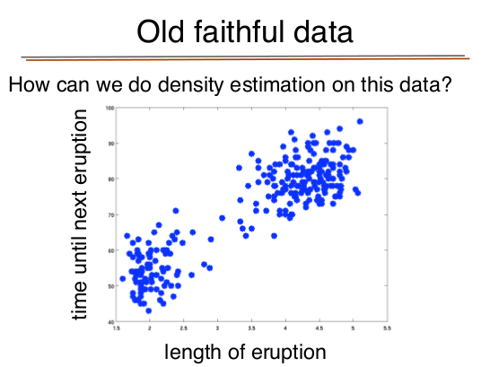
Figure 2. Mixture of Gaussians for Old Faithful Eruption
There are two groups of Data both belong to old faithful eruption. Instead of two parameters: one mean and one variance for a feature given its class, it will have two means and two variance for different groups. Also there is a latent variable Z, specifying the group that each data point belongs to.
Expectation Maximization (EM) algorithm[3] is used to estimated parameters for models with unobserved latent variables. Its iteration alternates between performing an expectation (E) step, which creates a function for the expectation of the log-likelihood evaluated using the current estimate for the parameters, and a maximization (M) step, which computes parameters maximizing the expected log-likelihood found on the E step. These parameter-estimates are then used to determine the distribution of the latent variables in the next E step.
- First, initialize the parameters to some random values.
- Compute the best value for given these parameter values.
- Then, use the just-computed values of to compute a better estimate for the parameters . Parameters associated with a particular value of will use only those data points whose associated latent variable has that value.
- Iterate steps 2 and 3 until convergence.

II. Implementation to Smart Phone Data Set
I test the above algorithm on Smart Phone Activity Recognition Data Set[4]. Data is downloaded from ref [5]. It has 9 features and 13 activity (class) to be classifed. Null activity is remove.

Experiment is perfumed by the following step:

(1) PCA is performed using R package “Stat”, to get uncorrelated features
(2) EM is performed by R in package “mclust”, in parameter estimation for each class and each feature. Number of groups is set to five.
(3) Naive bayes prediction is in implemented in R script (see attachment) using equations list in section I. Class label is chosen by the ones with largest probability.

III Evaluation

Accuracy is measured by cross validation. For each fold, data of one day is used as testing (about 80,000 on average) and the rest is used in training (about 110, 000 on average)
Comparing with performance of multi-layer perception is planned but not performance by the time of submittion.

IV Result
A. Accuracy
Table I. Prediction result for one fold against true class label
Diagonal represent the truth positive result

B. Performance
It takes more than 24 hours to run one fold of this algorithms (the complete cross validation result is not available by the time of write up submition). Major time is consumed by step (3) of prediction as listed before. EM step takes about one hour to run.

V. Discussion of Results

A. Accuracy

Prediction is really poor, expect for activity 5, 8 and 12.

One source of bad accuracy may come from the EM step, which I set the number of groups to five. It is hardly this case. I should have plot each attribute and chose the number of groups accordingly.
My lab mate is running a program which chose the group numbers by the ones gives best accuracy, which is not finished by the time of my submision.

Results may be damaged by data noise as well. There are of days with very few activities. By removing the days with less then 5 activities, which is the overall activity per day, accuracy is greatly improved. (Data not recorded).

Assumption of linearity, normality are not tested. Error could be raised from these reason as well. Using generalized PCA, EM algorithms may improve accuracy is these are the case.

B Time Performance

A lot of time is consumed in step (3) calculating equation 2.
Using

instead may reduce the time of calculation.

Second, time is consumed by multiply the probability of all features together. Choosing top K components, instead of using all 9, will reduce the time of computation.

VI Future Work

This algorithm could be parallelized by following steps.
- find each component value in PCA step
- estimate mean and variance for each feature in EM
- calculate class for each data point in EM
- calculate P(C) for each activity in naïve bayes
- calculate P(C|F) for each data in naïve bayes

Reference
[1] http://en.wikipedia.org/wiki/Naive_Bayes_classifier
[2] http://en.wikipedia.org/wiki/Maximum_likelihood
[3] http://en.wikipedia.org/wiki/Principal_component_analysis
[4] Jonathon Shlens, A Tutorial on Principal Component Analysis.
[5] http://en.wikipedia.org/wiki/Expectation%E2%80%93maximization_algorithm
[6] Stefan DernBach, et al. Simple and Complex Activity Recognition Through Smart Phones
[7] http://eecs.wsu.edu/~ckn/courses/f2012/ml.html

