Written Report

A Biological Solution to a Fundamental Distributed Computing Problem¹

Xiyu Xie

Summary of the paper: By studying the Sensory Organ Precursor (SOP) selection in fly's nervous system, they improved the distributed algorithm for Maximal Independent Set (MIS) problem-- with one bit optimal message complexity and without the prior knowledge of network topology. Later on by considering the local feedback from neighboring cells, their algorithms also achieved O(log N) time complexity ².

Section I: Significance of the contributions:

Although their simulation methods are under question whether it really mirrors biological system ³. Their result really heartened computer scientists not only (1) MIS algorithm do improved and achieved optimal message complexity that had been conceived by decades of computer scientists, not only (2) it is anther biologically inspired optimization solution to one problem that heartened back IBM's decision for their AIS. More importantly (3)it is the simple observations that “cells are distributed processors”, established the link between biological network and distributed system and networking, which inspired a new field of study.

Section II: A brief survey of related algorithms:

MIS is one of the fundamental method in sensor network to recover the its framework and efficient routing. While other are rapid method which takes O(log n) time, but the network is inundated with messages because all nodes must continuous monitor how they are connected ^{4,}. However, in a sensor network message send by a node may interfere with concurrent transmission, and there are other message overhead such as broadcast, wakeup, as well as message processing. Previous work try to reduce message complexity gives a O(log^2n/ loglog n) lower bound ^{5.} So this new algorithm which achieved one-bit optimal message complexity not only reduced message processing overhead also reduce the expense for the devises.
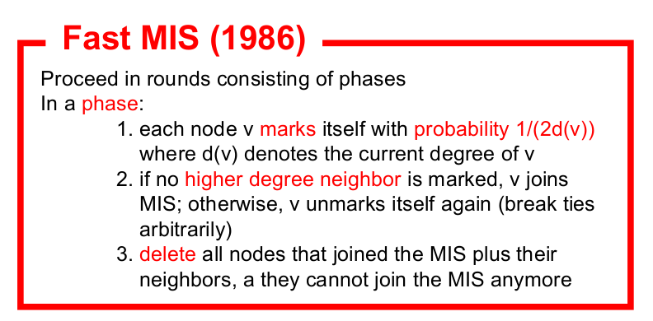

Section IV:Current and future trends:

Inspired by this paper, researchers begin to look for biological solutions or similarity an other wireless networks algorithms ^{7,8}. The influence of this paper goes beyond sensor work. A lot study springs up to establish the similarity and link between biological and computation system ^{9.}
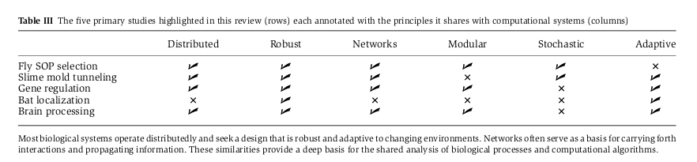

And a summary of papers
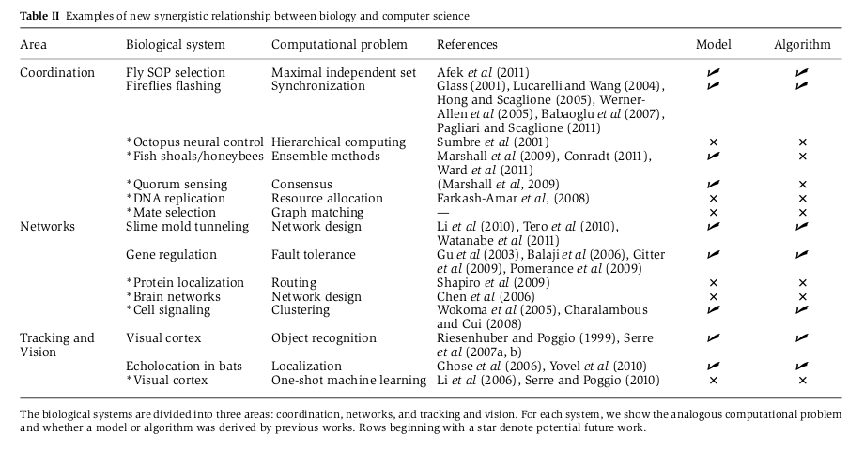

Section V: References:

- Afek, Yehuda, et al. "A biological solution to a fundamental distributed computing problem." Science Signaling 331.6014 (2011): 183.
- Scott, Alex, Peter Jeavons, and Lei Xu. "Feedback from nature: an optimal distributed algorithm for maximal independent set selection." arXiv preprint arXiv:1211.0235 (2012).
- Kephart, Jeffrey O. "Learning from nature." Science 331.6018 (2011): 682-683.
- Luby, Michael. "A simple parallel algorithm for the maximal independent set problem." SIAM journal on computing 15.4 (1986): 1036-1053.
- Moscibroda, Thomas, and Roger Wattenhofer. "Maximal independent sets in radio networks." Proceedings of the twenty-fourth annual ACM symposium on Principles of distributed computing. ACM, 2005.
- Agarwal, Rachit, et al. "Achieving small-world properties using bio-inspired techniques in wireless networks." The Computer Journal 55.8 (2012): 909-931.
- Agarwal, Rachit, et al. "Self-organization of nodes using bio-inspired techniques for achieving small world properties." GLOBECOM Workshops (GC Wkshps), 2011 IEEE. IEEE, 2011.
- Liu, Liang, et al. "Physarum optimization: A biology-inspired algorithm for minimal exposure path problem in wireless sensor networks." INFOCOM, 2012 Proceedings IEEE. IEEE, 2012.
- Navlakha, Saket, and Ziv Bar-Joseph. "Algorithms in nature: the convergence of systems biology and computational thinking." Molecular Systems Biology 7.1 (2011).

