tps に以下のテーブルデータを作成
CREATE TABLE stepList (
syain_no integer,
tempo_no integer,
name varchar(20),
entrance_day date,
salary integer,
tel_num varchar(13),
PRIMARY KEY (syain_no)
) DEFAULT CHARSET=utf8;

INSERT INTO tps.stepList values(1,1,'kimura takuya','2011-01-01',100000,'080-3477-2013');
INSERT INTO tps.stepList values(2,1,'kimura ichiro','2010-01-01',80000,'090-3477-2013');
INSERT INTO tps.stepList values(3,2,'tanaka hanako','2010-03-01',300000,'090-2477-2000');
INSERT INTO tps.stepList values(4,2,'yamasita tarou','2010-03-01',170000,'090-2477-2013');
INSERT INTO tps.stepList values(5,2,'ayase ichio','2010-03-01',170000,'090-2477-2013');
INSERT INTO tps.stepList values(6,4,'ayase haruka','2005-12-01',260000,'090-2477-2013');
INSERT INTO tps.stepList values(7,4,'yang insik','2005-02-01',300000,'090-2477-2013');

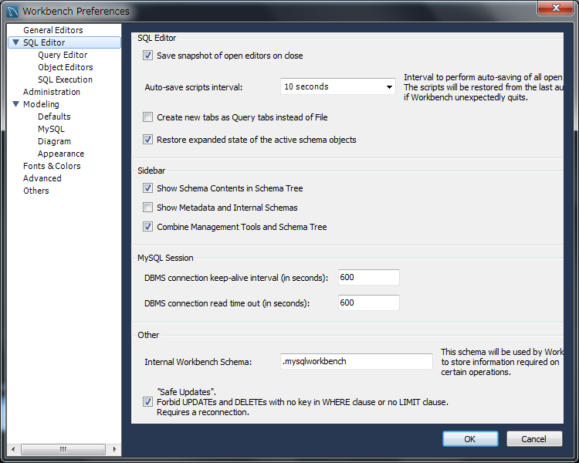
チェックをはずす

