计算机学院 计算机网络 课程实验报告

实验题目： Wireshark Lab:HTTP v8.1 |  | 学号：202300130150
日期：2025.3.7 | 班级： 23.4 | 姓名： 王成意
Email：202300130150@mail.sdu.edu.cn
实验方法介绍：
在介绍性实验中，我们已经熟悉了Wireshark数据包嗅探器，现在我们准备使用Wireshark来研究运行中的协议。在本实验中，我们将探索HTTP协议的几个方面：基本的GET/响应交互、HTTP消息格式、检索大型HTML文件、检索包含嵌入对象的HTML文件以及HTTP身份验证和安全性。
实验过程描述：
- 基本的HTTP GET/响应交互
输入地址后出现内容：
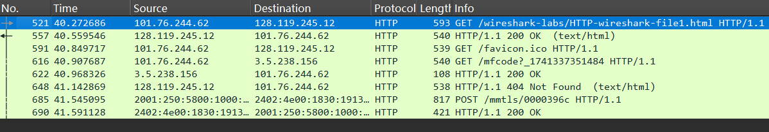
回答问题：1-7见结论分析。

- HTTP条件GET/响应交互
在执行：
在浏览器中输入以下URL
http://gaia.cs.umass.edu/wireshark-labs/HTTP-wireshark-file2.html您的浏览器应该显示一个非常简单的五行HTML文件。请快速再次在浏览器中输入相同的URL（或只需选择浏览器上的刷新按钮）
之后，出现：
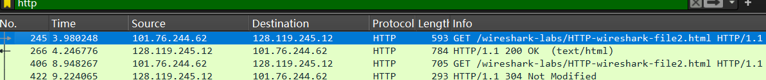
浏览器对应：
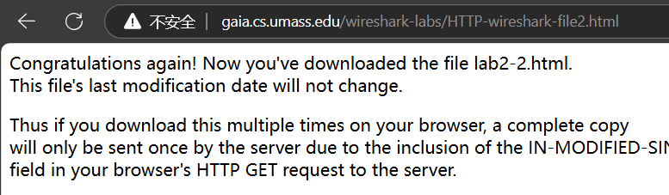
回答问题，8-11见结论分析。

- 检索长文档
清除缓存之后，输入
http://gaia.cs.umass.edu/wireshark-labs/HTTP-wireshark-file3.html：
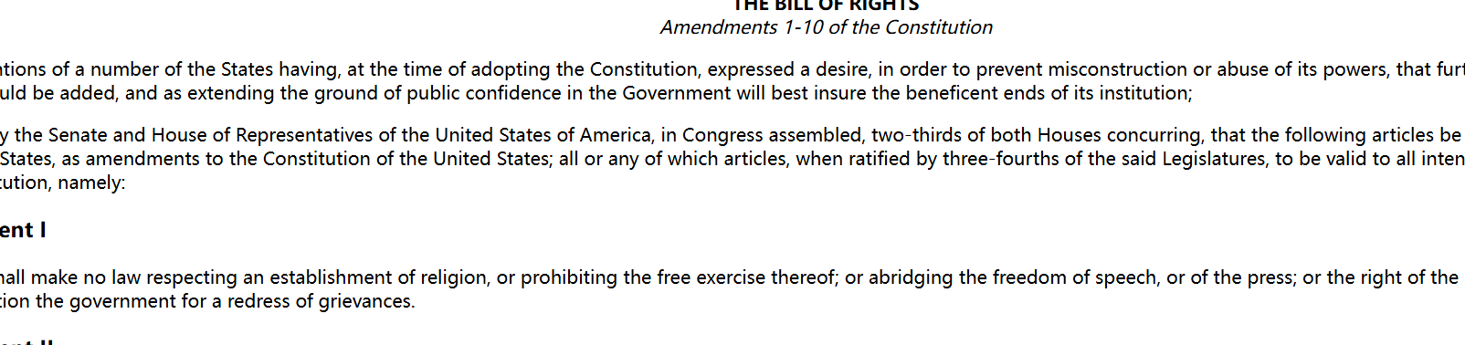
回答问题12-15见结论分析。

- 带有嵌入对象的HTML文档
清除浏览数据之后，打开相应的链接：
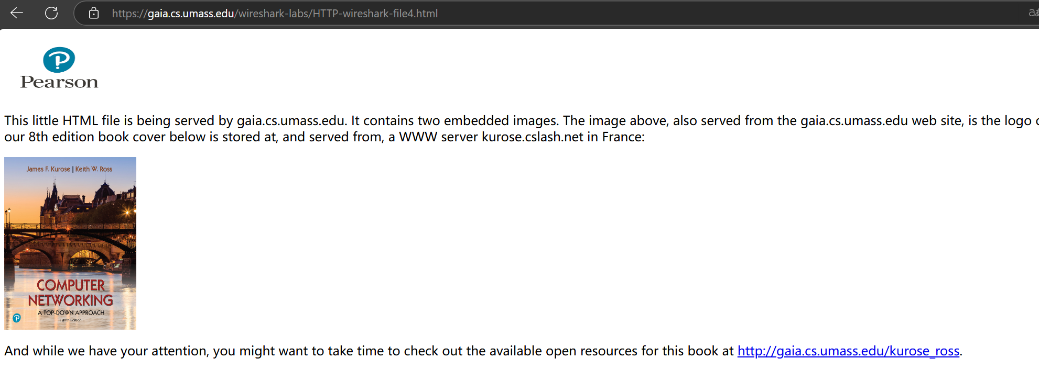
捕捉到的http：
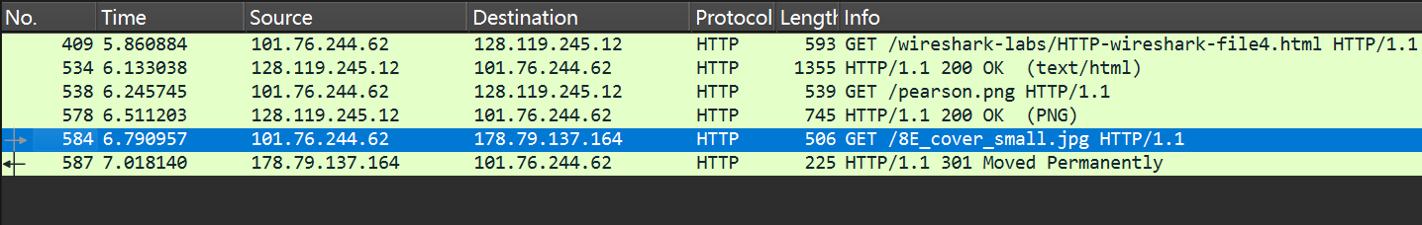
回答16-17，见结论分析
- HTTP身份验证
访问该网站：
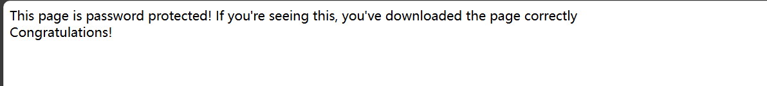
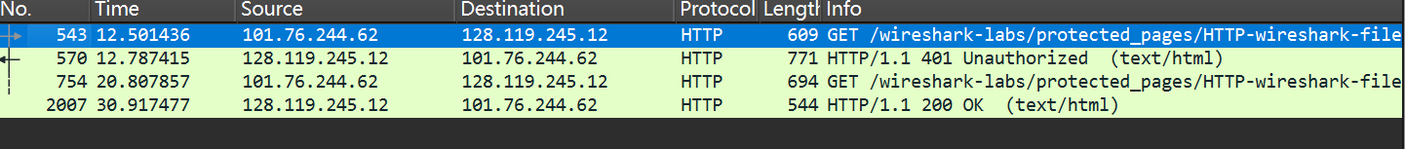
回答18-19见结论分析。

结论分析：
- Is your browser running HTTP version 1.0, 1.1, or 2? What version of HTTP is the server running?
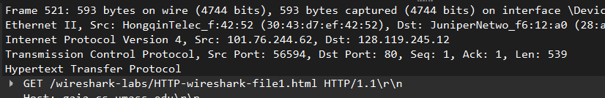
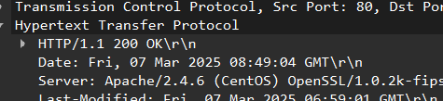
可见都是1.1版本。

- What languages (if any) does your browser indicate that it can accept to the server?
答案：见截图显示
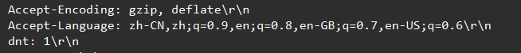

- What is the IP address of your computer? What is the IP address of the
gaia.cs.umass.edu server?
分析得知我的ip是101.76.244.62，对方的是128.119.245.12

- What is the status code returned from the server to your browser?
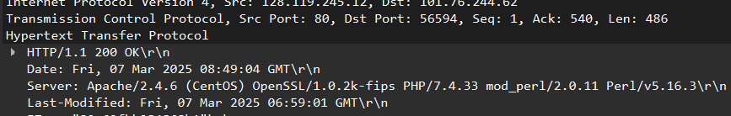
状态码是200 OK，成功找到并返回。
- When was the HTML file that you are retrieving last modified at the server?
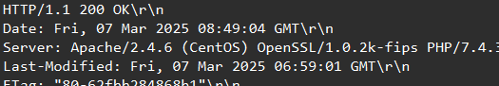
发现是2025.3.7 6：59：01最后一次修改。

- How many bytes of content are being returned to your browser?
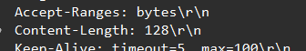
一共128字节。

- By inspecting the raw data in the packet content window, do you see any headers
within the data that are not displayed in the packet-listing window? If so, name
one.

发送：
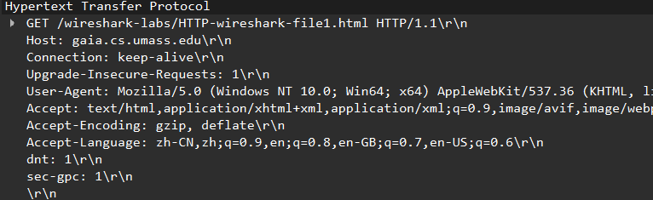
回应：
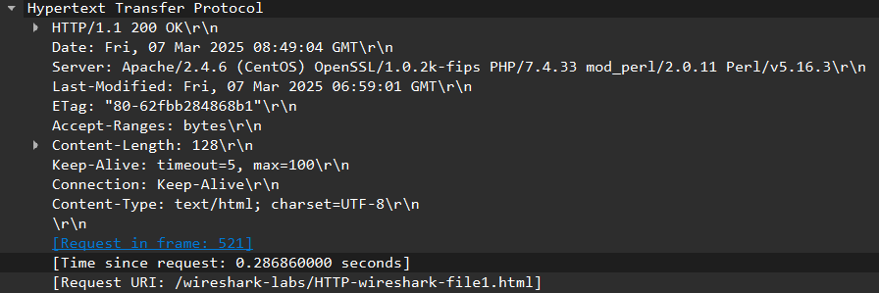
没有找到。

- Inspect the contents of the first HTTP GET request from your browser to the
server. Do you see an “IF-MODIFIED-SINCE” line in the HTTP GET?
没有看到：
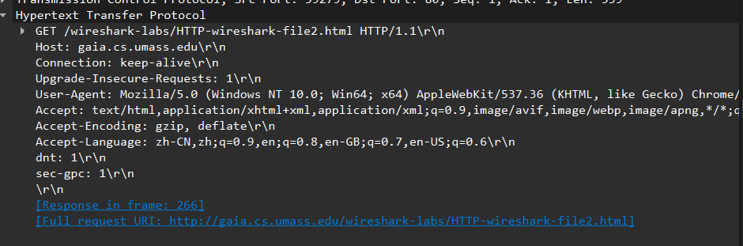

- Inspect the contents of the server response. Did the server explicitly return the contents of the file? How can you tell?
是，因为状态码是200 OK：
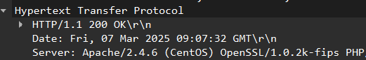

- Now inspect the contents of the second HTTP GET request from your browser to the server. Do you see an “IF-MODIFIED-SINCE:” line in the HTTP GET? If so, what information follows the “IF-MODIFIED-SINCE:” header?
是，信息：
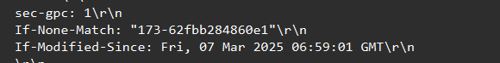
是最后一次修改的时间
- What is the HTTP status code and phrase returned from the server in response to this second HTTP GET? Did the server explicitly return the contents of the file? Explain.
HTTP状态代码和短语：
没有明确的反汇文件内容，因为该网页内容在上次访问之后未被修改，且本地有上次访问的缓存。

- How many HTTP GET request messages did your browser send? Which packet number in the trace contains the GET message for the Bill or Rights?
一个请求，在第一个包，详见引用部分：

- Which packet number in the trace contains the status code and phrase associated with the response to the HTTP GET request?
第一个数据包：
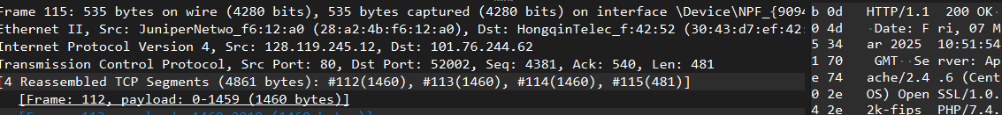
- What is the status code and phrase in the response?
200 OK：
- How many data-containing TCP segments were needed to carry the single HTTP response and the text of the Bill of Rights?
一共有四个：
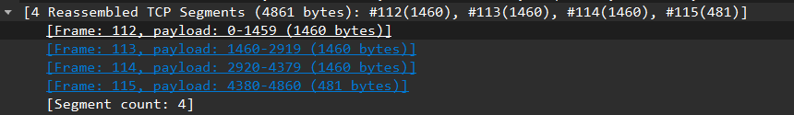

- How many HTTP GET request messages did your browser send? To which Internet addresses were these GET requests sent?
发送了三条http的请求信息。这些get发送给了128.119.245.12 和 178.79.137.164

- Can you tell whether your browser downloaded the two images serially, or whether they were downloaded from the two web sites in parallel? Explain.
两张图片是先后发出请求的，看时间戳：
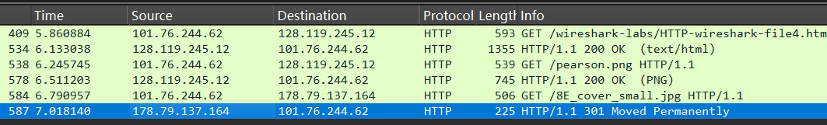
第一张图片返回ok之后才发送的第二个请求。

- What is the server’s response (status code and phrase) in response to the initial HTTP GET message from your browser?
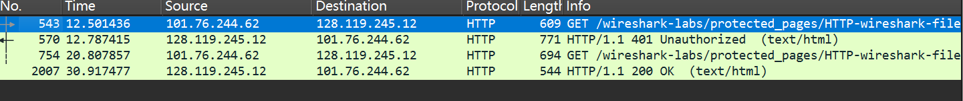
可见没有输入账号密码之前是401 Unauthorized，输入正确之后是200 OK。

- When your browser’s sends the HTTP GET message for the second time, what new field is included in the HTTP GET message?
对比：
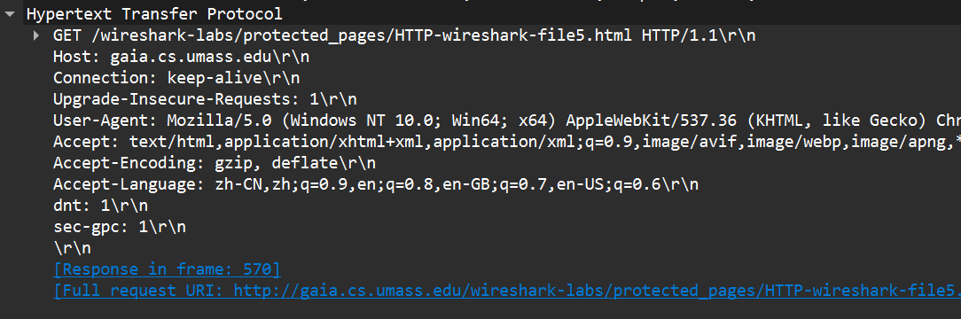
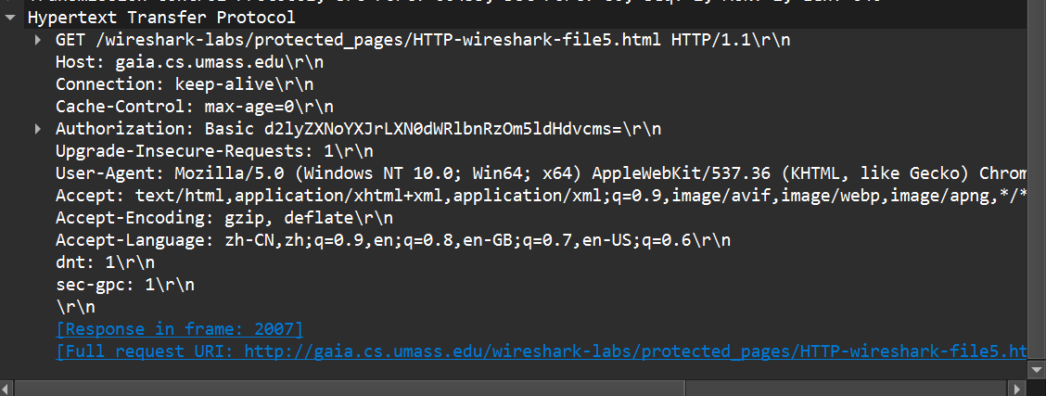
对比发现多了Authorization，cache-control.
结论：通过此次学习，我对于http有了更深刻的认知。

