计算机学院 计算机网络 课程实验报告

实验题目： Wireshark Lab:UDP v8.1 |  | 学号：202300130150
日期：2025.3.21 | 班级： 23.4 | 姓名： 王成意
Email：202300130150@mail.sdu.edu.cn
实验方法介绍：
通过wireshark抓包并分析UDP内容。
实验过程描述：
1.开启wireshark，并使用nslookup查找：
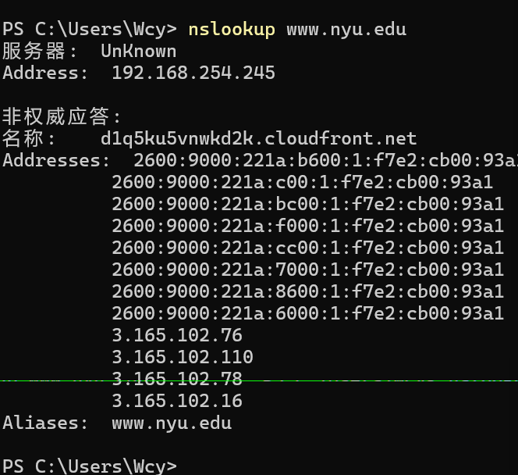
Wireshark抓包结果：
- Select the first UDP segment in your trace. What is the packet number of this segment in the trace file? What type of application-layer payload or protocol message is being carried in this UDP segment? Look at the details of this packet in Wireshark. How many fields there are in the UDP header? (You shouldn’t look in the textbook! Answer these questions directly from what you observe in the packet trace.) What are the names of these fields?
- By consulting the displayed information in Wireshark’s packet content field for this packet (or by consulting the textbook), what is the length (in bytes) of each of the UDP header fields?
- The value in the Length field is the length of what? (You can consult the text for this answer). Verify your claim with your captured UDP packet.
- What is the maximum number of bytes that can be included in a UDP payload?
(Hint: the answer to this question can be determined by your answer to 2. above)
- What is the largest possible source port number? (Hint: see the hint in 4.)
- What is the protocol number for UDP? Give your answer in decimal notation. To answer this question, you’ll need to look into the Protocol field of the IP datagram containing this UDP segment (see Figure 4.13 in the text, and the discussion of IPheader fields).
- Examine the pair of UDP packets in which your host sends the first UDP packet and the second UDP packet is a reply to this first UDP packet. (Hint: for a second packet to be sent in response to a first packet, the sender of the first packet should be the destination of the second packet). What is the packet number 5 of the first of these two UDP segments in the trace file? What is the value in the source port field in this UDP segment? What is the value in the destination port field in this UDP segment? What is the packet number 6 of the second of these two UDP segments in the trace file? What is the value in the source port field in this second UDP segment? What is the value in the destination port field in this second UDP segment? Describe the relationship between the port numbers in the two packets.
结论分析：
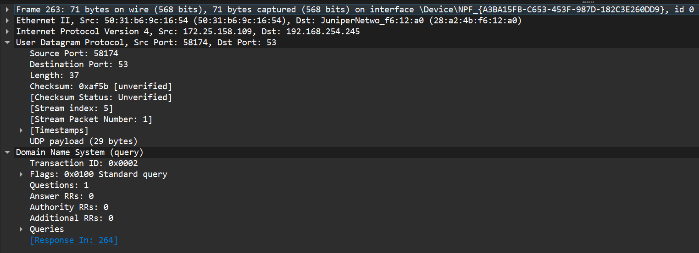
- 数据包编号是263，携带的是DNS，有四个字段：
Source port,Destination port,Length,Checksum;

- 观察得知：
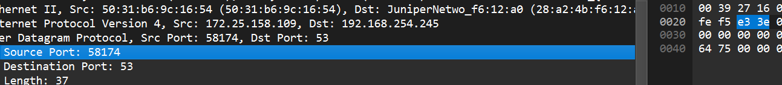
每一个字段长度都是2字节，一共是2*4=8字节。

- Length字节是37，观察：
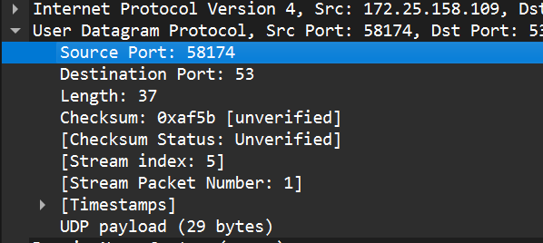
得知37 = 29+8(payload+header).

- 由2分析length占2字节，16比特，总就是2^16,除去header所以payload最长可以是（2^16-8）= 65528 bytes。

- 端口占2字节，所以最大表示的数字就是2^(2*8)-1 = 2^16 – 1 = 65535

- 见下图protocol：
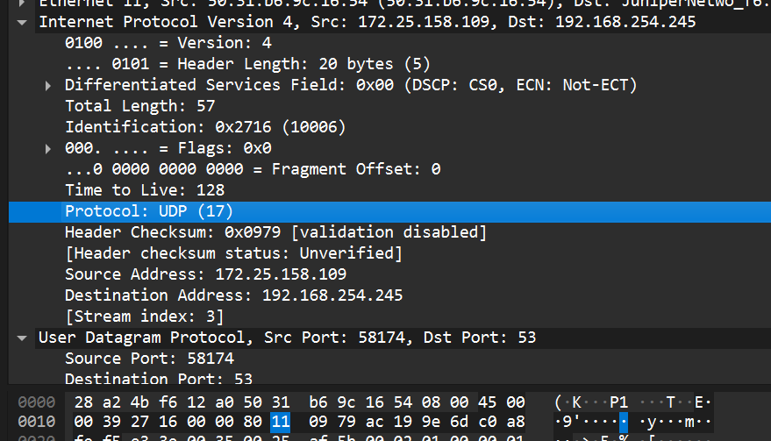
分析结果是0x11 = 17.

- 观察263与264：
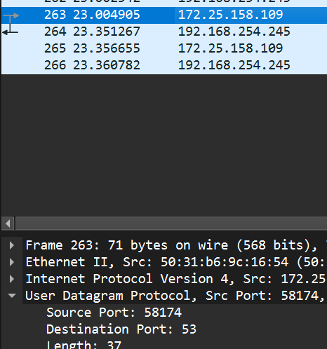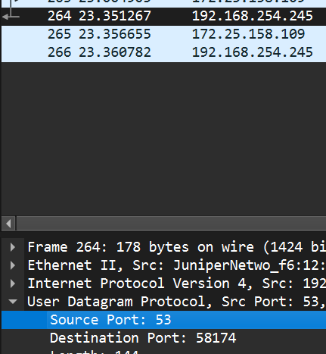
发现DNS查询的源端口号（58174）和目的端口号（53）分别与DNS查询响应的目的端口号（53）和源端口号相对应（58174）.
结论：通过此次实验，我对于UDP有了更深刻的理解。

