**Interactive Visualization Framework**

In this project, an interactive visualization framework for a correlation-based analysis is introduced. The data used here was from a study of the adverse events of a drug on 117 patients affected by Crohn’s disease. This visualization framework allows users to see the relationships between each feature.

**Directory Structure**

Here is the structure of all the files

README.md

/mysite

app.py

/input

the dataset (.csv)

/templates

index.html

/static

/css

...

* The Flask server's code is in app.py
* The custom CSS code is stored under /static/css
* All the charts and front-end code can be found in /templates/index.html

**The Visualization Framework**

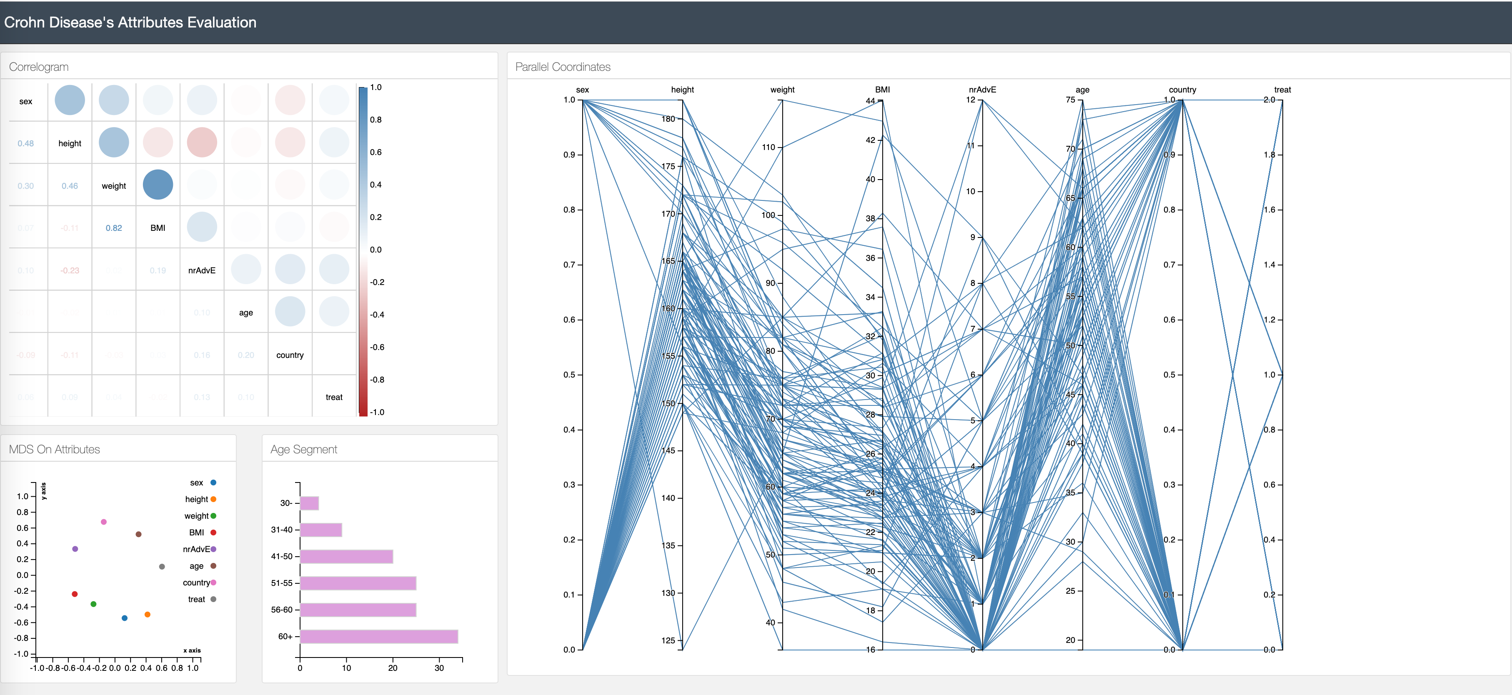

Here are in total 4 charts in the visualization framework:

* The **correlogram** (top left) shows the correlations between each feature
* The MDS **scatter plot** (bottom left) shows the embedded features in 2D space, which also indicate the correlations (if two features are close to each other, they are high correlated)
* **Age segment bar chart** (bottom middle) shows the distribution of age of patients
* **Detailed view** (right) in Parallel Coordinate for all the data in the datasets

**How to run the code**

* You need Python 2.7.x and 4 Python libraries: Pandas, sklearn, Numpy, Flask. You can install them using *pip*.
* Download the dataset (CrohnD.csv) from [R Datasets](https://github.com/vincentarelbundock/Rdatasets/blob/master/csv/robustbase/CrohnD.csv) and save the CSV file in the /input folder.
* From the /mysite folder, run *python app.py*

After the server initializes, it will listen on port 5000 waiting for connections. Then open up the web browser and enter the following URL in the address field:

[http://localhost:5000](http://localhost:5000/)

Now you can play on the visualization tool!