Eniversal Exhibit

Basic info:

The program is designed as universal program for all exhibits. It is using the .NET Framework 4.6.2.

The base is to show the entertaining content, which is mostly as HTML. Therefore I use CefSharp library. It's posible to show another program, which has to have correct size and position.

Structure:

\unex\unex
- Program.cs: is the Main for start of program. Check resolution, open settings, run WebServer for communication with Web content.

- BrowserBoundObject.cs
- BrowserCallback.cs
- WebKeyboardHandler.cs: it's for base communication with web content

- ComPort.cs: initialization COM ports, and communication with HW

- JsonReader.cs
- JsonStructure.cs: reading educational texts from extern file

- Magnifier.cs: feature for visually impaired people. Its about change a contrast, zoom e text and web content.

- PresentationScreen.cs: it is for a second monitor or for a marketing monitor

- QrReader.cs
- QrVideo.cs: libraries for read visitors tickets via a camera

- RunExe.cs: important library for set 3rd party program, which is used instead of web content. I check if the 3rd party program is running and I change the properties of this program.

- SvgPictureBox.cs: change the icons (saved as svg) according to current color scheme.

unex.cs: is an UI controller, which control all content

- VpassBuffer.cs: library which save visitors data for sending via VpassConnection
: library

- WebSocket.cs
- WebSocketClient.cs
- WebSocketJsonStructure.cs: libraries for communication with another program on an exhibit. This communication should specify API for sending statistics information

\unex\VpassConnection
- sending visitors results to our local server
- creating XML structure for http web request

\unex\Logger
- for logs

Design:

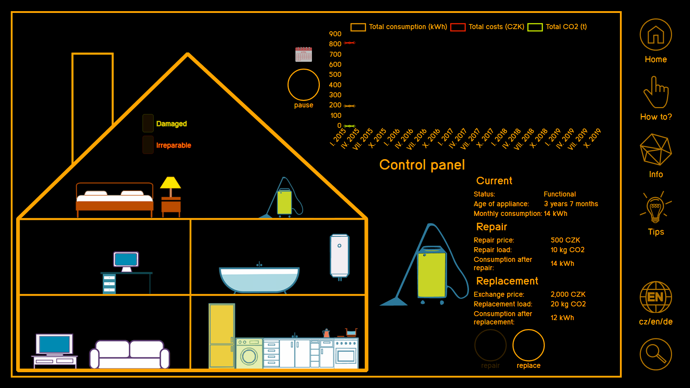
The main screen with web content

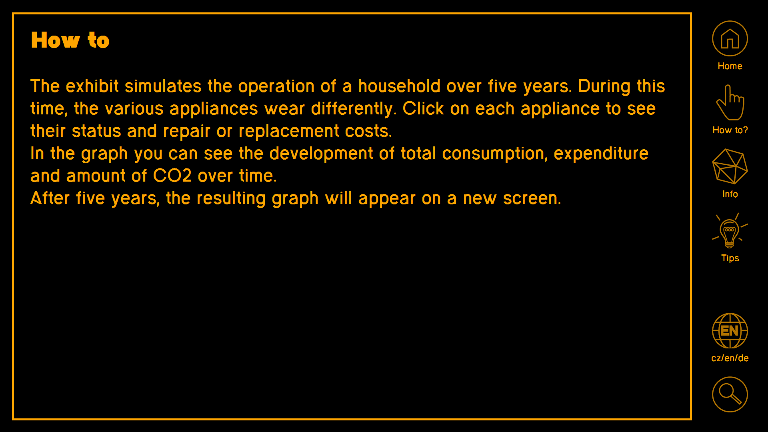
The text screen with defined json text

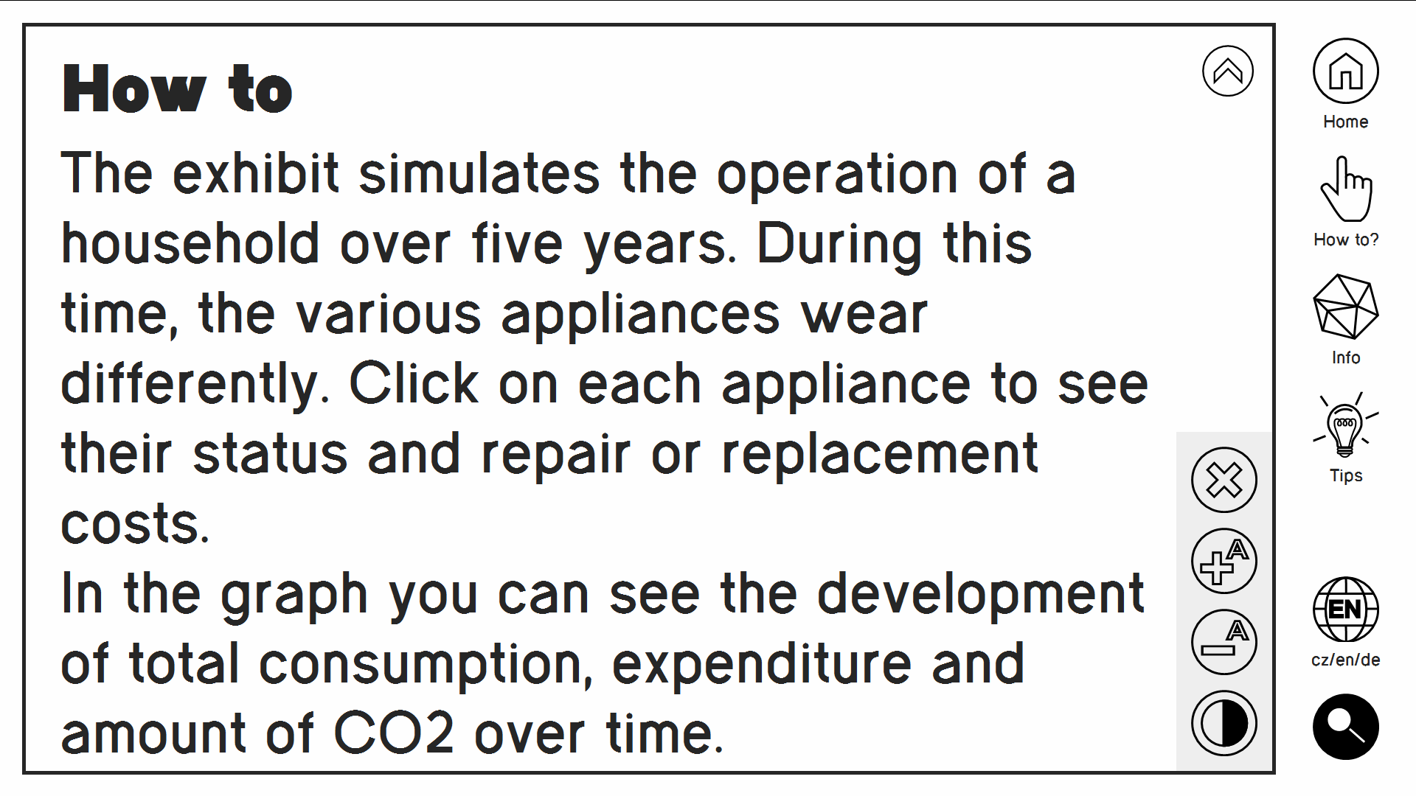
The text screen with defined json text with enabled feature for visually impaired people.

