Jeffrey Tran

Jefftran

INFO – I360

1 April 2019

Project Planning

**Purpose**

*Goals:*

The purpose of this project/portfolio is to demonstrate the skills and knowledge I have developed over my time here at Indiana University. Talking about what I know is great and all, but it would be nice for people to have a visual to look at while listening along to the conversation. They get to see the process I go through with each project and see how I overcame any obstacles that I may have faced. Also, having a link to a portfolio comes in handy because I would not want to carry around physical packets everywhere just in case, I encounter an employer. All I must do is send an email with the link or something and voila, he or she is able to view my work. Hopefully they take a liking to my skillset and allow me to join their team as an intern.

*Scope:*

For this portfolio, there will be information about me. Giving someone some work that I have done seems odd without letting the person having a chance to get to know me. Some information I will be providing is my contact information and how I became interested in the User Experience Design field. I will also be providing the skills I have acquired at Indiana University and what kind of proficiency I have with each tool. There will also be a way to download my resume if the employer or anyone would like to see it. Lastly, some of my projects I have done will be in this portfolio. With each project I am going to let viewers understand what kind of process I went through with each one.

*Audience:*

The audience for this portfolio site will be mainly hiring managers at various companies. Currently, I am seeking an internship for the summer. I want to be able to demonstrate what I know to them so that I can be an asset to their company and this project will help me do this. Some people apply to jobs such as User Experience Design without a portfolio and that does not let employers see what things they have done. I was one of those people. I believe employers enjoy looking at the applicant’s portfolio because they can go through a journey with him or her.

**Sitemap/Navigation**

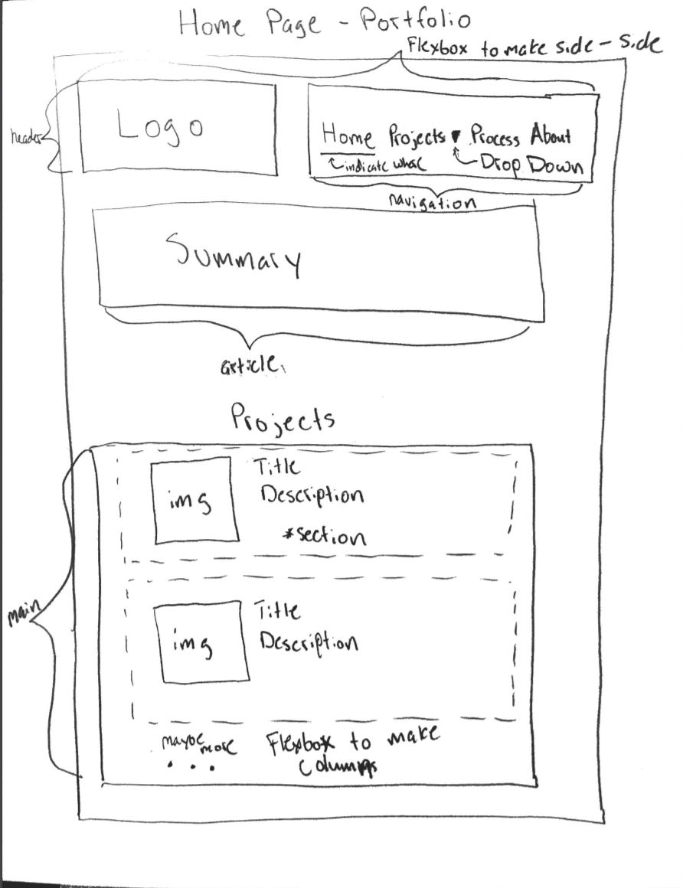

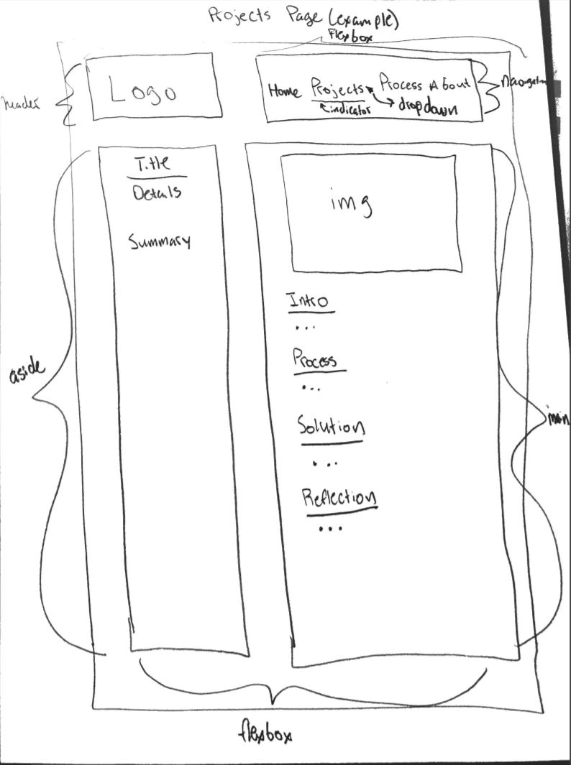

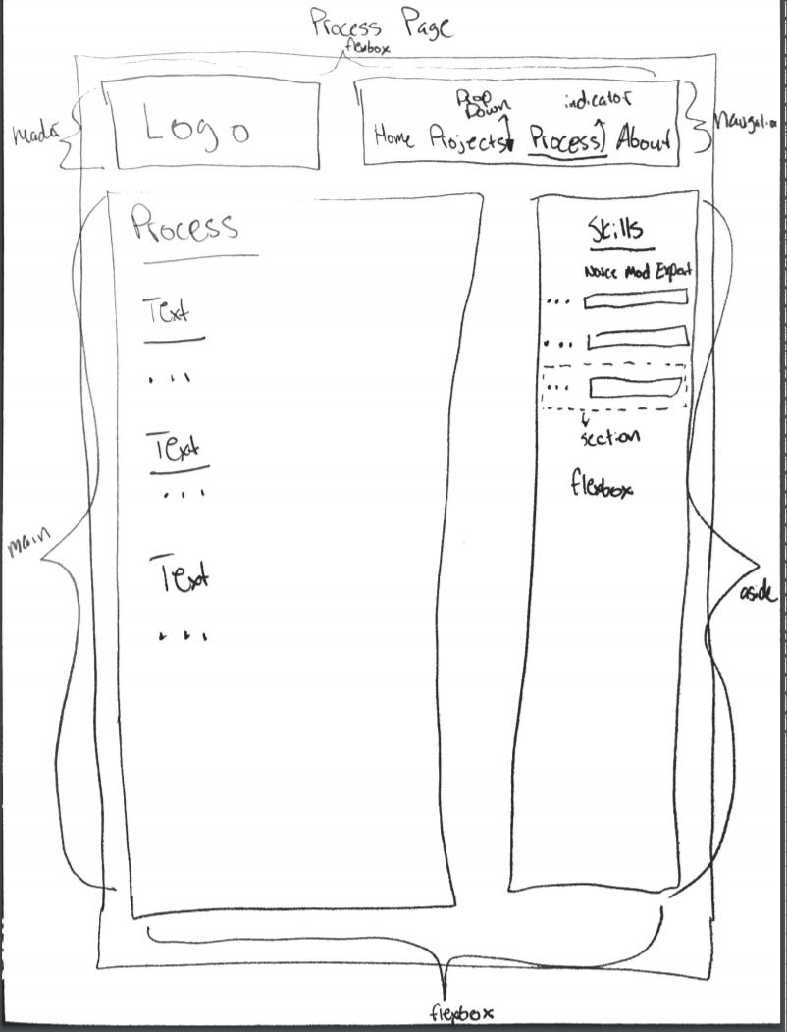

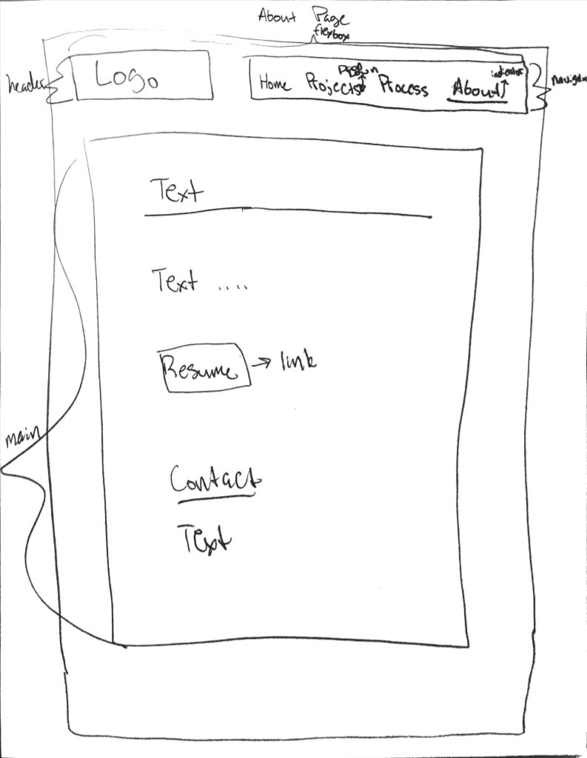

**Content**

For this project, I will need:

* Images of the work I have done
* Text about what I did for each project
* A drop-down link in my navigation
* My resume that is up to date
* Skills I know
* My projects about 2-4
* A video to showoff one of my projects
* A summary of my project
* Contact information (phone, email, address)
* Text about how I became interested in UX Design
* Design Methods that I have used in the projects

**Brand/Look and Feel/Style Tiles**

*Look and Feel*:

For this portfolio, I want it to have a clean, yet simple look to it. As a person, I am very simple. I like to do things that take minimal effort and have good results. I also want this project to be very chill because I believe that people can be themselves around me. Being stressed is something that I rarely encounter, and my friends call me a relaxer. When a viewer looks at my site, I want him or her to be comfortable. Because the site will think about how people feel when they go to it, it is also going to have a friendly vibe that is inviting. Not only will this site be user friendly, it will be informative so that when a user leaves the page, he or she will get to know something about me. To put it simply, I want this website to represent me as a person.

*Logo*:

For my logo, I plan on using a UX Design quote and the author using 1 sans and sans serif font.

*Style*:

* Color:
  + 
* Typography
  + Serif:
    - 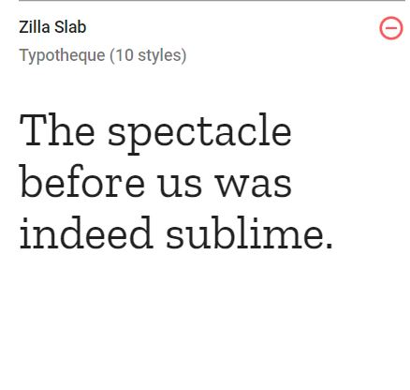
  + Sans-Serif:
    - 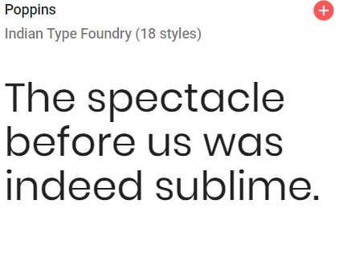
* Texture
  + 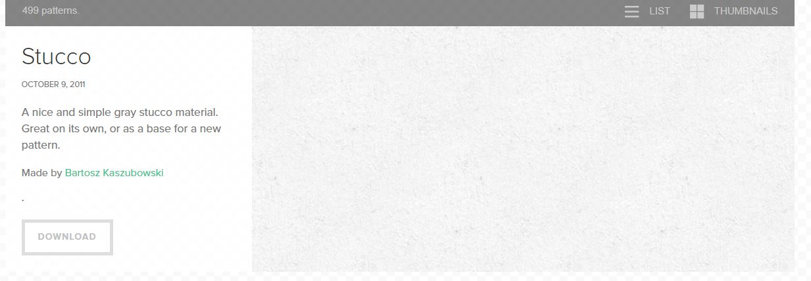
* Design Element
  + Navigation
  + Logo
  + Headers – one font
  + Text – another font
  + Links will be underlined when hovered
  + Current page will have background color
* Descriptor
  + Simple
  + Chill
  + Relaxed
  + Friendly
  + Inviting
  + Informative
  + Sharp
  + Creative
  + Personal