STEP 10 – Configuration, exclusions and copy
10.1-) Open your new theater root diretory. Open the file game.xml and edit and save the following modification:
Set ShowUIworld to FALSE
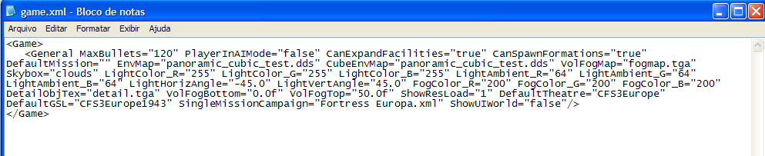

10.2-) Edit the file qclocations.xml (root dir). If you have a totally new theater delete all entries and put the new airfield data from your new global_layer.csv. If you have a theater with original area included, just add the new airfields data.
A totally new theater needs at least one airfield.
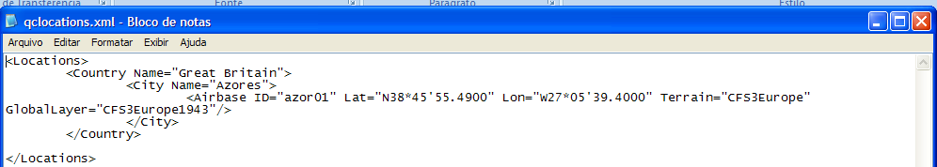

10.3-) Open the global_layer subdirectory on your new theater installation. DELETE global_layer.csv AND gsl.lib. Copy and paste these files FROM your GlobalLayer subdir of working dir into it.
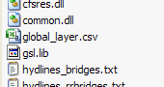

10.4-) On new theater directory, open the terrains2 dir and delete all files, and copy and paste the files cfs3hyl.zip and cfs3msh2.zip FROM YOUR WORKING DIR into it.
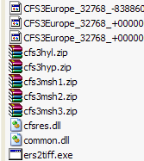
10.5-) Open the terrains subdir, and delete all *.zx files. Also, delete the original files CFS3eur.lcf, cfs3hyp.zip, cfs3msh1.zip and cfs3msh3.zip. Copy and paste these files from your working dir into it.
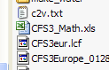
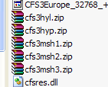

10.6-) Unzip terrdata.zip file and open terrdata subdir. Edit the terrain origin for the origin on CFS3_Math.xls. Save and close it.
I used decimal coordinates for origin. CFS3 original uses another format. For me, the decimal coordinates works.
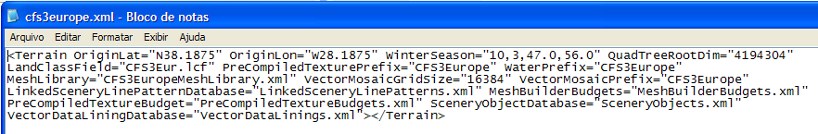
10.7-) Now, delete the old file terrdata.zip.
Open the terrdata directory, select all files and ZIP without compression. Name it terrdata.zip and move the new zip file to terrains subdir.

10.8-) Close all apps and fire CFS3.exe from new scenery installation. Choose Quick Combat - Free Flight. The new airfield will show on Location. Click FLY button. If all procedures was correct, you will see a new naked scenery.
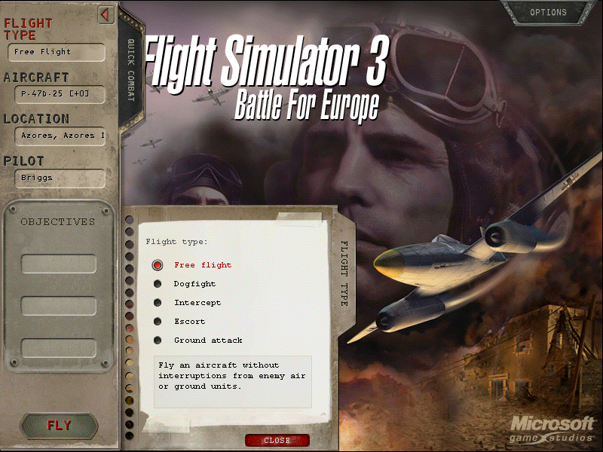
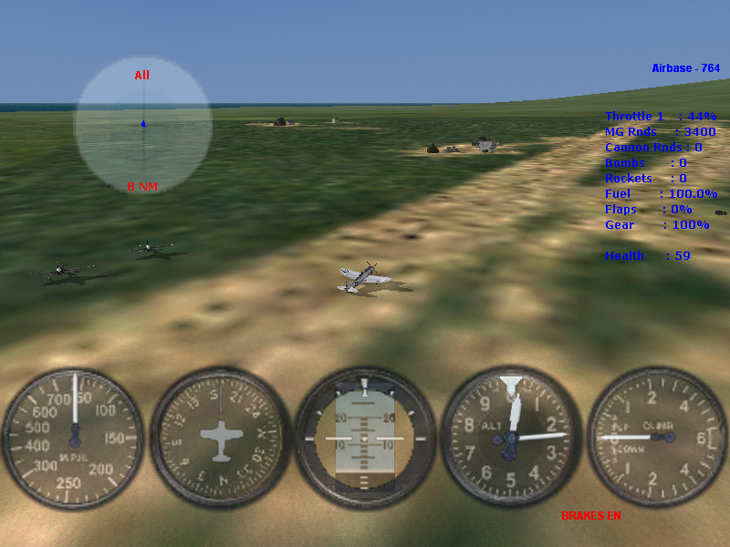

10.9-) If you find errors, or want to add more info, fell free to edit all the tutorial.
Thanks a lot SOH team!
10.10-) END OF STEP 10.

