JM  CURRICULUM  VITAE  2026  PORTUGAL | 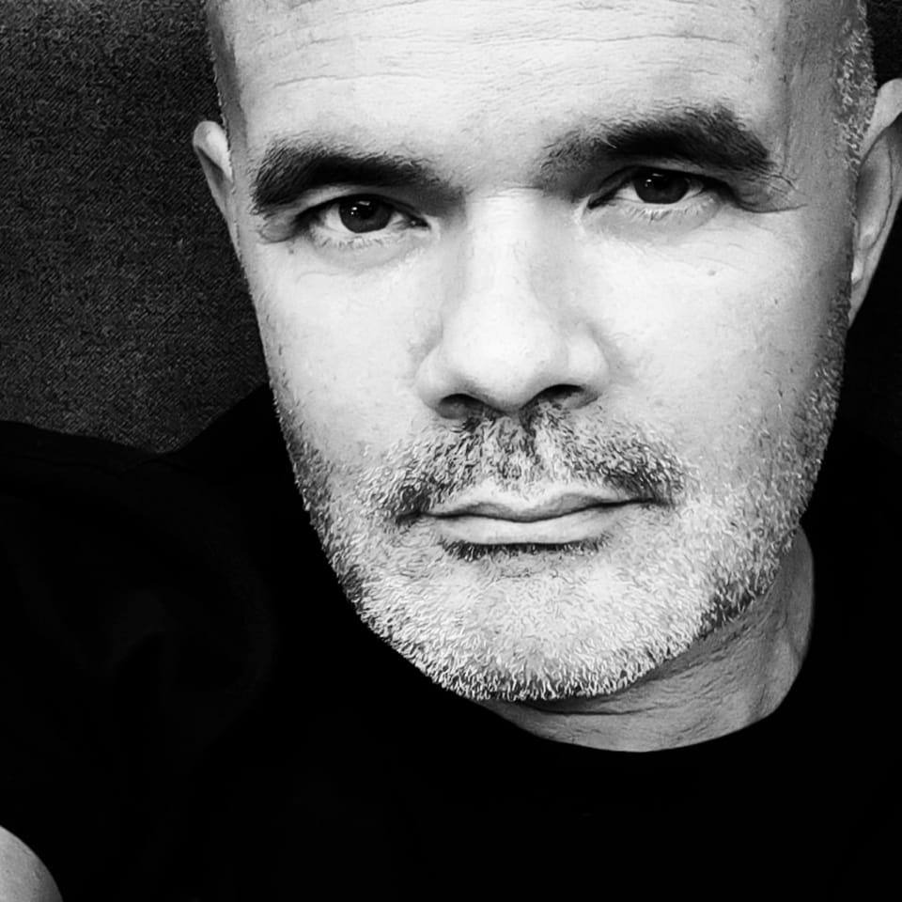  JOSÉ MAURÍCIO  FULL-STACK DEVELOPER / OTHER ROLES  Tech Lead / Team Leader / Software Architect / Scrum-Master / Product Owner / CI/CD Engineer  xjpmauricio@gmail.com | +351 933627429 | www.linkedin.com/in/josemauricio | Born: 25 September 1973
PROFESSIONAL FOCUS
Senior software profile focused on modernizing business platforms, guiding delivery teams, and translating complex technical decisions into maintainable systems.
40+  PROJECTS |  | 25+  YEARS OF EXPERIENCE |  | 65+  TECHNOLOGIES
ARCHITECTURE  Clean Architecture, CQRS, APIs | DELIVERY  Team leadership, product ownership |  | ENGINEERING  .NET, Blazor, SQL, integrations |  | AUTOMATION  Azure DevOps API, AI-assisted workflows
INDEX
01  EXPERIENCE | 02  TECHNOLOGIES | 03  PROJECTS | 04  EDUCATION | 05  LANGUAGES | 06  ABOUT

01 | PROFESSIONAL EXPERIENCE
PERIOD |  | COMPANY |  |  | ROLE AND CONTEXT
Sep 2025 – Present |  |  | Crédito Agrícola |  | Senior Software Architect  Portugal · Hybrid
Sep 2025 – Present |  |  | AskBlue |  | Senior Software Architect  Portugal · Hybrid
Oct 2024 – Sep 2025 |  |  | Sotheby's International Realty |  | Senior Software Developer  Portugal · Remote
Sep 2024 – Sep 2025 |  |  | ERA Portugal |  | Senior Software Developer  Portugal · Remote
Oct 2014 – Oct 2022 |  |  | Itoorer |  | Senior Software Developer Team Lead  Porto, Setubal, Lisbon
Apr 2014 – Nov 2014 |  |  | Evolute |  | Web Developer  Lisboa
May 2013 – Oct 2014 |  |  | Freelancer |  | Freelancer  Setubal
Jan 2011 – Dec 2012 |  |  | Cofidis Portugal |  | Senior Software Architect  Lisbon · On-site
Jul 2012 – Nov 2012 |  |  | Shore Spun |  | Senior Software Developer
Jan 2012 – Nov 2012 |  |  | Delphi |  | Senior Software Architect  Lisbon · On-site
Jan 2012 – Sep 2012 |  |  | ITSector |  | Senior Software Developer  Lisbon · On-site
Jun 2009 – Jul 2012 |  |  | Highbrand |  | Senior Software Developer  Lisboa · On-site
Jan 2012 – Jun 2012 |  |  | Banco Montepio |  | Senior Software Developer  Lisbon · On-site
Jan 2009 – Dec 2010 |  |  | Price Waterhouse Coopers – PwC |  | Senior Software Developer  Lisbon · On-site
Jan 2009 – Dec 2010 |  |  | euroAtlantic Airways |  | Senior Software Architect  Lisbon · On-site
Jun 2007 – Jun 2009 |  |  | SetCom SGPS, SA |  | Senior Software Developer
Oct 2005 – May 2007 |  |  | EAD – Empresa de Arquivo de Documentação |  | Senior Software Developer Team Lead  Palmela, Setúbal · On-site
Jan 2003 – Oct 2005 |  |  | Softlab |  | Senior Software Developer

02 | TECHNOLOGIES
AI & AUTOMATION  OpenAI Vision API, Claude Code (Anthropic), Codex (OpenAI), Antigravity (Google), Grok Imagine Video (xAI) |  | BACKEND & FRAMEWORKS  ASP.NET, .NET Core, Blazor, Radzen.Blazor, MVC, Razor, SignalR, WCF, WPF, XAML, Windows Forms, Microsoft Ajax Control Toolkit, Microsoft Web Services, OutSystems |  | CMS & PLATFORMS  DotNetNuke, WordPress
CREATIVE & DESIGN  Adobe Lightroom, Adobe Photoshop |  | DATABASES & ORM  MSSQL Server, PostgreSQL, MySQL, Oracle 10, Oracle 11, Microsoft Access, Entity Framework, Linq2SQL, Toad |  | DEVOPS & INFRASTRUCTURE  Docker, Azure DevOps, Caddy, IIS, Jenkins, GIT, TFS, Tortoise, Windows Advanced Server
FRONTEND  React, Next.js, Angular, AngularJS 1.x, TailwindCSS, Bootstrap, HTML, CSS, jQuery, jQuery UI, ExtJs 2.0, ExtJs 3.0, ExtJs 4.0, ExtJs 4.2, MooTools |  | IDE & DEV TOOLS  Visual Studio, Visual Studio Code, Android Studio, Eclipse, NetBeans |  | LANGUAGES  C#, Java, JavaScript, PHP, Python, VB.NET, Visual Basic, Classic ASP (VB)
MOBILE
Android, Nativescript, jQuery Mobile, PhoneGap, Sencha Touch, J2ME

03 | MOST RELEVANT PROJECTS

01 | Crédito Agrícola / Sep 2025  Client: Crédito Agrícola | Role: Software Architect | Team: 10  As Software Architect, I planned the migration of a legacy company productivity management platform built with .NET Framework 4.5 MVC and web services to a modern .NET 9 solution. The project supports productivity management across the company, helping teams organize work, monitor delivery, and improve operational visibility. The new architecture follows Clean Architecture principles and applies CQRS with the Mediator pattern to separate commands from queries, improve maintainability, and support a safer modernization path. I also worked with Azure DevOps API integrations to connect delivery workflows with the platform ecosystem.  Stack: .NET 9, .NET Framework 4.5, ASP.NET MVC, Web Services, CQRS, Mediator Pattern, Clean Architecture, MSSQL Server, Azure DevOps API

02 | In-House Real Estate CRM/ERP / Oct 2023 - Sep 2025  Client: ERA and Sotheby's | Role: Full-Stack developer | Team: 20  I participated in migrating a platform to a new architecture, ensuring greater system efficiency and scalability. Additionally, I developed a proof of concept using OpenAI for process automation in the real estate sector, which involved extracting data from handwritten documents to enable automatic form filling in the new platform under development. Using OpenAI Vision, I implemented automated descriptions of property images (identifying rooms and elements present in the images) to generate SEO-optimized text, which required developing specific prompts to improve the accuracy of the results.  Stack: Entity Framework, Linq2SQL, Blazor Server App, C#, Azure, OpenAI, Visual Studio, Azure, Radzen.Blazor, SQL, Azure

03 | Veezit, City Guide, Backoffice / Sep 2013 - Oct 2022  Client: Gottsolutions / Itoorer | Role: Lead Developer | Team: 10  This project was initiated by a group of investors, mostly from Porto, and involved developing a mobile app (launcher) integrated into devices provided on a rental basis by car rental companies and hotels. The product aimed to offer unlimited Internet access (via HotSpot), unlimited national and international voice communications (via Sinch), GPS, and a tourist guide application. Initially, I served as the Lead Developer for the project, responsible for the overall architecture.  Key components of the project included the backoffice (MDM), which enabled business management and control over device rentals and maintenance; an Internet speed limiter implemented using iptables and tc; the Veezit app, which provided tourist content leveraging both the Google Places API and proprietary content; and real-time communication with devices via SignalR, allowing remote maintenance operations. Gott was present in several of the world’s largest car rental companies, including HERTZ US and SIXT US, and had dozens of employees distributed globally. As the team grew, my responsibilities evolved. I oversaw several CI/CD components, including GitLab, Jenkins, and Nexus, performed code reviews, conducted technical and functional analysis for new solutions, and continued programming in the research and development of new projects.  Stack: Android, Android Studio, AngularJs 1.x, ASP.NET, Bootstrap, C#, CSS, CSS3, Eclipse, GIT, HTML, HTML5, Java, Javascript, jQuery, jQuery UI, LINQ, Linux Ubuntu 14, MSSQL Server 2008, 2016, MVC, shell, SignalR, Single Page Application, Tortoise, Visual Studio 2012, Visual Studio 2017, Windows Advanced Server 2003, 2008, Windows Forms

04 | Educando School Management System / Mar 2013 - Jan 2014  Client: Personal Project | Role: Lead Developer | Team: 1  Educando was an online school management platform designed to simplify daily tasks and facilitate information sharing between students, teachers, and parents.  For the development of Educando, cutting-edge technologies were selected at the time, such as HTML5 and CSS3, which, combined with frameworks like jQuery and AngularJS, provided a robust web navigation experience similar to a locally installed desktop application. This approach maintained an attractive and modern visual design, significantly improving user interaction with the graphical interface.  Stack: AngularJs 1.x, ASP.NET, Bootstrap, C#, CSS, CSS3, HTML, HTML5, Javascript, jQuery, jQuery UI, LINQ, MSSQL Server 2008 R2, SignalR, Single Page Application, Tortoise, Visual Studio 2012

05 | Tachograph Card Reader / Jan 2013 - May 2012  Client: Frotcom | Role: Lead Developer | Team: 4  This project aimed at remotely reading data from tachographs. It integrated with an existing daemon that handled direct communication with digital tachographs and consisted of the following applications: a WPF client, a central orchestration daemon (Windows Service) managing all communications, and a daemon for tachograph communication. TCP/IP protocols were used for communication between clients and services, with data serialized/deserialized to JSON on both ends. This was my first and only experience working with WPF and XAML.  For creating MSI installation files for client deployment, I used the WiX Toolset, for which I completed a self-directed “crash course.”  Stack: ASP.NET, C#, Entity Framework, LINQ, MSSQL Server 2008 R2, TCP/IP, Tortoise, Visual Studio 2012, WCF, WIX Toolset, WPF, XAML

06 | Montepio Geral – Platform Migration / Jul 2012 - Nov 2012  Client: Montepio Geral | Role: Software Developer | Team: 20  Migrated a credit recovery platform, originally developed in Windows Forms, to a new Web Forms version using the ASP.NET Framework (C#).  Stack: ASP.NET, C#, Entity Framework, jQuery, LINQ, Microsoft Ajax Control Toolkit, Microsoft Web Services, MSSQL Server 2008 R2, TFS, Visual Studio 2010

07 | Host Hotel Systems - Platform Migration / May 2012 - Jun 2012  Client: Host Hotel Systems | Role: Software Architect | Team: 3  A hotel management platform, originally developed in Windows Forms, was migrated to a new web version using ExtJs 4.0.7 and MVC4 (ASP.NET). I designed the entire client-side architecture based on the ExtJs “Web Desktop” component, developing a system of independent modules representing business functionalities. T4 templates were created to accelerate development and ensure consistent coding standards throughout the project.  For performance optimization, “Sencha Cmd” was used to compress JavaScript and CSS files. All classes were consolidated into a single file (jsb3), which was compressed during the production release. The same technique was applied to CSS files, resulting in a reduction of more than 50% in the size of JavaScript and CSS files overall.  Stack: ASP.NET, C#, ExtJs 4.0, LINQ, MSSQL Server 2008 R2, Razor, Sencha Cmd, Visual Studio 2012

08 | Delphi Mobile Executive Dashboard / Feb 2012 - Apr 2012  Client: Delphi / Hewlett-Packard | Role: Software Architect | Team: 2  This project was developed in the Mobile area and had two distinct versions: one in jQueryMobile and another in Android (Java). The jQueryMobile version used PhoneGap as the application distribution platform. It was essentially a “one-man show,” where I handled all tasks, from developing WebServices connected to Oracle databases (accessible only on Delphi’s internal network worldwide) to building the application itself.  I worked with relevant concepts such as CORS (Cross-Origin Resource Sharing) and completed a crash course in HTML5 and CSS3, which was essential for developing with the PhoneGap API and jQueryMobile. I also gained experience working with Oracle’s TSQL via Toad.  Regarding architecture, I chose to apply the MVC concept (not Microsoft’s implementation, but the concept itself), which was applied in the jQueryMobile version.  Stack: Android, ASP.NET, C#, CSS3, Eclipse, HTML5, Java, jQuery, jQuery Mobile, LINQ, Microsoft Web Services, Oracle 10, Oracle 11, Phonegap, Toad, Visual Studio 2010

09 | DocumentCreator / Dec 2011 - Feb 2012  Client: Cofidis | Role: Software Architect | Team: 8  This project was carried out for the financial company Cofidis. The application was created to manage all communications between Cofidis and its clients, including letters, telegrams, SMS, and faxes. It was intended for internal use only and integrated with a number of existing systems. The main challenge was replicating online Word document editing—without any browser plugins—similar to the well-known Google Docs. The project also provided experience with some “new” technologies at the time, such as OpenXML, which was used for generating Word documents.  Stack: ASP.NET, C#, ExtJs 4.0, LINQ, MSSQL Server 2008 R2, TFS

10 | AECS’s / Jan 2010 - Nov 2010  Client: Edugep | Role: Software Architect | Team: 4  This project was developed for a Pedagogical Center in Setúbal. The purpose of the application was to manage all extracurricular activities for students, as well as all teaching staff required for these activities. From assigning evaluations, managing teacher curricula, to generating reports, the entire management process was designed to meet the needs of all participants involved. The application was fully developed using ExtJs 3.0, PHP, and MySQL.  Stack: ExtJs 3.0, MySQL, PHP

11 | CPBGest / Jan 2010 - Jan 2010  Client: Edugep | Role: Software Architect | Team: 4  This project was developed for a Pedagogical Center in Setúbal, with the goal of managing the school itself. The application handled integrated management of teachers and students, including numerous functionalities such as attendance tracking for students and teachers, reports, financial modules, and more. It was a large-scale project with a highly complex development process.  Stack: ExtJs 3.0, jQuery, jQuery UI, MySQL, PHP

12 | CrewManagement / Jun 2009 - Jul 2012  Client: EuroAtlantic | Role: Software Architect | Team: 5  This project was where I had my first experience with the ExtJs platform, at the then-current version 2.0. The application handled complete management of a civil aviation company and was in production at EuroAtlantic at the time. It included functionalities ranging from managing crew licenses and training, aircraft allocation, flight creation and corresponding RosterPlan, to legislation validation, among others. It was a very complex and large-scale project, but extremely interesting. I joined the project midway through and carried out a complete “face-lift” at multiple levels, including a full upgrade to ExtJs 3.0.  Stack: ASP.NET, C#, ExtJs 2.0, ExtJs 3.0, LINQ, MSSQL Server 2005, MSSQL Server 2008 R2, MVC, TFS, Visual Studio 2010

13 | Prémio Cidadania / Jan 2009 - Jan 2010  Client: Price Waterhouse and Coopers | Role: Software Developer | Team: 5  I was part of the team that developed the website for the national competition “Prémio Cidadania” in 2009 and 2010. I developed web methods used in several forms, aiming to perform remote data validation via Ajax and CustomValidators.  Stack: ASP.NET, C#, jQuery, MSSQL Server 2005, Visual Studio 2010

14 | Platform migration in OutSystems / Jan 2009 - Jan 2012  Client: Cofidis | Role: Software Developer | Team: 10  The migration of a platform from OutSystems to DotNetNuke (DesktopModules) was carried out—an application responsible for the entire support system of the Call Center for the Credit Recovery departments. Both web-based systems and batch systems for automatic data processing were utilized.  Stack: ASP.NET, C#, DotNetNuke, jQuery, Microsoft Ajax Control Toolkit, MSSQL Server 2005, OutSystems

15 | SetCom CMS / Jan 2009 - May 2009  Client: Partido Socialista | Role: Software Architect | Team: 8  This was a relatively simple content management system, but it included some drag-and-drop and sortable functionalities implemented via jQuery UI. The platform was used in the legislative political campaigns of one of Portugal’s two largest political parties. The project was particularly interesting: we received website layouts from the design team in Photoshop and were responsible for “translating” them into HTML and CSS. Significant attention was given to accessibility, with the project audited by a specialized company. Extensive testing was also conducted for cross-browser compatibility, as the site made heavy use of JavaScript and some relatively complex HTML and CSS solutions. Virtual machines with different operating systems, service packs, and multiple browser versions were used for these tests. Responsive design concepts were applied as well, using media queries and fluid layouts.  Stack: ASP.NET, C#, CSS, Javascript, jQuery, jQuery UI, LINQ, MSSQL Server 2005, Visual Studio 2005

16 | Nokia Spare Parts Manager / Jan 2008 - Dec 2008  Client: Nokia | Role: Lead Developer | Team: 3  The application was developed in Windows Forms and written in C#. It used WebServices for all operations, functioning solely as a Thin Client. The main objective was to manage the stock of real electronic components used in numerous SetCom satellite applications.  Stack: C#, Microsoft Web Services, MSSQL Server 2000, Visual Studio 2010, Windows Forms

17 | Look&Find ® / Jan 2008 - May 2008  Client: EAD – Empresa de Arquivo de Documentação | Role: Software Architect | Team: 3  This was a commercial product created for EAD, on which I worked for about two years. The project was developed after I had already left the company, at the request of Administrator Paulo Veiga, and due to my in-depth knowledge of the document custody business. We decided to develop a document management platform fully integrated with some of the company’s existing solutions, particularly the Kofax solutions. Simplicity, robustness, and an attractive interface ensured that this application remained in production with some of the company’s most important clients.  Stack: ASP.NET, C#, MooTools, MSSQL Server 2005, Visual Studio 2005

18 | Nokia Marrocos ASMS / Jan 2008 - Dec 2008  Client: Nokia | Role: Lead Developer | Team: 3  This project was created for managing the stock of components in Nokia’s repair line in Palmela, at Setcom SGPS. It was a website used internationally and, therefore, multilingual. The project followed a winding path, as we took an original PHP project and ended up translating/migrating everything to C# (.NET). It was interesting to understand the major differences between interpreted and compiled languages.  Stack: ASP.NET, C#, jQuery, MSSQL Server 2000, PHP

19 | Dynasys Sales Management System / Jan 2007 - Dec 2007  Client: Octal | Role: Software Architect | Team: 3  The project was developed in C# and used an MSSQL Server 2000 database. It was where I took my first steps in AJAX. At the time, I used a library by MVP M. Schwarz, through which I worked with interesting concepts, such as using server-side functions via JavaScript—something that is more common today.  Stack: ASP.NET, C#, jQuery, MSSQL Server 2000, Visual Studio 2005

20 | CttExpresso – Registo de Guias / Jan 2007 - Dec 2007  Client: CTT EXPRESSO | Role: Lead Developer | Team: 3  This application handled the registration of shipping guides for the company CTT Expresso. EAD was part of the CTT group, and after this merger, EAD undertook many custom developments for CTT.  Stack: ASP.NET, C#, MSSQL Server 2000

21 | RTD – Registo de Trabalho diário / Jan 2006 - Dec 2006  Client: EAD – Empresa de Arquivo de Documentação | Role: Lead Developer | Team: 5  The application was created for EAD with the purpose of managing all production tasks of employees directly linked to the departments responsible for the physical and digital custody of documents. Workflow concepts and state machines were used, similar to what is now Microsoft WWF. It included several modules with additional functionalities, namely the printing of various types of barcodes and quality control processes. The project was highly complex and carried significant responsibility.  Stack: ASP.NET, C#, MSSQL Server 2000

22 | Virtual Tours / Jan 2005 - Dec 2005  Client: Projeto Pessoal | Role: Software Architect | Team: 1  I created this content management system (CMS) to display my entire stock of 360º photographs online, a great passion of mine for several years. I became fascinated with this technology in 2002 after seeing some photos in a Diciopédia by Porto Editora, and since then, I have become an avid user of related technologies, namely the well-known ptviewer, Panoweaver, RealVizStitcher, and the expensive iPix.  Stack: Adobe Photoshop, ASP.NET, C#, Microsoft Access, MSSQL Server 2000, Visual Studio 2005

23 | eCommerce – Framing Services / Jan 2004 - Dec 2004  Client: Spiark Lda. – Franchise Moldura na Hora | Role: Lead Developer | Team: 2  The application was created to simulate picture framing. The user would select the artwork they wanted to frame and then begin the framing process, choosing from dozens of elements, including mats, frames, canvas, and more. This solution was based on a content management system called Comersus, developed in classic ASP. The project was created in 2003 for the company Spiark, where I worked.  Stack: Classic ASP (VB), CSS, HTML, Javascript, Microsoft Access

 | 04 | EDUCATION
PERIOD |  |  | PROGRAM | DETAILS
1996 – 1997 |  |  | Industrial IT Programming Course | Programming Languages Cobol, Pascal e Fortran – Database DBase.
1995 – 1999 |  |  | Classical Guitar Course | Conservatório Regional de Setúbal.
2001 – 2002 |  |  | Escola Superior de Educação de Setúbal | Bachelor’s degree in Primary Education Teaching with a specialization in Music Education.
2006 – 2007 |  |  | Kofax Ascent Capture | Advanced course in Kofax Ascent Capture at EAD, provided by Dicom Portugal.
2008 - 2009 |  |  | Microsoft .NET Framework | Advanced course in Microsoft .NET Framework 2.0 – Windows and Web Forms.
2022 |  |  | Bachelor’s Degree in Information Systems Management | I am currently in my last year of the Bachelor’s Degree in Information Systems Management at the Escola Superior de Ciências Empresariais in Setúbal.

05 | SPOKEN LANGUAGES
NATIVE  Português |  | FLUENT  Inglês |  | BASIC  Francês | BASIC  Spanish

06 | ABOUT ME
My path in IT has been far from conventional. My foray into music might initially seem irrelevant for a résumé, but it has enriched me in many ways: teamwork, persistence, determination, and more. Music gave me cultural depth and shaped me into an open-minded person, receptive to new and unfamiliar experiences.
From an early age, I showed a strong interest in computers. I remember receiving a Timex 2068 in the mid-1980s, the American version of the famous ZX Spectrum. This sparked a lifelong fascination with these machines. I started programming in BASIC and later progressed to machine code. This passion lasted several years until music took over when I was given a guitar. That began another of my passions: Music.
I studied music at the Conservatório de Setúbal, focusing on Classical Guitar. A love for electric guitar later drew me toward Jazz, Funk, and Soul. I became a professional musician, recorded several works, and performed internationally. While financial stability was limited in Portugal’s music scene, my passion kept me going until personal circumstances led me back to IT. This time, someone gifted me a PC, reigniting my love for computers, now with the Internet opening new worlds of opportunity.
Since then, I haven’t stopped. Programming has become both a personal passion and a source of income, giving me the ideal professional situation: doing work I truly love.
As software development continues to evolve, I have gradually incorporated AI-assisted tools into my workflow. I see this as part of a broader transformation in programming: today, I write less code line by line and spend more time guiding, reviewing, and integrating generated solutions. I am not fully embracing “vibe coding” yet, as most of my work involves existing projects where it is essential to evolve functionality while respecting the current architecture. I still do not trust AI to operate freely across a codebase, but when used with discipline, it has significantly increased my productivity.
Beyond IT, I revisited another passion: photography. After a hiatus of over ten years, I returned to photography during the pandemic as a way to find meaning in isolation. I have developed several photographic projects exploring my vision of Setúbal and its surroundings. Over the years, I’ve participated in exhibitions, sharing my work with the public and receiving recognition for my artistic approach, with some photos published in National Geographic. My portfolio can be viewed at facebook.com/josemauriciophotography.
José Maurício – 11 May 2026

