**Please choose courses before the deadline. The deadline is September**

**30th . Not allow change courses when the system close. If you finish confirm class, time table of class will show in your system.**

**How To Make Your University Email For Registration of Courses and Accessing The Student Portal**

1. In your web browser open the following link.

<http://gmis.xjtu.edu.cn/>

**Note:** Its better to use Google chrome with a translating feature.

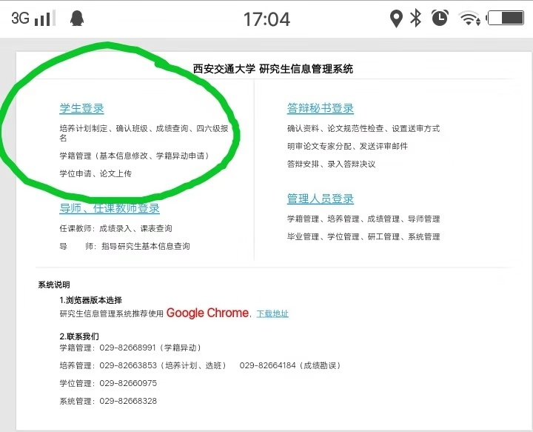

1. The above window will open now click on the third link, highlighted for your ease.

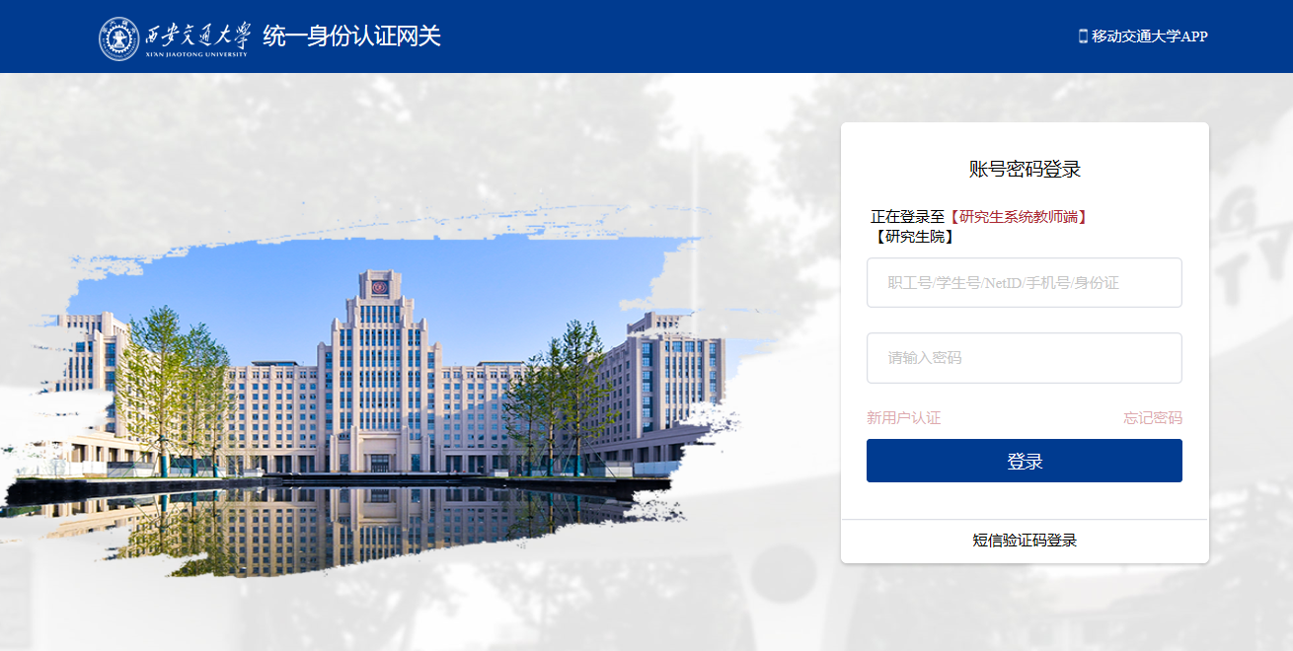

1. Again Click on the highlighted area. The below screen will appear.

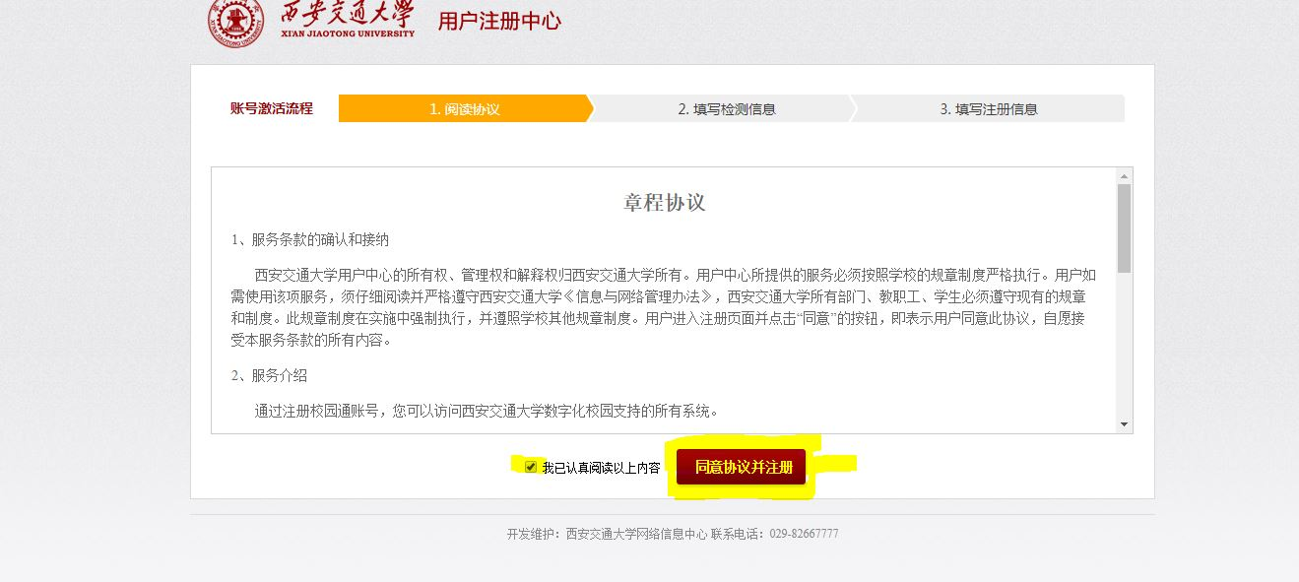

1. Click on the check box and then click on the highlighted button.

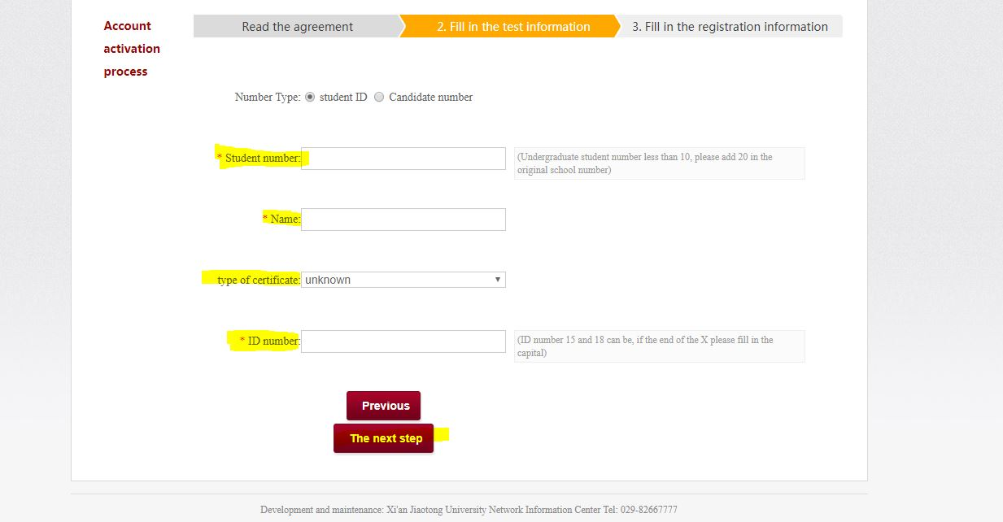

1. The next page as shown above will appear but for the ease and convenience I have translated the page into English using google chore translation feature you can do it to or simply Type your STUDENT ID NUMBER as on your student card in first field

Secondly, Your Passport Name in Capitals as on your student Card.

Thirdly, in type of certificate Select PASSPORT.

Lastly, in ID number write your PASSPORT number.

Now after rechecking and matching your data with student Card Press The highlighted button.

**Note:**

My user is already created so can’t go through the last step but you can use google chrome translation feature there and simply enter your email ID, your password and you have an email ID. Its better to select an email ID with your passport name.

For Example: [hussainhamid@stu.xjtu.edu.cn](mailto:hussainhamid@stu.xjtu.edu.cn)

Your email will remain with you even after you are done with your degree here.

**Best Regards:** Hussain Hamid

How to confirm class?

