# Introduction to the Back-to-School Management System during the Epidemic Period

On April 28, 2020, the school released "Xi'an Jiaotong University on Spring 2020 "Notice of Semester Students Returning to School" officially started the work of returning to school in the spring of 2020. In order to maintain Protect and consolidate the results of the early stage of the special epidemic prevention project, and protect the environment of the students in the process of returning to school Health and safety, the school builds and launches the “Smart Management System for Back-to-School in Outbreak Period” The students' real-time health information makes dynamic research and judgment, and conducts the prevention and control management status after entering the school Live Update.

According to the overall deployment of the school's return to school "Smart Management System for Returning to School in Emotional Period" completes the "no contact" prevention and control check, and handles the application for returning to school online. Please submit and approve various back-to-school processes such as personal information filling, department feedback.

System login method

**1. PC side access:**

① Enter the URL http://eps.xjtu.edu.cn;

② Click "Enter Application";

③ Enter the "Smart Management System for Back-to-School in Epidemic Period".

**2. Mobile access:**

① Xi'an Jiaotong University Enterprise Number

② Mobile Jiaotong University APP

# Read the return notice and check the initial campus code

* Log in to the "Smart Management System for Back-to-School during the Epidemic Period" and read the "Back to School Report" carefully "Knowledge Book", clarify the time when I return to school and check the reading instructions.
* View personal initial campus code

The initial campus code points of the "Smart Management System for Back-to-Schools during the Epidemic Period" [Green Code], [Yellow Code] And [red code] three categories. Different types of campus codes are based on students ’daily health data and school hospital health evaluation rules are automatically generated.

Among them, students whose initial campus codes are [green code] and [yellow code] can Scheduled back-to-school time to arrange the formation of back-to-school and log in to the “Smart Management System for Back-to-School in Outbreak Period” in time Submit a return application; students whose initial campus code is [red code] are temporarily not allowed to return to school.

**Note:**

Evaluation basis of initial campus code

[Green Code] The student resides outside the high-risk area in the epidemic and 14 days before returning to school There is no abnormality in the information of each form.

[Yellow code] Students are in the high-risk area of the epidemic within 14 days before returning to school, and before returning to school No abnormality in health monitoring within 14 days;

[Red Code] The current status of the student's location "One Code" is red or yellow; Those who have not lifted the mobility ban; or, those who have a history of traveling abroad in the past 14 days; or, Symptoms such as fever and respiratory tract before returning to school. (There are any one or more of the above conditions the campus code is "red code")

**The initial campus code is the solution to the red code:**

1. The counselor checks the reason of the student's red code in the back-to-school system.

 2. The counselor revises the data of the Student Health Daily in the teacher-student comprehensive service hall. In case If the temperature is filled in incorrectly, the temperature of the question that the student filled in incorrectly needs to be changed to 30 degrees; if other information is filled in Wrong, please ask the counselor to modify it according to the actual situation.

**Note:** The revised data in the teacher-student comprehensive service lobby will be updated within one day Synchronized to the back to school system.

# Fill in the application for returning to school

Application prerequisites: The initial campus codes are [green code] and [yellow code]

1. 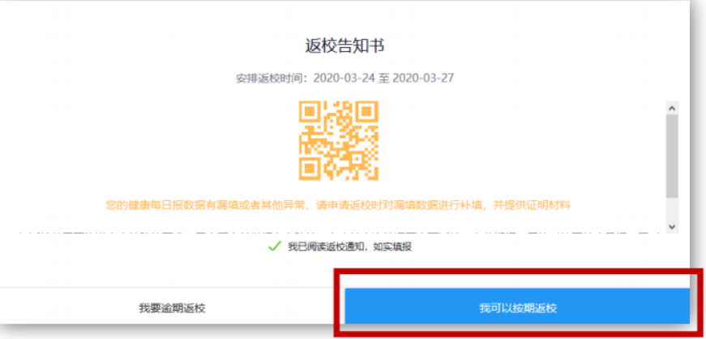Able to return to school on time according to the time specified in the return to school notice
2. Fill in "Personal Information"

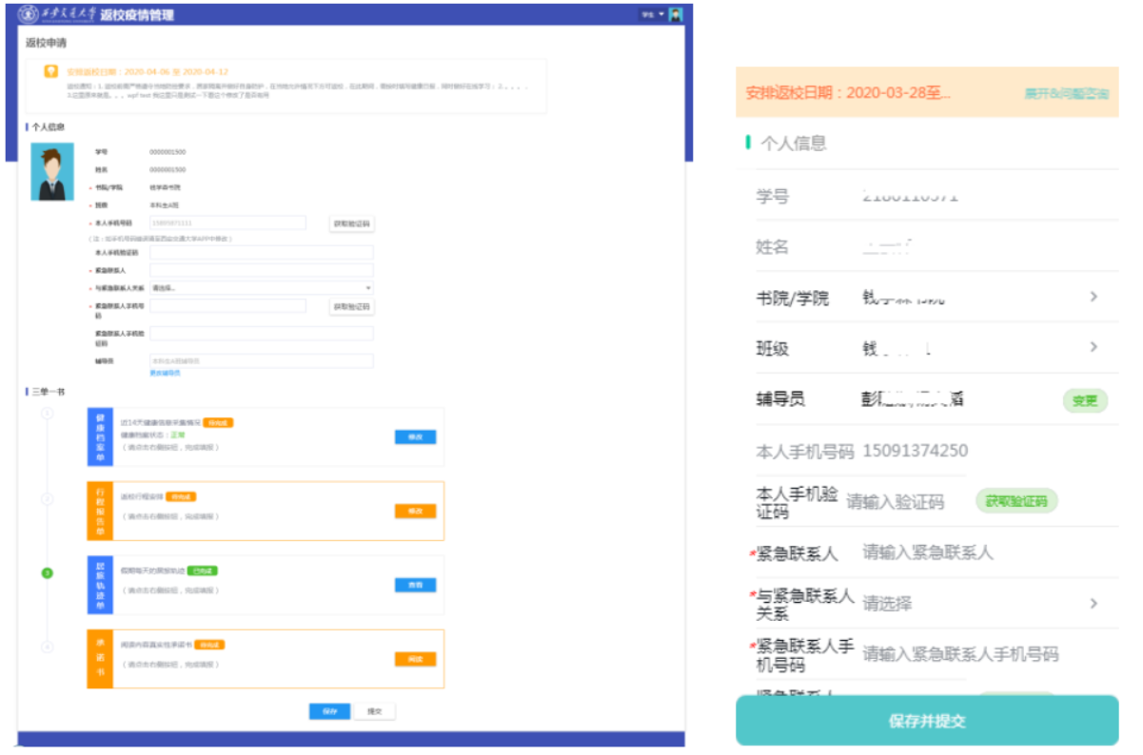Fill in emergency contact, relationship with emergency contact, emergency contact as required by the form Person's mobile phone number and other information.

1. Fill in "Three Single Books"

* Health record

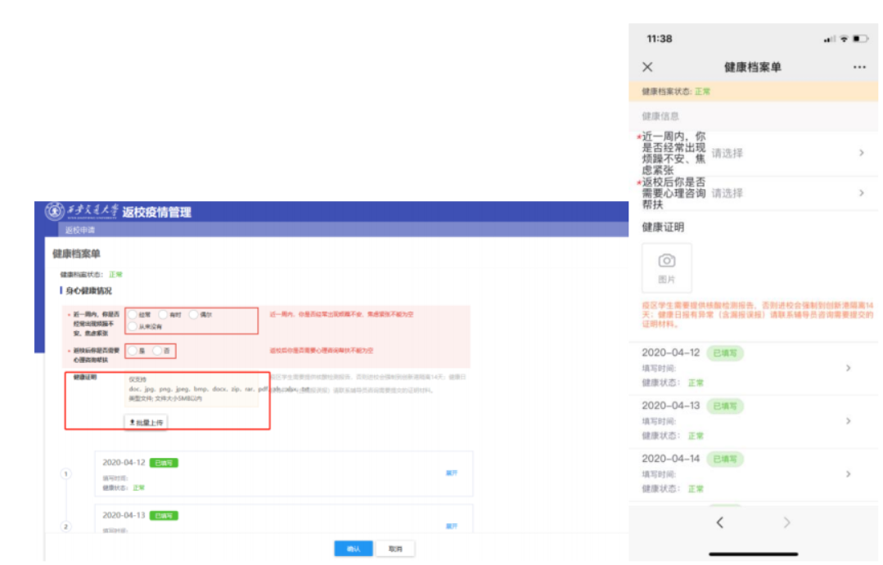If the health information in the past 14 days is [To be completed] click [Modify] in the health file Press the button to enter the information page for filling in the health file. If there is a missing or incorrect filling in the health daily report (Body temperature> 41 ℃ or <33 ℃) Need to fill or modify, need to upload health certification materials.

* Itinerary report

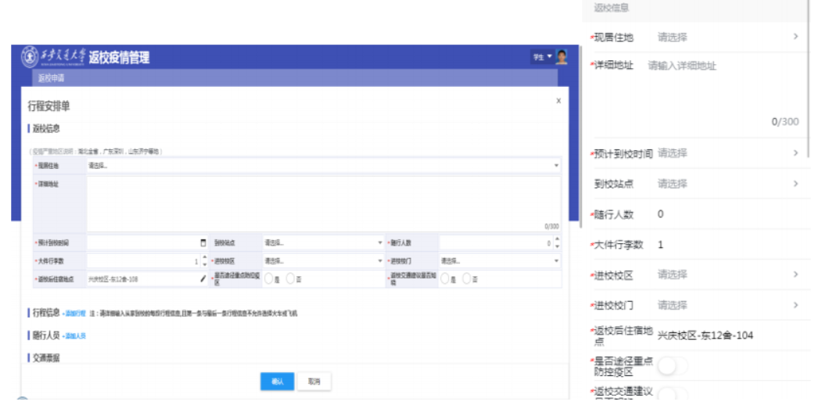If the schedule for returning to school is [To be completed], click the [Modify] button to enter the itinerary Fill in the information page.

* Residence track record

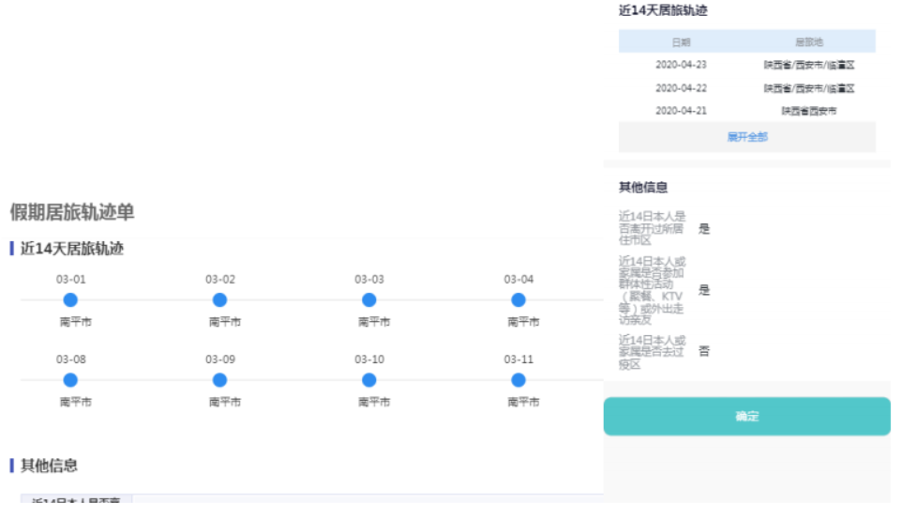The location information in the health daily report for the past 14 days will be automatically extracted. To be filled.

* Commitment

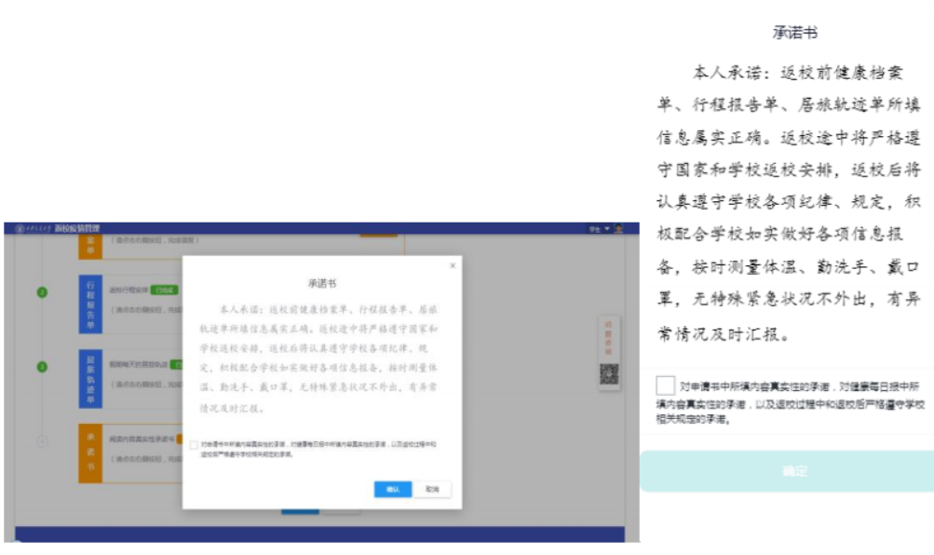Click on [Confirm] after reading carefully on the commitment page

1. Submit application for returning to school

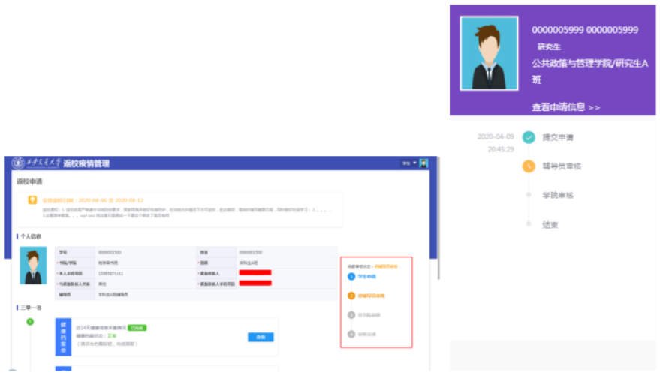After completing the above information, click on the [Submit] button at the bottom of the page On the right, you can view the review progress information of the application for returning to school. The counselor / schools / schools will be based on The initial campus code and fill in the information for online review of the application for returning to school.

**Note:** Back to school to review the basis for the change of Xijiao campus code

[Green code] After passing the review, you can return to school to study and live normally according to the notice time.

[Yellow code] It is in the high-risk area of the epidemic within 14 days before returning to school and 14 days before returning to school

If there is no abnormality in the internal health monitoring, the student who holds [Yellow Code] must directly enter the Innovation Harbor Collection when returning to school Medium isolation observation area;

[Red code] If the information is incorrect and it is determined that it is not suitable for returning to school; the personnel movement ban has not been lifted Orders; contacts within 14 days before returning to school in areas with high epidemic outbreaks; fever within the past 14 days, Abnormal conditions such as respiratory symptoms. (If there is any one or more of the above conditions, the campus code will be changed Is "red code")

1. Continue to do a good job of filling in student health files

After submitting the application for returning to school online, students must continue to report carefully and truthfully every day Health status (see Annex 2 for details). The “Smart Management System for Back-to-School in the Epidemic Period” will be based on The student ’s daily health file adds information to update the campus code in real time.

**Note:** Continuously update the evaluation basis of Xijiao campus code

[Green code] You can return to school and study normally according to the notice time.

[Yellow code] Received notice from the disease control department on the way back to school, there is a secret or suspected Contact situation; students who hold [Yellow Code] must go directly to the Innovation Harbor Centralized Isolation observation area

[Red Code] The current status of "One Code Pass" in the student's residence is changed to red or yellow; Persons who have been banned from movement; have abnormalities such as fever and respiratory symptoms within 14 days before departure. (If there is any one or more of the above conditions, the campus code will be changed to "red code")

# Enter school scan code (only for mobile terminal)

After submitting the application for returning to school, it is verified that the campus codes are [green code] and [yellow code] Students can return to school on schedule. On the day of returning to school, the student himself shall return the outbreak to the west in the management system Submit the campus code and the card to the security personnel for confirmation before entering the school

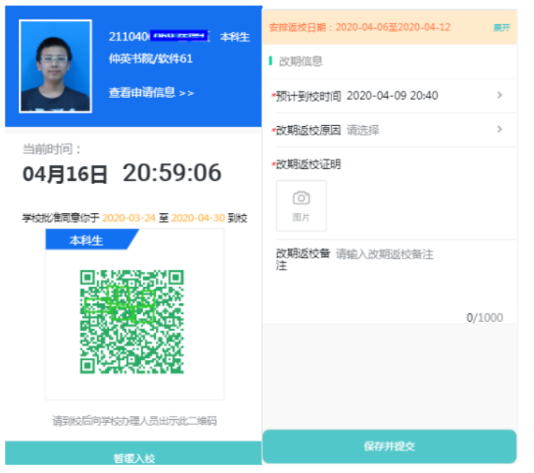.

**Note:** If there are special circumstances and you cannot return to school on time, you can click to suspend school and fill in the reason, After confirmation, you need to reapply to return to school and pass the review before you can generate the Xijiao campus code.

**Matters needing attention**

1. The system will conduct three reviews of campus codes based on daily health records for the past 14 days, including Initial campus code, Xijiao campus code, back-to-school campus code. Please pay close attention to yourself and your family the health status of the person, if any abnormal situation is reported in time, make the health file accurate and on time Fill in the report.

2. Students need to pay close attention to the change status of Jiaotong University, if there is any abnormality, please contact the school in time Contact the hospital, counselor, or system administrator, and students with [yellow code] must return directly to school Then enter the centralized isolation observation area of the innovation port.

**Appendix: Daily health status report**

1. Daily reporting time

Fill in the report 24 hours before 17 o'clock every day.

2. Fill in the channel

Mobile WeChat search [Xi'an Jiaotong University Enterprise Number-Health Daily] or computer

web (http://one2020.xjtu.edu.cn/)

3. Information filling method

* for foreign students to fill in their native place, please select foreign nationality first, and then fill in manually;
* for students who are currently abroad, please fill in the location, please select the location first, then Fill in manually;
* Fill in the information related to domestic provinces, cities and districts, please check in the drop-down box, do not manually fill in;
* Fill in body temperature to fill in Arabic numerals.

4. Information about reporting

* Basic information (such as name, student number, college / college) is automatically generated by the system;
* Personal information (such as ID number, hometown, home address, current detailed location) After adding once, the system will automatically record without filling in daily;
* Daily required information (such as body temperature on the day, whether you have been to the school and family area, and whether it is outside Out) needs to be filled in according to the actual situation every day.

5. FAQ

* Teachers and students in the comprehensive service hall (computer side) can search "Daily Health" in the service center "Health status report" keyword, you can find the service and complete the report;
* WeChat enterprise number (mobile phone) and WeChat applet (mobile phone) only need to complete the account No login is required for each visit;
* Filled information query: Initiated in "Teacher and Student Comprehensive Service Hall-Personal Center-I "Business" can be consulted.