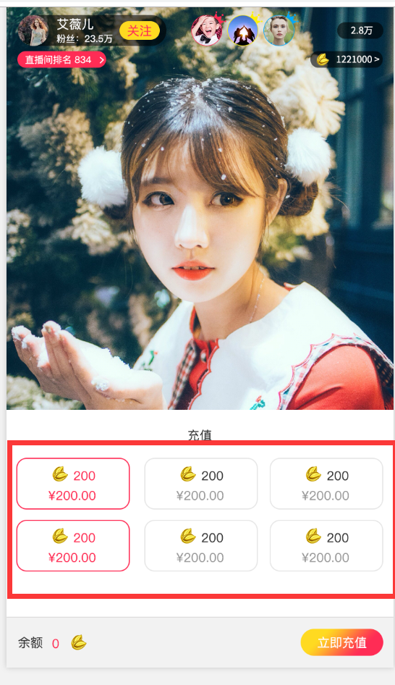

这些数据，要求后台可以配置

表名：Sys_Invest_Config

|  |  |  |  |
| --- | --- | --- | --- |
| 列名 | 类型 | 说明 |  |
| F_menoy | decmail |  |  |
| F_vcoin |  |  |  |
|  |  |  |  |

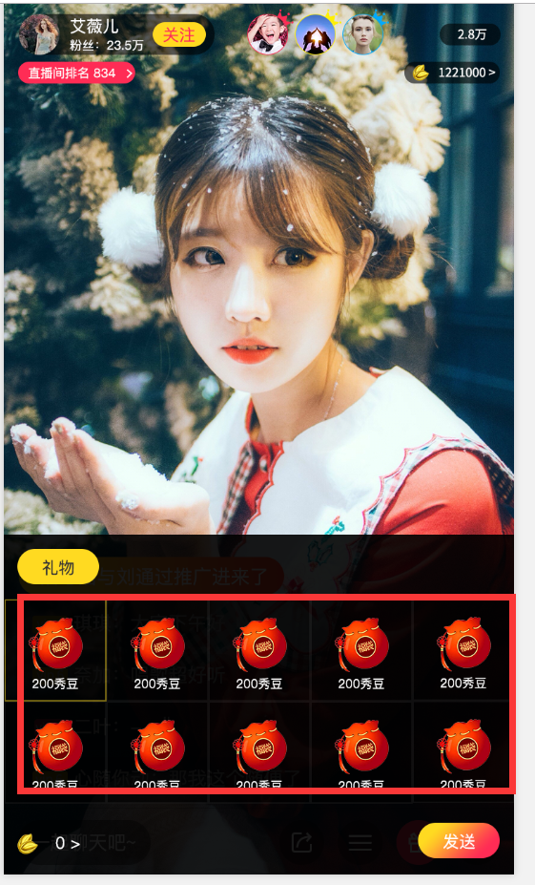

Sys_Gift

|  |  |  |  |
| --- | --- | --- | --- |
| 列名 | 类型 | 说明 |  |
| F_GiftName |  |  |  |
| F_VCoin |  |  |  |
| F_Gif_Url |  |  |  |
| F_Png_Url |  |  |  |