1.源文件改写 # -*- coding: utf-8 -*-

"""

Created on Sun May 13 23:33:52 2018

@author: wy

"""

import keyword

s = keyword.kwlist

n = input("输入一个文件名:")

f = open(n,"r").readlines()

ls = []

for i in f:

i = i.split

ls.append(i)

fo = open(n,"w+")

for i in range(len(ls)):

if f[i].isspace():

fo.write(" "+"\n")

for j in range(len(ls[i])):

x = ls[i][j]

if x not in s:

x = x.upper()

else:

x = x.lower()

if x == ls[i][len(ls[i])-1]:

fo.write(x+"\n")

else:

fo.write(x+" ")

2.图像压缩 # -*- coding: utf-8 -*-

"""

Created on Sun May 13 23:40:58 2018

@author: wy

"""

from PIL import Image

im = Image.open('C:\\1\\1.jpg')

im.size

im_resize = im.resize((256,256))

im_resize0 = im.resize((256,256), Image.BILINEAR)

im_resize0.size

im_resize1 = im.resize((256,256), Image.BICUBIC)

im_resize2 = im.resize((256,256), Image.ANTIALIAS)

3.去掉红色 # -*- coding: utf-8 -*-

"""

Created on Sun May 13 00:30:36 2018

@author: xj

"""

from PIL import Image

im = Image.open('C:\\2\\2.jpg')

r, g, b = im.split()

newr = r.point(lambda i: i*0.1)

om = Image.merge("RGB",(b, g, r))

om.save('测试7.jpg')

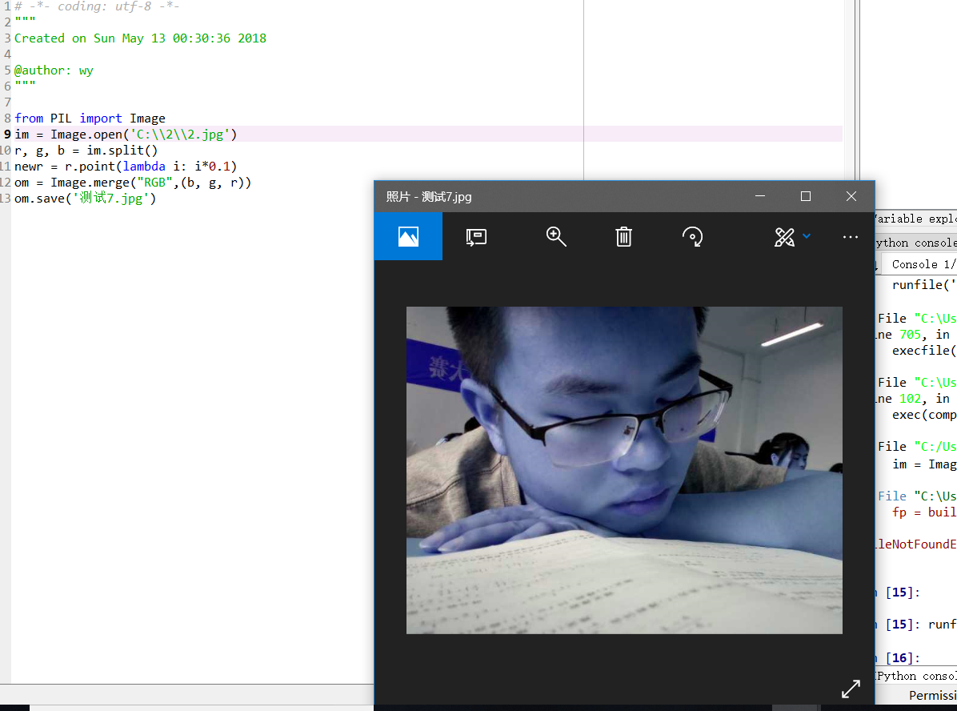

4人像轮廓# -*- coding: utf-8 -*-

"""

Created on Sun May 13 23:23:55 2018

@author: xj

"""

from PIL import Image

im = Image.open('C:\\2\\2.jpg')

r, g, b = im.split()

newr = r.point(lambda i:i*0.8)

newb = b.point(lambda i:i*0.5)

newg = g.point(lambda i:i<120)

om = Image.merge(im.mode,(newr,newb,newg))

om.save('测试8.jpg')

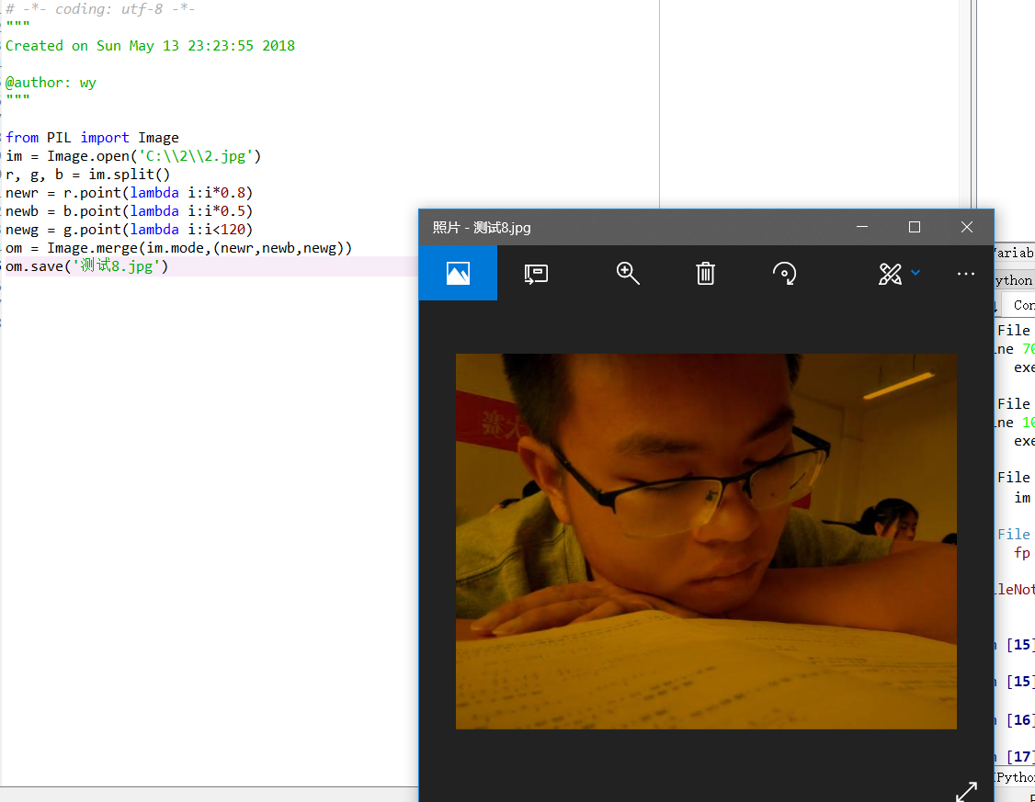

6简单p图# -*- coding: utf-8 -*-

"""

Created on Sun May 13 23:43:26 2018

@author: wy

"""

from PIL import Image

im = Image.open('C:\\2\\2.jpg')

r, g, b = im.split()

newr = r.point(lambda i:i*0.8)

newb = b.point(lambda i:i*0.5)

newg = g.point(lambda i:i<120)

om = Image.merge(im.mode,(newr,newb,newg))

om.save('测试9.jpg')

