表：teacher
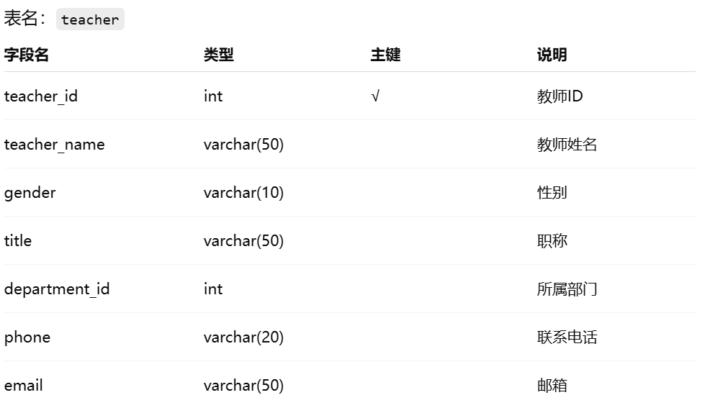

表：student
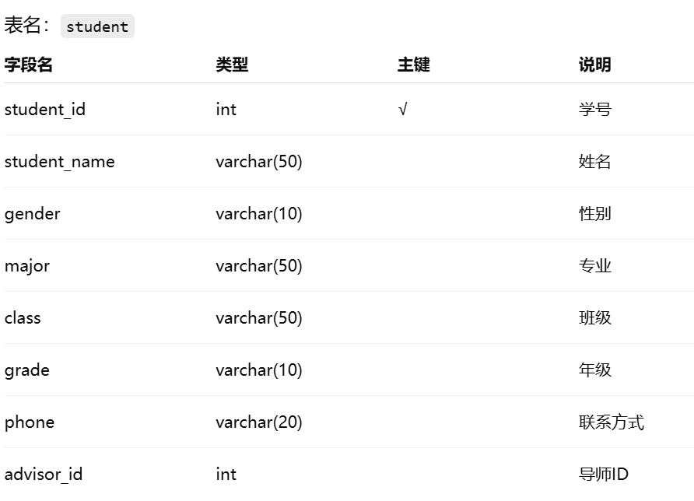

表：course
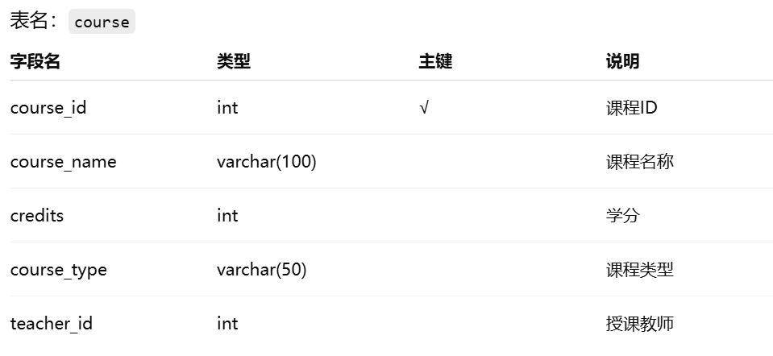

表：score
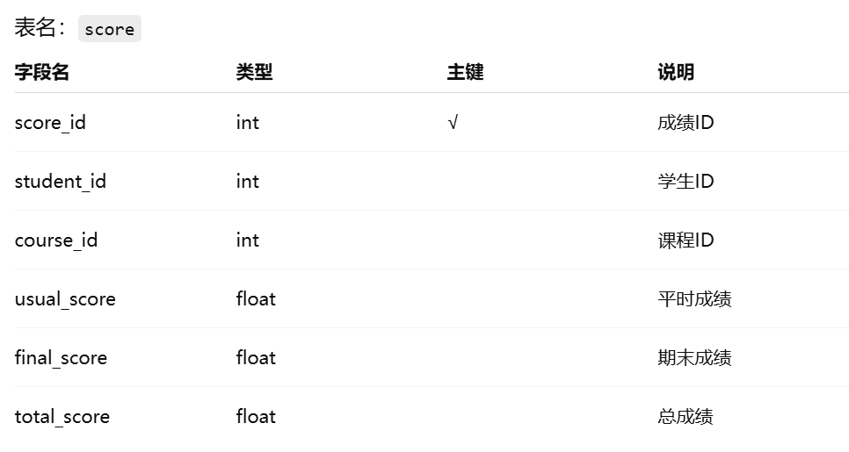

表：thesis
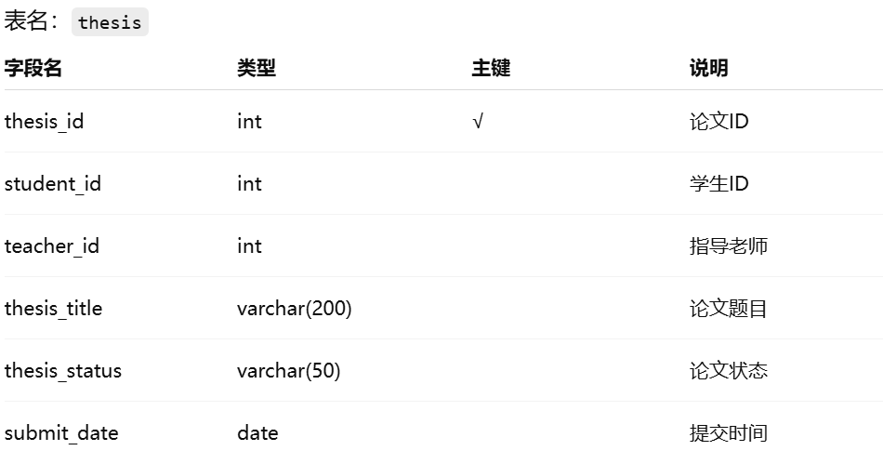

表：projects
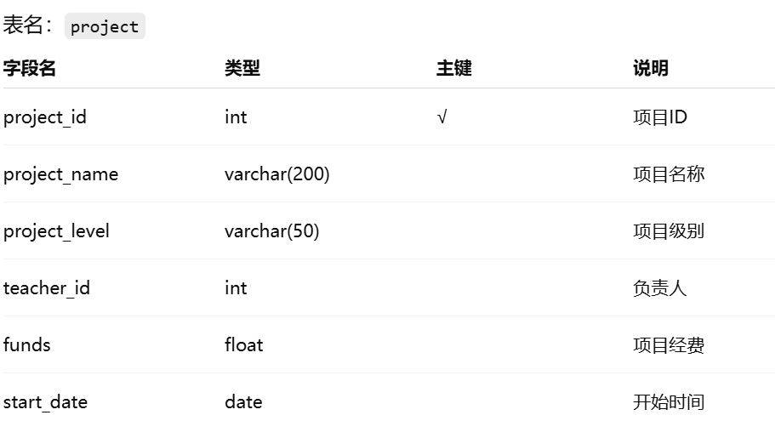

表：departement
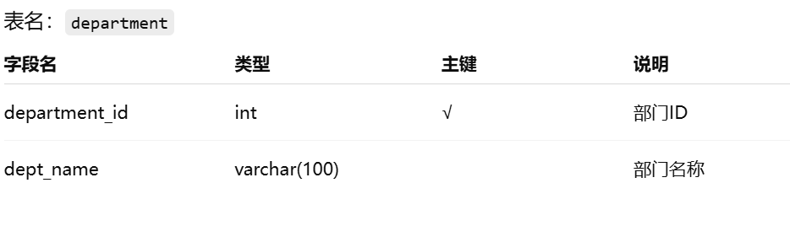

表：user
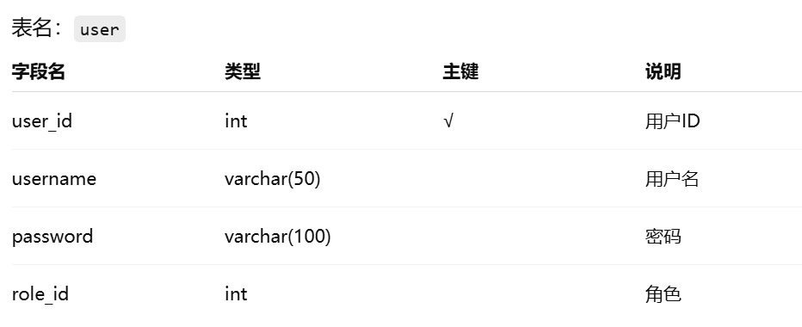

表：role
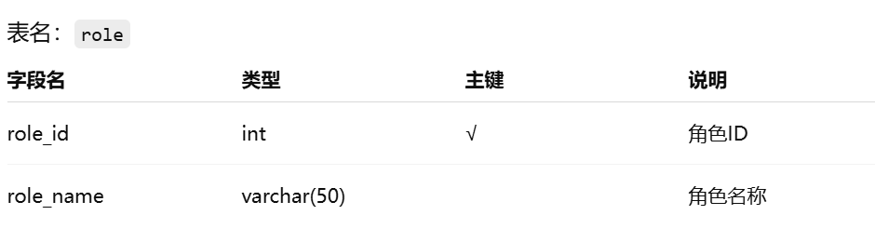
部门表
CREATE TABLE department (
department_id INT PRIMARY KEY AUTO_INCREMENT,
department_name VARCHAR(100) NOT NULL,
create_time DATETIME DEFAULT CURRENT_TIMESTAMP
);
教师表
CREATE TABLE teacher (
teacher_id INT PRIMARY KEY AUTO_INCREMENT,
teacher_name VARCHAR(50) NOT NULL,
title VARCHAR(50), -- 职称
phone VARCHAR(20),
department_id INT,
FOREIGN KEY (department_id) REFERENCES department(department_id)
);
学生表
CREATE TABLE student (
student_id INT PRIMARY KEY AUTO_INCREMENT,
student_name VARCHAR(50) NOT NULL,
gender VARCHAR(10),
major VARCHAR(100),
class_name VARCHAR(50),
enrollment_year INT,
department_id INT,
FOREIGN KEY (department_id) REFERENCES department(department_id)
);
课程表
CREATE TABLE course (
course_id INT PRIMARY KEY AUTO_INCREMENT,
course_name VARCHAR(100) NOT NULL,
credit INT,
teacher_id INT,
FOREIGN KEY (teacher_id) REFERENCES teacher(teacher_id)
);
成绩表
CREATE TABLE score (
score_id INT PRIMARY KEY AUTO_INCREMENT,
student_id INT,
course_id INT,
score DECIMAL(5,2),
exam_time DATETIME,
FOREIGN KEY (student_id) REFERENCES student(student_id),
FOREIGN KEY (course_id) REFERENCES course(course_id)
);
论文表
CREATE TABLE thesis (
thesis_id INT PRIMARY KEY AUTO_INCREMENT,
title VARCHAR(200),
student_id INT,
teacher_id INT,
status VARCHAR(50), -- 开题/进行中/完成
submit_time DATETIME,
FOREIGN KEY (student_id) REFERENCES student(student_id),
FOREIGN KEY (teacher_id) REFERENCES teacher(teacher_id)
);
科研项目表
CREATE TABLE project (
project_id INT PRIMARY KEY AUTO_INCREMENT,
project_name VARCHAR(200),
teacher_id INT,
funding DECIMAL(10,2),
start_date DATE,
end_date DATE,
FOREIGN KEY (teacher_id) REFERENCES teacher(teacher_id)
);
用户表
CREATE TABLE user (
user_id INT PRIMARY KEY AUTO_INCREMENT,
username VARCHAR(50) UNIQUE NOT NULL,
password VARCHAR(100) NOT NULL,
role_id INT,
related_id INT,
-- 关联 teacher_id 或 student_id
create_time DATETIME DEFAULT CURRENT_TIMESTAMP
);
角色表
CREATE TABLE role (
role_id INT PRIMARY KEY AUTO_INCREMENT,
role_name VARCHAR(50) -- admin / teacher / student
);

