[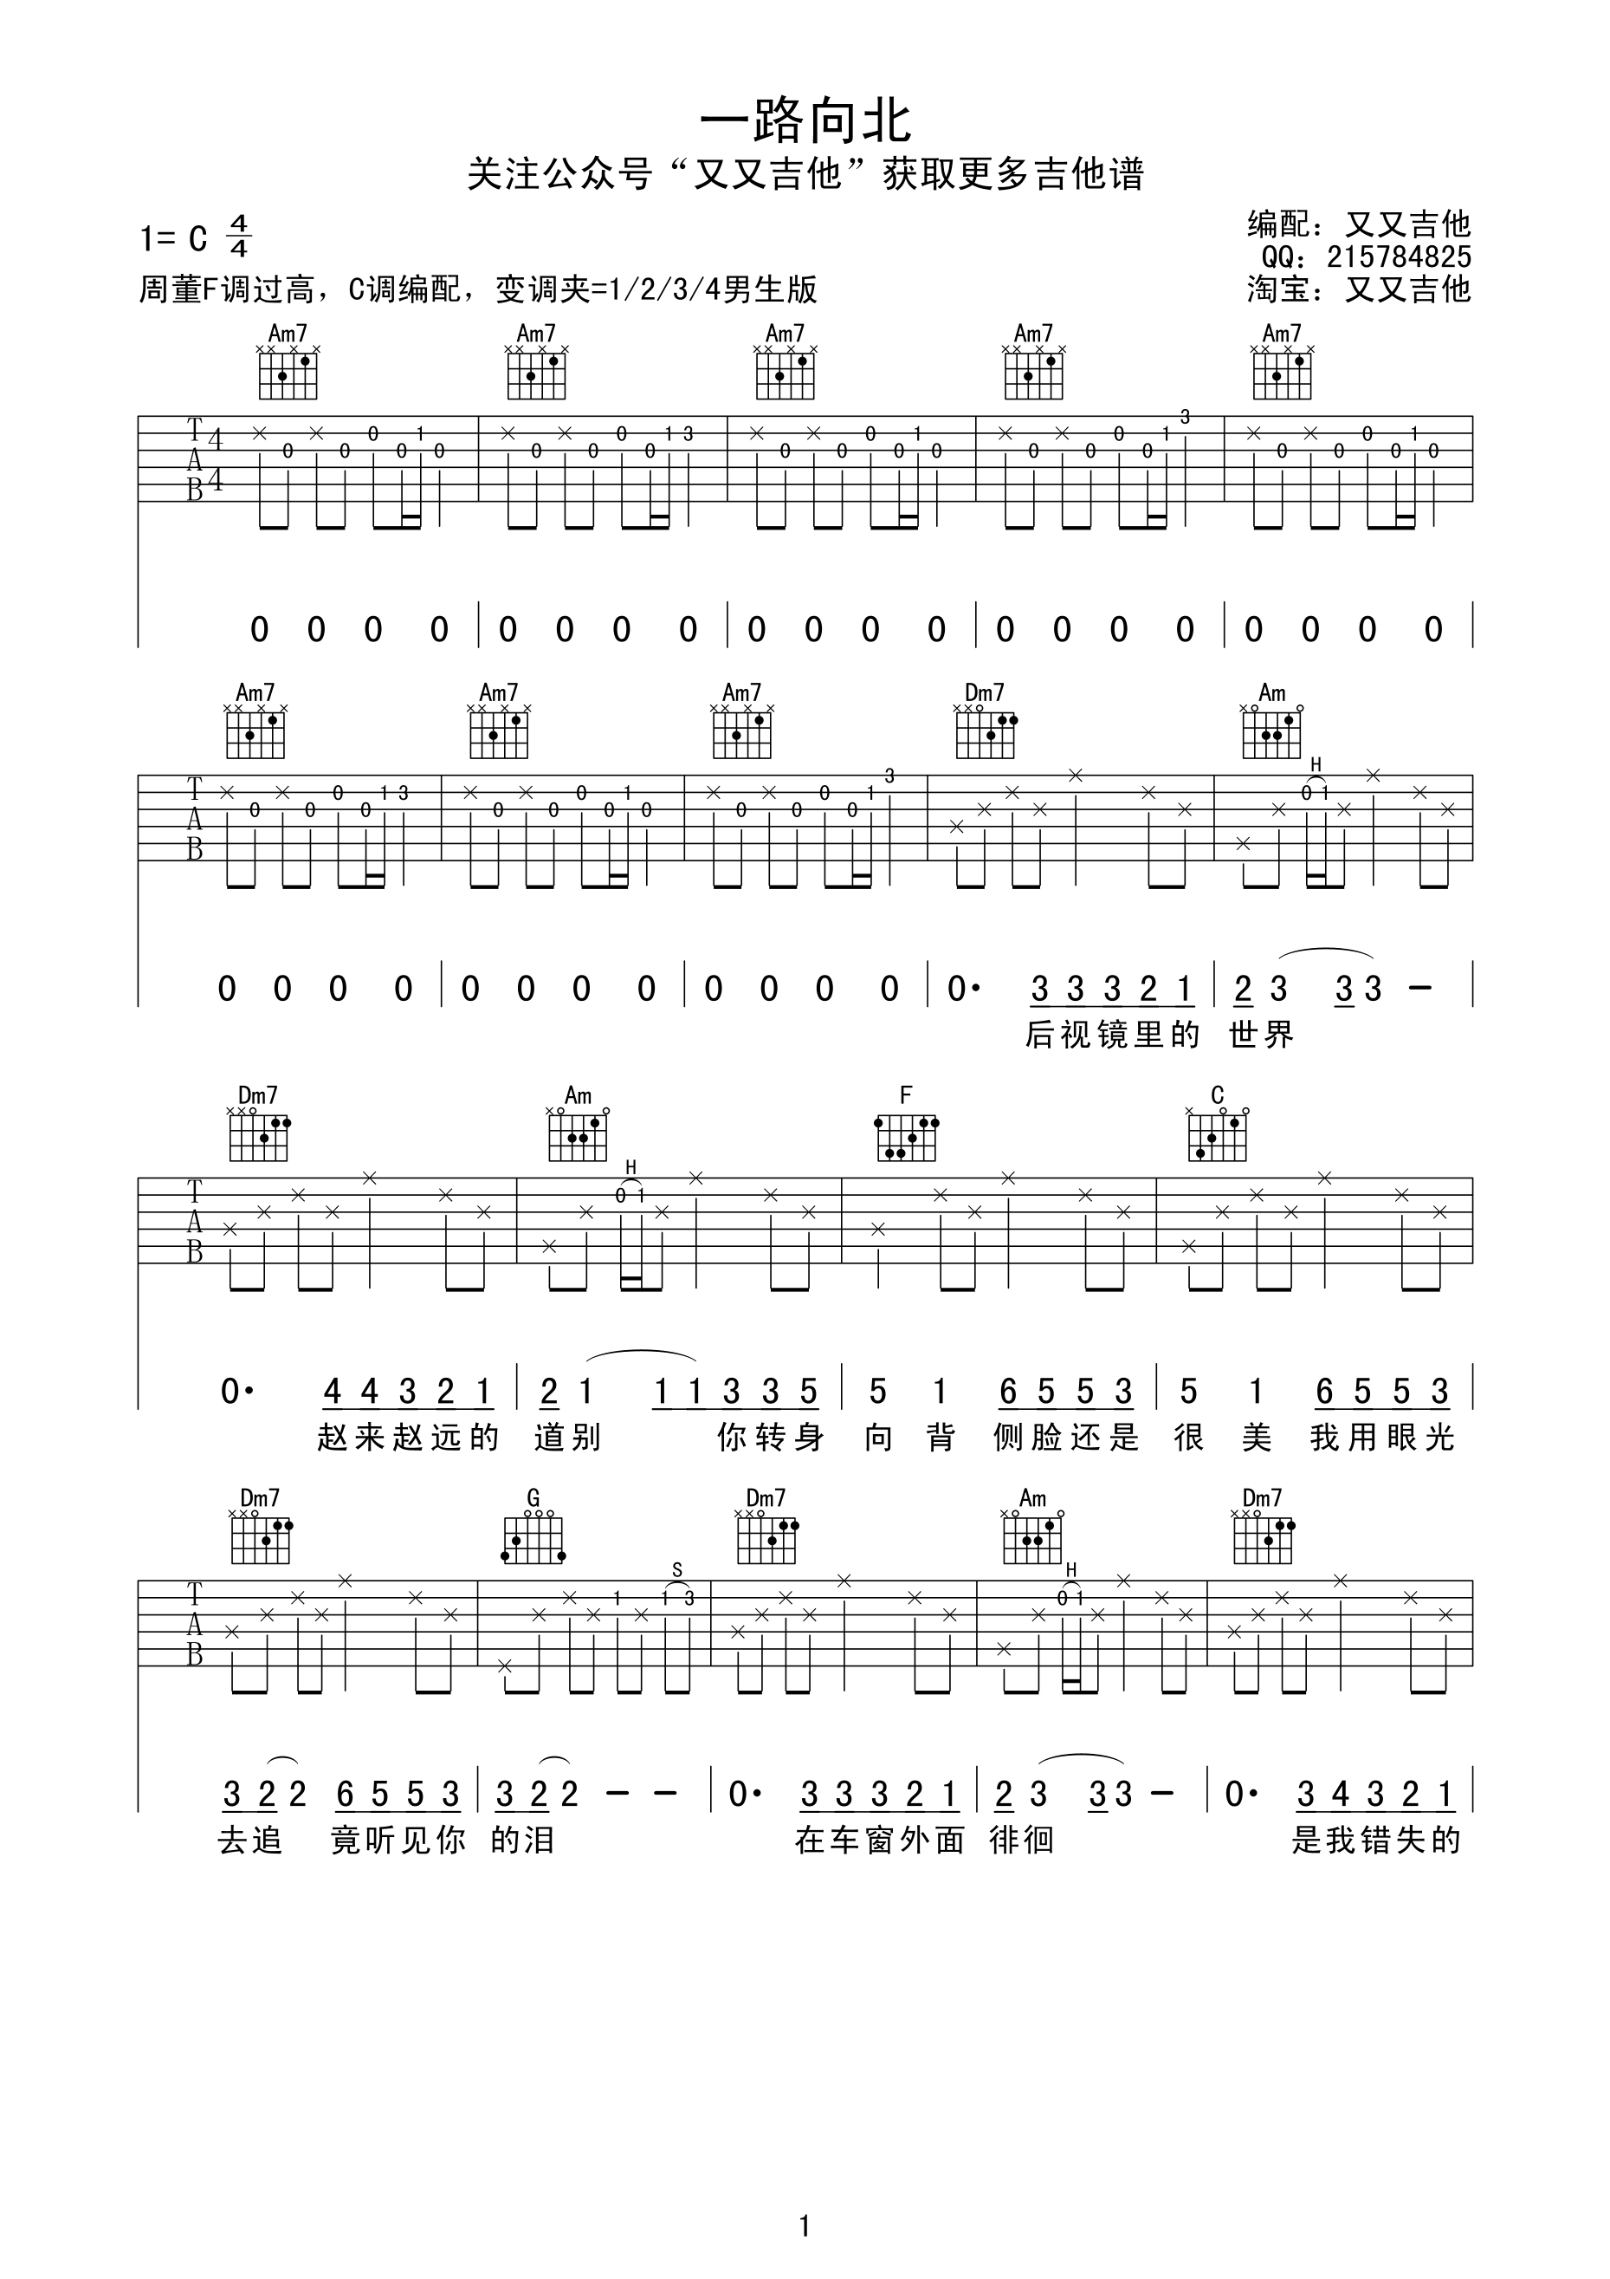](http://data.17jita.com/attachment/portal/201612/22/191422r63r2u59e0r8e86e.png)[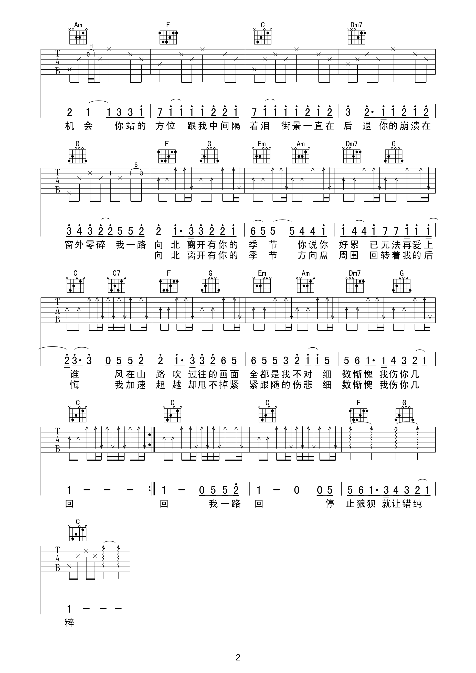](http://data.17jita.com/attachment/portal/201612/22/191423e3bftddestc5kodm.png)