[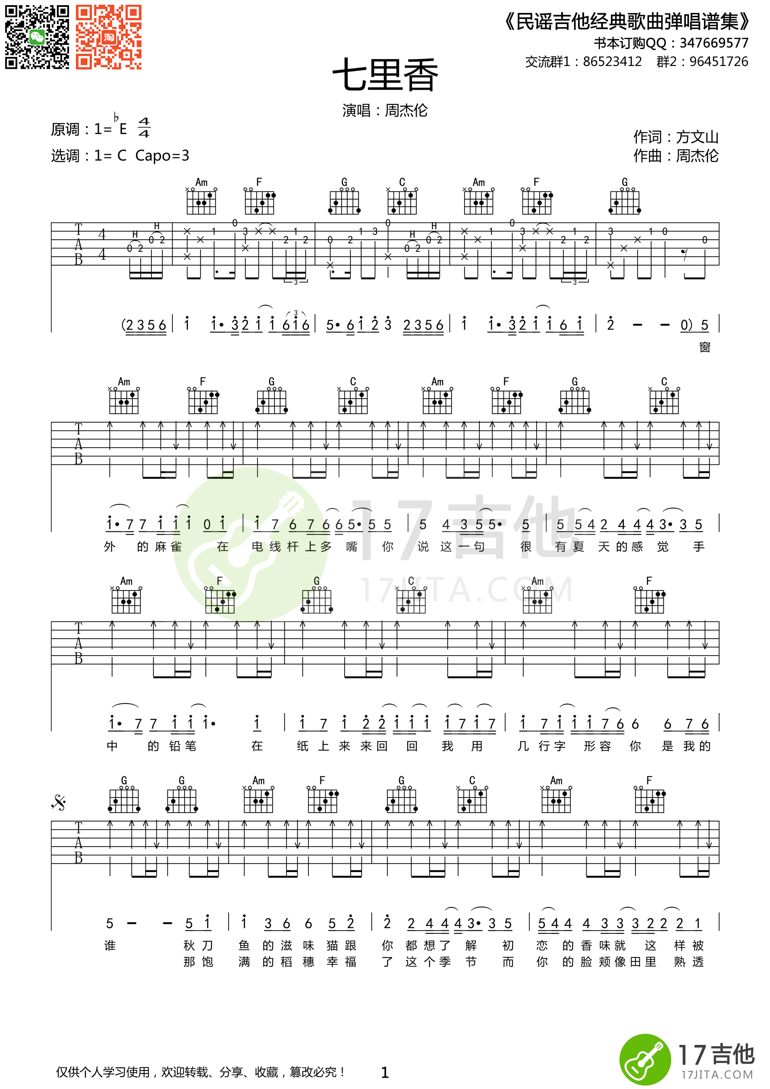](http://data.17jita.com/attachment/forum/201501/04/114338jd935fn3c3563s6z.png)