[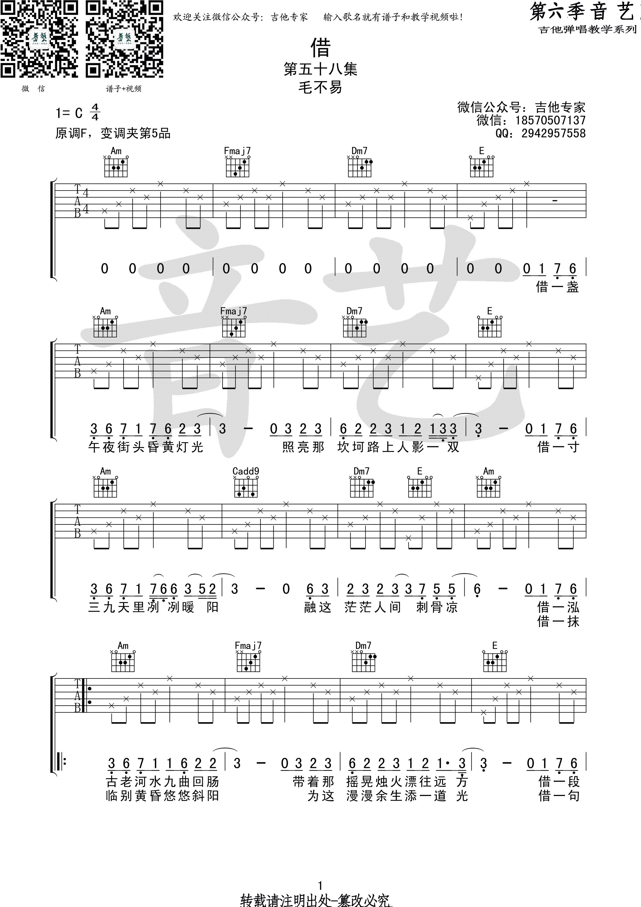](http://data.17jita.com/attachment/forum/201709/04/111114ajttfiqff1f8g67f.png)[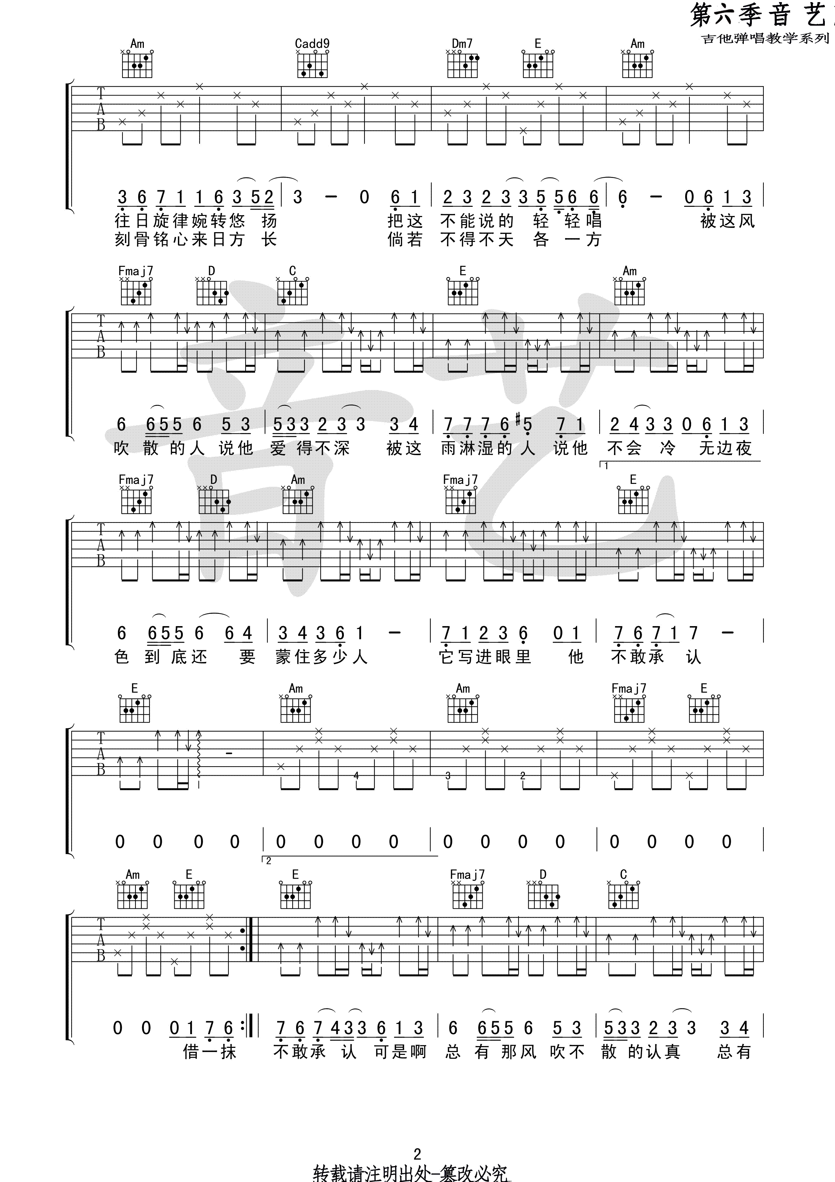](http://data.17jita.com/attachment/forum/201709/04/111114vugod1useaeoosoo.png)[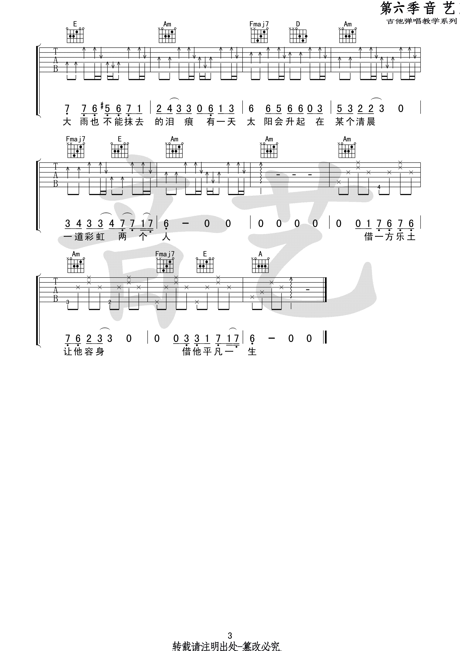](http://data.17jita.com/attachment/forum/201709/04/111115fjlyr6j44birjyil.png)