[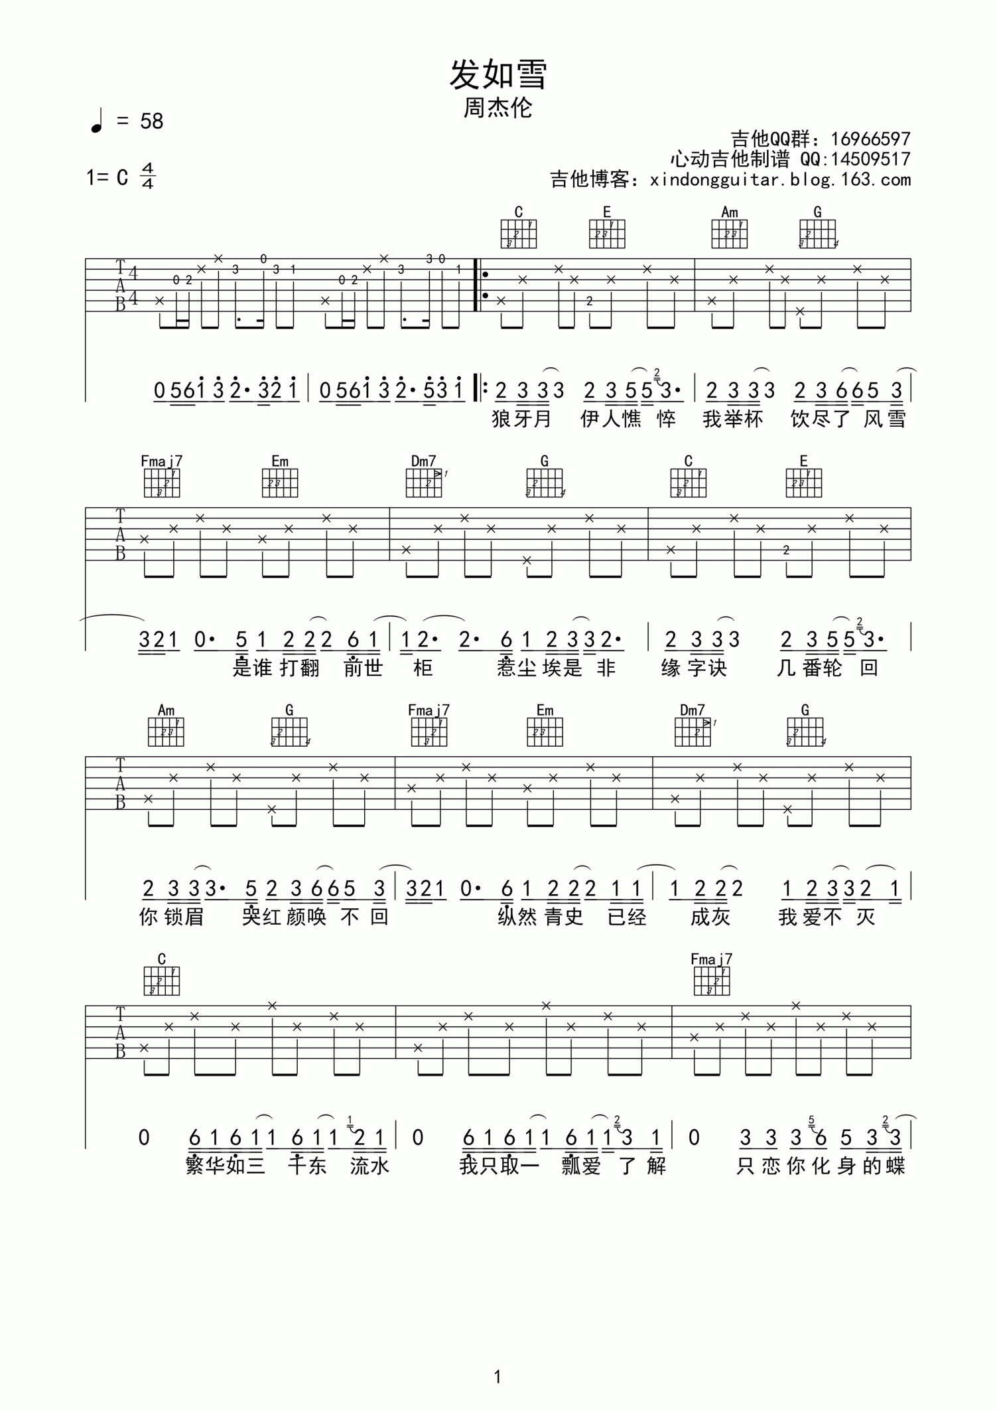](http://data.17jita.com/attachment/forum/201704/05/142642zaoawni00xxoag4w.png)