[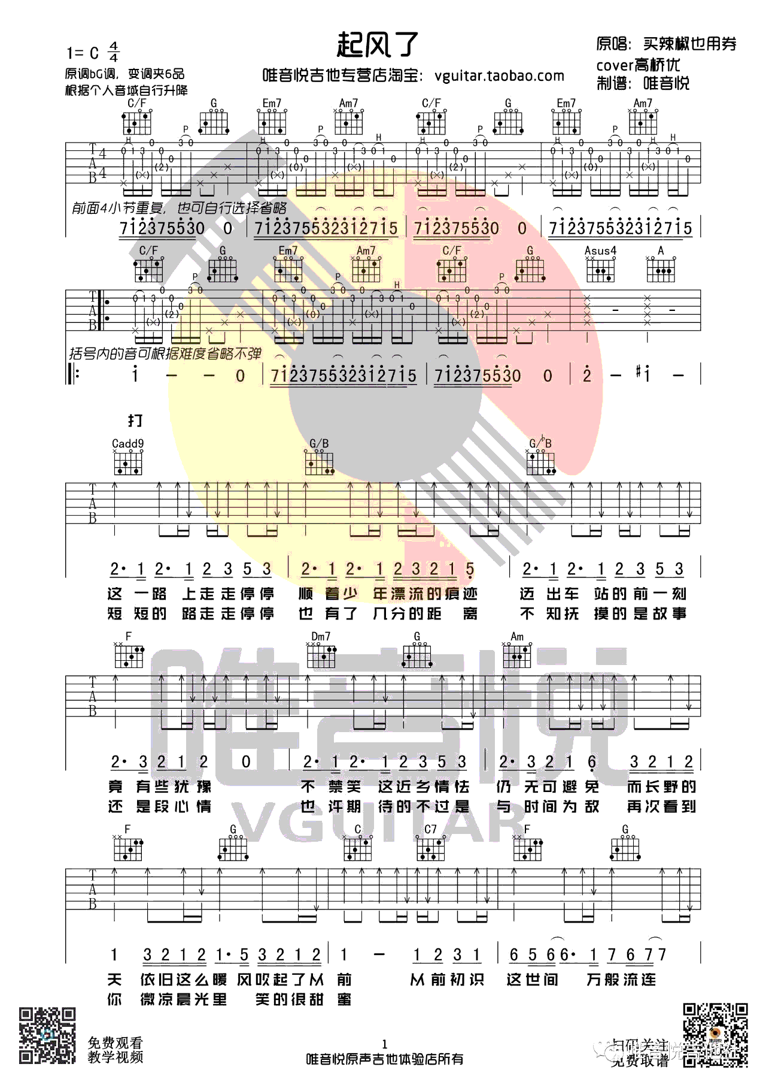](http://www.echangwang.com/up/imgs/1803/1-1P324125447.png)[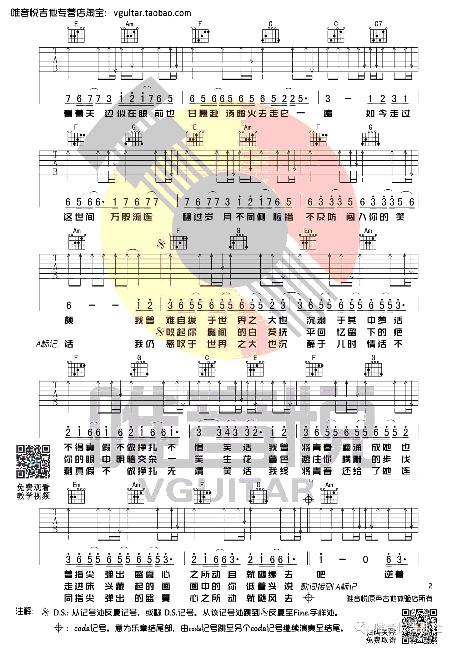](http://www.echangwang.com/up/imgs/1803/1-1P324125447-50.png)[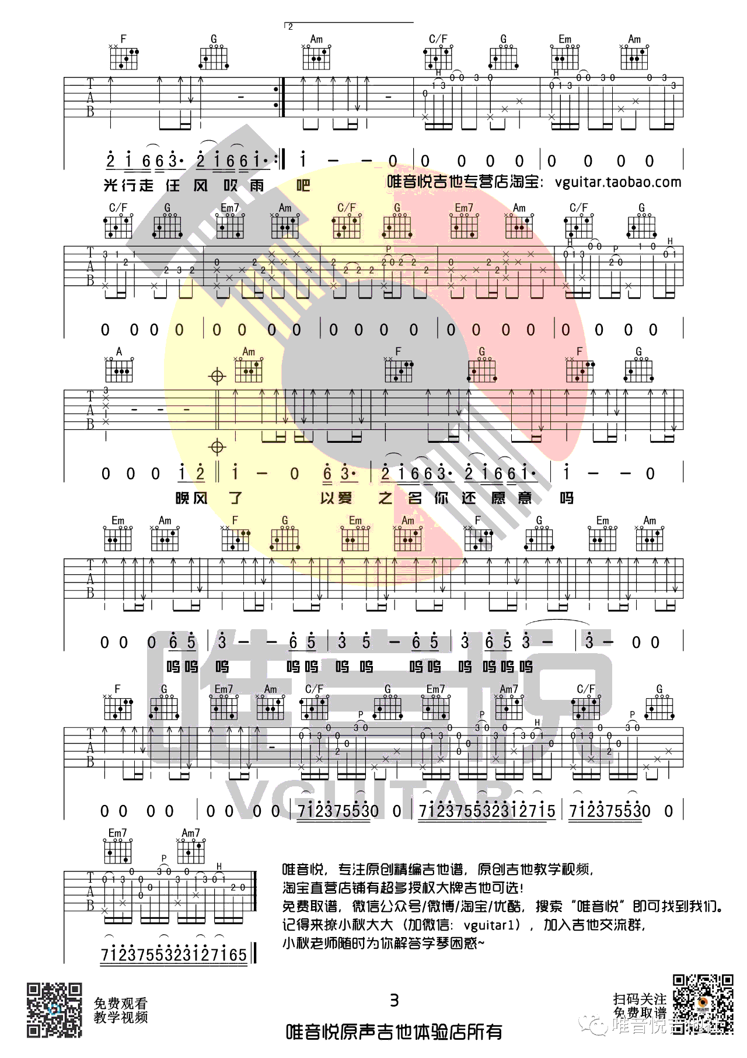](http://www.echangwang.com/up/imgs/1803/1-1P324125448.png)