[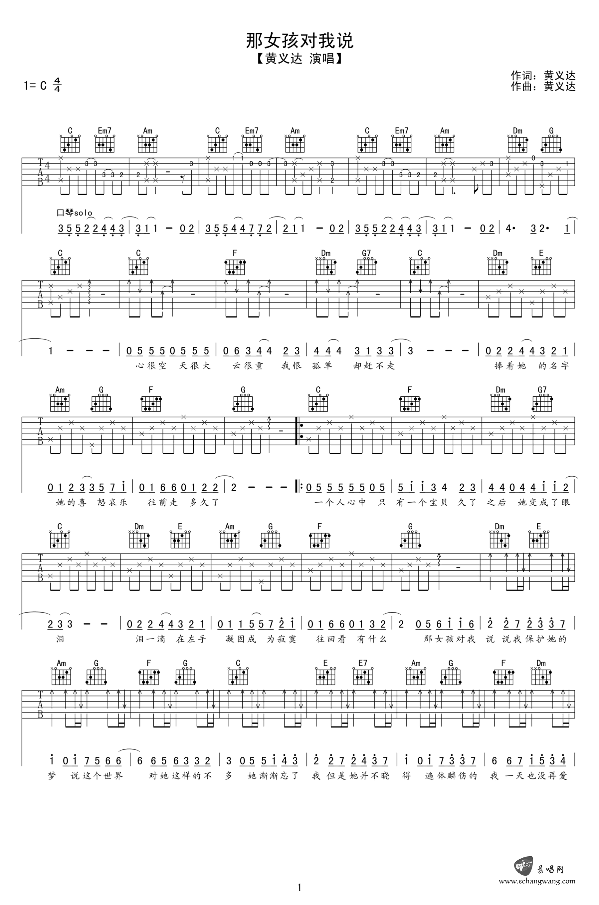](http://www.echangwang.com/up/imgs/1707/5-1FG5162052.png)[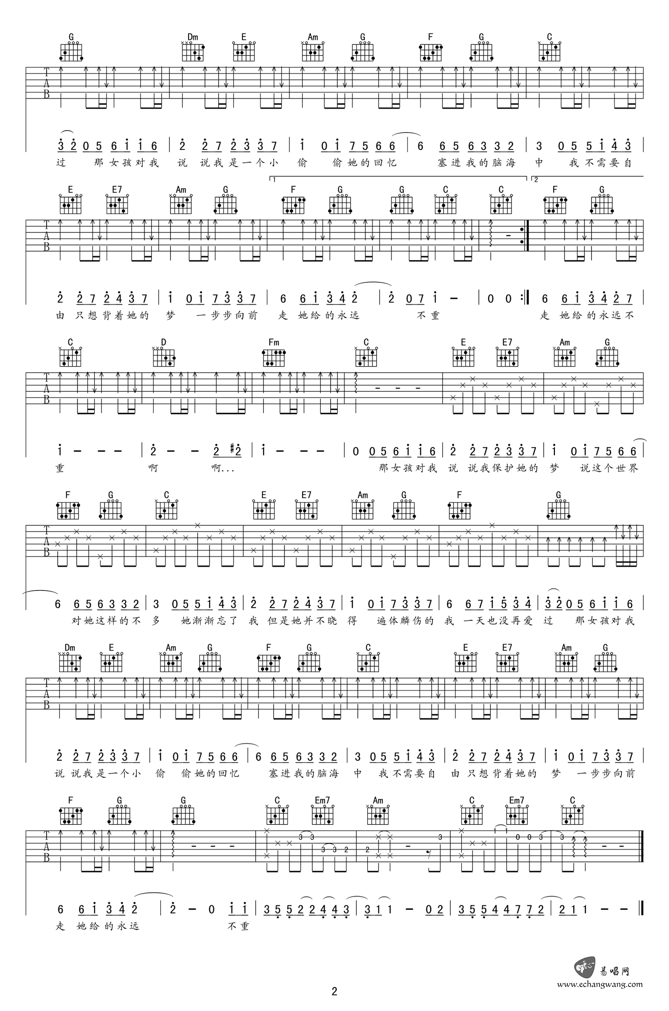](http://www.echangwang.com/up/imgs/1707/5-1FG5162053.png)