[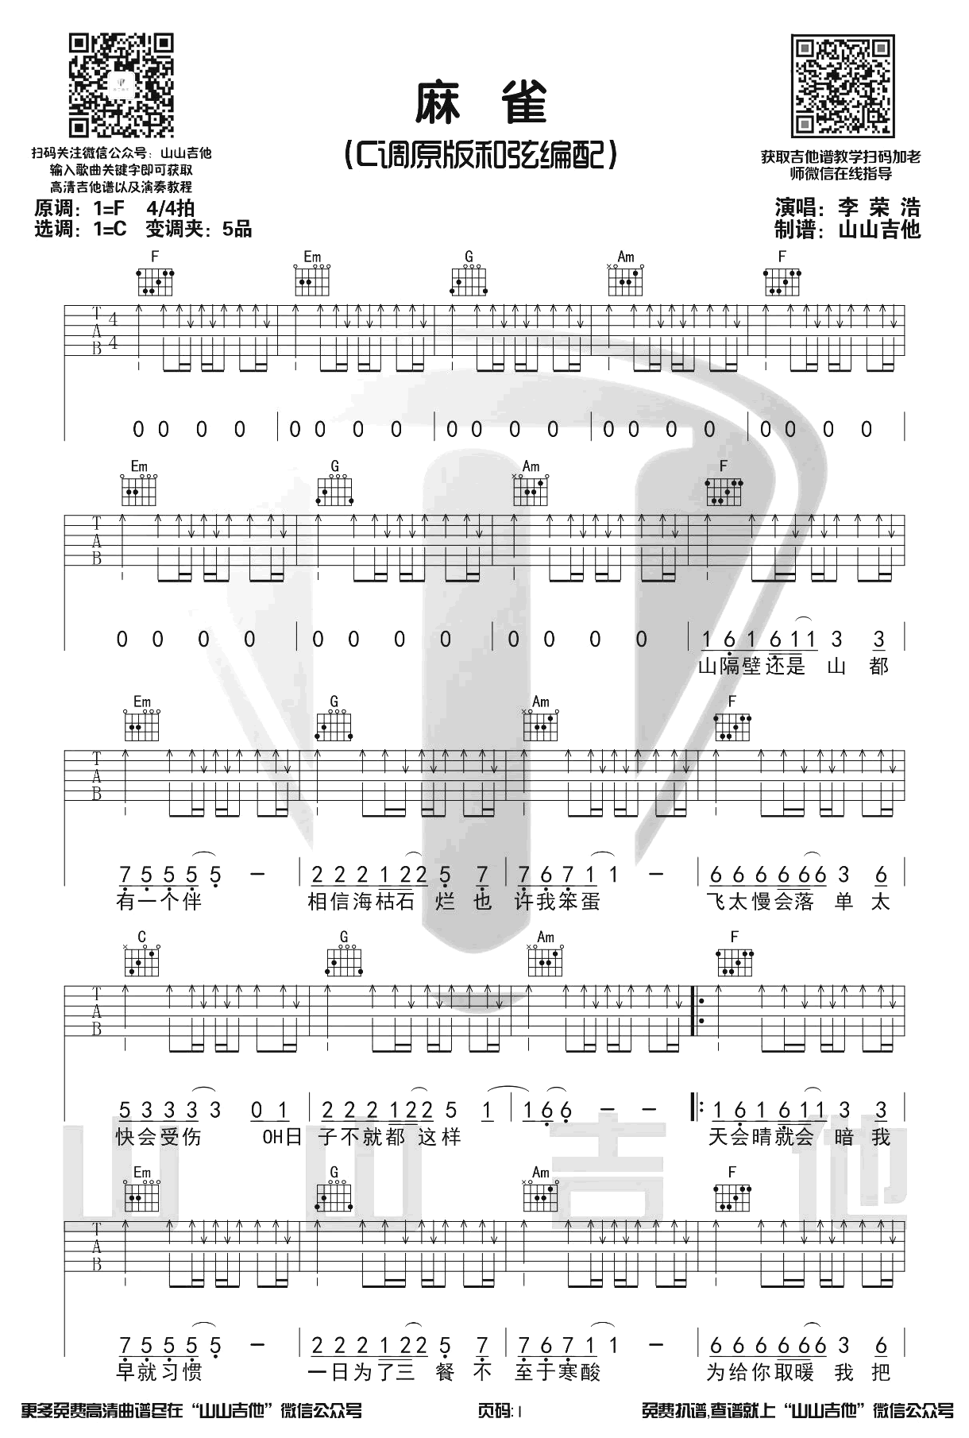](http://www.echangwang.com/up/imgs/2001/5-200113091102.png)[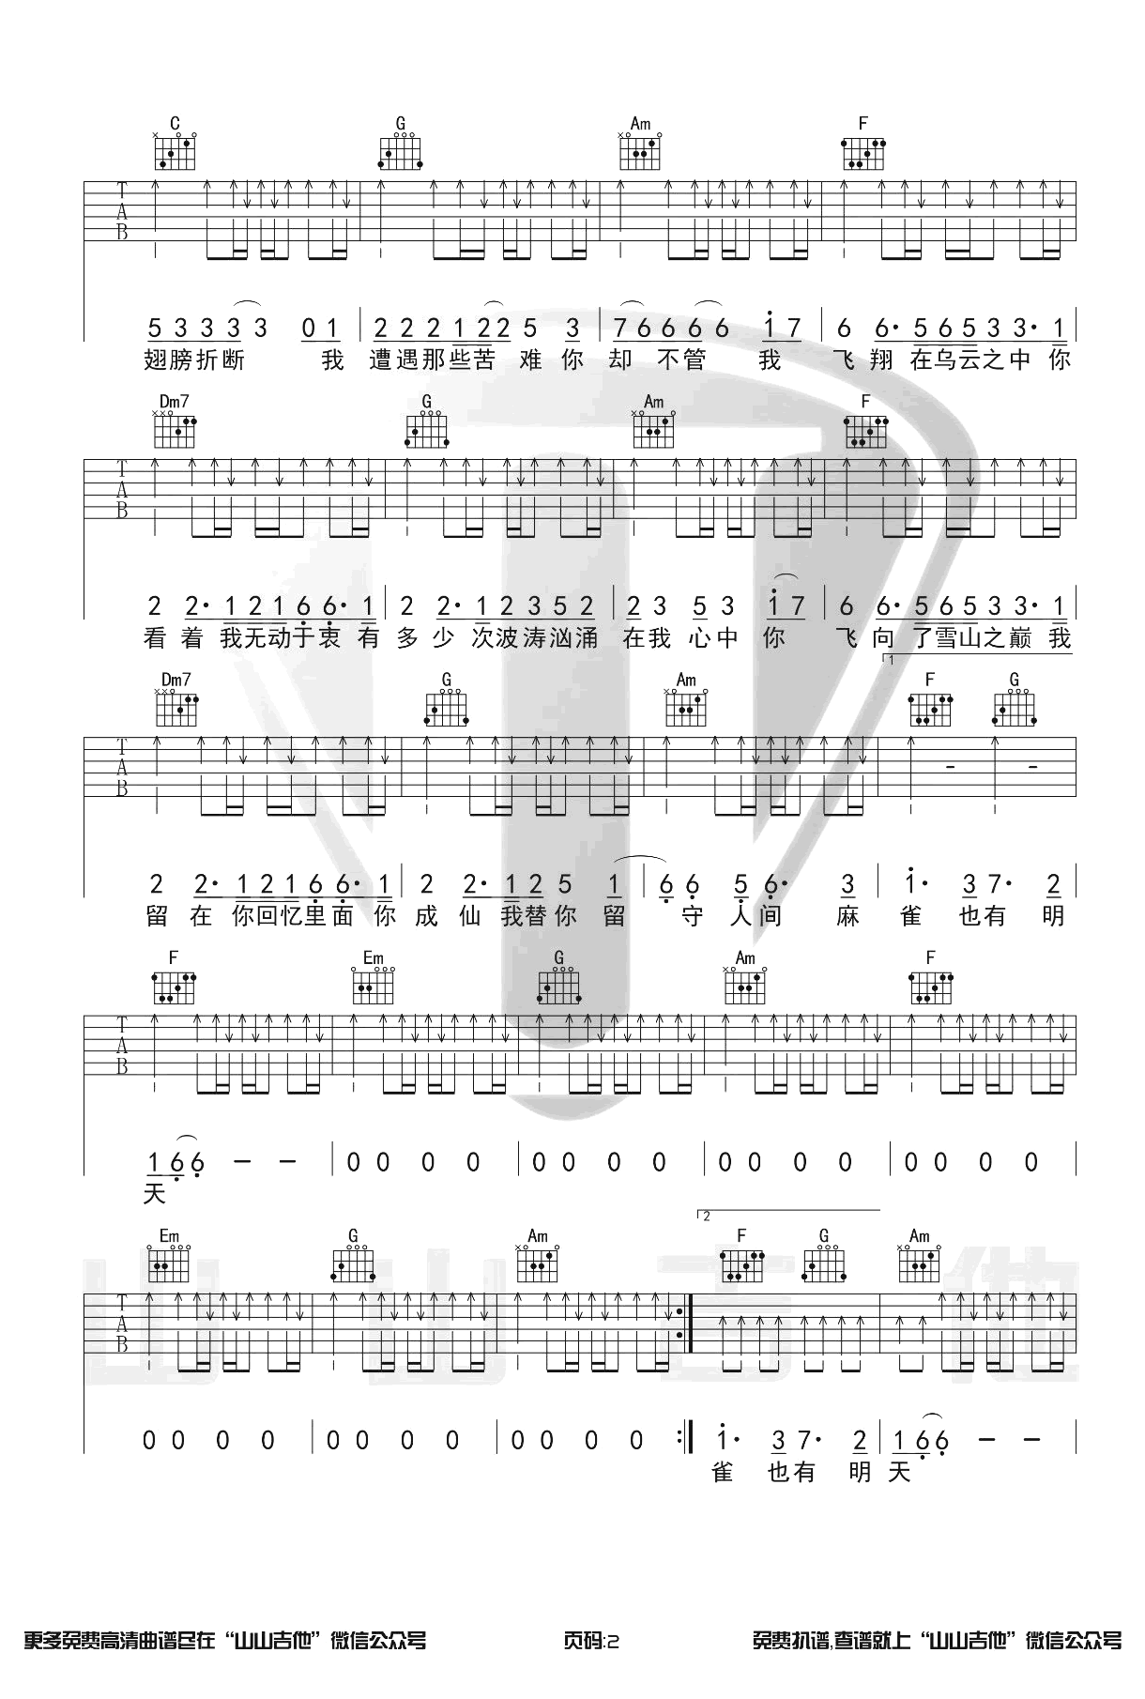](http://www.echangwang.com/up/imgs/2001/5-200113091103.png)[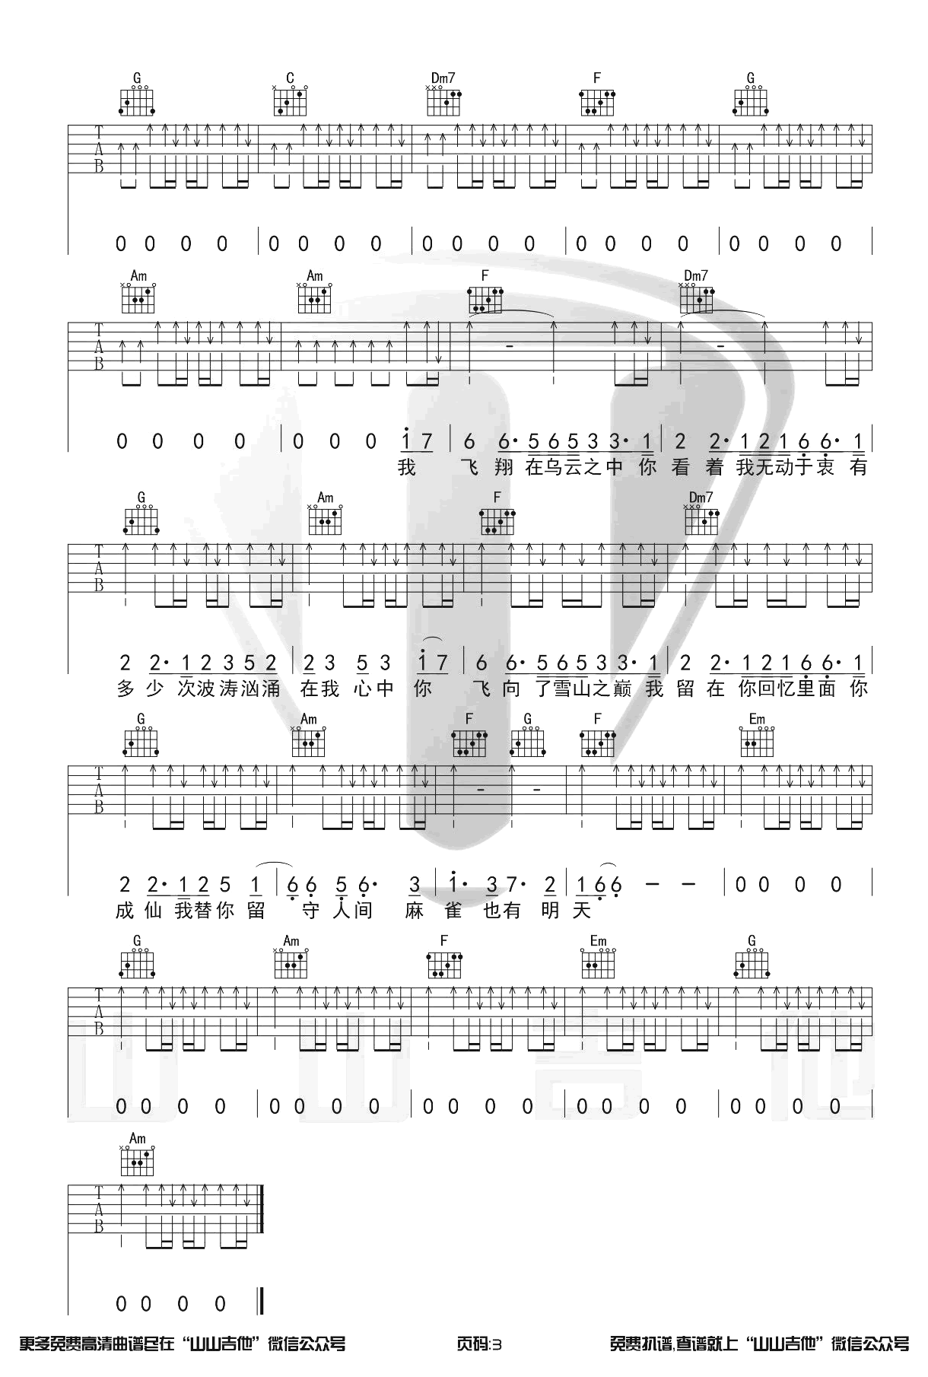](http://www.echangwang.com/up/imgs/2001/5-200113091103-50.png)