60 E.G.T.Bosch,I.Lazić/Ultramicroscopy156(2015)59–72

theobject.AneffectiveCTFcanalsobecalculateddirectlyfrom simulatedSTEMimageswhereboththeobjectandtheimageare known.Weusethisfacttovalidateourmodel.Partoftheex-pressionwederiveherewasalreadyderivedinHawkes&Kasper [6]butwithoutthequadraticterm which,aswe willproveinthis work,isdescribingtheADFcontribution.Startingfromthederi-vationin[6],which,aswewilldemonstrate,describes(A)BF-STEM, we develop a description that includes both bright field and

oneoverallexpression.
Withintheframeworkofourderivationthereisnoneedto imposeconditionsonthesample,suchastheweakphaseobject approximation or the presence of a lattice, as is often encountered intheliterature[1,5,13,16–19].Bothcrystallineandamorphous samplescanbetreatedequallywellusingourexpression.
The nonlinearity of STEM imaging requires careful consideration of what is to be considered the object that is imaged. Conventionally the

darkfieldimaging. desiredobjectisthephaseoftheoutputwaveaftertransmission

One ofthe well-knownresultsofthe theoretical workup tillnow is that an analytical expression for the CTF in the limiting case of a BF detector consisting of a point detector centered on the optical axis was found(namedBFδhere).Thiswasachievedusingthereciprocity theorem [12–15] which shows that it is equivalent to the case of TEM forwhichaCTFwasderivedearlier.AsstatedbyRose[12]“this equivalence[betweenCTEMandSTEM]hasbeenpointedoutinthe pastonnumerousoccasions”(e.g.[14,15]).Amathematicalproof

throughthesample.Thenonlinearitypreventsusfromobtaininga sample-independentCTFwhentheobjectisdefinedasthephaseof the output electron wave. Instead, we obtain an expression concerning twodifferentaspectsofthesample.Thefirstaspectcouldbecon-sideredastheobjectin(A)BFforweaklyscatteringsamplesandthe secondastheobjectfor(HA)ADFimaging.Forbothofthesespecial cases an effective (linear) CTF is found. These effective CTFs are already known in the literature, but often without the precise definition of the

based on the Bloch-wave formalism was given in [13]. We include an correspondingobject.

alternative mathematical proof that is valid for any type of thin sample notinvolvingtheBloch-waveformalism.
AlsointhecaseofADF-STEManapproximateformulawas established[1,2,6,9]basedonthenotionthatinthiscasethe imagingcanberegardedasbeingincoherent.Thisledtoanef-fectivedescriptionofADFandhighangleannulardarkfield (HAADF)imaging,withoutarigorousmathematicalproof.
Themainissueinthederivationofasimple,singleformula STEMmodelhasalwaysbeenthatadetectormeasuresthesquare oftheelectron wavefunctionatthedetector(althoughthisisnot thefundamentalreasonthatSTEMisnonlinear).Thisgivesriseto aquadratictermwhichisdifficulttodealwithmathematically. Manyauthorsthereforelimitedtheiranalysistoonlythefirstor-der (or insome casesthe secondorder) ofthe Taylor expansion of thesampletransmissionfunction.Hawkes&Kasper[6]workout thetheoryforarbitrary orderinthesampletransmissionfunction but are left with a quadratic term that “cannot be simplified in any usefulway”.Thisquadratictermis,however,essentialinde-scribingDFimagingandcannotbeignored.Inourderivationwe get an equivalent result, formulated in a more operational way, but thisformulationallowsafurtherinvestigationofthisquadratic term,therebylinkingtheexpressionsforBFandDFimaginginto

InSection2westartoutwithamathematicalformulationofthe STEM imaging process, and introduce our notation and assumptions. A proofofthereciprocitytheoremisincludedaswellasanoteonthe nonlinearity of the STEM imaging process. The simulation model that is used to validate our theoretical model is described in Section 3. The central equation describing an STEM image is derived in Section 4. The finalstepofobtainingtheeffectiveCTFforSTEMisthentakenin Section5.Inthesamesectionweshowthetwocaseswhichcorre-spondto thepartsofthetheorythathavealreadybeenfoundinthe literature. The first corresponds to the well-known weak phase object approximation(WPA),thesecondtopuredarkfieldimaging.We provethatinbothcasesourderivedgeneralformulareducestothe well-knownformulasforBFδand(HA)ADF.Furthermorewebriefly outlinearecipetoincludeincoherenciesofthesourceandthermal fluctuations of the sample in the model if required. Finally we present ourconclusionsinSection6.
2.MathematicalformulationoftheSTEMimagingprocess
TheSTEMimagingprocessisschematicallyshownintheleft partofFig.1.Inthefirststageaprobeisformedusing

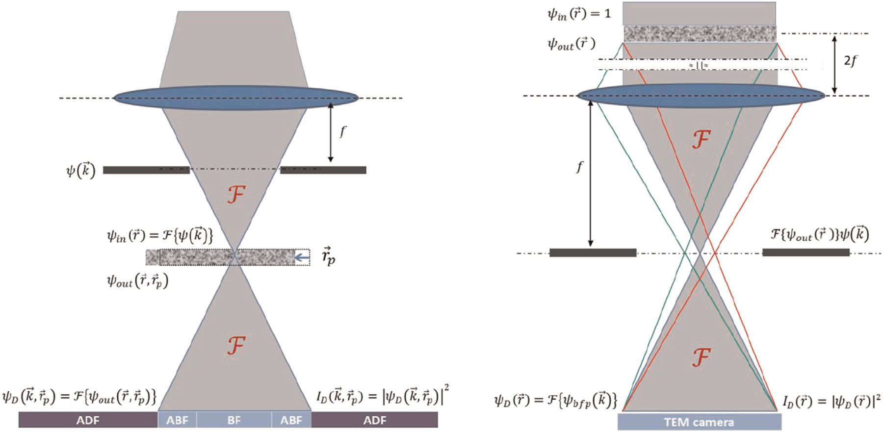
Fig. 1.SchematicoverviewoftheSTEMimagingprocess(left)andforcomparisontheTEMimagingprocess(right).Thestrongblacklinesindicatetheaperture,denoted
→  withAk ),whichisincludedin | →  ψ ( k ).

64 E.G.T.Bosch,I.Lazić/Ultramicroscopy156(2015)59–72
onlyitssquaredamplitude.Thesignalinthedetectionplaneis
therefore |  |  |  |  |  |  |  |  |  |  |  |  | Using(17)and(11),werewrite(16)as
I D |  |  |  |  |  |  |  |  |  |  | (→→)
 | (→→)= | ψ | STEM | (→→) | 2 | = | ψ | STEM | (→→)⋅ψ | STEM |  | ( 13 ) | 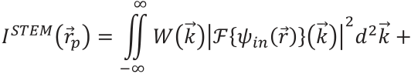
 |  |  | D |  |  |  |  | D |  | D
wherethenotation x¯indicatesthecomplexconjugateofx.

InordertoobtainthefinalSTEMimage,theintensitydis-tributioninthedetectorplanemustbeintegratedovertheactive areaofaspecificdetectorinthatplane.Thiscorrespondstoin-
tegrating(13)overarangeofwavenumbersk→.Theselectionof this range of wave numbersis realized using the detector window→
function Wk )asintroducedin(9).TheSTEMimageisgivenby
∞
I STEM (→)=∬WkI → D (→→) rdk 2 →

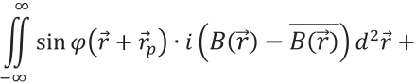
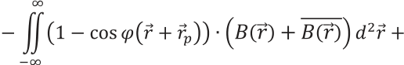
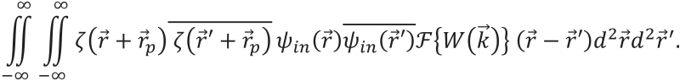
Notethatthesecondandthirdtermsin(18)havetheformofa

−∞ |  |  |  |  |  |  |  |  |  |  |  |  |  |  |  |  |  |  |  |  | cross-correlationintegral3.Alsonotethatthethirdandfourthterms
= |  |  | ∞ | →  Wk ) |  | ψ | STEM |  | (→→) |  | 2 | →  dk 2 .
 |  |  |  |  |  |  |  |  |  |  |  |  |  |  |  |  |  |  |  |  | are of order |  |  | φand higher whereas the second term is of order φand 2
 |  |  | ∬
 |  |  |  |  |  |  | D |  |  |  |  |  |  |  |  |  |  |  |  |  | higher.  Next,weproceedwiththelasttermin(18),which,afterin-  troducingachangeofvariabler→″ = →−→′,reads
−∞ |  |  |  |  |  | ( 14 )
Writingoutthisintegralweobtain
∞ |  |  |  | ∞ | ∞ |  |  |  |  |  |  |  |  |  |  |  |  |  |  |  | ∞ |  |  | ∞
I | STEM | (→)= | ∬∬∬ |  |  | ( 1 |  | − | ζ | (→+ →) |  |  |  | ) | ( 1 | − | ζ | (→′+ →) ) | ψin | (→)
 |  |  |  |  |  |  |  |  |  |  |  |  |  |  |  |  |  |  |  |  | Iζζ¯ | (→)≡ | ∬∬ζ |  |  | (→+ →″ + →)(→+ →) | ψin | (→+ →″) | ψin (→)
−∞ |  |  |  | −∞ | −∞
ψin (→′) |  |  |  |  | →  Wke |  |  | −2π→⋅(→−→)′ |  |  |  | dr drdk 2→2→′2→ |  |  |  |  |  |  | ( 15 ) |  | −∞ |  |  | −∞
 |  |  |  |  |  |  |  |  |  |  |  |  |  |  |  |  |  |  |  |  | - | →{ Wk ) | } | (→″) | drdr . 2→″2→ |  | ( 19 )
Workingouttheparenthesesinvolving ζweobtainfourterms whichcanberewrittenas
 |  |  |  |  |  |  |  |  |  |  |  |  |  |  |  |  |  |  |  |  | Usingthedefinitionofthecross-correlation(19)canbe
I | STEM | (→)= | ∞ | →  Wk ) |  | - | {ψin |  | →(→)( } k ) |  |  |  | 2 | →  dk 2
 |  |  | ∬
−∞
 | ∞ | ζ | (→+ →)⋅ψin |  |  |  |  | →{ Wk ) | - | − | 1 {ψin (→′) } |  |  | } | (→) rdr 2→− |  | ∞
− | ∬ |  |  |  |  | (→) | - |  |  |  |  |  | →  ( k ) |  |  |  | ∬ | ζ | (→′+ →)⋅ψin (→′) | - | − | →1 { Wk ) | - | {ψin | →(→)( } k ) | } | (→′) | dr 2→′
 | −∞ | −∞
 | ∞ | ∞ |  |  | (→+ →)(→′+ →)ψin |  |  |  | (→) |  | ψin (→′)- | →{ Wk ) |  |  | } | (→−→′) | dr dr 2→2→′
+ | ∬∬ |  |  | ζ |  |  |  |  |  |  |  |  |  |  |  |  |  |  |  |  |  |  |  |  |  |  |  |  | ( 16
 | −∞ | −∞
)

where we have executed theintegration overr→andr→′ in thefirst term, overr→′ andk→in the second term, overr→andk→in the third
term and overk→in the last term. Note that the third term in (16) is

rewrittenintermsoftheautocorrelationfunctionoftheproduct
ζ(→+ →)ψin (→)as
∞
Iζζ¯(→)=∬(ζ(→+ →)ψin (→)★(→+ →)ψin (→)(→″) )

thecomplexconjugateofthesecondterm.  The first term in (16) is independent ofrp→and hence a constant. ItrepresentsaDCoffsetoftheSTEMimage.  Introducingashort-handnotation |  |  |  |  |  |  |  |  |  |  |  |  |  |  |  |  |  |  |  |  |  |  |  |  | −∞
 |  |  |  |  |  |  |  |  |  |  |  |  |  |  |  |  |  |  |  |  |  |  |  |  | ⋅- |  |  |  |  | →{ Wk ) |  |  |  |  | } |  | (→″) |  | dr. 2→″ |  |  |  | ( 20 )
 |  |  |  |  |  |  |  |  |  |  |  |  |  |  |  |  |  |  |  |  |  |  |  |  | The autocorrelation function of a coherent probe |  |  |  |  |  |  |  |  |  |  |  |  |  |  |  |  |  |  |  |  |  |  |  | ψ | in | (i.e. excluding
Br (→)≡ |  |  | ψ | in |  |  | →{ Wk ) |  |  | - |  | −1 {ψ |  |  |  |  | →  ( k ) |  |  | (→) |  |  | wecanwritethe
 |  |  |  |  | (→) | - |  |  |  |  |  |  |  |  | in | (→′) } |  |  | } |  |  |  |  |  | the |  | effects |  |  |  |  | of |  | incoherence |  |  |  |  |  |  |  |  | of |  |  | the | source) |  |  | is |  | given | by
 |  |  |  |  |  |  |  |  |  |  |  |  |  |  |  |  |  |  |  |  |  |  |  |  | (ψ | in | (→)★ψ |  | in | (→)(→″)= ) |  |  |  |  |  |  |  | - | { A 2 |  | →  ( k ) |  |  | } | (→″),whichdirectlyfollowsfrom
secondandthirdtermsof(16)as
∞
 |  |  |  |  |  |  |  |  |  |  |  |  |  |  |  |  |  |  |  |  |  |  |  |  | theWiener–Khinchintheorem,anddropstozerooveralengthscale
− | ∬ | (ζ | (→+ →)⋅(→)+ |  |  |  |  |  |  |  | ζ | (→+ →)⋅(→) ) |  |  |  |  |  |  | dr 2→=
 |  |  |  |  |  |  |  |  |  |  |  |  |  |  |  |  |  |  |  |  |  |  |  |  | oftheorderof |  |  |  |  |  |  |  | 1/ | k | BF.Theautocorrelationfunctionofthesamplety-
 |  |  |  |  |  |  |  |  |  |  |  |  |  |  |  |  |  |  |  |  |  |  |  |  | picallyalsoshowsaninitialdrop(toafiniteconstantvalue)asa
−∞
− | ∞ | ζ | (→+ →)+ |  |  |  |  | ζ | (→+ →) |  |  |  | ⋅ | ( Br (→)+ |  |  | Br (→) ) |  |  |  | dr 2→ |  |  |  | functionof |  |  |  |  | r→′′overadistanceofthesizeofanatom.Forperiodic
 |  |  |  |  |  |  |  |  |  |  |  |  |  |  |  |  |  |  |  |  |  |  |  |  | samplesitwillpeakagainatpositionscorrespondingtothelattice periodicity,foramorphoussamplesthisautocorrelationwillalways remainsmallforlarger→″.Theautocorrelationoftheproductofthe
 | ∬
 |  |  | 2
 | −∞
− | ∞ | ζ | (→+ →)− |  |  |  |  | ζ | (→+ →) |  |  |  | ⋅iBr ( (→)− |  |  |  |  | Br (→) ) |  |  |  | dr 2→ |  | ( 17 )
 |  |  |  |  |  |  |  |  |  |  |  |  |  |  |  |  |  |  |  |  |  |  |  |  | twofunctionsalsodropstozeroandstaysatzero,providedthatthe
 | ∬
 |  |  | 2 i |  |  |  |  |  |  |  |  |  |  |  |  |  |  |  |  |  |  |  |  |  | 3The |  |  |  |  | cross-correlation |  |  |  |  |  |  |  |  |  |  |  |  | is |  |  |  |  | defined |  |  |  |  | as
 | −∞
whereitshouldbenotedthatthecombinationsBr (→)+ |  |  |  |  |  |  |  |  |  |  |  |  |  |  |  |  |  |  |  |  |  |  |  | Br (→)and
 |  |  |  |  |  |  |  |  |  |  |  |  |  |  |  |  |  |  |  |  |  |  |  |  | ⎛  ⎜f  ⎝ | →  ()‵★g |  | →  () |  | ⎞⎟⎠ | →  ()≡ |  |  | ∞ |  | →¯ →  fr ()( r |  |  |  | + |  | →  r ) | →dr 2 |  | .
iBr ( (→)− |  |  |  | Br (→) ) |  |  | arebothreal. |  |  |  |  |  |  |  |  |  |  |  |  |  |  |  |  |  |  |  |  |  |  |  |  |  |  | ∬
 |  |  |  |  |  |  |  |  |  |  |  |  |  |  |  |  |  |  |  |  |  |  |  |  |  |  |  |  |  |  |  |  |  | −∞

