

ADU AI Student Assistant: Smart Advising, Automatic Attendance and Study & GPA Support

By

Ahmed Alameri (1090726), Said Taha (1093667), Rayyan Daqqa (1097796)

A Project Presented to SWE 401: Software Engineering
CSIT Department
College of Engineering
Abu Dhabi University

Instructor: Dr. Muhammad Nasir Mumtaz Bhutta

Abu Dhabi, United Arab Emirates

Fall 2026
Phase 1 Submission: 28 September 2026
Phase 2 Submission: 1 November 2026
PHASE 1: Project Proposal and Planning
5. Project Description (The Software System Proposal)
Introduction and definition of the problem
To register, students at Abu Dhabi University (ADU) need an academic advisor, and each advisor has many students to cover: NACADA's 2011 national survey reports a median caseload of 296 students per full-time advisor [2]. Some students register for courses whose times clash or whose prerequisites they have not completed. Instructors still take attendance by hand. Students with falling grades often learn of probation risk only after final grades, even though a CGPA below 2.0 after 30 credit hours means probation and a limit of 12 credit hours per semester [1]. This project adds an AI Student Assistant to the existing ADU student portal.
General overview and main functionality
The assistant is a portal module with three functions. F1, the smart advising bot, answers registration questions from the student handbook and ADU policies alone. It also builds a next-semester schedule that has no clashes and follows prerequisites and the study plan. F2, automatic attendance, marks a student present when the phone's location is inside the classroom building during class time, and a rotating QR code covers cases where location cannot be used. F3, the study assistant and GPA support function, turns an approved lecture recording into a PDF summary that lists where the instructor stressed a topic or mentioned the exam. It also predicts the end-of-semester GPA and warns the student before the GPA falls below 2.0 or a personal target. Attendance feeds this prediction, and the predicted GPA helps F1 set the credit load (Table 1).
Stakeholders and intended users
Students can get advice at any time, along with a schedule without clashes, lecture summaries and early GPA warnings. Advisors can see which advisees are at risk and spend less time on routine questions, and instructors no longer need to call the roll. The Registrar can audit attendance records, IT staff manage accounts, and management can track retention.
Description of the current (as-is) system
Today, students register after meeting an advisor. The portal shows grades and posts warnings when absence in a course reaches 10% and 20%, then records a withdrawal due to absence (WA) at 30% [1]. Schedule checks, grade prediction and lecture review are all missing.
Problems and limitations of the current system
P1. Registration advice comes from advisors, so a student without an appointment may choose a course that clashes with another or whose prerequisite they have not completed. (F1)
P2. Roll calls use up lecture time, and mistakes in recording them affect the absence warnings. (F2)
P3. Warnings cover absence only, so falling grades go unnoticed until the CGPA is below 2.0. A student who misses a lecture also has no record of what the instructor stressed. (F3)
Key challenges during development
Grades are confidential and the student information system is closed to us. The GPA model will therefore use synthetic data based on ADU grading rules, and a separate database will simulate the portal. GPS is less accurate indoors, so the geofence covers the whole building, and off-campus tests use simulated coordinates. Transcription may make errors on mixed Arabic and English audio. A local language model is slower than cloud models and needs about 8 GB of free memory, so we use a compact model, transcribe in the background and demo on the strongest laptop. We also limit the chatbot to approved documents to reduce invented answers.
Ethical, privacy, security, accessibility, bias and societal considerations
Location is personal data under UAE Federal Decree-Law No. 45 of 2021 [3], so the assistant reads it only at check-in and keeps only the in-or-out result. Students who decline can use the QR code. Lectures are recorded only with the instructor's permission, the audio is deleted within one hour of transcription, and no student data leaves our server. Gender and nationality are excluded from the GPA model, and each prediction appears as guidance with its reasons. Instructors can correct attendance, and policy questions go to a human advisor. A summary helps with revision, but a missed lecture still counts as an absence. Accounts use hashed passwords and role-based access, and the interface supports Arabic, English and screen readers.
Technologies
The React front end runs in phone browsers, so check-in needs no app. Location comes from the browser Geolocation API, and the Python qrcode library generates the fallback code. We chose Python with FastAPI for the back end because the AI libraries are in Python, and PostgreSQL stores the data. Whisper transcribes lectures, and a local model run with Ollama answers questions and writes summaries through retrieval-augmented generation (RAG) with ChromaDB. scikit-learn predicts GPA, and ReportLab creates the PDFs. UML diagrams are drawn in draw.io, testing uses pytest and Postman, and GitHub handles version control.
5.1 Functional Model of the Proposed System
Function | Inputs | Process | Outputs
F1 Smart advising bot (new) | Student question; study plan; completed courses; prerequisite rules; offered sections; predicted GPA from F3 | Retrieve handbook passages and cite them in the answer; filter eligible courses; build a schedule with no clashes; lower the credit load when F3 predicts risk | Answer with citation; schedule with no clashes and alternative sections; referral to a human advisor
F2 Automatic attendance (enhanced) | Location at check-in; class time and geofence; enrolled students; rotating QR token | Check the location against the geofence and class time, or validate the QR token; instructor confirms or corrects | Attendance record per session; absence percentage; data sent to F3
F3 Study assistant and GPA support (new and enhanced) | Approved lecture recording; coursework grades; attendance from F2; credit hours; GPA target | Transcribe, summarise and detect exam mentions; predict grades and GPA, compare with 2.0 and the target, and calculate the grades required | PDF summary with "Exam focus" list and timestamps; warning; required grade per course; predicted GPA sent to F1
Table 1. Functional model: inputs, processes and outputs of the three functions
5.2 Team Members' Brief CVs
Ahmed Alameri (1090726) is an undergraduate in the CSIT Department who has built an AI search engine for online listings (Plate Hunter), a Premiere Pro plugin for automatic subtitles and a React Native (Expo) app. Skills: Java, JavaScript, HTML, CSS, SQL, REST APIs and Git; learning RAG with Ollama. Ahmed leads F1, supports F3 transcription, owns the repository and edits the report.
Said Taha (1093667), also a CSIT undergraduate, has taken courses in programming, databases and web development. Skills: Python, JavaScript, SQL and Git; learning React, the Geolocation API and pytest. Said leads F2 and testing, builds the shared database and runs the interviews.
Rayyan Daqqa (1097796) is a CSIT undergraduate with coursework in programming, statistics and data analysis. Skills: Python, SQL and Git; learning pandas, scikit-learn and Ollama. Rayyan leads F3 and runs the student survey.
6. Market Potential
User interest
Every ADU student already uses the portal, so nobody needs to install a new app. Students can get advice outside office hours, build a schedule without clashes, read a summary of any missed lecture and see their expected GPA during the semester. The survey and interviews in Appendix A test this interest; Section 10.2 reports the results.
Social and environmental impact
Students who are warned earlier have more chance to recover before probation or dismissal, which can save them time and tuition. Those who miss a class through illness can read the lecture summary, and digital check-in replaces paper sign-in sheets.
Similar or related systems
Ellucian Degree Works is a degree audit and planning tool with "what if" scenario planning [4]. EAB Navigate360 gives university staff predictive models and automated alerts, plus an AI agent that answers student questions [5]. At Georgia State University, GPS Advising tracks every undergraduate daily against more than 800 alerts [6] and prompted 52,000 advisor meetings in one year [7], while the Pounce chatbot answered more than 200,000 questions in its first summer [8]. Top Hat verifies in-class attendance with geolocation [9], but students must enter a code, and those whose location fails are marked absent [10]. Otter.ai transcribes lectures and generates summaries [11].
Novelty of the proposed idea
Each of these tools covers one need. Our assistant brings advising, attendance and study support together inside the portal students already use, and the three share data: attendance feeds the GPA prediction, and the prediction changes the credit load the advising bot suggests. F3 also marks each point where the instructor said a topic may appear in the exam, which general note-takers do not offer. Because students set their own GPA target, a warning can come well before the 2.0 threshold.
6.1 Benchmark Comparison of Existing Solutions
System / App | Key Features | Strengths | Limitations / Gaps | Our Improvement
ADU portal (as-is) [1] | Registration, grades, absence warnings | Official data used by all ADU students | Absence-only warnings; manual attendance; depends on advisor meetings | Adds all three functions inside the portal
Ellucian Degree Works [4] | Degree audit, "what if" planning | Clear view of remaining requirements | No grade prediction, attendance data or conversational assistant | Clash-free schedule that also uses the predicted GPA
EAB Navigate360 [5] | Predictive models, alerts, AI student agent | Wide feature set for staff | Built mainly for staff; commercial licence; no location attendance | Warnings go to the student against a personal target
GSU GPS Advising [6], [7] | Daily tracking of 800+ alerts | 52,000 meetings in one year | Depends on advisor capacity; no personal target | Shows the required grade without waiting for an advisor
Pounce chatbot, GSU [8] | Chatbot for incoming students | 200,000+ answers in its first summer | Not linked to grades or planning | Linked to the study plan, schedule and predicted GPA
Top Hat attendance [9], [10] | Geolocation and code check-in | Verifies presence in the room | Code entry each class; absent if location fails | Location check with QR fallback; the result feeds GPA prediction
Otter.ai [11] | Lecture transcription and summaries | Real-time notes | General summaries; not linked to the course or grades | PDF summary with an exam-focus list
Table 2. Benchmark comparison of existing solutions and the proposed system
7. Project Management Plan
7.1 Activities and Work Plan
Activity | Owner(s) | Depends on | Start | Finish | Deliverable
A1 Form team, choose idea, consult instructor | All | None | 01 Sep | 07 Sep | Approved project idea
A2 Study the as-is ADU portal and policies | Ahmed | A1 | 08 Sep | 14 Sep | As-is system notes
A3 Research similar systems and statistics | Said | A1 | 08 Sep | 17 Sep | Benchmark table, references
A4 Prepare survey and interview questions | Rayyan | A2 | 15 Sep | 20 Sep | Appendix A instruments
A5 Phase 1 proposal, GitHub and Discourse | All | A2, A3, A4 | 21 Sep | 28 Sep | Phase 1 report, repository, Discourse post
A6 Run survey and interviews | Rayyan, Said | A5 | 29 Sep | 08 Oct | Survey results, interview summaries
A7 Requirements engineering (Phase 2) | All | A6 | 09 Oct | 25 Oct | Phase 2 report
A8 Analysis diagrams (Phase 3) | All | A7 | 26 Oct | 08 Nov | Phase 3 report
A9 System design, UI mockups (Phase 4) | All | A8 | 09 Nov | 15 Nov | Phase 4 report
A10 Build the shared portal database | Said | A7 | 26 Oct | 31 Oct | Database and seed data
A11 Develop F1, F2 and F3 | One lead each | A10 | 01 Nov | 12 Nov | Three function modules
A12 Integrate and test F2, F3, then F1 | All | A9, A11 | 16 Nov | 20 Nov | Tested system, test evidence
A13 README and final report (Phase 5) | All | A12 | 21 Nov | 22 Nov | Phase 5 and final report
A14 Live demo and presentation | All | A13 | 23 Nov | 25 Nov | Demo
Table 3. Activities, owners, dependencies and deliverables (all dates in 2026)
The project manager (PM) role rotates as the course requires: Said manages Phases 1 and 4, Rayyan Phases 2 and 3, and Ahmed Phase 5. Each PM tracks that phase's activities and checks the deliverable against the course requirements before submission. The team meets weekly and keeps every activity as a card on a GitHub Projects board, moving it from To do to In progress to Done, so the PM can see what is late. Commit history shows each member's work, and all members stay responsible for the project's quality.
7.2 Software Project Methodology Selection
We selected an incremental and iterative process model. The course phases build on each other, and feedback in later phases has to be carried back into earlier deliverables, which a strict waterfall model does not allow. We will first build the shared database that simulates the portal, then deliver attendance, the study assistant and GPA support, and the advising bot as separate increments, testing each one before adding the next. Attendance feeds the GPA prediction and the prediction feeds the bot, so every increment can use real output from the one before it. Development starts before the Phase 4 report is due, so the design of each function is agreed before its code is merged, and any change goes back into the design report.
The AI components also need experimentation. Geofence rules, the prediction model and the chatbot prompts will change after testing, and short iterations leave room to repeat those cycles. We considered Scrum, but a team of three part-time students cannot staff separate Scrum roles, so we borrow only its weekly meeting and task board.
7.3 Project Schedule: Gantt Chart
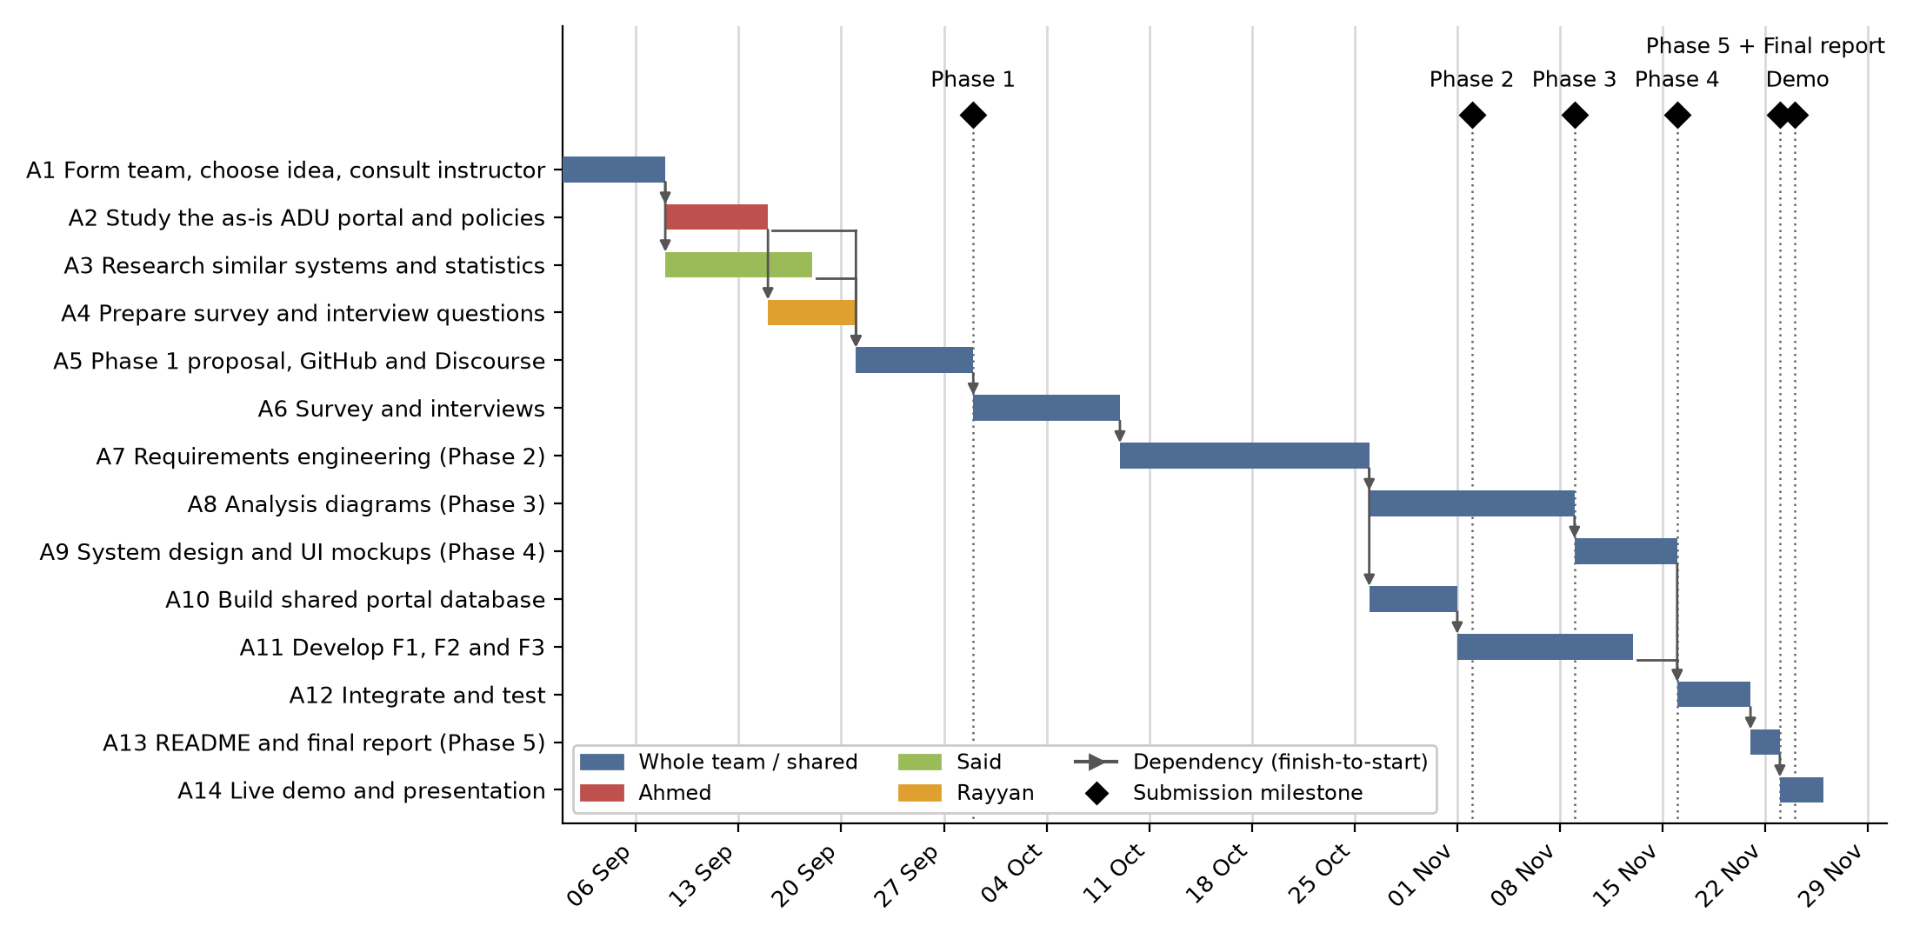
Figure 1. Project Gantt chart with dependencies and submission milestones
7.4 Budget
No budget is required: the estimated total cost is 0 AED. All development tools (VS Code, Python, React, FastAPI, PostgreSQL, Ollama, Whisper, scikit-learn, ChromaDB, ReportLab, draw.io, pytest, Postman and GitHub) are free. The prototype and demo run locally on team laptops, with students' phones for check-in, so there are no API or hosting fees.
8. Project Repository (GitHub)
The repository is https://github.com/xk88x/ADU-AI-Student-Assistants. It is public, so the instructor can view it without an invitation, and all three members are collaborators: xk88x (Ahmed Alameri), saeed789987 (Said Taha) and y0-x9 (Rayyan Daqqa). The main branch holds the stable version. Members work on feature branches (feature/advisor, feature/attendance and feature/study-assistant), and another member reviews each pull request before it merges. From Phase 5, a develop branch will collect the three functions before they reach main.
PHASE 2: Requirements Engineering and Functional Modeling
9. System Context Diagram
Figure 2 shows the assistant as one system with its users and the two external systems it depends on. The language model, Whisper and the vector store run on our own server, so they sit inside the system boundary. The real student information system is closed to us, so the simulated database stands in for it.
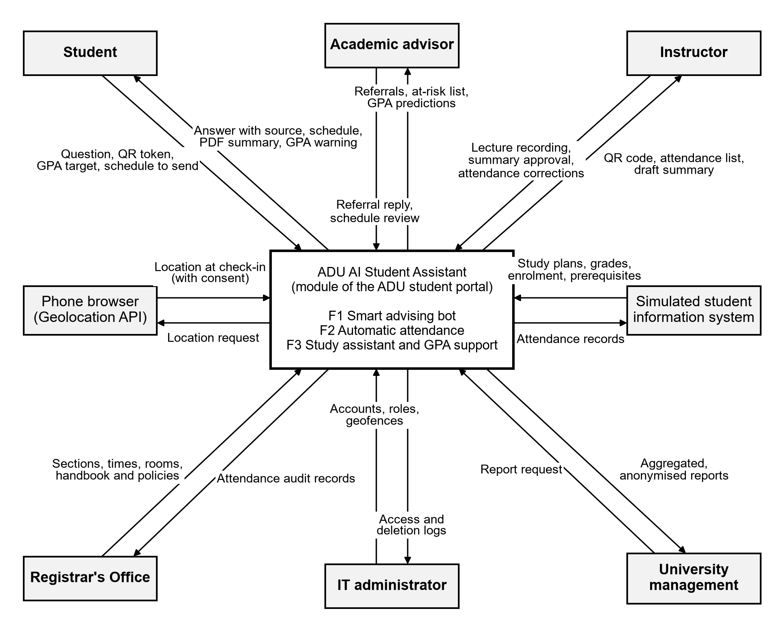
Figure 2. System context diagram
10. Requirements Engineering
10.1 Requirements Elicitation Techniques
No single technique reaches every stakeholder [12], so we chose four. A questionnaire suits students because there are many of them: a three-minute anonymous online form reaches several programs, and its closed questions give numbers we can compare with P1 to P3 (Appendix A.1, target at least 30 students). Interviews suit advisors and instructors, since few people hold this knowledge and open questions let them explain how registration and attendance work in practice (Appendix A.2, target at least one of each, about 15 minutes). The student handbook and portal hold the exact rules the system must follow, and document analysis captures rules people rarely recall precisely. Benchmarking the systems in Section 6.1 shows which features users already expect and where those systems fall short. Rayyan handles the questionnaire and Said the interviews.
10.2 Requirements Elicitation Results
Document analysis. The handbook [1] sets the thresholds the system must apply: absence warnings at 10% and 20%, WA at 30%, and probation with a 12 credit hour limit when the CGPA is below 2.0 after 30 credit hours. FR1.5, FR2.6 and FR3.7 come from these thresholds. FR1.3, FR1.4, FR3.3 and FR3.5 exist because the portal has no schedule check, grade prediction or lecture review. UAE law treats location as personal data [3], so FR2.2 stores only the in-or-out result.
Benchmarking. A Top Hat student whose location fails is marked absent [10], so FR2.4 gives every student a QR route. Pounce answers questions without using grades or plans [8], and FR1.5 connects our bot to the predicted GPA. Otter.ai writes general summaries [11], while FR3.3 adds the exam-focus list with timestamps.
Questionnaire. We received responses from 43 students in 4 programs. On advising (P1), 48.8% reported a clash or a missing prerequisite (Q4). Appointment access averaged 2.4 out of 5 (Q3), and likely use of an assistant averaged 4.3 out of 5 (Q12). On attendance (P2), 62.8% said roll call takes more than 5 minutes (Q5) and 37.2% had been marked absent by mistake (Q6). For location checks, 32.6% would allow one and 51.2% would allow one only with a QR option (Q7). On study and grades (P3), a PDF summary with an exam list rated 4.6 out of 5 (Q9), 41.9% did not know their expected GPA (Q10), and 27.9% had been near probation without noticing (Q11).
Interviews. Advisor A reported roughly 180 to 200 undergraduate advisees, with registration meetings at peak times lasting 10 to 15 minutes each. Most routine questions concern prerequisite waivers and clashing lecture sections. Struggling students are usually identified only after midterm warning rosters or when probation holds appear late in the term. Instructor A spends roughly 6 to 8 minutes on manual roll call at the start of every 75-minute class, and supported audio recording on three conditions: processing stays local, summaries go only to students enrolled in that section, and the raw audio is permanently deleted immediately after the summary is generated.
Analysis. The findings support problems P1, P2 and P3: 48.8% of respondents reported a clash or a missing prerequisite, 62.8% said roll call takes more than 5 minutes, and 41.9% did not know their expected GPA. Since 51.2% would allow a location check only with a QR option (Q7), FR2.4 and UC-05 offer QR check-in prominently to every student who declines location access or whose GPS fails. Instructor A's privacy conditions are written into FR3.4 as mandatory constraints: publication limited to enrolled students in that section and audio deletion within one hour of transcription (NFR11), a measurable limit for Instructor A's request for immediate deletion. Most respondents came from engineering and computing majors (N = 43). They are the main target group, but they may be more technically ready than the wider student body, which limits these results.
11. System Users
Students are the primary users: they ask the bot, build schedules, check in, read summaries of their own sections and set a GPA target. Academic advisors handle referrals and contact at-risk advisees, with access to records and predictions for their own advisees only. Instructors upload recordings, show the QR code, confirm attendance and approve summaries for their own sections only. The Registrar's Office audits attendance and keeps section, time and room data correct, because F1 and F2 depend on that data. The IT administrator manages accounts, roles and geofences and applies the retention rules. University management sees only aggregated, anonymised reports and uses them to plan advising and track retention and probation.
12. Functional Requirements
ID | Functional Requirement | Priority
FR1.1 | The system shall answer registration questions in English or Arabic from the handbook and approved policies only, and shall cite the source passage. | Must
FR1.2 | The system shall refer a question to the student's advisor if no approved passage supports an answer or if it needs a policy decision. | Must
FR1.3 | The system shall list the courses a student may take next semester, based on the study plan, completed courses and prerequisite rules. | Must
FR1.4 | The system shall build a next-semester schedule with no time clashes and shall show alternative sections where they exist. | Must
FR1.5 | The system shall lower the suggested credit load when the predicted GPA is below 2.0 and shall apply the 12 credit hour limit to students on probation. | Should
FR1.6 | The system shall let a student send a saved schedule to the advisor, who can approve it or reply with a comment. | Should
FR2.1 | The system shall read the student's location only when the student taps Check in during the class-time window. | Must
FR2.2 | The system shall mark an enrolled student present when the location is inside the building geofence, and shall store only the in-or-out result. | Must
FR2.3 | The system shall show the instructor a rotating QR code for the current session. | Must
FR2.4 | The system shall provide a rotating QR code check-in prominently on the check-in screen for students who decline location access or experience GPS failure. | Must
FR2.5 | The system shall let the instructor confirm or correct the attendance list of a session and shall log each correction. | Must
FR2.6 | The system shall calculate each student's absence percentage per course, warn at 10% and 20%, and flag WA at 30%. | Must
FR2.7 | The system shall let the Registrar's Office read and export attendance records for audit. | Should
FR3.1 | The system shall let an instructor upload a lecture recording for a section they teach. | Must
FR3.2 | The system shall transcribe a recording in the background and delete the audio within one hour of transcription. | Must
FR3.3 | The system shall generate a PDF summary with an "Exam focus" list that links each point to a timestamp. | Must
FR3.4 | The system shall publish a summary only after the instructor reviews and approves it, and only to students enrolled in that section. It shall delete raw lecture recordings within one hour of transcription. | Must
FR3.5 | The system shall predict course grades and the end-of-semester GPA from coursework, attendance and credit hours, and shall update the predictions when new data arrives. | Must
FR3.6 | The system shall let a student set a personal GPA target. | Should
FR3.7 | The system shall warn the student and advisor when the predicted GPA is below 2.0, and warn the student alone when it is below the personal target. | Must
FR3.8 | The system shall show the grade needed in each course to reach 2.0 or the target. | Must
FR3.9 | The system shall present each prediction as guidance with the reasons behind it. | Should
FR4.1 | The system shall require login and limit each user to the data their role allows. | Must
FR4.2 | The system shall show an advisor the at-risk advisees and their predictions. | Must
FR4.3 | The system shall let the Registrar's Office manage sections, times and rooms. | Must
FR4.4 | The system shall let the IT administrator manage accounts, roles and geofences. | Must
FR4.5 | The system shall give management aggregated, anonymised retention and probation reports. | Could
FR4.6 | The system shall let users switch the interface between Arabic and English. | Should
Table 4. Functional requirements (F1 = FR1.x, F2 = FR2.x, F3 = FR3.x, shared = FR4.x)
13. Non-Functional Requirements
Timings assume the demo laptop with a local language model. Accuracy targets for the GPA model apply to synthetic data, and we will report them as such.
ID | Quality Attribute | Requirement and Measurable Acceptance Criterion
NFR1 | Performance | The system shall confirm a check-in within 3 seconds for at least 95% of requests with 100 students checking in within one minute.
NFR2 | Performance | The bot shall return an answer within 30 seconds for at least 90% of questions, and within 2 seconds for cached questions.
NFR3 | Performance | The system shall build a schedule within 5 seconds for at least 95% of requests with up to 500 offered sections.
NFR4 | Performance | The system shall produce the draft summary of a 60-minute lecture within 2 hours of upload.
NFR5 | Accuracy | At least 85% of 40 test questions shall match the handbook when checked by hand, and no answer shall appear without a source.
NFR6 | Accuracy | The GPA model shall have a mean absolute error of at most 0.30 grade points on a held-out test set.
NFR7 | Accuracy | The exam-focus list shall include at least 80% of the exam mentions marked by hand in three sample lectures.
NFR8 | Accuracy | The geofence check shall give the correct result for at least 95% of 40 simulated check-ins, and the campus test shall be reported separately.
NFR9 | Security | Passwords shall be hashed with bcrypt, session tokens shall expire within 60 minutes, and QR tokens shall expire within 30 seconds; all expired tokens shall be rejected in tests.
NFR10 | Security | All role-violation test requests shall return HTTP 403, including another section's records and another advisor's advisees.
NFR11 | Privacy | The database shall contain no coordinates, audio shall be deleted within one hour of transcription, and a network capture shall show no student data sent to outside services.
NFR12 | Fairness | The GPA model shall use no gender or nationality features, and its mean absolute error shall differ by at most 0.15 between any two majors.
NFR13 | Usability | On a phone screen 360 pixels wide, at least 8 of 10 student testers shall complete a first check-in within 30 seconds without help.
NFR14 | Accessibility | An automated check of the main pages shall find no WCAG 2.1 Level AA failures [13], and all labels shall exist in Arabic and English.
NFR15 | Reliability | At least 99% of requests shall succeed during a 2-hour run with 50 simulated users. Check-in shall keep working if the language model is stopped.
NFR16 | Maintainability | Unit tests shall cover at least 70% of back-end lines, and the generated API documentation shall list every REST endpoint.
NFR17 | Constraint | The full system shall run on a laptop with 8 GB of free memory at a software cost of 0 AED.
Table 5. Non-functional requirements with measurable acceptance criteria
14. Use Case Modeling
14.1 UML Use Case Diagram
Login is not drawn separately because every use case requires a logged-in user (FR4.1). UC-14 runs automatically when new grades or attendance arrive, and the use cases that need a prediction also include it.
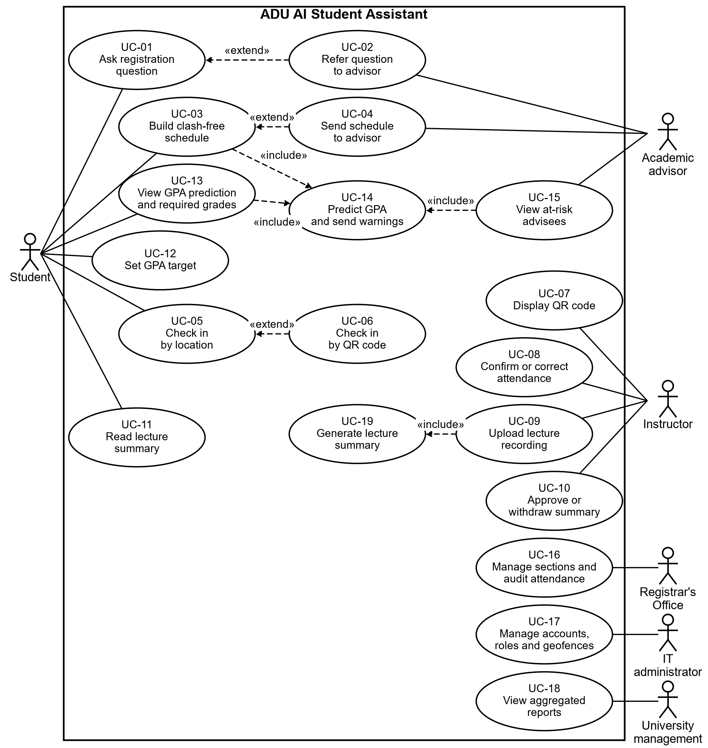
Figure 3. UML use case diagram of the ADU AI Student Assistant
14.2 Detailed Use Case Descriptions
Use Case 1: Build clash-free schedule
Field | Description
Use Case ID | UC-03 (FR1.3, FR1.4, FR1.5)
Primary Actor(s) | Student; simulated student information system as supporting actor
Goal / Description | The student gets a next-semester schedule with no clashes that respects prerequisites, the study plan and a safe credit load.
Preconditions | The student is logged in. The study plan, completed courses and next-semester sections are available.
Trigger | The student selects Plan next semester.
Main Success Scenario | 1. The system reads the study plan, completed courses, prerequisite rules and offered sections.  2. The system lists the eligible courses.  3. The system obtains the predicted GPA (UC-14) and sets the suggested credit load.  4. The student selects courses from the list.  5. The system builds a schedule with no time clashes.  6. The system shows the schedule with alternative sections.  7. The student saves the schedule and may send it to the advisor (UC-04).
Alternative / Exception Flows | 2a. No study plan or no eligible course is found: the system refers the student to the advisor (UC-02).  4a. The selection exceeds the credit limit for a student on probation: the system asks the student to remove a course.  5a. No clash-free combination exists: the system names the clashing courses and asks the student to change the selection.
Postconditions | A draft schedule is saved for the student. The student still registers through the portal.
Table 6. Use case description for UC-03
Use Case 2: Check in by location
Field | Description
Use Case ID | UC-05 (FR2.1, FR2.2, FR2.4)
Primary Actor(s) | Student; phone browser as supporting actor
Goal / Description | The student is recorded as present without a roll call.
Preconditions | The student is logged in and enrolled in the section, and the class-time window is open.
Trigger | The student taps Check in.
Main Success Scenario | 1. The system asks the browser for the location.  2. The student allows it.  3. The system checks the location against the building geofence.  4. The system stores the in-or-out result and discards the coordinates.  5. The system marks the student present and shows a confirmation.  6. The student appears on the instructor's list for the session.
Alternative / Exception Flows | 2a. The student declines: the system offers QR check-in (UC-06).  3a. The location is outside the geofence or unavailable: the system offers QR check-in (UC-06).  1a. The window is closed: the system refuses and tells the student to contact the instructor.  1b. The student has already checked in: the system shows the existing record.
Postconditions | An attendance record exists for the session, and the absence percentage is available to F3.
Table 7. Use case description for UC-05
Use Case 3: Upload lecture recording
Field | Description
Use Case ID | UC-09, including UC-19 (FR3.1 to FR3.4)
Primary Actor(s) | Instructor
Goal / Description | Students in the section receive a PDF summary of the lecture with its exam-focus points.
Preconditions | The instructor is logged in and teaches the section.
Trigger | The instructor selects a section and lecture date and uploads a recording.
Main Success Scenario | 1. The system validates the file and queues it.  2. Whisper transcribes the recording in the background.  3. The system deletes the audio within one hour of transcription.  4. The language model writes the summary and detects exam mentions with timestamps.  5. The system creates the PDF and notifies the instructor.  6. The instructor reviews and approves the draft (UC-10).  7. The system publishes the PDF to the section and notifies its students.
Alternative / Exception Flows | 1a. The file type is not supported: the system rejects it and lists the accepted types.  2a. Transcription fails: the system retries once, then tells the instructor and keeps the audio until the retry ends.  6a. The instructor withdraws the draft: the system deletes it and publishes nothing.
Postconditions | Only students of the section can read the summary. The audio no longer exists on the server.
Table 8. Use case description for UC-09
15. Requirements Specifications
The specifications below use the structured natural language form from the course [12], with shall for mandatory behaviour.
Spec ID | Req. ID | Specification
S1 | FR1.4 | Function: Build next-semester schedule.  Inputs: Selected courses (from the student); offered sections with days and times (from the database).  Action: For each selected course the system shall choose one section so that no two chosen sections overlap on the same day. If no combination exists, the system shall return the courses that clash.  Output: Schedule with up to two alternative sections per course (to the student).  Precondition: Every selected course is on the eligible list (FR1.3).  Postcondition: The draft schedule is saved. No registration record changes.
S2 | FR2.2 | Function: Record location check-in.  Inputs: Student ID, session ID, latitude and longitude (from the phone browser).  Action: IF the student is enrolled in the section AND the time is within the window AND the coordinates are inside the geofence, THEN the system shall store present. OTHERWISE the system shall store no present record and shall offer QR check-in.  Output: Confirmation or QR offer (to the student).  Precondition: The student allowed location for this check-in.  Postcondition: The coordinates are discarded in all cases.
S3 | FR3.7 | Function: Send GPA warning.  Inputs: Predicted GPA (from FR3.5); personal target between 2.0 and 4.0, if set (from FR3.6).  Action: WHEN a prediction is updated, IF the predicted GPA is below 2.0, the system shall warn the student and advisor. ELSE IF it is below the target, the system shall warn the student only. The system shall send no repeat warning unless the predicted GPA has dropped since the last one.  Output: Warning with the reasons and the required grade per course (FR3.8, FR3.9).  Precondition: At least one coursework grade exists this semester.  Postcondition: The warning and its date are stored.
Table 9. Structured natural language specifications
16. Requirements Traceability Matrix
Source shows the problem, document or Appendix A question behind each requirement. Modules and test IDs are planned, and the analysis, design and implementation references will be added in Phases 3 to 5.
Req. ID | Source | Use Case | Planned Module | Test ID
FR1.1 | P1, Q12 | UC-01 | src/advisor | TC-1.1
FR1.2 | P1, A.2 | UC-02 | src/advisor | TC-1.2
FR1.3 | P1, Q4 | UC-03 | src/advisor | TC-1.3
FR1.4 | P1, Q4 | UC-03 | src/advisor | TC-1.4
FR1.5 | [1], [8] | UC-03, UC-14 | src/advisor | TC-1.5
FR1.6 | P1, A.2 | UC-04 | src/advisor | TC-1.6
FR2.1 | P2, Q7 | UC-05 | src/attendance | TC-2.1
FR2.2 | P2, [3] | UC-05 | src/attendance | TC-2.2
FR2.3 | P2, [10] | UC-07 | src/attendance | TC-2.3
FR2.4 | Q7, [10] | UC-06 | src/attendance | TC-2.4
FR2.5 | P2, Q6 | UC-08 | src/attendance | TC-2.5
FR2.6 | [1] | UC-08 | src/attendance | TC-2.6
FR2.7 | Section 11 | UC-16 | src/attendance | TC-2.7
FR3.1 | P3, A.2 | UC-09 | src/study_assistant | TC-3.1
FR3.2 | P3, A.2 | UC-19 | src/study_assistant | TC-3.2
FR3.3 | P3, Q9, [11] | UC-19 | src/study_assistant | TC-3.3
FR3.4 | A.2 | UC-10, UC-11 | src/study_assistant | TC-3.4
FR3.5 | P3, Q10 | UC-14 | src/study_assistant | TC-3.5
FR3.6 | P3 | UC-12 | src/study_assistant | TC-3.6
FR3.7 | P3, Q11, [1] | UC-14 | src/study_assistant | TC-3.7
FR3.8 | P3 | UC-13 | src/study_assistant | TC-3.8
FR3.9 | Section 5 | UC-13 | src/study_assistant | TC-3.9
FR4.1 | Section 5 | All | shared | TC-4.1
FR4.2 | A.2 | UC-15 | shared | TC-4.2
FR4.3 | F1, F2 data | UC-16 | shared | TC-4.3
FR4.4 | Section 11 | UC-17 | shared | TC-4.4
FR4.5 | Section 11 | UC-18 | shared | TC-4.5
FR4.6 | Section 5 | All | shared | TC-4.6
NFR1 | Performance (FR2.1, FR2.2) | As FR | src/attendance | TC-N1
NFR2 | Performance (FR1.1) | As FR | src/advisor | TC-N2
NFR3 | Performance (FR1.4) | As FR | src/advisor | TC-N3
NFR4 | Performance (FR3.2, FR3.3) | As FR | src/study_assistant | TC-N4
NFR5 | Accuracy (FR1.1) | As FR | src/advisor | TC-N5
NFR6 | Accuracy (FR3.5) | As FR | src/study_assistant | TC-N6
NFR7 | Accuracy (FR3.3) | As FR | src/study_assistant | TC-N7
NFR8 | Accuracy (FR2.2) | As FR | src/attendance | TC-N8
NFR9 | Security (FR4.1, FR2.3) | As FR | shared | TC-N9
NFR10 | Security (FR4.1, FR4.2) | As FR | shared | TC-N10
NFR11 | Privacy (FR2.2, FR3.2) | As FR | shared | TC-N11
NFR12 | Fairness (FR3.5) | As FR | src/study_assistant | TC-N12
NFR13 | Usability (FR2.1, FR2.4) | As FR | src/attendance | TC-N13
NFR14 | Accessibility (FR4.6) | As FR | shared | TC-N14
NFR15 | Reliability (FR2.1, FR1.1) | As FR | shared | TC-N15
NFR16 | Maintainability (All) | As FR | tests | TC-N16
NFR17 | Constraint (All) | As FR | shared | TC-N17
Table 10. Requirements traceability matrix (without weight)
References
[1] Abu Dhabi University, "Undergraduate Student Handbook," p. 53. [Online]. Available: https://cdn.adu.ac.ae/flipbooks/UGHandbook/files/basic-html/page53.html. Accessed: Sep. 28, 2026.
[2] NACADA: The Global Community for Academic Advising, "Advisor to student ratio/caseload resources," NACADA Clearinghouse. [Online]. Available: https://nacada.ksu.edu/Resources/Clearinghouse/View-Articles/Advisor-to-Student-Ratio-Caseload-Resources.aspx. Accessed: Sep. 28, 2026.
[3] United Arab Emirates, Federal Decree-Law No. 45 of 2021 on the Protection of Personal Data. [Online]. Available: https://u.ae/en/about-the-uae/digital-uae/data/data-protection-laws. Accessed: Sep. 28, 2026.
[4] Ellucian, "Ellucian Degree Works," product brochure. [Online]. Available: https://www.ellucian.com/assets/emea-ap/brochure/emea-ellucian-degree-works.pdf. Accessed: Sep. 28, 2026.
[5] EAB, "Navigate360." [Online]. Available: https://eab.com/solutions/navigate360/. Accessed: Sep. 28, 2026.
[6] Georgia State University, "GPS Advising." [Online]. Available: https://success.gsu.edu/gps-advising/. Accessed: Sep. 28, 2026.
[7] Association of Governing Boards of Universities and Colleges, "Case Study: Georgia State University." [Online]. Available: https://agb.org/wp-content/uploads/2019/01/case_study_innovation_georgia.pdf. Accessed: Sep. 28, 2026.
[8] Georgia State University, "Reduction of Summer Melt." [Online]. Available: https://success.gsu.edu/reduction-of-summer-melt/. Accessed: Sep. 28, 2026.
[9] Top Hat, "Class Attendance & Attendance Tracking Software." [Online]. Available: https://tophat.com/features/attendance/. Accessed: Sep. 28, 2026.
[10] Indiana University Center for Innovative Teaching and Learning, "Accurate Attendance & Participation with Top Hat." [Online]. Available: https://citl.indiana.edu/teaching-resources/academic-integrity/tophat-attendance/index.html. Accessed: Sep. 28, 2026.
[11] Otter.ai, "Lecture Notes: Real-time for Students & Teachers." [Online]. Available: https://otter.ai/education. Accessed: Sep. 28, 2026.
[12] I. Sommerville, Software Engineering, 10th ed. Pearson, 2015, ch. 4.
[13] World Wide Web Consortium, "Web Content Accessibility Guidelines (WCAG) 2.1." [Online]. Available: https://www.w3.org/TR/WCAG21/. Accessed: Oct. 31, 2026.
Appendix A: Requirements Elicitation Instruments
A.1 Student Questionnaire
1. What is your program and year of study? [drop-down list]
2. How many times per semester do you meet your academic advisor? [0 / 1 / 2 / 3 or more] (P1)
3. How easy is it to get an advisor appointment during registration? [1 = very difficult to 5 = very easy] (P1)
4. Have you ever registered for a course that clashed with another class or was missing a prerequisite? [Clash / Missing prerequisite / Both / No] (P1)
5. How many minutes does the attendance roll call take in your lectures? [Less than 2 / 2 to 5 / 5 to 10 / More than 10] (P2)
6. Have you ever been marked absent by mistake? [Yes / No / Not sure] (P2)
7. Would you allow the portal to check your location once, at the start of class, to record your attendance? [Yes / Yes, if a QR option exists / No] (P2)
8. When you miss a lecture or revise for an exam, how do you find out what the instructor said was important? [Classmates / Slides only / Ask the instructor / I do not / Other] (P3)
9. How useful would a PDF summary of each lecture that lists what the instructor said may appear in the exam be? [1 = not useful to 5 = very useful] (P3)
10. Do you know your expected GPA before final grades are posted? [Yes / Roughly / No] (P3)
11. Have you ever been on academic probation, or close to it, without noticing until late in the semester? [Yes / No / Prefer not to say] (P3)
12. How likely are you to use an assistant that answers registration questions at any time? [1 = very unlikely to 5 = very likely] (P1)
13. Any other comments or suggestions? [open answer]
A.2 Interview Questions for Advisors and Instructors
1. How many students do you advise, and how long does each registration meeting take?
2. What questions do students ask you most often, and how often are they about time clashes or prerequisites?
3. When do you usually find out that a student is struggling, and when is it too late to help?
4. How many minutes does taking attendance take in each of your lectures?
5. Would you allow your lectures to be recorded for a summary shared only with your section? What conditions would you set?

