Day 6th - 29th May 29, 2025

Bharath -113229047

Task 1:

RegEX Symbols in linux

List them down with description

**Regular experssions**

Basic Regular Expression Characters:

1. . (dot) - Matches any single character
2. ^ (caret) - Matches beginning of line
3. $ (dollar) - Matches end of line
4. * (asterisk) - Matches zero or more occurrences of previous character.
5. [] (brackets) - Matches any single character within brackets
6. [^] (caret in brackets) - Matches any single character NOT within brackets

Common Regular Expression Patterns:

1. [0-9] - Matches any digit
2. [a-z] - Matches any lowercase letter
3. [A-Z] - Matches any uppercase letter
4. [a-zA-Z] - Matches any letter
5. [a-zA-Z0-9] - Matches any alphanumeric character

Special Characters:

1. \ - Escape character
2. \w - Matches word characters [a-zA-Z0-9_]
3. \W - Matches non-word characters
4. \d - Matches digits [0-9]
5. \D - Matches non-digits
6. \s - Matches whitespace (space, tab, newline)
7. \S - Matches non-whitespace

Quantifiers:

1. ? - Matches 0 or 1 occurrence
2. * - Matches 0 or more occurrences
3. + - Matches 1 or more occurrences
4. {n} - Matches exactly n occurrences
5. {n,} - Matches n or more occurrences
6. {n,m} - Matches between n and m occurrences

Task 2:

What are the imp features of Linux os ?

Features Of Linux

* Open Source: Linux is developed collaboratively by a global community of developers and is freely available to use, modify, and distribute.
* Stability and Reliability: Linux is known for its stability and reliability, making it a popular choice for servers and mission-critical systems.
* Security: Linux is inherently more secure than some other operating systems due to its robust permissions system and the availability of frequent security updates.
* Customizability and Flexibility: Linux offers a high degree of customization, allowing users to tailor their operating system to their specific needs and preferences. Linux is highly customizable, which means that users can modify the system to suit their needs.
* Performance: Linux is often more efficient in terms of resource usage, making it suitable for running on older hardware or in resource-constrained environments.
* Compatibility: Linux supports a wide range of hardware architectures and file systems, making it versatile and adaptable to various use cases.

Task 3:

WHAT IS Kernal and can you explain its functions

A Kernel is the core component of an operating system that acts as a bridge between computer hardware and software.

Key Functions:

Memory Management: Controls and allocates memory to different programs

Process Management: Schedules and manages running processes

Device Management: Handles communication with hardware devices

File System Management: Controls file storage and access

Security: Provides security and access control

Task 4:

What is BASH? Full form with explaination.

BASH - Bourne Again SHell

Full Form: Bourne Again SHell

BASH is a command-line interpreter and scripting language for Unix-like operating systems. It's a successor to the original Bourne Shell (sh), hence the name is "Bourne Again."

Key features:

Default shell for most Linux distributions and older macOS versions

Allows users to interact with the operating system through text commands

Supports scripting with variables, loops, conditionals, and functions

Provides command history, tab completion, and wildcards

Created by Brian Fox for the GNU Project in 1989

BASH is powerful for both everyday system tasks and complex automation through shell scripts.

Task 5

What is the diffrenece between window and linux

**Linux:**

* Ownership: Open-source operating system with community development
* Cost: Free to download, install and distribute
* Architecture: Unix-based, modular kernel design
* Interface: Multiple desktop environments available (GNOME, KDE, XFCE, etc.)
* Terminal: Powerful command-line interface central to operation
* Security: Granular permission system; less targeted by malware
* Updates: Can update most components without system restart
* Software: Package managers for centralized software installation
* Customization: Highly configurable at all levels
* Primary Use Cases: Servers, development work, technical computing

**Windows:**

* Ownership: Proprietary operating system owned by Microsoft
* Cost: Requires paid licensing
* Architecture: NT kernel with monolithic design
* Interface: Standardized GUI with limited desktop environment options
* Terminal: Command prompt/PowerShell less central to everyday use
* Security: User Account Control system; frequent target for malware
* Updates: Often requires system restarts to complete updates
* Software: Direct installation of .exe/.msi application files
* Customization: Limited to options provided by the system
* Primary Use Cases: Business environments, gaming, general consumer use

| **S. No** | **Linux** | **Windows** |
| --- | --- | --- |
| 1. | Linux is an **open-source** operating system. | Windows is **not** an open-source operating system. |
| 2. | Linux is **free of cost**. | Windows is **paid** and requires a license. |
| 3. | **File names are case-sensitive**, meaning file.txt and File.txt are different. | **File names are case-insensitive**, meaning file.txt and File.txt are treated the same. |
| 4. | Uses a **monolithic kernel**. | Uses a **hybrid kernel**. |
| 5. | **More efficient and stable**, especially for servers and developers. | **Less efficient** due to resource-intensive processes. |
| 6. | Uses **forward slash (/)** for directory separation. | Uses **backslash (\)** for directory separation. |
| 7. | **More secure** with better user control and fewer vulnerabilities. | **Less secure** due to higher susceptibility to malware and viruses. |
| 8. | Preferred by **hackers and security experts** due to its open-source nature and control. | **Not widely used for hacking** as it lacks built-in security tools. |
| 9. | Has **3 types of user accounts**: (1) Regular, (2) Root, (3) Service Account. | Has **4 types of user accounts**: (1) Administrator, (2) Standard, (3) Child, (4) Guest. |
| 10. | **Root user** has all administrative privileges. | **Administrator user** has all administrative privileges. |
| 11. | In Linux, you **can have two files with the same name** but different cases (File.txt and file.txt). | In Windows, **you cannot have two files with the same name** in the same folder. |

Task 6:

Define the basic components of Linux

1. Kernel

The core of the Linux operating system

Manages hardware resources and system calls

Controls memory, processes, file systems, and device drivers

2. Shell

Command-line interface to interact with the kernel

Interprets user commands and executes programs

Examples: Bash, Zsh, Fish

3. File System

Hierarchical structure where everything is treated as a file

Standard directories: /, /home, /etc, /bin, /var, etc.

Follows the Filesystem Hierarchy Standard (FHS)

4. System Libraries

Shared code that applications use to access kernel functionality

Example: GNU C Library (glibc)

5. System Utilities

Essential tools and commands for system administration

Examples: coreutils (ls, cp, mv), grep, find, sed

6. Package Management System

Tools to install, update, and remove software

Examples: apt, dnf, pacman

7. Boot Loader

Program that loads the operating system during startup

Examples: GRUB, LILO

8. Init System

First process started by the kernel (PID 1)

Manages system services and startup processes

Examples: systemd, SysVinit

10.25 o 10.30

Task 7:

Is it legal to edit Kernal?

Yes, it is completely legal to edit the Linux kernel.

2 min 10.31 to 10.33

Task 8:

how many of you have gone through techadamy Linux plz raise ur hand

16 pax done out of 29

Can you explain LILO

ILO (Linux Loader) is a legacy boot loader used to load the Linux kernel into memory when a computer starts. It's a simple, reliable tool that was commonly used in the early days of Linux. When the computer boots, LILO displays a menu, allowing users to choose which operating system or kernel to start.

10.34 to 10.40 6 min

Task 9:

What is shell? How many shells are there and what are they ? can you explain.

What is a Shell?

A shell is a command-line interpreter that provides an interface between the user and the operating system kernel. It processes commands entered by the user and executes them.

Major Types of Shells

**Bourne Shell (sh)**

Original Unix shell developed by Stephen Bourne

Foundation for many other shells

**Bash (Bourne Again SHell)**

Enhanced version of the Bourne shell

Default on most Linux distributions

Includes command history, tab completion, aliases

**C Shell (csh)**

Syntax similar to C programming language

Introduced history and job control features

**Korn Shell (ksh)**

Combines features from Bourne and C shells

Enhanced scripting capabilities

**Z Shell (zsh)**

Highly customizable with powerful features

Default in macOS since Catalina

Excellent auto-completion and theming via oh-my-zsh

**Fish**

Modern, user-friendly shell

Features syntax highlighting and suggestions

10.41 to 10.51 10 min

Task 10:

What is Swap space ?

swap space acts as an extension of RAM, providing additional virtual memory when physical memory is full. It's a portion of the hard drive or a dedicated file that the system uses to temporarily store inactive processes or data when RAM is exhausted.

2 min 10.52 to 10.54

Task 11:

What is Mount ? how do you mount and unmount file system in Linux?

Mounting:

Mounting is the process of attaching a storage device or partition to a [directory](https://www.geeksforgeeks.org/structures-of-directory-in-operating-system/) or [mount point](https://www.geeksforgeeks.org/mount-command-in-linux-with-examples/) so that its contents can be accessed and managed by computer system users.

Unmounting:

Unmounting is the reverse mounting process where the storage device or partition is detached from the computer system. it is making its content no longer accessible until it is mounted again in the computer system.

Task 12:

What is chmod command ? how to use it?

The **chmod**, or *change mode*, command allows an administrator to set or modify a file’s permissions. Every **UNIX/Linux** file has an owner user and an owner group attached to it, and every file has permissions associated with it. The permissions are as follows: read, write, or execute

5 min

Task 13:

Can you add a new user account? Crate a new user in different ways and paste ss

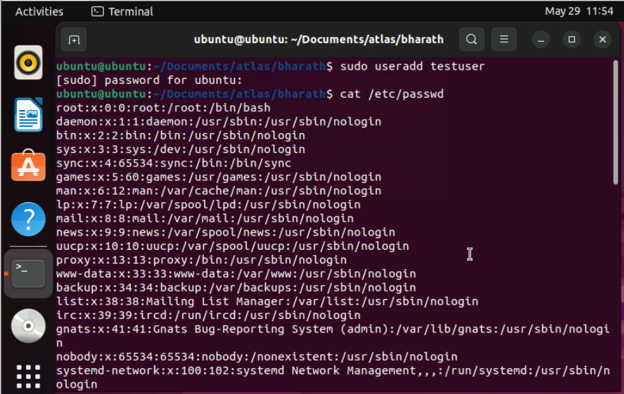

Task 14:

Can you change the password of a user?

How do you do that? Plz share ss

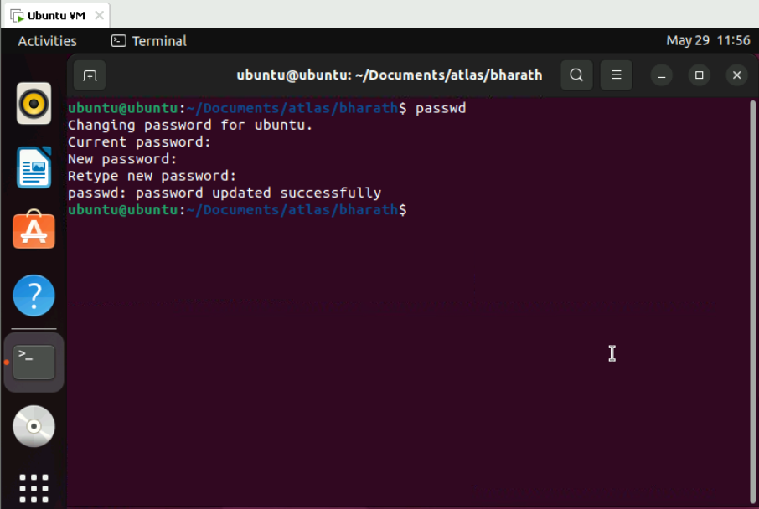

5 min

Task 15:

What is diff between Process and Thread?

**Process**

* Independent program execution instance
* Has its own memory space (completely isolated)
* Contains its own program counter, stack, and data segments
* More resource-intensive to create and switch between
* Higher overhead for inter-process communication
* Better isolation (one process crashing doesn't affect others)
* Example: Each application like browser, editor is a separate process

**Thread**

* Lightweight execution unit within a process
* Shares memory space with other threads in the same process
* Has its own stack but shares heap memory with other threads
* Less expensive to create and switch between
* Can communicate directly through shared memory
* Lower isolation (one thread crashing can bring down the whole process)
* Example: Web browser using multiple threads to load different page elements simultaneously

Task 16:Doc 14 Linux Grep commands .. plz work on it.. 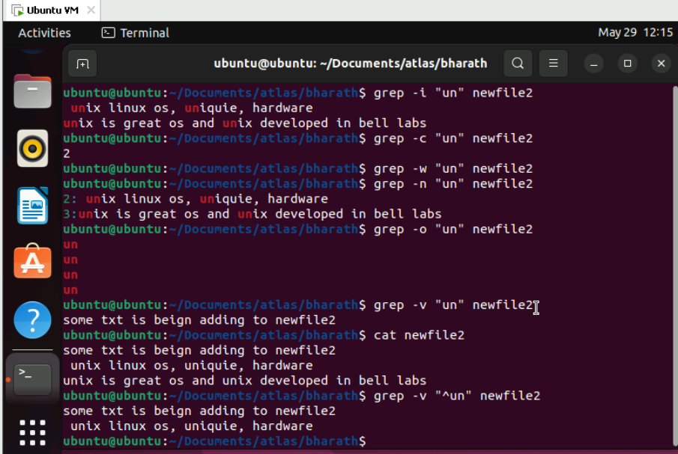

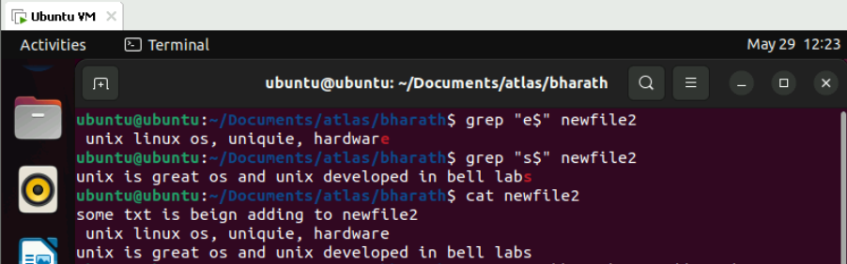

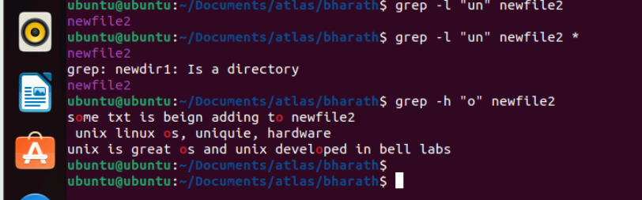



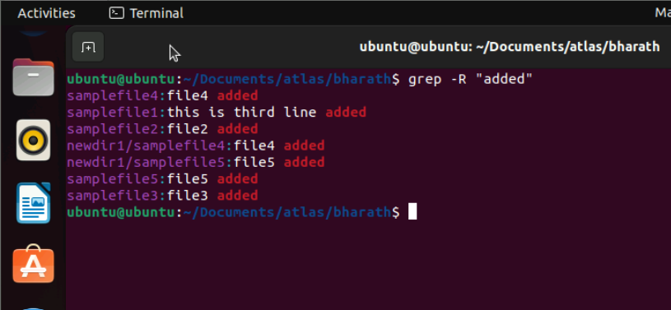

Task 17 AWK commands in doc 15 Linux AWK commands.. 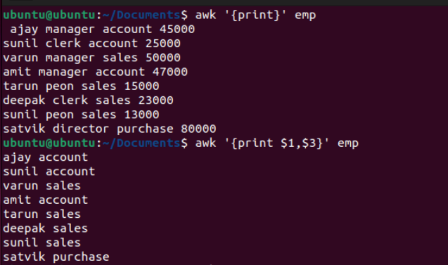

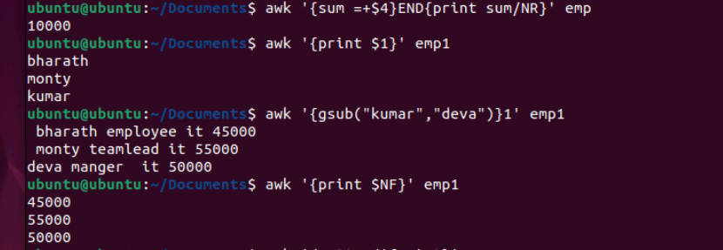

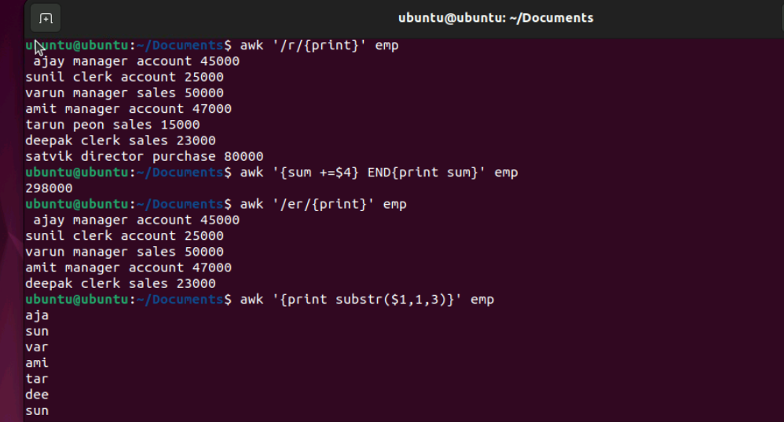

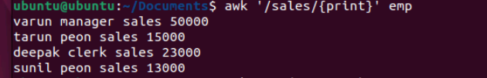

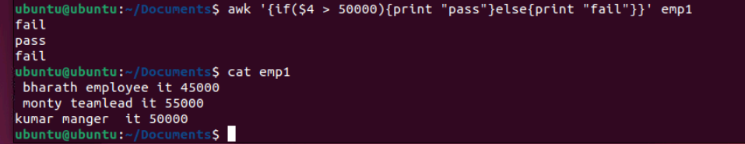



Task 18

How to check file access permission in Linux?

Hint use:

 Ls -l

Task 20:

What is the command to change the permisssion to read only for the owner, group and all other users

HInt: chmod 444 filename

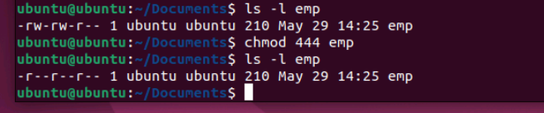

Task 19:

What are the default permissions for a new file ?

Plz find out for

Owner   → ?

Group → ?

All and others → ?

Default file permissions: 644 (rw-r--r--)

* Owner: read and write
* Group: read only
* Others: read only

Task 21:

Can you change the file permissions to match the following:

* owner: Read and Write
* group: Read
* other: no permissions (None)

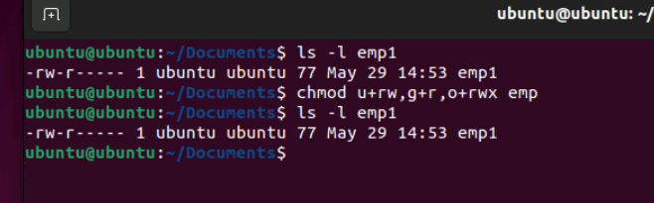

Task 22:

What was the command for changing the file permissions to -rw-r-----?

Hint : use chmod 640 filename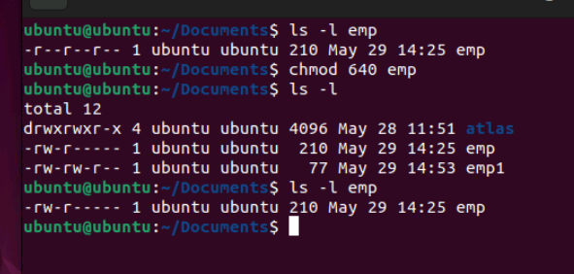

Task 23:

Change chmod.exercises permissions to -rwxr-x--x

Change the file permissions to match the following:

owner: Read, Write and Execute

group: Read and Execute

other: Execute

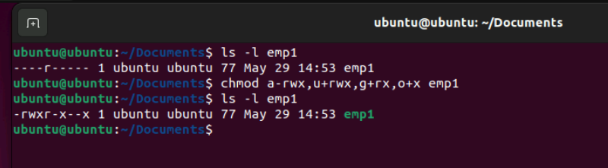

Task 24:

What was the command for changing the file permissions to -rwxr-x--x

Hint : use chmod 751 filename

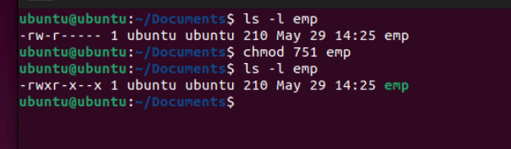

Task 25:

Guys what will this command do?

chown -c master file1.txt

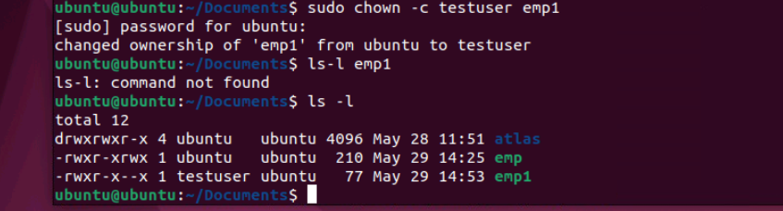

Task 26

Can you define what is  a process

A process is an instance of a program in execution. Each process has:

* A unique Process ID (PID)
* Its own memory space
* System resources allocation
* An execution state
* Security context (user/permissions)

Task 27:

What is command to check foreground process and background process

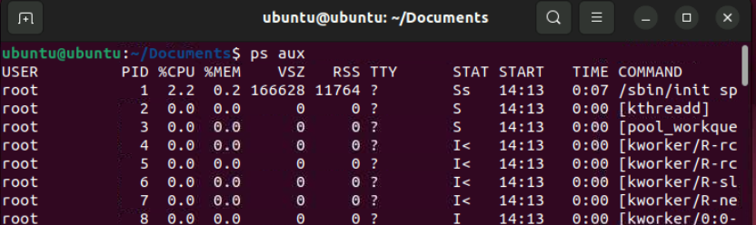

Task 28

Can you list all the running processes?

Hint use ps

Task 29

What will ps -f command do ? plz try n check .. ss required.

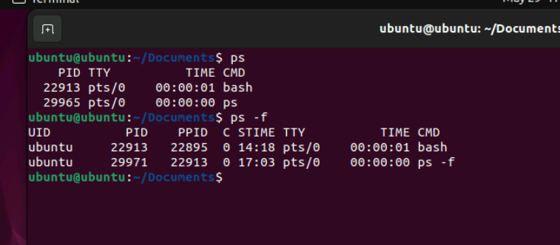

Task 30:

Can you createa  a variable name with your name in it

Ex:

Name =  “prasunamba”

Id  = 10001

And check

Echo $Name

Chek the output

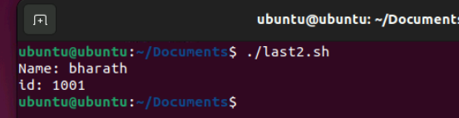

Task 31:

Can you make the above name variable read only..

Ex:

Name = “Prasunamba”

Readonly Name

Name = “Meher” —>what will this display.. Is it saying read only?? Pl check

Task 32:

Now will unset or delete the variables

Use the below command and check

Unset Name

Now check for

 echo $Name   —> this should not print anything.. Plz try also specify the reason

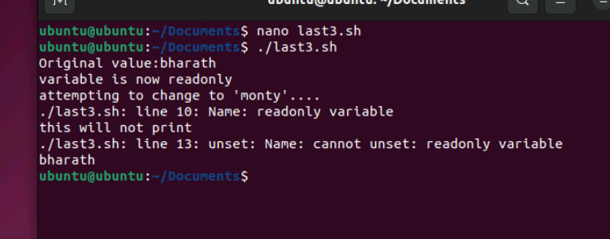

Task 33:

CAn u try to add a list of your friends names in an array and try to printout

Ex:

NAME[0]="Ram"

NAME[1]="Sita"

NAME[2]="Tina"

NAME[3]="Veena"

NAME[4]="Tim"

echo "First Index: ${NAME[0]}"

echo "Second Index: ${NAME[1]}"

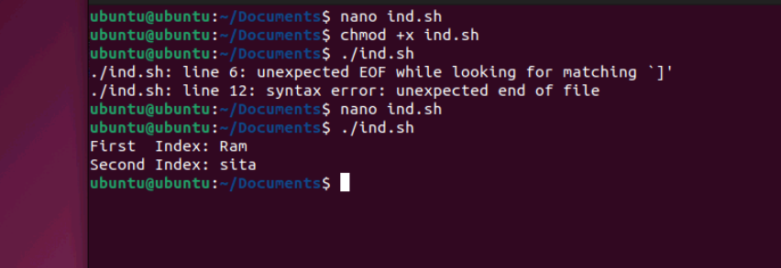

Task 34:

Can you print all the list at once in an array.. Try the below cmds and check

Echo “${array_name[*]}”

Echo “${array_name[@]}”

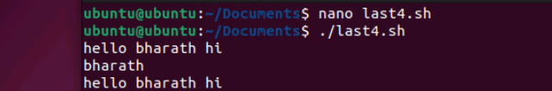

Task 35:

Plz let me know whats the output of the below snippet:

a=0

while [ "$a" -lt 10 ]    # this is loop1

do

   b="$a"

   while [ "$b" -ge 0 ]  # this is loop2

   do

      echo -n "$b "

      b=`expr $b - 1`

   done

   echo

   a=`expr $a + 1`

Done