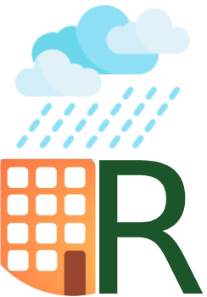

**Project Rainroof**

Website • Docs • Support us

## Overview

**Project Rainroof** is a [Rain water harvesting](https://en.wikiversity.org/wiki/Rainwater_harvesting) initiative started by Chandradeo Arya and his friends. The initiative's stated purpose is "mapping the planet's rain water harvesting potential, one roof at a time."

Project Rainroof, inspired by Project [Sunroof](https://www.google.com/get/sunroof) primarily works to encourage the private adoption of rain water harvesting by providing a set of tools to facilitate the purchase and installation of rain water harvesting systems. Using data from [Google Maps](https://en.wikipedia.org/wiki/Google_Maps) to calculate shadows from nearby structures and buildings and taking into account historical data of monsoon, rain, weather and temperature patterns, the Project Rainroof website calculates how much water a user can expect to save yearly by making use of rain water harvesting system. In addition, the Project Rainroof website also provides a list of local rain water harvesting retailers capable of installing rain water harvesting system in that area.

While initially launching only in the cities of Hyderabad, Bangalore, and [Chennai](https://en.wikipedia.org/wiki/Chennai), the project is planned eventually to expand nationally or even globally, depending upon the project's success in its launch areas.

## Why

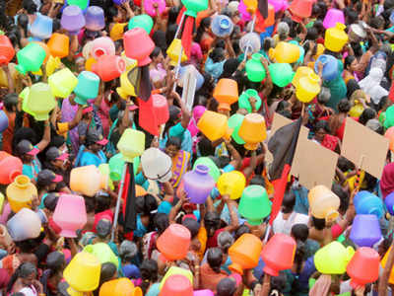

All major cities in India are facing acute shortage of water with Chennai being the worst this year. According to a report by NITI Aayog, 21 cities in India including Delhi, Bengaluru, Chennai and Hyderabad will run out of groundwater by 2020. This will affect around 100 million people. Government in all the states and center are working and making policies for the same with latest being GoI forming total new ministry for this Jal Shakti. In spite of almost all states in India having some rain water harvesting rules and policies, hardly anyone is actually followed. But as the awareness increases people are ready to adopt water saving methodologies.

## What

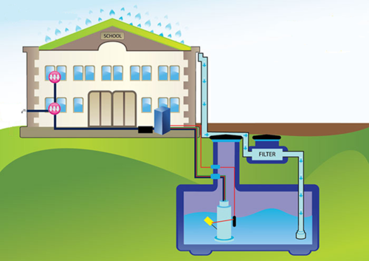

Rain water harvesting is the simple technique of saving rain water which can be either immediately used or sent to ground water. There is huge knowledge gap and know-how on starting rain water harvesting and its potentials. Our projects intends to answer three problems that a normal person faces if starting rain water harvesting.

1. What is RWH - one stop complete information about rain water harvesting.
2. How much water can you save - Using Google earth data we capture your rooftop area precisely and using historical monsoon and rainfall data we estimate how much water can you save for your family.
3. How to start - Complete DIY procedure of rain water harvesting or connecting you to local government authorised rain water harvesting experts from ministry of water.

## How

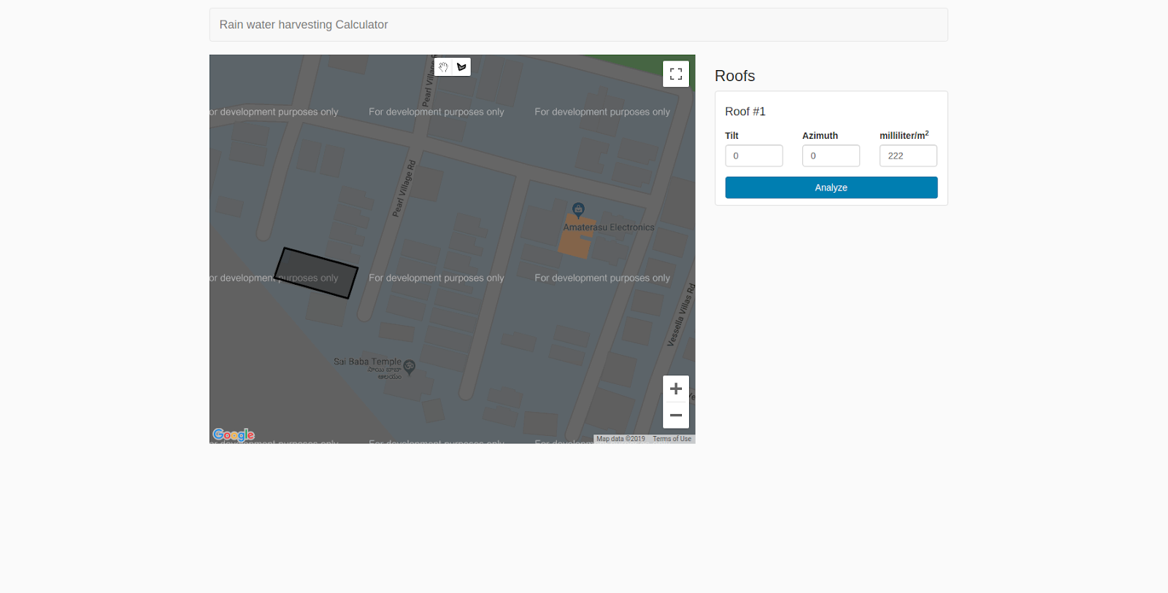

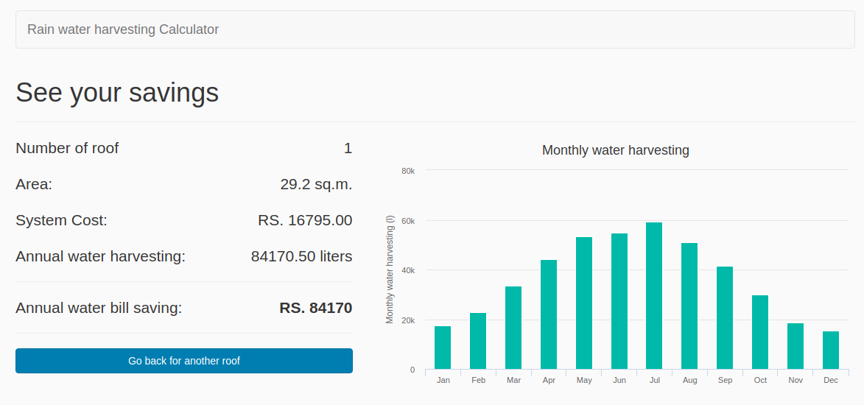

You just have to go to the portal which is under development and give your adress on Google maps. You have to point out your roof and give how many family members you are and what is your average daily usage. Based on that information portal will give you best estimated on how much water and hence money can be saved. We are looking for support in terms of financial and social and governmental outreach for its public adoption.

Contact us:

Chandradeo Arya

chandradeoaryaarya@gmail.com