

Production Release Document
(Digital PL)

(NEWGEN CONFIDENTIAL)

Newgen Software Technologies Ltd.
New Delhi, INDIA

Deployment Document-Digital Personal Loans

Prerequisite for the Deployment
- Admin Username and password to login in omniapp.
- WAS console username and password for deployment of war.
DataBase Activities:

- Execute ‘Master’ script shared in the release in DBScripts
- Execute ‘External Table’ script shared in the release.
- Execute ‘Masters’ script shared in the release.
- Execute ‘Procedures’ script shared in the release.

Route Registration:
- Login to Omniapp and Open Process Designer.
- Go to Local -> Import shared Digital_PL route.
- Digital_PL Process will be imported.

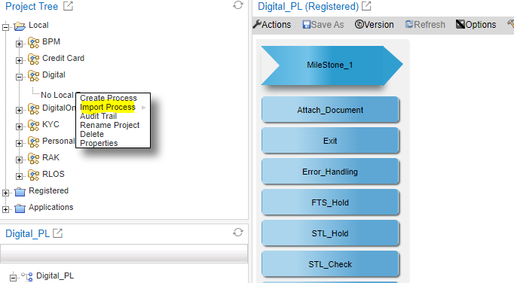

- Archival.
Insert Admin credentials on the above workstep
Archival Path : Digital/PL/&<WorkItemName>&

Associate Data Class : DPL_DataClass

Do the mapping of below listed document as given in the table.

Document Name | Archival Step
Passport_FirstPage | Archival
Passport_LastPage | Archival
Passport_AddressPage | Archival
Key_Facts_Statement | Archival
Terms_and_Conditions | Archival
EMID_Front | Archival
EMID_Back | Archival
MOI | Archival
Insurance_Terms_and_Conditions | Archival
DPL_STP_CAM_Report | Archival
FTS_Statement | Archival
FTS_Statement_Analysis | Archival
DPL_NON_STP_CAM_Report | Archival
DPL_Security_Cheque | Archival
DPL_W9Form | Archival
DPL_SalamContract | Archival
DPL_W8-Form | Archival
DPL_AGENCY_LETTER | Archival
DPL_OnePager | Archival
Digital_PL_KYC | Archival
Digital_PL_RiskScore | Archival
Other Document | Archival
STL | Archival
VISA | Archival
Entry_Currpassport | Archival
Entry_prevpassport | Archival
Pol_clearance | Archival
Marriage_cert | Archival
Mot_Fathersname | Archival
Wet_signature_form | Archival
Signature | Archival

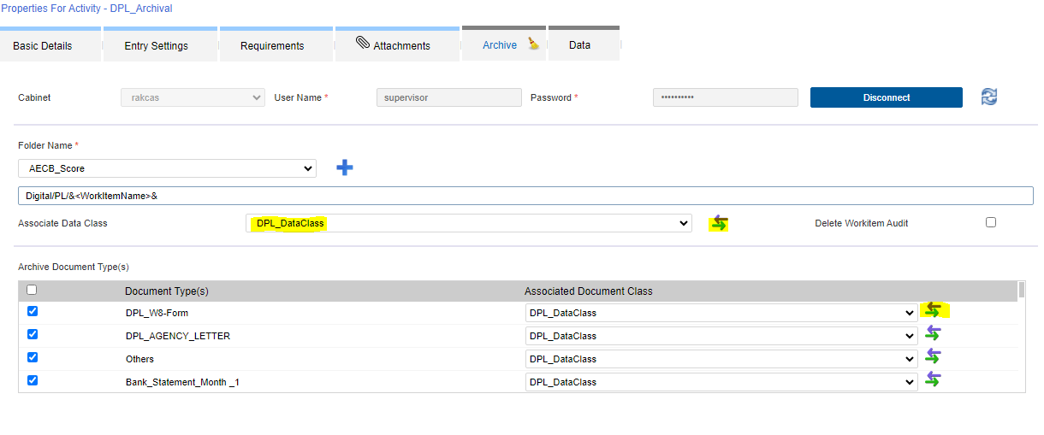

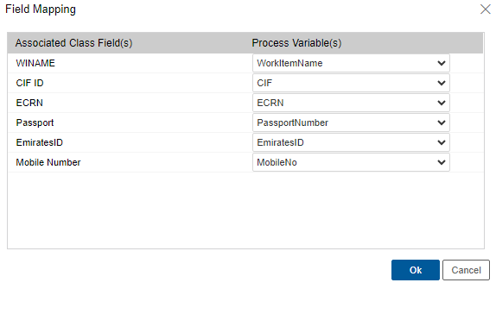
- Right Click on Digital_PL -> Check-in the Process.

WAS Console activity:

1. Deploy Digital_PL.war in WAS Console.

- Give Application Name as NBTL
- Reference Library: omnidocs_library & ibps_library& wfs_library;
- Context Root: /Digital_PL
- Manage Module: class loaded with local class loader first (parent last)

- Deploy client.js at following location ../webdesktop.war/resources/scripts.
- Update MQService_WICreateEjb at WAS console with shared ‘OmniflowWorkitemCreation.jar’ – to be done during downtime.

Perform Audit log configuration.

Perform queue group mapping as per the details available in pre-requisites.

- RAKDigitalIntegrationUtility

- Go to Services.msc and stop the RAKDigitalIntegrationUtility
- Replace the RAKDigitalIntegrationUtility.jar at D:\Newgen\Custom Utilities’ path.
- Go to Services.msc and Start RAKDigitalIntegrationUtility.
- Deploy the file provided in ‘DPL_Integration’ folder in release at path:
D:\Newgen\Custom Utilities\ RAKDigitalIntegrationUtility\DPL_Integration’

Note: Take Application Server (Linux) restart post clearing temp/wdtemp/wstemp.

- Generate Template Socket UAT

- Go to desktop to check if there is a running instance of Generate_Template, close it by pressing Ctrl+C
- Replace the provided class files from com/newgen/generate to class file in path
‘D:\Custom Utilites\Generate Template Socket Code UAT\com\newgen\generate’.
- Deploy file provided in ‘Templates’ folder in the release at this ‘D:\Custom Utilites\Generate Template Socket Code UAT\ Templates’ location.

Internal Communication :

- To Email : EmailAddress
- From Email : applicationstatus@rakbank.ae
‎

Rollback Steps:
- Revert Utility jar (WI Creation Service) from Back up FROM IBM console .
- Revert Utility jar (ibps update contract rlos) from Back up FROM IBM console .
- Disable Process from process manager module.

DR Deployment
- Perform all application server related activities given in the release.
- Perform all service server related activities given in the release.

