Website: Antony’s Anime Reviews

Planning:

1. The purpose of this website is for me to review the anime that I have watched and keep track of the anime that I watched
2. Implication

* End-user considerations

The website should be easy to navigate around and simple to understand where everything is. Im going to address this by making the website layout simple so that the important information is display at the index page of my website so they don’t have to dig around the website it find it.

* Usability

Code log:

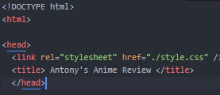

Added the title of the website a and also external css



The css for the title

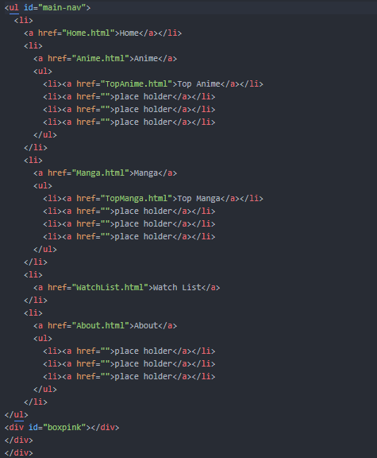

added the main drop down nav code. The nav is a list using ul and li tags and links.

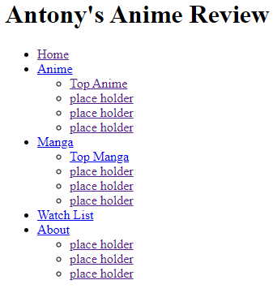

**This is what the nav looks like with out any css.**

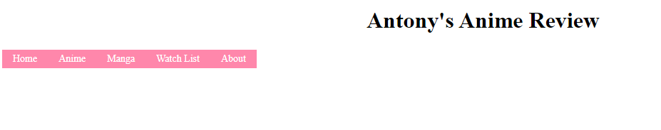

The navbar with css and the color theme of pink

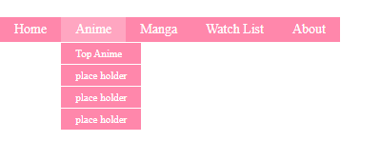

The drop down menu is working

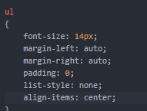

Trying to center the nav bar

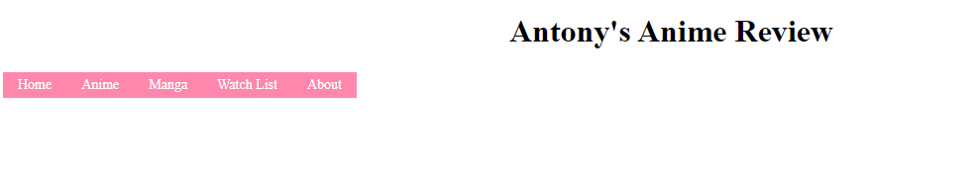but has not effect on the website and it doesn’t move it towards the center .

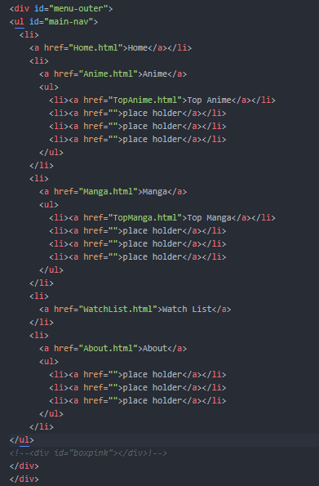



Then I tried to put the nav bar in a div and added a id and added margin on the left



Which moved the nav bar over closer to the middle

I found out that when you resized the window the title and the nav bar moves at a different rate and the titles stays at the middle

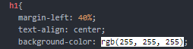

So I used margin left instead of text-align center

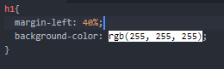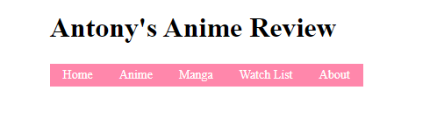

I set the margin-left one both element on 40%.

I got feed back that my nav bar font size is too small

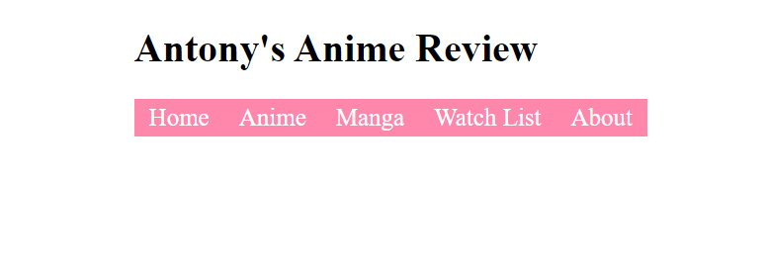

I increase the font size so its easier to read. I also got feed back from keegan that I should move my nav next to my header. So I put my nav and h1 into a header tag

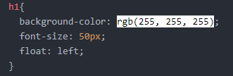

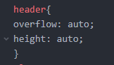I added float left on h1 and overflow auto on the header tag.



The nav and the header is next to each other but its doesn’t line up so I added padding top on ul to lower it so its lines up.

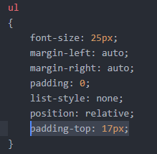





I found on issue where there is a gap between the drop down menu and because there is too much content it doesn’t fit in the header element

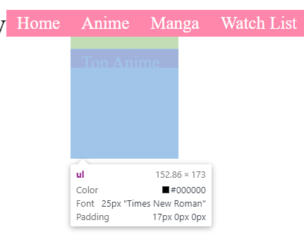

Using inspect element on google chrome I found out that there is padding at the top. 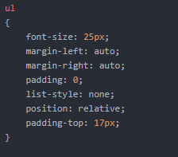

After checking my css file I found that the padding I used to line up the nav bar with the title appiled to all the ul tags which my drop down menu is inside of a ul tag.

 I added a id to the main nav bar ul so I can apply the padding to only that ul tag.

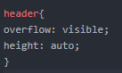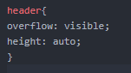

With the school bar issue I found out that because I set my overflow to auto which pick scroll with added a scroll bar so I just change it to visible so it extend it beyond the header element.

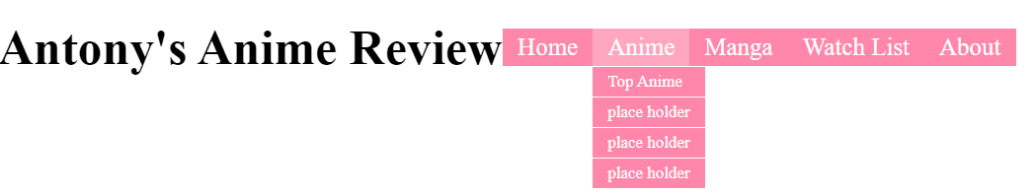

I also decrease the font size for the dropdown nav to show that theses are sub categories. 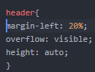 I added left margin to the header so that I would be in the center of the page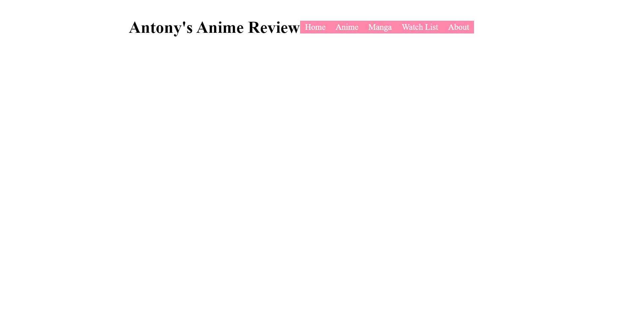

I added margin to the right of the title so there is some space between the title and the nav bar

