1. Circles Intersection

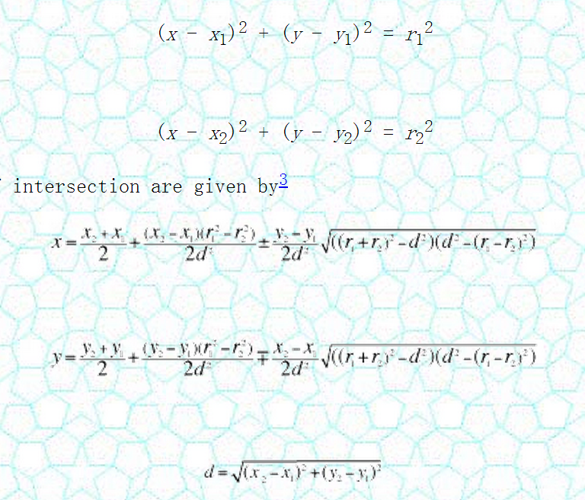

2. Forward Kinematics (Theta in degrees)

int delta_calcForward(float theta1, float theta2, float theta3, float &x0, float &y0, float &z0) {

float t = (f-e)*tan30/2;

float dtr = pi/(float)180.0;

theta1 *= dtr;

theta2 *= dtr;

theta3 *= dtr;

float y1 = -(t + rf*cos(theta1));

float z1 = -rf*sin(theta1);

float y2 = (t + rf*cos(theta2))*sin30;

float x2 = y2*tan60;

float z2 = -rf*sin(theta2);

float y3 = (t + rf*cos(theta3))*sin30;

float x3 = -y3*tan60;

float z3 = -rf*sin(theta3);

float dnm = (y2-y1)*x3-(y3-y1)*x2;

float w1 = y1*y1 + z1*z1;

float w2 = x2*x2 + y2*y2 + z2*z2;

float w3 = x3*x3 + y3*y3 + z3*z3;

// x = (a1*z + b1)/dnm

float a1 = (z2-z1)*(y3-y1)-(z3-z1)*(y2-y1);

float b1 = -((w2-w1)*(y3-y1)-(w3-w1)*(y2-y1))/2.0;

// y = (a2*z + b2)/dnm;

float a2 = -(z2-z1)*x3+(z3-z1)*x2;

float b2 = ((w2-w1)*x3 - (w3-w1)*x2)/2.0;

// a*z^2 + b*z + c = 0

float a = a1*a1 + a2*a2 + dnm*dnm;

float b = 2*(a1*b1 + a2*(b2-y1*dnm) - z1*dnm*dnm);

float c = (b2-y1*dnm)*(b2-y1*dnm) + b1*b1 + dnm*dnm*(z1*z1 - re*re);

// discriminant

float d = b*b - (float)4.0*a*c;

if (d < 0) return -1; // non-existing point

z0 = -(float)0.5*(b+sqrt(d))/a;

x0 = (a1*z0 + b1)/dnm;

y0 = (a2*z0 + b2)/dnm;

return 0;

}