22 February 2026
To whom it may concern,
This letter is to confirm that [Student Full Name] (Student ID: [Student ID Number]) is currently enrolled as a student at Macquarie University in [Program / Degree Name].
[He/She/They] is enrolled in the current teaching period and is an active student in good standing.
This letter is being provided to support [his/her/their] application for verification of student status where the student identification card may not display an expiry date.
Please accept this letter, together with the student’s Macquarie University identification [OIPTIONAL and supporting enrolment documentation (e.g., unofficial transcript)], as confirmation of current student status.
If you require any further information, please contact me at the details below.
Yours sincerely,
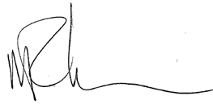
Michael J Richardson, Ph.D.
Professor
Director of Research
School of Psychological Sciences
Macquarie Univerisity
Faculty of Medince, Health and Human Sciences
michael.j.richardson@mq.edu.au
https://researchers.mq.edu.au/en/persons/michael-richardson/

