GDD

# Island Battle Royal

21129006 Clement XU

# Game presentation

## Game title

The game title is **Island Battle Royal.**

## Intended game systems (PC, Mobile, XBOX, PlayStation)

The game will be playable on pc

## Target age of players

Between 10 and 20 years old.

## Intended ESRB rating

## Projected ship date

The project will be fully completed by the by 12th November 2021

# Game outline

## Game story summary

One day, when we open our eyes, we notice that our appearance is that of a harmless rabbit in the middle of a ruin. Quickly enough, while exploring the surroundings, we notice that there are traces of combat, interactive objects that we don't know what use they are and finally other people in this ruin. So, we are not alone in this ruin, knowing that we rush to meet them but we discover that there are in fact other rabbits like us.

Unfortunately, it seems that these rabbits are not open to discussion and want to harm us. As soon as their eyes are on us, they rush towards us with great speed in order to tackle us as a rugby player makes us move back several meters.

Once at the edge of the ruins we don't know what's out there, everything is black, but something tells us that it's the end if we get out of the ruins, that's why in an excess of anxiety we dodge the rabbit which finds itself out of the ruins because of the momentum and disappears under our eyes. We are now certain of one thing: we must not leave the ruins in order to stay alive, and possibly kill all the other rabbits in order to live peacefully in the ruins and to have time to recover our memories peacefully.

## Game flow

### Game type

The game will present itself with a top-down view

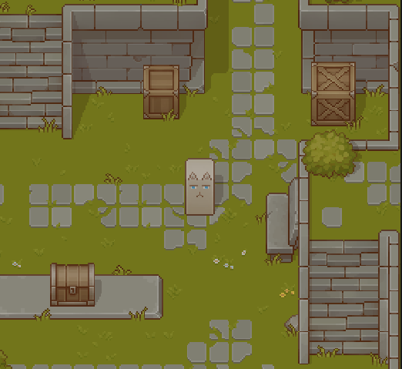

It will be played with 2 players on a single computer.

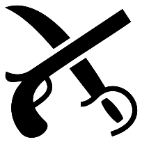The game will be of:

Exploration Action With a bit of Fright mixed in

The game will be a Battle royal

### Environment

The entire game will take place in and around the ruin

### Player’s Goal

As in all Battle Royal games, the players goal is to the last man standing.

### Challenges

Very quickly the player will be attacked by mob who will want to kill the player, so the player will have to quickly take these marks in the game and fight to survive.

Only when the player will have succeeded in killing all the mob around then he will have won, the main part of the game will be the fight against the mob that hunt the player.

As the mob will try to push the player out of the field, the player will have to push all the mob out of the field in order to win.

### Mob ability:

* The mob can move freely in the map
* The mob can push the player
* The mob can also interact with object in the map

### Progression

* The player becomes better as he learns the mob patterns
* The player can learn to use the objects on the card to gain an advantage.

### How does the story ties into the gameplay:

Depending on the vision of the story we have, we can have several visions of the game, either the player is a prey who is hunted and therefore tries to survive, or he is a predator who endangers a colony of rabbits who just want to defend their territory. That's why the game will be very much centered on the action of **pushing**.

### Victory conditions:

In order to win the player will have to push all the rabbits out of the map and be the last survivor.

# Characters

There is no real character except the rabbit played by the player

## Rabbit

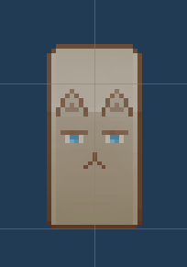

The rabbit is a bit deformed, it has a long cop and stands all the time. It also has a completely white neck but tinted yellow by dirt.

He can move by walking or running and has the ability to push things.

Having kept its natural prey reflexes it has very good instincts, and is very fearful.

# Controllers

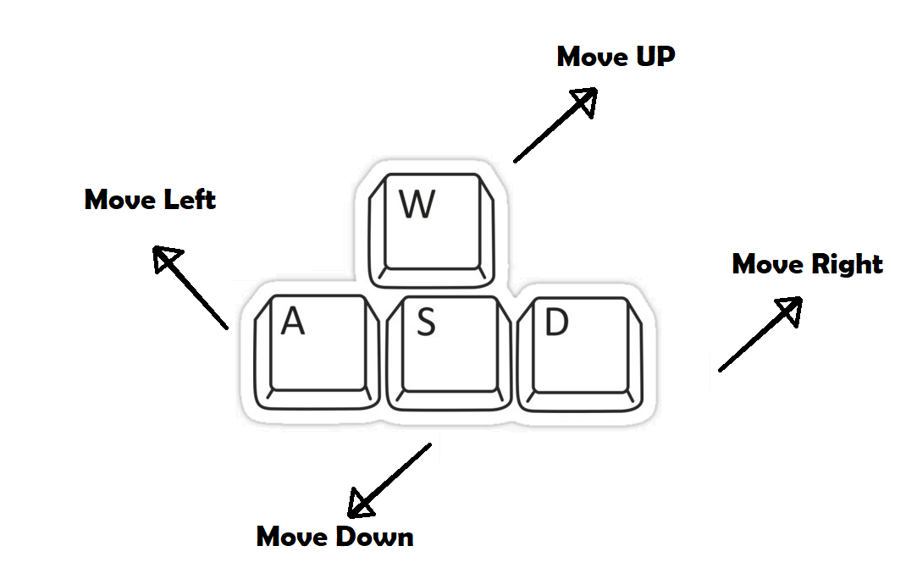

# Game Play

## Game type

The game will be a combination of multiple game type:

Action/exploration

The game will be oriented action and exploration

Horror

The game will be scary because of the mob and the oppreance

## Game Story

The game story will be entirely focus on the surviving of the player against the mob.

## Game action

The player will wander in the ruin in the first place, searching for the mob and trying to kill them by pushing them out of the map.

The mob will first be trying to find the player then they will also try to push the player outside the map in order to survive.

# Game World

The game will take place in a ruin plane in 2d abandon, it is composed of several layers with stairs leading upwards.

In this ruin there are many traces of battle we can presume that these traces have been left by a terrible war.

In this ruin several objects are present and can be pushed by the player or the mob.

There is absolutely nothing outside the ruins

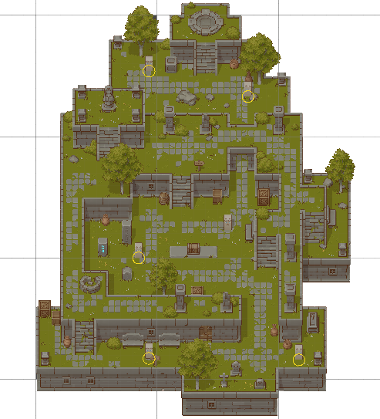

# Game Experience

The concept of the **game experience** encompasses not just gameplay, but the total package of what the game is and what it makes the player feel through its progression.

First and foremost, we recommend our players to relax and to play in quiet surroundings to make the experience more enjoyable. While starting a playthrough, the story begins with the player embodying a rabbit that explores the surroundings. The general “feeling” (mood) of the game while playing can be described in 3 main terms:

|  |  |  |
| --- | --- | --- |
|  |  |  |
| **Wariness** | **Surprise** | **Anticipation** |
| *Caution about possible dangers (Perhaps traps? ~)* | *Feeling of sudden wonder or astonishment, something unexpected or surprising* | *Preparation for something happening, or predicting something* |

These feelings are handled by the following way, a rollercoaster with high and low moments of tension:

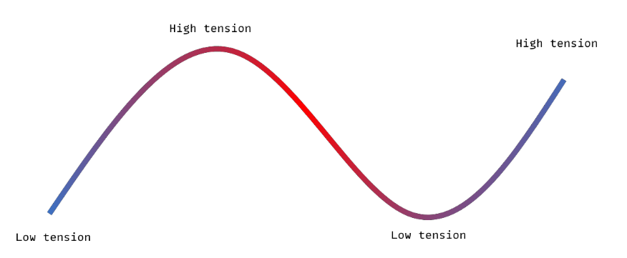

The atmosphere paired with the context of the game including music and sound effects makes the whole experience immersive.

# Game Play Mechanics

## Movement

Both Players will be able to move in the world in the 2 dimensions, in 8 directions.



Both players will have 2 movement state, walking and running.

When running, they can’t do anything else other than running.