**From:** Luo, Xiao Kai

**To:** AE 523

**Date:** 11-30-2016

**Subject:** Project 3: Flow over a Three-Element Airfoil

**Problem Description**

A first and second-order finite volume method needs to be implement to solve for the flow properties compressible, subsonic flow over a three-element, high-lift airfoil (see geometry of figure below). Postprocessing calculations include coefficient of forces, field contour of pressure and and Mach, streamlines, and convergence over iteration plots.

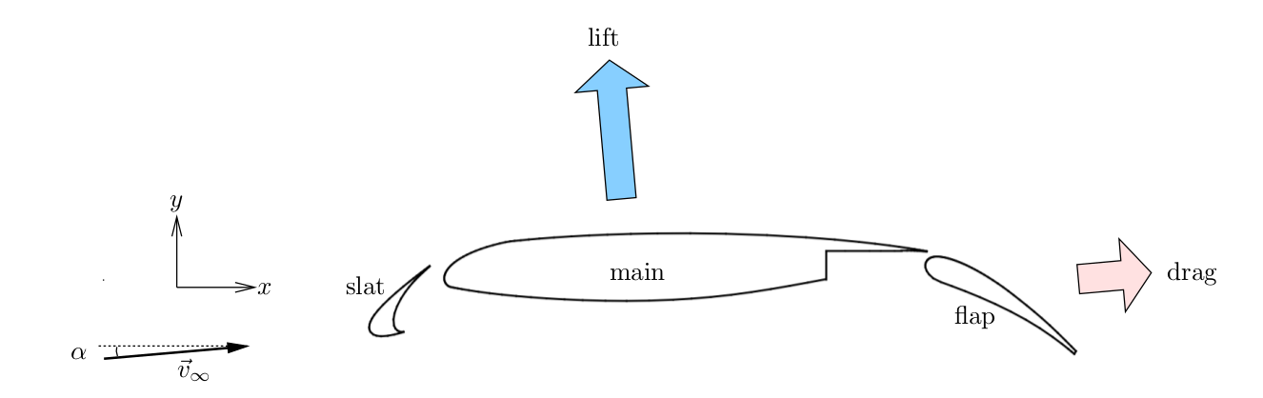Figure 1. Geometry and setup of the three-element, high-lift airfoil.

**Summary**

**PART 1: PROBLEM SETUP AND MESH**

**PART 2: MARCH TO STEADY STATE CONVERGENCE**

**PART 3: POSTPROCESSING**

**CONCLUSION**