**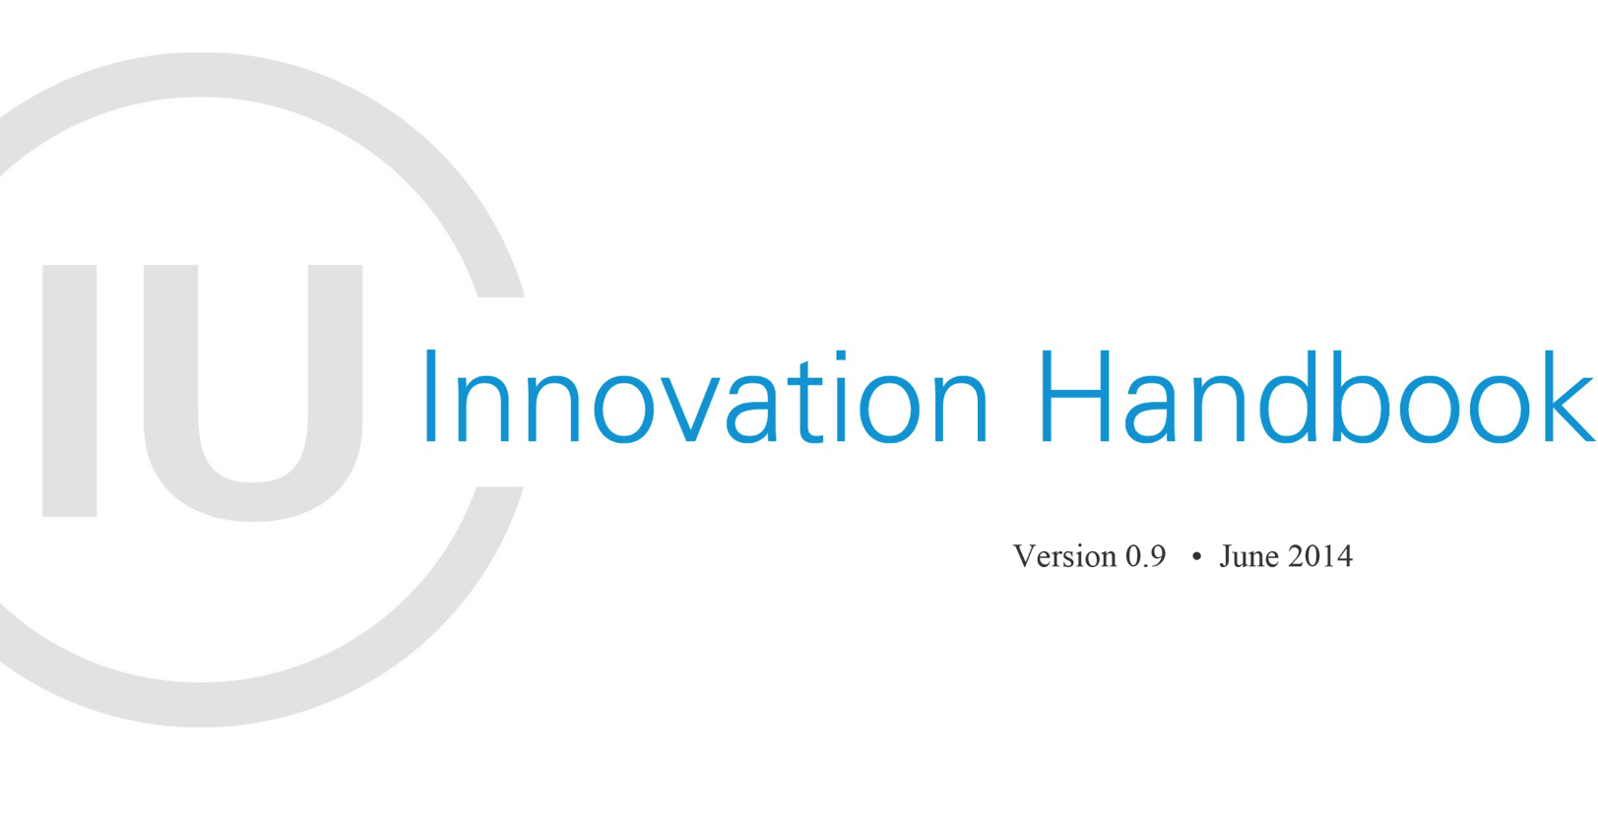**

The Innovation Handbook is a compilation of resources and tools that provide an overview of the innovation landscape across UNICEF. It includes information on the strategic approach, guiding principles, organizational support structures, current portfolio, future areas of focus, etc. The Handbook is intended to support UNICEF Country Offices and partners in accessing the most up-to date information, connecting to other Offices doing similar work, and developing plans for effectively integrating innovation into country programming.

Innovation Unit

Office of the Executive Director

UNICEF NYHQ

**TABLE OF CONTENTS**

I. Introduction 4

II. Definition and Key Principles 7

*Innovation in UNICEF is “doing something new or different that adds value.” There are nine key principles that UNICEF created to guide successful innovation work (agility, ability to fail, openness, etc.), and these have been endorsed or adopted by many other agencies and funders.*

III. Overview of Global Team Structures and Functions 9

*There is a small team in New York, which has members provided by various divisions and Country Offices, as well as other key teams in Copenhagen, Nairobi, and San Francisco. There are also 15 Innovation Labs in Country Offices in every region.*

IV. Current Innovation Portfolio 11

*Innovation projects in UNICEF are not necessarily technological in nature, but break into three key categories: gathering and using real-time information, engaging young people, and addressing fundamental infrastructure gaps.*

V. Future Areas of Focus 17

*UNICEF is convening a series of conversations around the intersection of high growth tech industries and social good, with particular focus on: future of money; identity; transportation; and wearable technologies.*

VI. Innovation Labs 18

*Innovation Labs are spaces in Country Offices that allow programme colleagues to create collaborations among young people, the private sector, government, and academia for solving local problems, with global implications.*

VII. Communications Resources 24

*UNICEF Innovation Unit tries to be as open and public as possible about communication –* [*www.unicefstories.org*](http://www.unicefstories.org) *is a blog that shares country successes and* [*www.unicef.org/innovate*](http://www.unicef.org/innovate) *is the global site for Innovation.*

**I. Introduction**

Fundamentally, UNICEF Innovation work has a focus on providing access to information, opportunity, and choice to the world's most vulnerable populations. This is an introduction to some of the projects that illustrate that focus.

The space between young people and power structures has fundamentally changed, and we believe that only by innovating in our work can UNICEF be truly prepared for the future. We see this change coming in many forms:

1) We know that real-time data will drive more decisions than anything else (not always for good) – that decisions, which are in any case not made on specifics of data, will be increasingly driven by trends of real-time "user" behavior. *Example:*[UReport Uganda](http://unicefstories.org/2013/09/19/u-report-empowers-230000-young-ugandans-tv-show-episode-1/) ([RapidSMS](https://www.rapidsms.org/)/[RapidPro](https://docs.google.com/document/d/17-z5_4KXjyJUFONT1XKHhRQah9W5yQUjSK2VIG0cnhY/edit?pli=1)family) empowers young people to work with community leaders to affect positive change.

2) A different picture of the world is emerging through mapping and the ability to "see" things that were previously hidden or obscured. Young people are becoming empowered to map the world around them – and these representations are new. In Kosovo, young innovators [mapped their microbus routes](http://unicefinnovation.org/projects/public-transportation-pristina" \t "_blank) with open source technology – making the invisible, or hard-to-describe, readily apparent.

3) There is a new ability for young people to connect to each other and counsel each other (through technology) that allows them to share and scale their own solutions, without "top down" or more traditional information flows. This impacts how UNICEF and our partners disseminate information – and, importantly, shows us the need for being an agent of transfer, moving ideas from one geography to another. *Example:* [UReport Zambia](http://unicefstories.org/2014/01/02/revolutionizing-hiv-response-among-adolescents-in-zambia-through-the-use-of-mobile-phones/) ([RapidSMS](https://www.rapidsms.org/)/[RapidPro](https://docs.google.com/document/d/17-z5_4KXjyJUFONT1XKHhRQah9W5yQUjSK2VIG0cnhY/edit?pli=1)family) provides 24/7 counseling services on HIV and STIs to adolescents and youth.

4) This "south-south" rapid transfer of ideas – sometimes excluding traditional development actors – means that we have to be able to share knowledge and possibilities in new and open ways. It means a changed role for large institutions – and increased need to create the pathways for idea transfer rather than the ideas themselves. *Example:* [RapidFTR](http://unicefstories.org/2013/12/31/rapidftr-an-app-for-reuniting-families-in-disaster-situations/" \t "_blank) (coming from South Sudan, Uganda, and going to the Philippines) is an app for reuniting families in disaster situations.

This means that not only do young people increasingly have a voice, but that voice can be used for change. *Example:*[Voices of Youth Maps / UNICEF-GIS in Brazil](http://unicefstories.org/2013/11/14/voices-of-youth-takes-digital-mapping-to-the-next-level/" \t "_blank) empower young people by training them to digitally map and participate in the improvement of their neighborhoods.

5) These types of global collaborations rely on new techniques for working together. The tools we have at our disposal, in 2014, can allow us to create the largest change-engine in the world – and power that through the energy and needs of young people. *Example:*

[Global Design for UNICEF Challenge](http://unicefstories.org/2014/02/26/building-the-next-generation-of-global-innovators/" \t "_blank) is an academic competition that gives students the opportunity to come up with innovative solutions to pressing development problems.

6) In order to build this machinery, we embrace open source ideas. Open source is the single biggest idea of this generation. It fundamentally changes how intellectual property can be used for global innovation for children. It creates public goods that can be adapted and scaled by anyone – and that have business models around them that can still foster entrepreneurship and profit. *Example:*[MobiStation](http://unicefstories.org/2014/01/07/unicef-pioneers-high-tech-education-for-marginalized-children/" \t "_blank) (China/Uganda Honghe partnership) is a solar powered school in a suitcase that provides access to quality learning content.

Finally,

7) We will need new models for investing in the type of solutions that we see on the horizon – we believe that new methods of investment and funding in low-liquidity markets are changing the way that the "global north" views previously marginalized economies. This runs the gamut from VC funds investing in new areas/regions to vehicles like social impact bonds that are providing different types of returns to investors. *Example:*[UNICEF Innovation Fund](http://unicefstories.org/model/innovationfund/" \t "_blank) has been modeled on venture investment structures that can quickly assess, invest in, and scale innovations that work.

However…

Infrastructure remains a challenge – human advances in information technology haven't impacted transport nearly as much as they have our ability to communicate. It still takes 33 days to send a piece of paper from northeast Zambia to Lusaka even though [Project Mwana](http://unicefstories.org/2014/03/24/reducing-medical-test-delays-from-30-days-to-30-seconds-part-2-of-4-innovation-in-zambia/" \t "_blank) ([RapidSMS](https://www.rapidsms.org/)/[RapidPro](https://docs.google.com/document/d/17-z5_4KXjyJUFONT1XKHhRQah9W5yQUjSK2VIG0cnhY/edit?pli=1)family) has reduced the *other* half of that journey from 30 days to 0, by using a text message.

In the space of energy, solar and alternative power will be one of the key drivers of development (and where it is lagging/lacking, so are development indicators). Models of producing and sharing electricity at a community level are emerging, and might be stymied by traditional actors. *Example:*[Project Lumiere in Burundi](https://www.youtube.com/watch?v=qen9QEeuO0w" \t "_blank) helps identify a scalable model for delivering household energy supply in isolated areas.

And emergencies and natural disasters are going to be even more critical to all of us, and we see UNICEF increasing the amount and intensity of its work in humanitarian situations.  How we respond, as a planet, to these changing realities will require everyone to work together toward common goals. *Examples:*[Global Innovation Challenge: First 72 Hours](http://www.first72hours.org/" \t "_blank) engages private individuals, academia, businesses, and organizations in coming up with ideas that will help to better respond to disasters. [Emergency Kit for Adolescents in Indonesia](http://unicefstories.org/2014/04/01/engaging-adolescents-and-youth-in-emergency-preparedness-and-response/" \t "_blank) focuses on building the capacity of youth to be self-empowered to address the risks associated in emergency situations.

Fundamental to all of this, is the question of learning: what adolescents have at their disposal to interact with the world around them – and we need to help suggest and provide those tools for them to interface with their future. Without a change in how kids learn, and what they're taught, none of the big global changes will have the impact on the world's most vulnerable populations that we need them to. *Examples:*[Khan Academy](https://medium.com/p/e11a72d3673a) built parts of the next version of their authoring platform in South Sudan. [Raspberry Pi for Learning Initiative (Pi4L) in Lebanon](http://unicefstories.org/2014/05/05/learning-anywhere-and-everywhere-with-raspberry-pi-technology/) uses innovative ways to provide non-formal education to displaced children. [Digital game contest in Brazil](http://unicefstories.org/2014/02/20/unicef-and-electronic-arts-introduce-sao-paulo-students-to-game-design-contest/" \t "_blank) combined education, football, video games, and the spirit of innovation.

This is the world of UNICEF's global innovation work in 2014. Thank you for joining us on our journey, and we look forward to shaping the future together.

Read more about our projects: [www.unicefstories.org](http://www.unicefstories.org/) and [www.unicefinnovation.org](http://www.unicefinnovation.org/).

**II. Definition and Key Principles**

For UNICEF,innovation is defined as doing something new or different that adds value, and can refer to processes, products, programmes, or partnerships. Integrating innovation into existing programming offers an opportunity to solve bottlenecks at large scale, with relatively small interventions.

UNICEF innovation work is built on a set of principles, which provide a common framework for working on innovation, and have been adopted by a number of partners both within and outside of the UN.[[1]](#footnote-1)

**PRINCIPLES**

|  |  |
| --- | --- |
| Design with the user | -Develop context appropriate solutions informed by user needs.  -Include all user groups in planning, development, implementation and assessment.  -Develop projects in an incremental and iterative manner.  -Design solutions that learn from and enhance existing workflows and plan for organizational adaptation.  -Ensure solutions are sensitive to, and useful for, the most marginalized populations: women, children, those with disabilities, and those affected by conflict and disaster. |
| Understand the existing ecosystem | -Participate in networks and communities of like-minded practitioners.  -Align to existing technological, legal, and regulatory policies. |
| Design for scale | -Design for scale from the start, and assess and mitigate dependencies that might limit ability to scale.  -Employ a “systems” approach to design, considering implications of design beyond an immediate project.  -Be replicable and customizable in other countries and contexts.  -Demonstrate impact before scaling a solution.  -Analyze all technology choices through the lens of national and regional scale.  -Factor in partnerships from the beginning and start early negotiations. |
| Build for sustainability | -Plan for sustainability from the start, including planning for long-term financial health, i.e. assessing total cost of ownership.  -Utilize and invest in local communities and developers by default and help catalyze their growth.  -Engage with local governments to ensure integration into national strategy and identify high-level government advocates. |
| Be data driven | -Design projects so that impact can be measured at discrete milestones with a focus on outcomes rather than outputs.  -Evaluate innovative solutions and areas where there are gaps in data and evidence.  -Use real-time information to monitor and inform management decisions at all levels.  -When possible, leverage data as a by-product of user actions and transactions for assessments. |
| Use open standards, open data, open source, and open innovation | -Adopt and expand existing open standards.  -Use open data and functionalities and expose them in documented APIs (Application Programming Interfaces) where use by a larger community is possible.  -Invest in software as a public good.  -Develop software to be open source *by default* with the code made available in public repositories and supported through developer communities. |
| Reuse and improve | -Use, modify and extend existing tools, platforms, and frameworks when possible.  -Develop in modular ways, favoring approaches that are interoperable over those that are monolithic by design. |
| Do no harm | -Assess and mitigate risks to the security of users and their data.  -Consider the context and needs for privacy of personally identifiable information when designing solutions and mitigate accordingly.  -Ensure equity and fairness in co-creation, and protect the best interests of the end-users. |
| Be collaborative | -Engage diverse expertise across disciplines and industries at all stages.  -Work across sector silos to create coordinated and more holistic approaches.  -Document work, results, processes and best practices and share them widely.  -Publish materials under a Creative Commons license by default, with strong rationale if another licensing approach is taken. |

**III. Overview of Global Team Structures and Functions**

One goal of UNICEF Innovation is to mainstream the skills and competencies of innovation across the organization. We recommend that innovation focal points and leads come from existing staff rather than be created as additional roles.

The Innovation Unit in NY is tasked with supporting Country Offices in identifying this talent, providing the training and connections to other partners to create additional skills, and working with Programme Division to provide technical support to Country Offices for thematic innovation work.

**Who we are:**

UNICEF Innovation is an interdisciplinary team of individuals around the world tasked with identifying, prototyping, and scaling technologies and practices that strengthen UNICEF’s work. UNICEF Innovation is comprised of:

* An **Innovation Unit in New York** that supports UNICEF programmes on the ground and the organization at large through integration of technology, design thinking, and partnerships with the private sector and academia. This team is two staff members, with other members being provided from various parts of Programme, EMOPS, and other divisions;
* An **Innovation Center in Nairobi** that identifies and field tests scalable innovations;
* A **node in San Francisco** that builds partnerships with the technology sector and will help scale social innovation startups;
* A **Supply Innovation Unit in Copenhagen**, which works closely with private sector and other partners on supply and product innovation;
* A **network of 14 Innovation Labs around the world** (from Armenia to Zambia) that bring together the private sector, academia, and the public sector to develop solutions to key social issues, and ensure that we are always watching for new ideas from unexpected places; and
* **Regional Office Leads** in East Africa, Latin America, and soon East Asia/Pacific who help add a regional perspective and support work in Country Offices.

**What we do:**

Since 2007, UNICEF Innovation has worked with partners to develop open-source technologies that have:

* [Reported over 18 million births in Nigeria](http://unicefstories.org/2012/10/17/nigeria-using-rapidsms-for-birth-registration/) over a 20 month period;
* [Provided antenatal care to thousands of pregnant women across Rwanda](http://unicefstories.org/2013/11/13/the-mobile-phone-rwandas-key-weapon-in-making-maternal-deaths-history/);
* Tracked the distribution of more than 25 million mosquito nets in Nigeria;
* Provided a direct, real-time feedback loop for more than 250,000 [young Ugandans to engage with their government](http://unicefstories.org/tools/ureport/" \t "_blank) and change policy;
* Mentored and supported more than 1,000 youth entrepreneurship projects in Kosovo; and
* Supported innovations in learning in emergencies in Lebanon.

The [principles](http://unicefstories.org/principles/) that underpin our work, including open collaboration and learning from fast failures, have informed our successes and been built from our failures.

**IV. Current Innovation Portfolio**

UNICEF Innovation recently conducted a global mapping of innovations, with more than 300 project entries from Country Offices around the world tackling problems dealing with health, HIV/AIDS, nutrition, water and sanitation, education, protection, emergencies and other needs.

The main areas of focus are real-time data, infrastructure, logistics, and personal information. A surface analysis of some of these areas is included below, while the specific project examples associated with each are described in more detail in the next section.

The global map is by no means comprehensive and is being updated daily. You can view it at [http://cdb.io/1n9xIAa](http://cdb.io/1n9xIAa" \t "_blank)​​​ and add your projects to <http://goo.gl/l5F82U>.

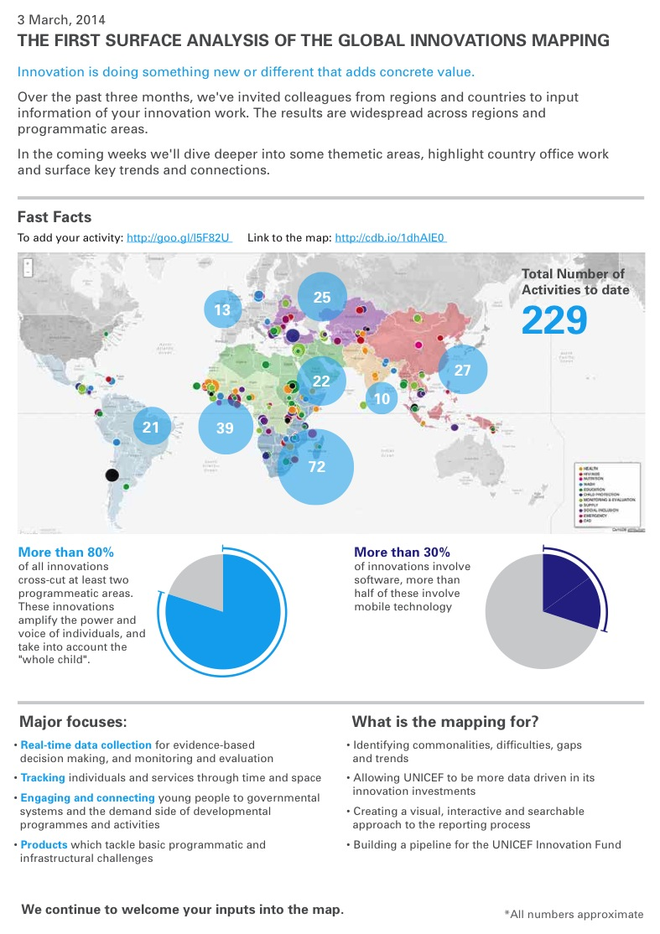

Macintosh HD:Users:mimastojanovic:Desktop:-DOCS-:Global Mapping #2.pdf

Macintosh HD:Users:mimastojanovic:Desktop:Global Mapping 2nd page.pdf

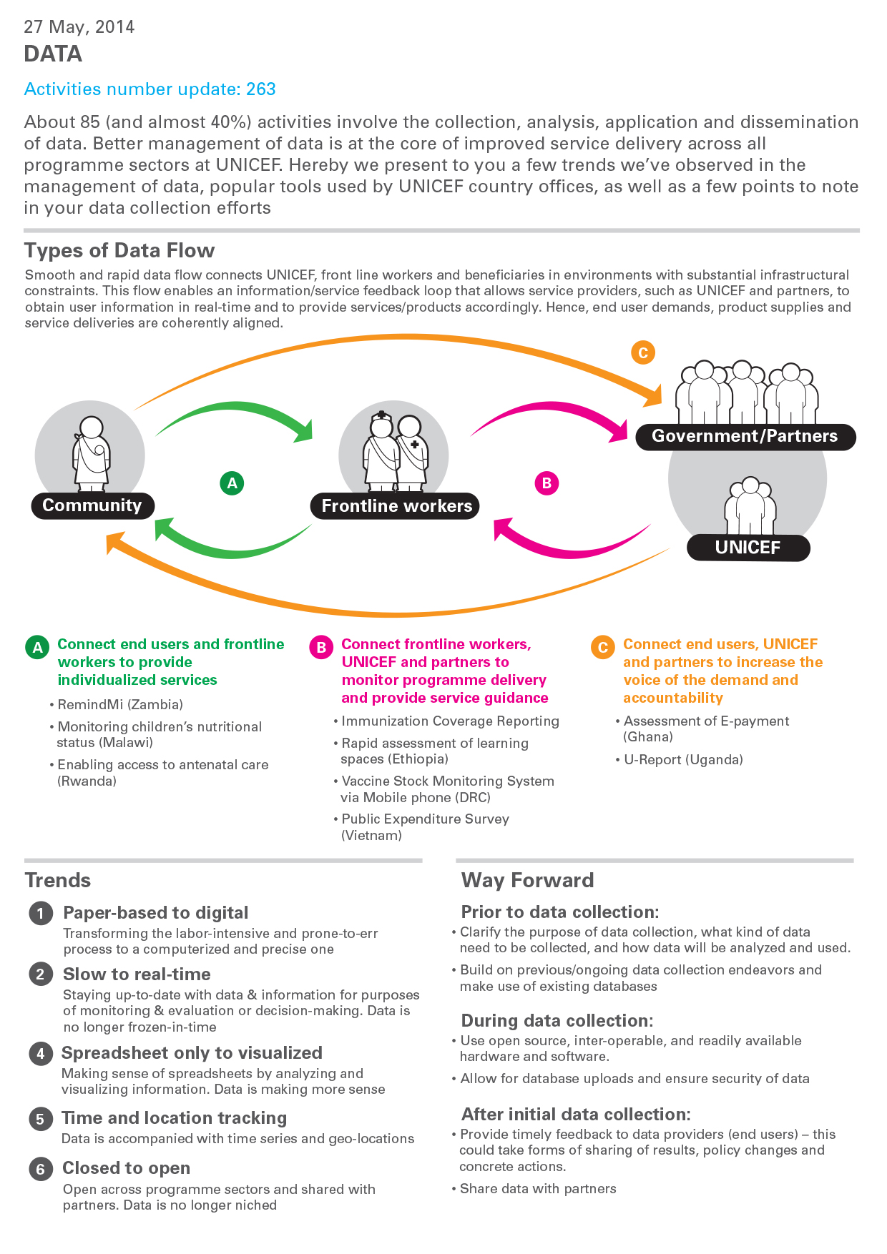

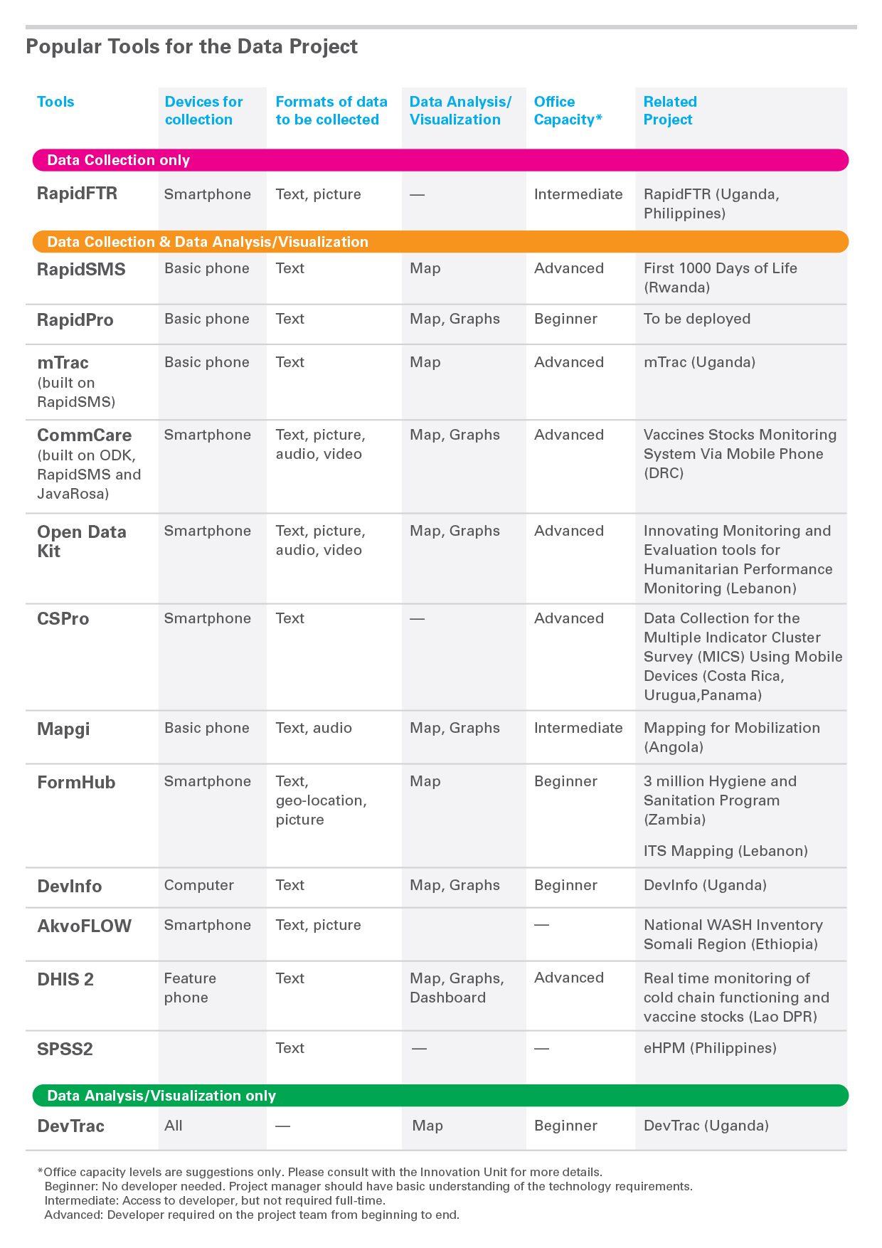

**V. Future Areas of Focus**

In collaboration with a key set of partners, UNICEF is convening conversations around the intersection of high growth tech industries and social good. These conversations will bring together corporations, designers, entrepreneurs, and other international development partners to examine how technology and business expansion in emerging markets can deliver expanded profit while also supporting social development and inclusion in these countries. The main areas of focus will be:

1. **Future of money:**the opportunity for people to be financially included, which can help lift them out of poverty through small scale entrepreneurship, easier forms of remittances, etc.
2. **Identity:**how technology can be used to give voice to young people, the intersection between social identity and an official birth certificate.
3. **Transportation:** how we move people and goods, how we expose informal networks and make them accessible, how we create better transport networks without large investments in traditional infrastructure.
4. ​**Wearable technologies:** the ability for people at the edge of connectivity to generate, understand, and use data for better decisions about their health, education, etc.

More information on these four areas can be found [here](https://docs.google.com/document/d/1FzaNeOSDj3J9DknQP1FkqpuwNsFwGhUlWTMwxQ62o5w/edit?usp=sharing).

**VI. Innovation Labs**

UNICEF Innovation Labs ([www.unicefinnovationlabs.org](http://www.unicefinnovationlabs.org)) are open, collaborative spaces that bring together young people, the private sector, academia, government, and civil society to co-create sustainable solutions to the most pressing challenges facing marginalized women and children. Labs work to support the country programme through the integration of new technologies and approaches, design thinking, and partnerships with different constituents.

**1. AFGHANISTAN**

**Lab lead:** Richard Stanley

**Primary focus:** Health and polio

UNICEF Afghanistan Innovation Lab uses mobile technologies to monitor programme inputs and quality. Key upcoming activities are a monitoring service using SMS and voice for polio field teams and frontline health workers, and UReport for community-based reporting on polio campaigns, health, nutrition, and WASH.

**2. ARMENIA**

(Lab up and coming)

Resources:

[Innovative initiative Kolba Labs empowers youth in Armenia](http://unicefstories.org/2013/10/31/innovative-initiative-kolba-labs-empowers-youth-in-armenia/)

**3. BURUNDI**

**Lab leads:** Alfred Mukasa and Chelsey Lepage

**Primary focus:** Technology for development (T4D); micro-energy rural entrepreneurship models; digital education tools; mobile-based information platforms ([UReport Burundi](http://ureport.unicefburundi.org), Project KiraMAMA)

UNICEF Burundi Innovation Lab is a creative space that aims to bring together children and young people, technologists, academics, business experts and policymakers to unlock some of the greatest challenges facing Burundi’s children. The Innovation Lab aims to provide unique opportunities to connect leaders within academia, the private sector and civil society directly with end-users – and is currently working with [UNICEF Next Gen](http://unicefstories.org/2014/01/28/next-generation-offer-expertise-pro-bono-to-support-global-unicef-innovation-work/) to further this goal. The lab’s efforts are focused around two core challenges: strengthening delivery of essential social services to the most vulnerable, and developing new communication tools and platforms to harness the ideas and opinions of young people and community volunteers, and integrate their feedback into resource allocation and monitoring decisions. Given that only 3% of the population has access to the electrical grid (which is mostly concentrated in a small number of cities), the Lab became particularly interested in creating solutions for energy and lighting.

Resources:

[UNICEF Next Generation travel to support Burundi Innovation Lab](http://unicefstories.org/2014/04/25/unicef-next-generation-travel-to-support-burundi-innovation-lab/)

[Sciences Po Paris students develop innovative concepts for UNICEF Burundi](http://unicefstories.org/2014/04/04/sciences-po-paris-students-develop-innovative-concepts-for-unicef-burundi/)

[Design for UNICEF student project: Amplifying light in Burundi](http://unicefstories.org/2014/01/06/design-for-unicef-student-project-amplifying-light-in-burundi/)

[Burundi: 3% access to the electrical grid. 50%+ malnutrition. #Uinnovation day 4](http://unicefstories.org/2013/03/07/burundi-3-access-to-the-electrical-grid-50-malnutrition-uinnovation-day-4/)

**4. COPENHAGEN**

**Lab lead:** Kristoffer Gandrup-Marino (Chief Innovation)

**Primary focus:** Product innovation

**Specific products:** [ARIDA](http://unicefinnovation.org/projects/strengthening-pneumonia-diagnostic-tools-low-resource-settings), [School Furniture](http://unicefinnovation.org/projects/improving-primary-school-furniture-design-and-procurement-guidelines), [Weight Measurement Tapes](http://unicefinnovation.org/projects/weight-measurement-tapes), [Visual Vaccines](http://unicefinnovation.org/projects/visual-vaccines)

**More info:** <http://unicefinnovation.org/>

Located at UNICEF Supply Division, the Lab is a hub for engagement across cultures, distances, and disciplines. It focuses on product innovations that have the potential to improve programme achievements and results at large scale. One example of such a product is school furniture to make learning spaces more conducive. Another is Weight Measurement Tape to allow community health workers to quickly and effectively determine a child’s nutritional status and prescribe the proper treatment.

Resources:

[A week at the Innovation Unit in Copenhagen](http://unicefstories.org/2013/12/16/a-week-at-the-innovation-unit-in-copenhagen/)

[School furniture – Produced in Africa, for Africa](http://unicefstories.org/2014/04/18/school-furniture-produced-in-africa-for-africa/)

[UNICEF and global health partners open market entry for innovative HIV Point of Care diagnostics](http://unicefstories.org/2014/04/21/unicef-and-global-health-partners-open-market-entry-for-innovative-hiv-point-of-care-diagnostics/)

[YeAH! (Youth e-Aid in HIV testing and counseling)](http://unicefstories.org/2013/12/26/yeah-youth-e-aid-in-hiv-testing-and-counselling/)

**5. INDONESIA**

**Lab lead:** Jeff Hall

**Primary focus:** Youth engagement and emergency

The recently created Indonesia Innovation Lab will focus on adolescent and youth engagement projects – specifically through involving Indonesian students in the [Global Design for UNICEF Challenge](http://unicefstories.org/2014/02/26/building-the-next-generation-of-global-innovators/) in the upcoming year. Through this Challenge and other youth engagement projects, the Lab will partner with young people to explore solutions around issues such as birth registration and disaster response. Another project aims at establishing a two-way communication platform that enables young people to be actively involved in social development and policy through social media channels.

Resources:

[Innovations in Indonesia: The story of our beginnings](http://unicefstories.org/2014/03/31/innovations-in-indonesia-the-story-of-our-beginnings/)

[Video: Info Bidan – Information for Indonesian midwives via SMS](http://unicefstories.org/2014/03/03/video-info-bidan-information-for-indonesian-midwives-via-sms/)

[Engaging adolescents and youth in emergency preparedness and response](http://unicefstories.org/2014/04/01/engaging-adolescents-and-youth-in-emergency-preparedness-and-response/)

**6. KOSOVO**

**Lab lead:** Josh Harvey

**Primary focus:** Community engagement and youth partnership

**More info:** <http://kosovoinnovations.org/>

The Kosovo Innovation Lab consists of a multidisciplinary team (project managers, engineers, advocacy practitioners, designers, social entrepreneurs, educators, communications and marketing specialists, and graphic/ web designers) who seek to advance the use of information and technology and to evolve youth’s relationship with UNICEF from beneficiary to partner. This is done through developing a method of training young entrepreneurs. The Kosovo Lab is managed in three separate pillars:

* By Youth For Youth (mentorship program offering grants)
* Youth Advocacy Platform (partner youth participants with consultants and experts)
* Design Centre (leverages their technical expertise for making Kosovo an open-source technology hub for the region)

Resources:

[Post-2015: The voice of young Kosovo](http://unicefstories.org/2014/01/21/post-2015-the-voice-of-young-kosovo/)

[Prototyping social problems in 48 hours](http://unicefstories.org/2013/09/16/prototyping-social-problems-in-48-hours/)

<http://sicampkosovo.org/>

**7. LEBANON**

**Lab lead:** James Cranwell-Ward

**Primary focus:** Technology development and partnerships

The Lebanon Innovation Lab is working to develop key technologies for development, including:

* Equitrack, an open-source tool that enables UNICEF to have all partnership-related information in one repository, to map partnerships, and to aggregate planned results, progress and budgets
* ActivityInfo, an online real-time reporting tool for partners
* Open Data Kit and Formhub, which are both open source platforms for collecting data in the field using smart phones and tablets
* [RapidSMS](https://www.rapidsms.org/), a framework for real time SMS based monitoring systems such as UReport

Resources:

[Learning anywhere and everywhere with Raspberry Pi technology](http://unicefstories.org/2014/05/05/learning-anywhere-and-everywhere-with-raspberry-pi-technology/)

[Innovating non-formal education](http://unicefstories.org/2014/02/17/innovating-non-formal-education/)

**8. NAIROBI INNOVATION CENTRE**

**Director:** Sharad Sapra

The Nairobi Innovation Centre identifies and field-tests scalable innovations. Main activities include:

1. Harvesting innovations that are working as pilots but have not been tested for scalability, replicability, robustness and effectiveness
2. Incubating great concepts that do not yet have the financial support to be tested
3. Educating youth, exposing them and connecting them to innovative processes
4. Disseminating global implementation of successful innovations proven to be scalable, replicable, robust, and effective

The vision of the Innovation Center is enabling exponential change in reducing inequities and results for children. The Center focuses on innovations that benefit the most deprived people in the most remote locations through new technologies, tools and solutions.

**9. SAN FRANCISCO**

**Lab lead:** Blair Palmer

**Primary focus:** Technology and social impact

The new San Francisco Lab is UNICEF Innovation’s first US-based venture, located in the San Francisco Bay Area at NASA’s Ames Research Center. As an impact partner in the [Corporate Innovation Exchange (CIX) program](http://unicefstories.org/2014/02/14/unicef-bay-area-partners-in-corporate-innovation-exchange-at-singularity-university/) at Singularity University, UNICEF Innovation will work with partners to reach impact at scale with innovations in areas of unmet need.

**10. SOUTH SUDAN**

**Lab lead:** Stuart Campo

(Lab currently on hold)

**11. SUDAN**

**Lab lead:** Gaizka Mentxaka

**Primary focus:** Vaccination services, school kit distribution, and birth registration

In response to the growing recognition of the need for efficiency and effectiveness in programmes for children, UNICEF Sudan aims to strengthen the innovation culture within the office, build collaborative networks to facilitate new technologies and approaches, and apply them in the field. By making local communities a part of the innovation process, UNICEF and partners will be able to better identify, adapt, and advocate for government scale-up of solutions. Under these premises, a pilot project for the establishment of an Innovation Lab in Sudan was initiated in September 2012 in the University of Khartoum and the Sudan University of Science and Technology with the objective of:

1. Bringing UNICEF Sudan and government partners closer to local capacity in higher education institutions
2. Providing a capacity building environment where students can interact with real world problems and stakeholders

The pilot project demonstrated promising potential as well as the power to serve as the forum where UNICEF and partners, with an invaluable drive from young people, could harness efforts to bring positive change to the lives of the most disadvantaged children. UNICEF Sudan is committed to supporting the establishment of permanent Innovation Labs to foster a culture collaboration and experimentation focused on making people’s lives better, particularly the lives of children. Specific projects include:

1. [RapidSMS](https://www.rapidsms.org/) for vaccination services (reminding mothers of the due dates for taking their infants for routine vaccination)
2. RapidSMS for school kit distribution (tracking the delivery of school kits from the warehouse to end user)
3. RapidSMS for increasing Birth Registration rates

**12. TANZANIA**

(Lab up and coming)

**13. UGANDA**

**Lab lead:** Stefan Bock

**Primary focus:** Product and service development

The Uganda Innovation Lab is now part of the UNICEF Global Innovation Center, although still closely tied to the Uganda Country Office. The Lab is a physical prototyping workshop, a [RapidSMS](https://www.rapidsms.org/) service development hub, an electronics workshop, a video production set, a place for hosting skills workshops, and an informal, accessible venue that allows for greater co-creation between UNICEF and the community. The principal focus for UNICEF Uganda is to close the opportunity gap for the most marginalized and hard-to-reach sections of the population. The Lab’s strategy to accomplish this is to develop technology in the form of physical products and mobile services that provide the end-user with an unprecedented level of access to information and also create opportunities for real-time feedback loops and improved data collection methods. In this vein, the Uganda Lab uses initiatives like [MobiStation](http://unicefinnovation.org/projects/mobistation) (a solar-powered multimedia kit) to address some of the biggest challenges of the education system: teacher absenteeism, poor-quality instruction, and lack of textbooks, and thereby bring quality education to marginalized groups. The Uganda Lab acts as the backbone of the UNICEF Innovation team, rolling out existing and new solutions to other Country Offices. For instance, the lab is currently working with several Offices that are in the process of adopting RapidSMS2.0 (also called RapidPro) applications, such as UReport.

Resources:

[Narrative of a partnership: Open source hardware in Uganda](http://unicefstories.org/2014/01/07/unicef-pioneers-high-tech-education-for-marginalized-children/)

[UReport empowers 230,000 young Ugandans – TV show Episode 1](http://unicefstories.org/2013/09/19/u-report-empowers-230000-young-ugandans-tv-show-episode-1/)

[CNN reports on Uganda Innovation Lab - Video](http://unicefstories.org/2013/09/12/cnn-reports-on-uganda-innovation-lab-video/)

**14. ZAMBIA**

**Lab lead:** Priscilla Chomba-Kinywa

**Primary focus:** [UReport](http://unicefstories.org/2014/01/02/revolutionizing-hiv-response-among-adolescents-in-zambia-through-the-use-of-mobile-phones/) and health

The Zambia Innovation Lab will continue working on bringing UReport to Zambian youth as a way to receive free, confidential, and real-time information on critically important issues, such as how they can protect themselves from HIV. The Lab is also pursuing innovative projects in the Water, Sanitation and Health programme, as well as partnering with local start-up incubator BongoHive to support projects across program areas. Yet another Lab initiative is [Programme Mwana](http://unicefstories.org/2014/03/24/reducing-medical-test-delays-from-30-days-to-30-seconds-part-2-of-4-innovation-in-zambia/), which uses [RapidSMS](https://www.rapidsms.org/) to deliver Early Infant Diagnosis (EID) health results and facilitate communications between clinics and community health workers for post-natal follow-ups.

Resources:

[Newest UNICEF Innovation Lab in Zambia](http://unicefstories.org/2014/03/19/zambia-chosen-as-the-latest-unicef-innovation-lab/)

[Revolutionizing HIV response among adolescents in Zambia through the use of mobile phones](http://unicefstories.org/2014/01/02/revolutionizing-hiv-response-among-adolescents-in-zambia-through-the-use-of-mobile-phones/)

**15. CHILE**

**Lab lead:** Julio Cezar Dantas

**Partners:** Socialab

**Projects:** 72 Hour Challenge (<http://www.first72hours.org/>)

The Chile Innovation Lab is managed in close collaboration with Socialab, a Latin American NGO for social entrepreneurship, and focuses on connecting global problem solvers to emergencies. The [Global Innovation Challenge](http://www.first72hours.org/) was launched to find ideas that will help the world better respond to emergencies. From a rough idea to a finished product, the contest seeks world-changing ideas that will improve how the humanitarian community responds at the early onset of a crisis. Proposed ideas can be for affected communities or humanitarian actors, and should focus on one of four areas: Energy, Health, Communications and Information, and Food and Water.

Resources:

[New Innovation Lab in Chile connects global problem solvers to emergencies](http://unicefstories.org/2013/10/29/new-innovation-lab-in-chile-fights-against-emergencies-in-co-operation-with-entrepreneurs/)

More resources:

[UNICEF Innovation Labs: Do-It-Yourself Guide](http://unicefstories.org/2012/11/06/unicef-innovation-lab-do-it-yourself-guide/)

[Laboratorios de Innovación: Una Guía Práctica](http://unicefstories.files.wordpress.com/2013/09/laboratorios-de-innovacic3b3n-una-guc3ada-prc3a1ctica1.pdf)

**VII. Communications Resources**

Innovation Slide Deck – [https://www.dropbox.com/sh/c4x0wyq1kiy2bhk/FAlQIbLeQE](https://www.dropbox.com/sh/c4x0wyq1kiy2bhk/FAlQIbLeQE" \t "_blank)

[TEDx talk with Christopher Fabian](https://www.youtube.com/watch?v=msn5Kd96RhM) – Aalto University, May 2012

[Article on scaling social innovation startups by Erica Kochi](http://techcrunch.com/2013/02/16/scaling-social-innovation-erica-kochi/) – Tech Crunch, February 2013

[Talk by Erica Kochi](https://www.youtube.com/watch?v=oAxadAAvhww) – Mobile Health Stanford, May 2013

[Google Hangout with Christopher Fabian](https://www.youtube.com/watch?v=KV7wVxi7trU) – UNICEF Next Generation, August 2013

[Article on mHealth innovations co-authored by Erica Kochi](http://www.ghspjournal.org/content/early/2013/08/06/GHSP-D-13-00031.full.pdf) – Global Health: Science and Practice, August 2013

[Interview with Christopher Fabian](http://www.worldwewant2015.org/node/398622) – World We Want, October 2013

[Interview with Erica Kochi and Christopher Fabian: Innovation, technology and the changing face of development](https://www.youtube.com/watch?v=A_wRSxyAS4E&feature=youtu.be) – Chatham House, December 2013

1. UNICEF innovation principles have been endorsed or adopted by the following partners: UNICEF, USAID, Gates Foundation, EOSG Global Pulse, WFP, OCHA, UNDP, SIDA, IKEA Foundation, UN Foundation, and UNHCR. [↑](#footnote-ref-1)