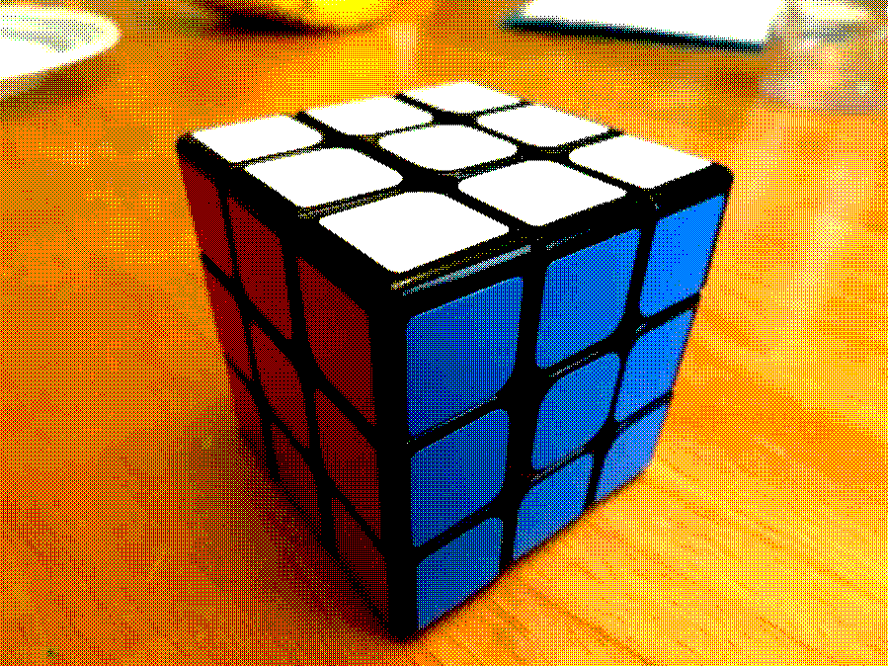

./a.out -input cube.jpg -orderedDither 1 -output orderedDither.png