SPAASM Assignment 1  
- Documentation

Ondrej Krajčovič

Slovenská technická univerzita v Bratislave

Fakulta informatiky a informačných technológií

Systémové Programovanie A Assemblery

[xkrajcovico@stuba.sk](mailto:xkrajcovico@stuba.sk)

18. march 2025

IV.Semester Bc Štúdia

# Content

**Content 2**

**Assignment: 3**

Number of Assignment: 3

Bonuses: 3

**Solution: 4**

Structure 4

Main.s 4

readFile.s 4

Running the project: 4

Summary: 4

# 

# Assignment:

## Number of Assignment:

* Assignment:
  + Number 6:

*“Vypísať všetky riadky vstupu a pred každý napísať jeho poradové číslo.”*

## Bonuses:

* I would like to try to fulfill these bonus requirements(10 & 12):

* + *“10.Plus 2 body je možné získať ak pridelená úloha bude realizovaná ako externá procedúra (kompilovaná samostatne a prilinkovaná k výslednému programu).*

*…*

* + *12.Plus 1 bod je možné získať za (dobré) komentáre, resp. dokumentáciu, v anglickom jazyku.”*

# Solution:

## Structure

* Project is made of these elements:
  + Main - assembly code
  + readFile - assembly function
  + ahoj.txt - file being read
  + documentation

## 

## Main.s

* Is first one to be run.
* After start, it calls external function readFile stored in readFile.s
* After readFile returns, main returns 0 and safely exits

section .text

global _start

extern _start_readFile ; Declare _start_readFile as an external symbol

_start:

; Call the _start_readFile function in readFile.s

call _start_readFile

; Exit the program

mov rax, 60 ; syscall number for sys_exit

xor rdi, rdi ; return 0

syscall

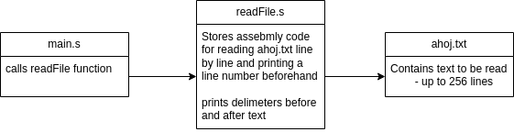

## 

## readFile.s

## Running the project:

* To run the project we need i used commands necessary, stored in run_commands.txt
* Example output for ahoj.txt containing 15 lines of just letter a: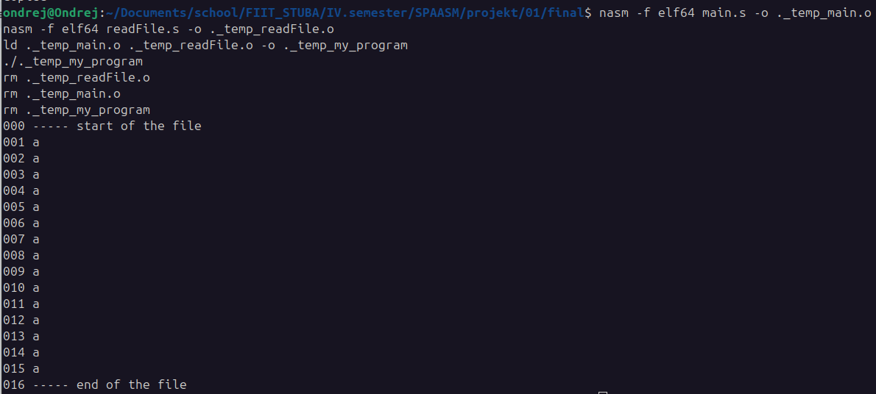

## Summary: