February 2023 Electronic and Electrical Engineering

ELEC0019 Electromagnetic Theory

Interference, Diffraction and Polarization of Electromagnetic Waves

21014622– Nooreldin Elmosalamy

## Introduction

Wave propagation is one of the fundamental concepts in electromagnetic theory and modern-day communication systems. Through centuries of research and discoveries, the understanding of waves has allowed for the globalization and technological growth we see today. Electromagnetic waves have shaped our modern life and are vital to the way we are able to perceive and experience the world; and specifically here, electromagnetic waves are essential to Electrical Engineering.

## Abstract

This remote lab focuses on the propagation, diffraction, refraction, and polarization of microwaves and its purpose is to further our understanding of wave propagation theory through research and analyzing experiments. Using MATLAB and academic sources, the analysis of each experiment is better understood and completed.

## Wave Propagation

## Part 1 Interference of Waves

**Question 1**

Equation for the total field at $x$:

$$E_{T}≈\frac{1}{D}\left(e^{-jk\left[\left(d/2-x\right)\sin{θ_{1}+D\cos{θ_{1}}}\right]}+e^{-jk\left[\left(d/2+x\right)\sin{θ_{2}+D\cos{θ_{2}}}\right]}\right)$$

We are given the following approximations as $θ_{1}$ and $θ_{2}$ are small:

$$\sin{θ_{1}}≈θ_{1}≈(d/2-x)/D$$

$$\sin{θ_{2}}≈θ_{2}≈(d/2+x)/D$$

$$\cos{θ_{1}}≈1-θ_{1}^{2}/2$$

$$\cos{θ_{2}}≈1-θ_{2}^{2}/2$$

Hence, we can substitute these approximations into $E_{T}$:

$$E_{T}≈\frac{1}{D}\left(e^{-jk\left[\left(Dθ_{1}\right)(θ_{1})+D\left(1-θ_{1}^{2}/2\right)\right]}+e^{-jk\left[\left(Dθ_{2}\right)(θ_{2})+D\left(1-θ_{2}^{2}/2\right)\right]}\right)$$

$$≈\frac{1}{D}\left(e^{-jk\left[\left(Dθ_{1}^{2}\right)+\left(D-Dθ_{1}^{2}/2\right)\right]}+e^{-jk\left[\left(Dθ_{2}^{2}\right)+\left(D-Dθ_{2}^{2}/2\right)\right]}\right)$$

$$≈\frac{1}{D}\left(e^{-jk\left[D+Dθ_{1}^{2}/2\right]}+e^{-jk\left[D+Dθ_{2}^{2}/2\right]}\right)$$

Split up the exponentials:

$$≈\frac{1}{D}e^{-jkD}\left(e^{-jk\left[Dθ_{1}^{2}/2\right]}+e^{-jk\left[Dθ_{2}^{2}/2\right]}\right)$$

Substitute in the approximates for $θ_{1}$ and $θ_{2}$:

$$≈\frac{1}{D}e^{-jkD}\left(e^{-jk\left[\frac{{\left(d/2-x\right)}^{2}}{2D}\right]}+e^{-jk\left[\frac{{\left(d/2+x\right)}^{2}}{2D}\right]}\right)$$

$$≈\frac{1}{D}e^{-jkD}\left(e^{-jk\left[\frac{d^{2}/4-dx+x^{2}}{2D}\right]}+e^{-jk\left[\frac{d^{2}/4+dx+x^{2}}{2D}\right]}\right)$$

$$≈\frac{1}{D}e^{-jkD}\left(e^{-jk\left[\frac{d^{2}-4dx+4x^{2}}{8D}\right]}+e^{-jk\left[\frac{d^{2}+4dx+4x^{2}}{8D}\right]}\right)$$

$$≈\frac{1}{D}e^{-jkD}e^{-jk\left[\frac{d^{2}+4x^{2}}{8D}\right]}\left(e^{-jk\left[\frac{-4dx}{8D}\right]}+e^{-jk\left[\frac{4dx}{8D}\right]}\right)$$

$$≈\frac{1}{D}e^{-jk\left[D+\frac{d^{2}+4x^{2}}{8D}\right]}\left(e^{jk\left[\frac{dx}{2D}\right]}+e^{-jk\left[\frac{dx}{2D}\right]}\right)$$

Use Euler’s Formula $\cos{x=Re\left(e^{jx}\right)=\frac{e^{jx}+e^{-jk}}{2}}$:

$$≈\frac{1}{D}e^{-jk\left[D+\frac{d^{2}+4x^{2}}{8D}\right]}\left(2\cos\left(\frac{kdx}{2D}\right)\right)$$

Rearrange

$$≈\frac{2}{D}\cos\left(\frac{kdx}{2D}\right)e^{-jk\left[D+\frac{d^{2}+4x^{2}}{8D}\right]}$$

The absolute value of complex exponential equals 1

$$\left|E_{T}\right|≈\frac{2}{D}\cos\left(\frac{kdx}{2D}\right)$$

Solve for the absolute value of ${\left|E_{T}\right|}^{2}$.

$${\left|E_{T}\right|}^{2}≈\frac{4}{D^{2}}\cos^{2}\left(\frac{kdx}{2D}\right)$$

*The distance between the consecutive maxima or minima is $\frac{2Dπ}{kd}.$*

**Question 2**

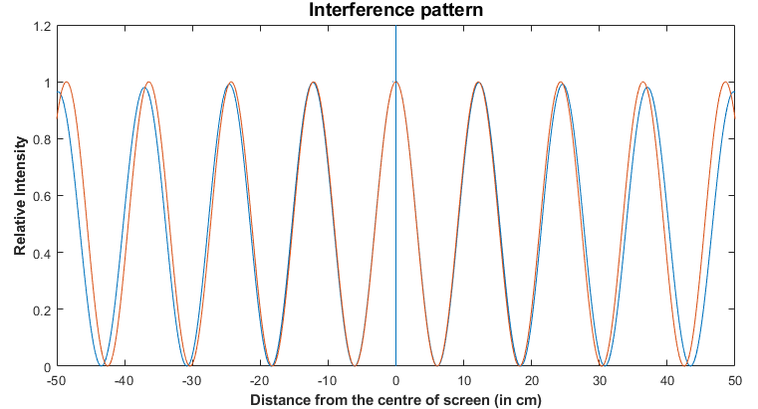

Figure

As depicted by Figure 1, the approximation (the orange line) from equation 4 is perfectly in phase with the calculated relative intensity (the blue line) from equation 1 at position $x=0$, however the phase difference increases the further displaced from the center. Equation 1 is an oscillator with an exponential envelope. The Taylor series uses a sum of sin waves, and since the approximations are derived from the first two terms of the Taylor series, it doesn’t calculate the exact decay and wavelength.

### Experiment 1.1: Interference of waves

**Question 3**

This experiment consists of a rectangular waveguide, emitting two signals which is received by a horn and is then fed into a microwave detector. The detector diode’s purpose is to depolarize the microwaves and acts as a half-wave rectifier. The advantage of a half-wave rectifier over a full-wave rectifier is that it will not need to double the frequency when detecting the microwaves. The frequency of the signal carried by the coaxial cable is 5kHz, because that is the frequency of the envelope where the information is carried. The RF carrier within the envelope is the 10 GHz microwave signal. [1]

The square-law range of a diode is essentially a range at low voltages where the current yielded is proportional to the voltage squared. Gradually, as the voltage increases, a linear relationship will develop. [2] However, during the square voltage range, and knowing that the intensity is directly proportional to the voltage, we can determine:

$I∝{\left|E_{T}\right|}^{2}$

**Question 4**

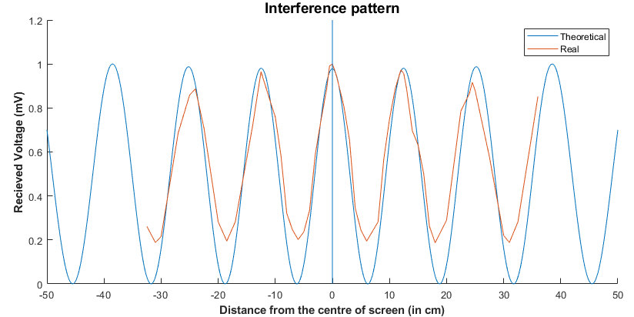

Figure

At the central maxima of Figure 2, the phase and amplitude almost perfectly line up and as the distance from the center of the screen increases, the larger the real waveform decays – the phase and amplitude decreases. The theoretical waveform calculated from equation 1 shows that the maximums are at the arbitrary value of 1 and the minimums are at 0. However, the real values imported from ‘Int1.txt’, has approximately a maximum of one at the center, but then decreases with distance, and the minimums have an almost stable value of approximately 0.2 relative intensity, but slightly fluctuates with no obvious sign of decay. Therefore, the maximums are a better representative of the position, as it depicts a clear decay which is expected further from the center.

### Experiment 1.2 Measurement of relative permittivity of a dielectric material

**Question 5**

Experiment 1.2 depicts the same schematic as Experiment 1.1, but has introduced a dielectric slab placed in between one of the waveguide sources and the receiving horn. The rectangular waveguide produces two sources at distance $d$ apart from one another and both are horizontally distance $D$ apart from the horn. Since the horn is positioned at an equal distance from both openings, it will receive both signals at angle $θ$. The dielectric slab institutes a phase shift dependent on the thickness of the slab, $δ$.

The aim of this experiment is to derive the equation of relative permittivity of the sheet, $ε_{r}$. As the wave propagates through the dielectric slab, it will refract, therefore, to simplify our calculations, we must assume that the attenuation of the wave through the slab is negligible.

First off, solve for the distance the wave propagates to the horn:

$$∆d=d\sin{θ}$$

Distance $D$ is substantially large meaning the value of $θ$ can be determined using the small angle assumption and along with this assumption, we can determine that the incident wave is the normal to the dielectric slab.

$$\frac{\sin{θ}}{\cos{θ}}=\tan{θ}=\frac{∆s}{D}$$

$$\sin{θ}=\frac{∆s∙\cos{θ}}{D}$$

Small angle assumption: $\cos{θ}$ can be approximated to $=1$, as $θ$ is small and we can substitute this back into the original equation:

$$\sin{θ}=\frac{∆s}{D}$$

$$∆d=d\frac{∆s}{D}$$

The optical path difference is can be found through the following equation:

$$∆d=δn_{1}-δn_{2}$$

where $n_{1}$ is the refractive index of the first material and $n_{2}$ is the refractive index of the second material. In this experiment the first material will be the dielectric slab, and the wave then propagates back into air, which is known to have a relative permittivity of approximately 1:

$$n_{2}≈1$$

$$∆d=δn_{1}-δ$$

Simplify,

$$∆d=δ(n_{1}-1)$$

The dielectric slab is made of isotropic material, meaning that its refractive index is:

$$n=\sqrt{ε_{r}}$$

Therefore,

$$∆d=δ(\sqrt{ε_{r}}-1)$$

Combine the equations to derive the final solution:

$$\frac{d∆s}{D}=δ(\sqrt{ε_{r}}-1)$$

$$\frac{d∆s}{δD}=\sqrt{ε_{r}}-1$$

$$\sqrt{ε_{r}}=1+\frac{d∆s}{δD}$$

$$ε_{r}={\left[1+\frac{d∆s}{δD}\right]}^{2}$$

**Question 6**

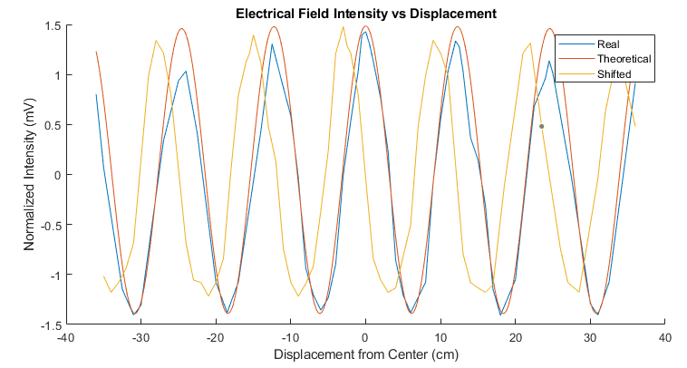

Figure

In Figure 3, the ‘real’ plot, is derived from the actual calculations, and the ‘theoretical’ is derived from the approximation. As the graph depicts, the approximation has a high accuracy at the center, but as the displacement increases, it does not take into consideration the decay of the intensity. The ‘shifted’ plot is similar to the real, but decays less than the ‘real’ plot.

Using MATLAB, the phase difference between the ‘shifted’ and the ‘real’ is exactly 3cm. Taking $δ=0.012 m$, the relative permittivity of the dielectric slab will be:

$$ε_{r}={\left[1+\frac{d∆s}{δD}\right]}^{2}={\left[1+\frac{(0.63)(0.03)}{(0.012)(2.55)}\right]}^{2}=2.617$$

Using thicker sheets would also be suitable, as the wave front will take longer to propagate through them. This will increase the phase difference in the interference patterns. Using sheets of higher permittivity would increase the refractive index, which will also lead to an increase in the phase difference. Lastly, the position of the dielectric sheet will significantly impact the results. If the sheet were placed too far from the source, or not centered in the path of the wavefront, not all the wavelets will propagate through the sheet causing the horn to detect different waveforms which will change the result. Although it does not have to be placed at exactly 25 cm, like in the experiment, any substantial displacement of it will vary the result significantly.

### Exercise 1.3 Antenna Arrays

**Question 7**

$$E\left(r,θ\right)=\frac{e^{-jk\left(r+d\cos{θ/2}\right)}}{r}+\frac{e^{jφ}e^{-jk\left(r-d\cos{θ/2}\right)}}{r}$$

The aim is to find a function for $F\left(θ\right)$, therefore we have to remove the variable $r$.

$$F\left(θ\right)=\left|E\left(r,θ\right)\right|∙r$$

First, we will separate the exponentials.

$$E\left(r,θ\right)∙r=e^{-jkr}e^{-jk\left(d\cos{θ/2}\right)}+e^{jφ}e^{-jkr}e^{jk\left(d\cos{θ/2}\right)}$$

$$=e^{-jkr}\left(e^{-jk\left(d\cos{θ/2}\right)}+e^{jφ}e^{jk\left(d\cos{θ/2}\right)}\right)$$

The complex exponential is always equal to 1, therefore, $e^{-jkr}$ can be removed.

$$F\left(θ\right)=\left|E\left(r,θ\right)\right|∙r=\left(e^{-jk\left(d\cos{θ/2}\right)}+e^{jφ}e^{jk\left(d\cos{θ/2}\right)}\right)$$

Figure 4 is the polar plots for each case:

Case a, where $d=0.015$ and $φ=0$: Case b, where $d=0.015$ and $φ=90$:

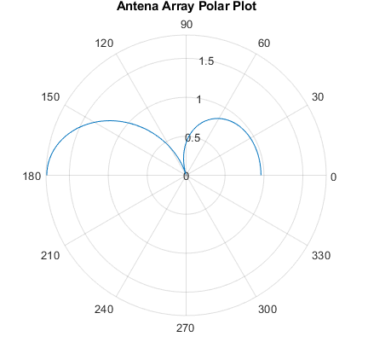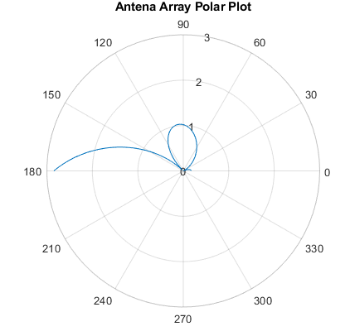

Case c, where $d=0.015$ and $φ=180$: Case d, where $d=0.0075$ and $φ=0$:

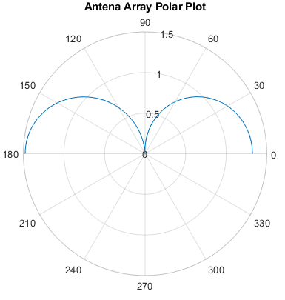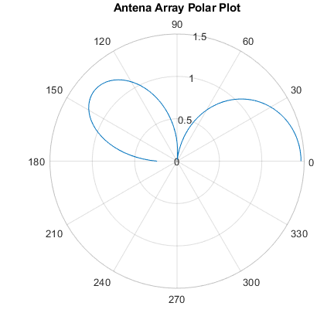

Case e, where $d=0.0075$ and $φ=90$: Case f, where $d=0.0075$ and $φ=180$:

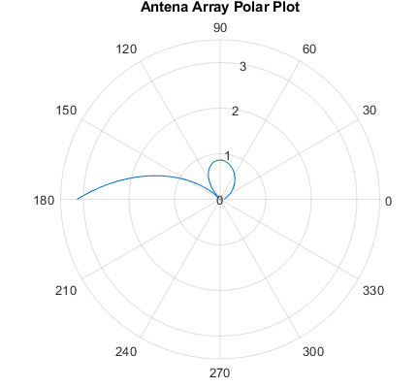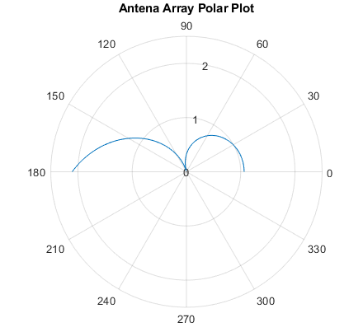

Figure

## Part 2 Diffraction and Polarization

**Question 8**

Experiment 2.1 depicts diffraction occurring due to an opaque screen, at point C, blocking part of the wave plane. Huygens’ Principle infers that waves do not diffuse over distance due to the wavefronts being modeled as point sources propagating waves in all directions, meaning that at any point, the amplitude of the waveform is equal to the superpositions of the amplitudes from all the secondary (previous) wavelets [3]. Therefore, up until point C, the measure of intensity at any focal point is the same. However, starting at point C, because of the obstacle, there will not be any interference from the from the previous wavelets from the previous wave front causing the curvature seen in Fig. 7, which leads to the transition area, thus Huygens’ Principle is only sufficient to describe Experiment 2.1 up to point C where the diffraction begins. In this experiment, far-field diffraction occurs, also known as Fraunhofer diffraction.

Born in the 18th century, Joseph Fraunhofer is one of the most respected German physicists and well-known for his Theory of Diffraction. [4] The Fraunhofer diffraction equation models wave diffraction patterns in the far-field domain and only occurs at small Fresnel number. Fresnel number was developed by French engineer and physicist, Augustin-Jean Fresnel, and is a dimensionless parameter used in optics. Fresnel number $F$ is defined as

$$F≡\frac{a^{2}}{λR}$$

where $λ$ is the wavelength, and $R$ is the distance from the aperture, $a$ is the characteristic size of the aperture – in this case: the length of the wedge. The $F≪1$ regime of small Fresnel number is where Fraunhofer diffraction occurs. [5][6] This can be assumed to happen at point C, where the wave diffracts and curves into the shadow region. The intensity of wave will die down quickly, with distance away from the illuminated region, but since this is at far field observation, there will still be small amounts of microwaves propagating through the shadow region. Past point D, in the illuminated region, Huygens’ principle will still be applicable as the wave front will continue propagating through it.

To understand the difference between the far field and near field regions, it is necessary to detail Fresnel diffraction and how observation of the diffraction in this region differs to the observation of Fraunhofer diffraction. Opposite to Fraunhofer diffraction, it occurs at Fresnel numbers around one or larger [7] and as it is in the near field region, the propagated wave in the shadow and illuminated region will be circular. However, as the wave continues to propagate through the illuminated region it will return to its original planar shape – Fraunhofer diffraction.

**Question 9**

Diffraction can be defined as the spreading out of the wave as it passes around an obstacle or through an aperture while refraction is when the wave changes its direction as it travels into a different medium. Refraction occurs due to each medium having different densities causing the wave to travel at different speeds and bends it. [8]

Most communication systems use either radio or microwaves. Initially scientists believed that like microwaves, radio waves would only be limited to the line of sight, [9] meaning that it will travel straight across the Earth’s atmosphere. However, due to radio waves’ large frequency, they are in fact able to diffract following the curvature of the Earth. Microwaves, on the other hand, will mostly only propagate straight outwards, as their wavelength is only centimeters in the length. Therefore, in communication systems, radio waves are better used for signaling to a larger area of people, while microwaves are more suitable for direct communication. [10]

Diffraction grating can be used to separate white light into the seven major colors. This occurs as each color has its only wavelength and frequency; therefore, they will propagate into the grating device at different speeds [11], causing them to diffract. [12]

### Experiment 2.1: Diffraction of a wave by a conducting plane

**Question 10**

For this section, the experiment is composed of two horns placed opposite of one another at distance $D$ apart, where one functions as a generator and one as a receiver. A conducting screen is positioned vertically in between the two horns and can be slid up and down then fully or partially blocking the wavefront, creating a shadow region. This will affect the intensity received by the horn.

Importing the file ‘diffraction.xlsx’ into MATLAB and then plotting for the relative intensity to the position produces the following graph, Figure 5. To normalize the intensity, the steady-state value of 0.345 was used.

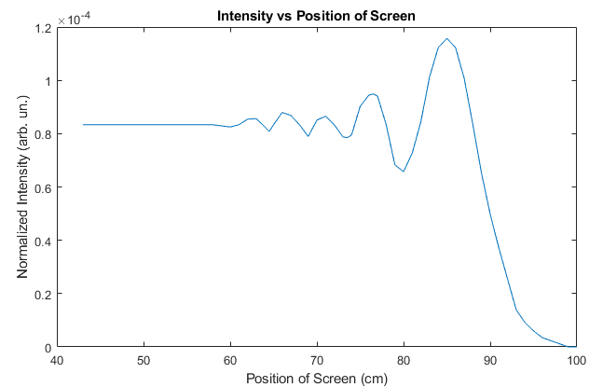

Figure

As previously discussed in Q8., near field and far-field refer to the perspective the diffraction is viewed from. At the near field regime, Fresnel diffraction theory is used, while at far field, Fraunhofer diffraction theory is used.

#### Polarization of Electromagnetic Waves

**Question 11**

Electromagnetic waves propagate in all directions and the process of polarization limits the direction of propagation to a certain plane by removing the symmetry and bringing one-sidedness in the wave. [13] A polarizer is a filter used mostly in optics that transmits light into a single direction and eliminates the other waves propagated at different angles. [14] Polarizing filters are an important part of sunglasses as light tends to reflects off of smooth surfaces – like lenses – at one angle. If this light is reflected directly into one’s eye, known as glare, it can hurt and damage the eye. Therefore, polarized lenses are anti-glare by having a filter with only vertical openings and only allows light rays that can fit through the opening to reach the eye. [15]

Polarizers are also essential in many other aspects of optics, in this case: radio propagation and antenna design. Antennas can act as transmitters or receivers, and convert radio frequency electriq2c current to electromagnetic waves and then are radiated into space. [16] A polarizer, placed on the same plane as a polarized field, would allow the field to pass through. And if the polarizer is placed perpendicularly to the field, little to no waves will pass. The intensity of the wave passing through will vary when the polarizer is placed at different angles. Malus discovered in the nineteenth century that when a light was reflected on a calcite crystal, it would generate polarized light and when the crystal was rotated the intensity of the reflected light varied from a maximum to a minimum. Therefore, Malus suggested that the amplitude of the reflected light must be

$$A(θ)=A_{0}\cos{θ}$$

where $A_{0}$ is the initial amplitude and the intensity is the amplitude relation squared. [17] Hence,

$$A^{2}(θ)=A_{0}^{2}\cos^{2}{θ}$$

Since, $I$ is proportional to $A^{2}$, we develop Malus’s law – the following equation:

$$I(θ)=I_{0}\cos^{2}{θ}$$

where $I_{0}$ is the initial intensity. This equation describes how the intensity varies as the angle of the polarizer is rotated. [18]

In this case, assuming that the polarizer of the receiver has the same orientation as the transmitted signal, the intensity of the received wave would vary from maximum to minimum as well. The following plot, Figure 6, is an example of how the intensity would vary as theta would change.

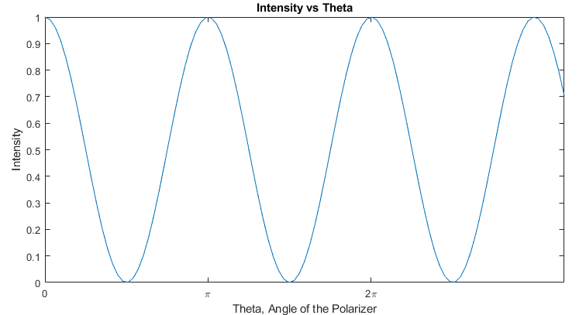

Figure

### Experiment 2.2: Polarization

**Question 12**

The polarization of the emitted wave will be horizontal; this is due to the fact that a rectangular waveguide will polarize more of the electromagnetic wave that is perpendicular to the shorter side of the rectangle than it will for the part perpendicular to the longer side. Since the waveguide is rectangular and has the longer side perpendicular to the vertical, more of the vertical aspect of our wave will be blocked; meaning that a horizontally polarized wave is emitted.

The polarization of the emitted wave can be confirmed to be horizontal by the data provided. The relative intensity received is much higher in horizontal configurations as compared to vertical ones for both filter setups. For the grid setup, the horizontal configuration results in an intensity of 0.33 as compared to a vertical of 0.015; for the mesh setup, the horizontal results in an intensity of 0.28 compared to 0.1. The reason that this implies a horizontally biased waveform is due to the blocking mechanism behind filters. As the wave passes through the filter, any mesh obstructs certain orientations of the lines of electric flux in an EM field. This means that whichever orientation of filter results in the most overall intensity of a polarized EM wave passing through is most likely in the same orientation as the polarization of the wave itself.

The grid setup can be described as the more effective as a polarizer. This is because in the configuration that is perpendicular to the polarization of our horizontally biased wave, the resulting relative intensity received is 0.015, as compared to 0.1 in the mesh setup. This means that the polarization is working as intended for the grid – it is only letting through the comparatively insignificant vertical components of our wave. For the mesh, while the component that isn’t blocked is still small relative to the intensity received in the horizontal configuration, it is not blocking out as much of the intended wave orientation as for the grid which makes it a less effective polarizer than the grid.

## Conclusion

In this remote lab we strove to understand the core concepts surrounding the theory of wave propagation. Through research, deriving mathematical equations, and understanding different experiments, we were able to further our understanding on electromagnetic theory. To summarize, the theories dealt in this lab include: theories of diffraction and refraction, polarization, understanding antenna arrays and communication systems and more.

## References

**Question 3**

[1] “Modulation”, *TSCM*. [Online]. Available: <http://www.tscm.com/modulate.pdf>. [Accessed: 02- Mar- 2022].

[2] J. Aparici, “A Wide Dynamic Range Square-Law Diode Detector”, *in IEEE Transactions on Instrumentation and Measurement,* vol. 37, no. 3, 1988. Available: <https://ieeexplore.ieee.org/stamp/stamp.jsp?arnumber=7469>. [06- Mar- 2022]

**Question 8**

[3] “Huygens’ Principle’, *MathPages.* [Online]. Available: <https://www.mathpages.com/home/kmath242/kmath242.htm>. [Accessed 03- Mar- 2022].

[4] “Fraunhofer, Joseph von (1787-1836)”, *WolframResearch:* Eric Weisstein’s World of Physics, 2007. [Online]. Available: <https://scienceworld.wolfram.com/biography/Fraunhofer.html>. [Accessed: 03- Mar- 2022].

[5] “Fraunhofer Diffraction”, *WolframResearch:* Eric Weisstein’s World of Physics*,* 2007. [Online]. Available: <https://scienceworld.wolfram.com/physics/FraunhoferDiffraction.html>. [Accessed: 03- Mar- 2022].

[6] “Fresnel Number”, *WolframResearch:* Eric Weisstein’s World of Physics*,* 2007. [Online]. Available: <https://scienceworld.wolfram.com/physics/FresnelNumber.html>. [Accessed: 03- Mar- 2022].

[7] “Fresnel Number”, *RP Photonics Encyclopedia.* [Online]. Available: <https://www.rp-photonics.com/fresnel_number.html>. [Accessed: 04- Mar- 2022].

**Question 9**

[8] Science Mission Directorate. “Wave Behaviors”, *National Aeronautics and Space Administration*. [Online]. Available: <https://science.nasa.gov/ems/03_behaviors>. [Accessed: 02- Mar- 2022].

[9] H. Sobol, “Microwave Communications – An Historical Perspective,” *in IEEE Transactions on Microwave Theory and Techniques,* vol.32, no.9, pg. 1171, 1984. Available: <https://ieeexplore.ieee.org/document/1132829>. [Accessed 06- Mar- 2022].

[10] “Radio Waves and Microwaves”, *Math is Fun.* [Online]. Available: <https://www.mathsisfun.com/physics/waves-radio-microwave.html#:~:text=Diffraction%20is%20very%20important%20for,the%20corner%20of%20an%20obstacle.&text=The%20maximum%20effect%20is%20when,are%20about%20the%20same%20size.&text=over%20hills%20and%20through%20valleys%20so%20you%20can%20easily%20get%20reception>. [Accessed: 06- Mar- 2022]

[11] A. Hemenstine, “The Visible Spectrum: Wavelengths and Colors”, *ThoughtCo.* [Online]. Available: <https://www.thoughtco.com/understand-the-visible-spectrum-608329>. [Accessed: 06- Mar- 2022].

[12] “Exploring Diffraction With a Spectroscope”, *National Aeronautics and Space Administration*. [Online]. Available: <https://www.nasa.gov/pdf/350514main_Optics_Exploring_Diffraction.pdf>. [Accessed: 06- Mar- 2022]

**Question 11**

[13] M. Avadhanulu and P. Kshirsagar, “Polarization,” *in A Textbook of Engineering Physics:* S.Chand & Company, 2008, pp. 198-199. [Accessed: 01- Mar- 2022].

[14] D. Basu, “Filters (Optical),” *in Dictionary of Pure and Applied Physics*: CRC Press, 2001, pp. 144. [Accessed: 01- Mar- 2022].

[15] K. Boyd and D. Turbert, “What Are Polarized Lenses For?”, *American Academy of Ophthalmolgy,* 2021. [Online]. Available: <https://www.aao.org/eye-health/glasses-contacts/polarized-lenses> [Accessed: 01- Mar- 2022].

[16] J. Sankar, “Antenna Polarisation”, *Electronics For You*, 2016. [Online]. Available: <https://www.electronicsforu.com/technology-trends/learn-electronics/antenna-polarisation>.

[17] E. Collett, “Field Guide to Polarization”, *SPIE Press,* 2005. [Online]. Available: <https://spie.org/publications/fg05_p03_maluss_law?SSO=1> [Accessed: 02- Mar- 2022].

[Accessed: 02- Mar- 2022].

[18] W. Potter and D. Webb, “4. Polarization and Polarizers”, *Physics LibreTexts by UC Davis,* 2019. [Online]. Available: <https://phys.libretexts.org/Courses/University_of_California_Davis/UCD%3A_Physics_7C_-_General_Physics/10%3A_Electromagnetism/10.4%3A_Electromagnetic_Waves%3A_Light/4._Polarization_and_Polarizers> [Accessed: 02- Mar- 2022].

## Appendix

**Question 2**

% Script to model the interference between 2 point sources

% separated by a distance d and on a line parallel to a screen

% at a distance D.

% variables names as in Fig. 1 in the lab. script

%

% CHANGE THESE VALUES ACCORDING TO YOUR EXPERIMENTAL SETUP:

d=0.63; % separation between the sources (in m)

D=2.55; % distance from sources to screen (in m)

lambda=0.03; % wavelength (in m)

k=2*pi/lambda;

%

x=-0.5:0.001:0.5; % to cover 50 cm at either side of the center

theta1=atan((d/2-x)/D);

theta2=atan((d/2+x)/D);

l1=D./cos(theta1);

l2=D./cos(theta2);

j=0+1i;

Et=exp(-j*k*l1)./l1+exp(-j*k*l2)./l2;

Et=Et.*conj(Et)/(max(Et)^2); %Normalize Et

%

%Calculating the intensity with eqn.(4)

In = (4/(D^2))*(cos((k*d*x)/(2*D))).^2;

In2 = (In-min(In))./(max(In))-min(In) %Normalite In

%

figure()

y=x*100; % converting to cm

plot(y,abs(Et))

axis([-50 50 0 1.2]);

set(gca,'XTick',-50:10:50)

title('{\bfInterference pattern}','FontSize',14)

xlabel('{\bfDistance from the centre of screen (in cm)}')

ylabel('{\bfRelative Intensity}')

line([0 0],[0 1.2])

hold on

plot(y, abs(In2))

line([-0.5 0.5],[1 1],'linestyle',':')

%text(-0.48, 1.1,'drawn by {\bf Joan }')

**Question 4**

%Pattern1.m

%Loads the file Int1.txt

fid = fopen('Int1.txt','rt');

F = textscan(fid,'%f%f%f','MultipleDelimsAsOne',true,'Delimiter','[;','HeaderLines',2);

fclose(fid);

%Input values of constants

d = 0.63; %Distance between the sources (m)

D = 2.55; %Distance from the source to screen (m)

lambda = 0.03; %Wavelength (m)

k = 2*pi/lambda; %Constant k

%Calculations and plotting

x = -0.5:0.001:0.5; %Vary x

theta1 = atan((d/2-x)/D); %Given approximations

theta2 = atan((d/2+x)/D);

l1 = D.*cos(theta1);

l2 = D.*cos(theta2);

j = 0+1i; %Complex value

Et = exp(-j*k*l1)./l1+exp(-j*k*l2)./l2; %Equation for Et

Et = Et.*conj(Et)/(max(Et)^2);

t = max(F{1,2});

y= x*100; %Convert to cm

%Plot functions

figure();

hold on

plot(y,abs(Et)) %Absolute value of Et

plot(F{1,1},F{1,2}/t);%Plotting the imported file

axis([-50 50 0 1.2]); %Labeling x-axis

set(gca,'XTick',-50:10:50)

title('{\bfInterference pattern}','FontSize',14)

xlabel('{\bfDistance from the centre of screen (in cm)}')

ylabel('{\bfRecieved Voltage (mV)}')

line([0 0],[0 1.2])

legend("Theoretical","Real")

**Question 6**

%ShiftedPattern.m

%Calculating and Plotting Electrical Field Intensity vs Displacement

%Set Variables

D = 2.55;

d = 0.63;

lambda = 0.03;

k = 2*pi/lambda;

dis = 0.36; %Determined from the data sheetg

x = -dis:0.001:dis; %varying x

theta1 = atan((d/2-x)/D);

theta2 = atan((d/2+x)/D);

l1 = D./cos(theta1);

l2 = D./cos(theta2);

j = 0+1i;

Et = exp(-j*k*l1)./l1+exp(-j*k*l2)./l2;

Et = Et.*conj(Et)/(max(Et)^2);

y = x*100;

%Plotting

figure()

hold on

plot(X1,normalize(V1))

plot(y,normalize(abs(Et)))

plot(X2, normalize(V2))

legend('Real', 'Theoretical', 'Shifted')

pbaspect([2 1 1])

xlabel('Displacement from Center (cm)')

ylabel('Normalized Intensity (mV)')

title('Electrical Field Intensity vs Displacement')

%Calculating Er

%Setting variables

dis = 2;

d = 63;

D = 255;

delta = 16;

ds = 3;

theta1 = atan((d/2-x)/D);

theta2 = atan((d/2+x)/D);

l1 = D./cos(theta1);

l2 = D./cos(theta2);

j = 0+1i;

Et = exp(-j*k*l1)./l1+exp(-j*k*l2)./l2;

Et = Et.*conj(Et)/(max(Et)^2);

Er = (1+(ds/delta)*(d/D))^2

**Question 7**

%Array.m

%Calculate the array factor

%Set the variables

lambda = 0.03;

theta = 0:pi/100:pi;

k = 2*pi/lambda; %Set constant for k

%For loop for each case

for i = 1:6 %Iterate from 1 to 6

if (i == 1) %Case a

d = lambda / 2; %Set variables

phi = 0;

r = ((2*(d^2))/lambda)*5; %far-field distance to a factor of 5

A1 = exp(-(1i*k)*(r+d*cos(theta./2)));

A2 = exp(1i*phi)*exp(-(1i*k)*(r-d*cos(theta./2)));

end

if (i == 2) %Case b

d = lambda / 2; %Set variables

phi = 90;

r = ((2*((d)^2))/lambda) * 5; %far field distance to a factor of 5

A1 = exp(-(1i*k)*(r+d*cos(theta./2)));

A2 = exp(1i*phi)*exp(-(1i*k)*(r-d*cos(theta./2)));

end

if (i == 3) %Case c

d = lambda / 2; %Set variables

phi = 180;

r = ((2*((d)^2))/lambda) * 5; %far field distance to a factor of 5

A1 = exp(-(1i*k)*(r+d*cos(theta./2)));

A2 = exp(1i*phi)*exp(-(1i*k)*(r-d*cos(theta./2)));

end

if (i == 4) %Case d

d = lambda / 4; %Set variables

phi = 0;

r = ((2*((d)^2))/lambda) * 5; %far field distance to a factor of 5

A1 = exp(-(1i*k)*(r+d*cos(theta./2)));

A2 = exp(1i*phi)*exp(-(1i*k)*(r-d*cos(theta./2)));

end

if (i == 5) %Case e

d = lambda / 4; %Set variables

phi = 90;

r = ((2*((d)^2))/lambda) * 5; %far field distance to a factor of 5

A1 = exp(-(1i*k)*(r+d*cos(theta./2)));

A2 = exp(1i*phi)*exp(-(1i*k)*(r-d*cos(theta./2)));

end

if (i == 6) %Case f

d = lambda / 4; %Set variables

phi = 180;

r = ((2*((d)^2))/lambda) * 5; %far field distance to a factor of 5

A1 = exp(-(1i*k)*(r+d*cos(theta./2)));

A2 = exp(1i*phi)*exp(-(1i*k)*(r-d*cos(theta./2)));

end

E = A1+A2;

E = normalize(E); %Normalize function

%Plot

figure()

polarplot(theta,abs(E)) %absolute value

title("Antena Array Polar Plot")

end

**Question 10**

%Intensity vs Postion of Screen

% Normalize Data

diffNorm = normalize(Diff,"norm",0.3942); %Intensity from imported data normalized

%Plot results

figure()

plot(X, diffNorm)

title("Intensity vs Position of Screen")

xlabel("Position of Screen (cm)")

ylabel("Normalized Intensity (arb. un.)")

**Question 11**

%Plotting intensity vs change in angle

X = [0:0.1:10]; %Range of x-values

I0 = 1; %Set initial intensity to 1

I = I0*(cos(X).^2) %Formula for intensity

figure; %Create figure

plot(X, I) %Plot intensity

set(gca,'XTick',-2*pi:pi:2*pi) %Set x-axis to radians

set(gca, 'XTickLabel', {'-2\pi','-\pi','0','\pi','2\pi'});

xlabel("Theta, Angle of the Polarizer") %Labels

ylabel("Intensity")

title("Intensity vs Theta")