ELEC0019 Electromagnetic Theory and Semiconductor Devices Interference and Diffraction

Coursework Test 2023

Xiaokun Du

**Question 1**

**In relation to the setup shown in Fig. 1 of the Tutorial script,**

**i)  Show that with the small angle approximation (script, p.3), an approximate expression for the field intensity is given by eqn. (4).**

Showing procedure:

**ii) If D = 2.55 m, d = 63 cm and the operating frequency is 10 GHz, what is the distance (in cm) between consecutive maxima or minima in the corresponding interference pattern?**

There’s phase difference between maxima and minima, and as shown in last question , so the distance between consecutive maxima or minima = .

**Question 2**

**In relation to Q2 in the script, what is the difference between the plots calculated using eqn. (1) or the approximated eqn. (4)? [10 marks]**

* the difference (error) between the accurate one and the approximated one is the smallest when x approaching 0, with they meet at point (0, 1).
* However, as it goes further away from x = 0, the error becomes larger. It can be observed that the approximated one is always having constant maximum intensity, while the actual one starting to be attenuated as it goes away from x=0; Also, while the period of the approximated equation is always fixed, as it goes along from x = 0, the actual period becomes larger.

Explain: To explain this,

* 1. approximation of 'd is much larger than D', where we got 'l1 =l2 = D'. In this way, we underestimated the value of l1 and l2 to be D all the time, while D is their minimum value.
  2. approximation of ‘ approximately = 0’, where we got and the Taylor expansion of centred at .

**Question 3**

**For the setup shown in Fig. 2 in the script, what is the frequency of the signal in the coaxial cable that connects the detector diode to the meter? Explain. (no marks given without the explanation)**

In the setup, the detector diode is used to convert the receiving AC signal with high frequency into DC output (low frequency output). As the signal is modulated with an envelope of 5kHz on a 10 GHz microwave, and this diode is actually a microwave diode who filtered the frequency lower than 1GHz, thus the frequency carried by the cable is 10 GHz.

**Question 4**

**Is the current reaching the meter:**

**i)  proportional to |*E*ρ|? proportional to |*E*ρ|2? neither?**

**It is proportional to .**

**ii)  why?**

**Question 5**

**In the setups shown, in Fig. 2 in the script the polarisation of the field is along the *y*-axis. Would there be any difference if the polarisation of the sources were in the *x-z* plane instead?  
i) yes / no**

**Yes, there will be difference.**

**ii) explain**

**In figure 2, the wave is transmitting along x-y plane while the electric field along z direction, which is perpendicular to the transmitting x-y plane. If change the polarization of the source to x-z plane, the electric field would be in the y direction. The detector diode is sensitively detecting the component of electric field along its direction, so if the polarization were in x-z plane, there would be no component of electric field along the y direction anymore, resulting in loss in detection.**

**Question 6**

**In relation to Fig. 3 in the script, inserting a dielectric slab (ε*r* >1) as shown will cause the central maximum to move:  
i) Will it move in the positive or the negative *x* direction?**

It moves in the negative x direction.

**ii) why?**

It is because a dielectric slab represents a longer light path, due to the high permittivity (>1) in the slab, and thus the upper side light path should be longer at length, in order to compensate the increase in the bottom light path and making the phase difference to zero. So it will move in the negative downward direction.

**Question 7**

**If the slab had a relative permittivity of 2.56, what would be the shift in cm observed in the interference pattern? Show your calculations.**

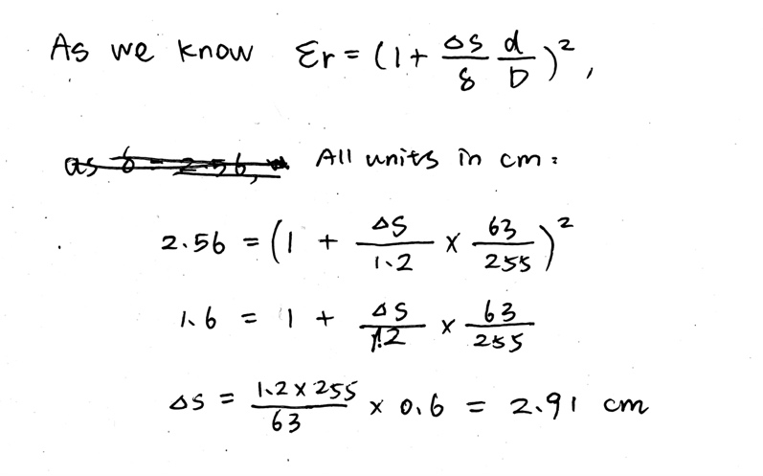

So the shift in cm would be 2.91 cm.

**Question 8**

**Copy in your answer sheet your plot corresponding to the array factor for two antennas with a separation of λ 2 and phase difference of 180°.**

**Question 9**

**(i) What is the difference between refraction and diffraction?**

**(ii) Comment on the effect of diffraction in microwave communications systems.**

In microwave communication systems, they utilize electromagnetic waves that have wavelengths ranging from 100 um to 1m. If the wave encounters a gap that is similar in size to its wavelength, there will be diffraction. However, if the obstacle is too large, such as a mountain, diffraction may not occur, which could result in signal attenuation or loss.

As a result, microwave communication is considered line-of-sight communication and necessitates the use of microwave relay stations.

**(iii) explain the use of a grating in a device that can separate light with a narrow band of wavelengths from a white source (monochromator)?**

**10. In reference to the Experiment 2.2, do the results shown in the table in the tutorial script, indicate that the polarisation of the source is:**

**i) horizontal (on the *x-z* plane) – or – vertical (along *y*-axis)**

It is horizontal (on the x-z plane).

**ii) why? [6 marks]**

It is because the photoelectron energy increases with the increase in wavelength, and it is said in the script that the longer side is horizontal leading to a relatively large wavelength, thus to a stronger polarization. Because of this, the intensity of received wave in horizontal is much larger than the vertical one.

Referring to the table in the script, the horizontal component of the received wave of both wire grid and wire mesh are much larger than its vertical component. Thus we can conclude that the polarization is horizontal.

**iii) why is there a difference between the results using a wire grid and the rhomboidal mesh?**

**Explain.**

