The code ‘TOW_length.cpp’ will print the relationship between displacement and time in the TOW model.

The parameter ‘snap’ is the number of steps of Gillespie algorithm. The higher the snap, the more loops. To ensure accuracy, snap should be set at least 106.

The parameter ‘seed’ is used to determine whether to output the value of the parameter. If seed = 1, it means that the parameters of kinesin and dynein will be output while outputting time and run length. On the contrary, the parameters of motors will not be output.

The parameter ‘Np’ means the number of plus motors called kinesin while ‘Nm’ means the number of minus motors called dynein. The parameters ‘Fsp’, ‘Fdp’, ‘pip’, ‘Vfp’, ‘Vbp’ and ‘gamma0p’ are the stall force, the detachment force, the binding rate, the forward velocity, the backward velocity and the unbinding rate of kinesin respectively. The parameters ‘Fsm’, ‘Fdm’, ‘pim’, ‘Vfm’, ‘Vbm’ and ‘gamma0m’ are same as above but the parameters of dynein.

For a group of parameters, the change relationship of cargo position with time in TOW model is shown in the figure below:

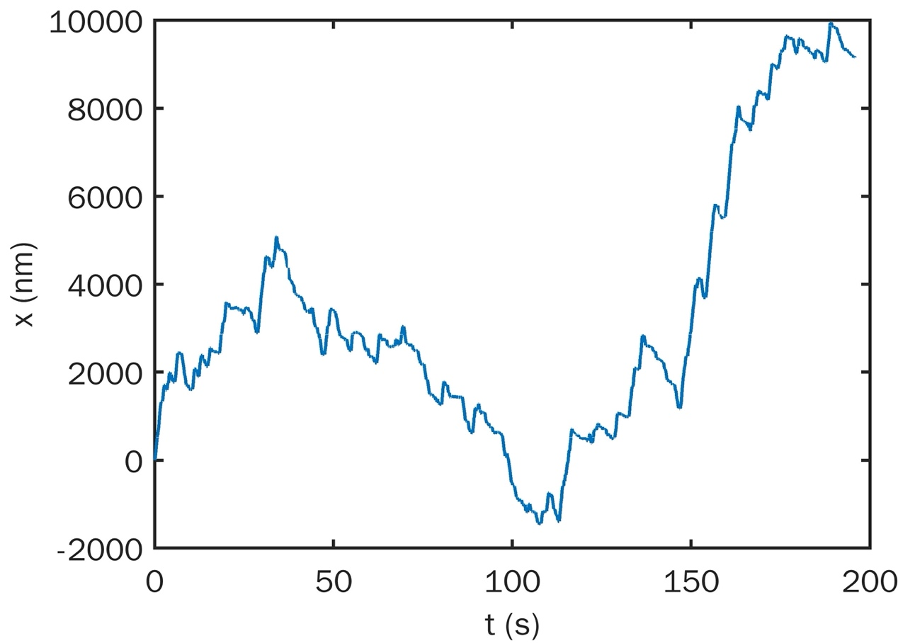

In order to get this data, we should run commends

g++ TOW_length.cpp

./a.out

Then we can see the data in ‘run.txt’.

The code ‘crunlength.cpp’ prints the average velocity of short and long runs. It also prints the average run length of plus and minus directions.

The parameter ‘pause_x’ means the maximum length of a pause. The parameter ‘pause_t’ means the pause duration. The parameter ‘reverse_x’ means the minimum length of a reverse.

In the output result, the ‘plus velocity of short run’ and ‘minus velocity of short run’ are the average velocity of run whose length is between 30nm and 100nm. The ‘plus velocity of long run’ and ‘minus velocity of long run’ are the average velocity of run whose length is between 500nm and 1000nm. The ‘runlength plus’ and ‘runlength minus’ are the average length of plus and minus run which ignores the pause (run length > 30nm in 0.16s).

In order to get this data, we should put ‘crunlength.cpp’ and ‘TOW_length.cpp’ in the same folder and set the parameter ‘seed’ as 1 in ‘TOW_length.cpp’. Then run those commends:

g++ TOW_length.cpp

./a.out

g++ crunlength.cpp

./a.out

Then we can see the date in ‘output.txt’.