Sepsis Prediction using ML and EHRs

General information
In this assignment, we will build predictive model for Sepsis risk prediction using data extracted from electronic health records (EHR) and supervised machine learning.

Obtaining the dataset:
The synthetic data are generated based on the public dataset that was used for the “2019 PhysioNet Challenge”. The information for each patient is saved into a ".csv” file and the file name is the patient’s ID (it is unique). In each “.csv” file, patient’s features were condensed into hourly bins from admission to discharge. The column “Hours_Since_Admission” contains this information. If you want to know more details about the original dataset, you can go to “https://physionet.org/content/challenge-2019/1.0.0/ ”.

Problem 1: Outcome determination
- Sepsis is the body's overwhelming and life-threatening response to infection that may lead to tissue damage, organ failure, and death. The definition of sepsis can be found here. Whether and when a patient went into septic shock is provided in the data (see the column of “Sepsis_Onset”). For patients who do not develop sepsis, the Sepsis_Onset column is 0. For patients who do develop sepsis, the Sepsis_Onset column is 1.

Experimental setup
For the remaining problems, we will design experimental setting to predict sepsis.

Sepsis prediction: We will predict whether or not patients will develop sepsis 6 hours prior to onset.
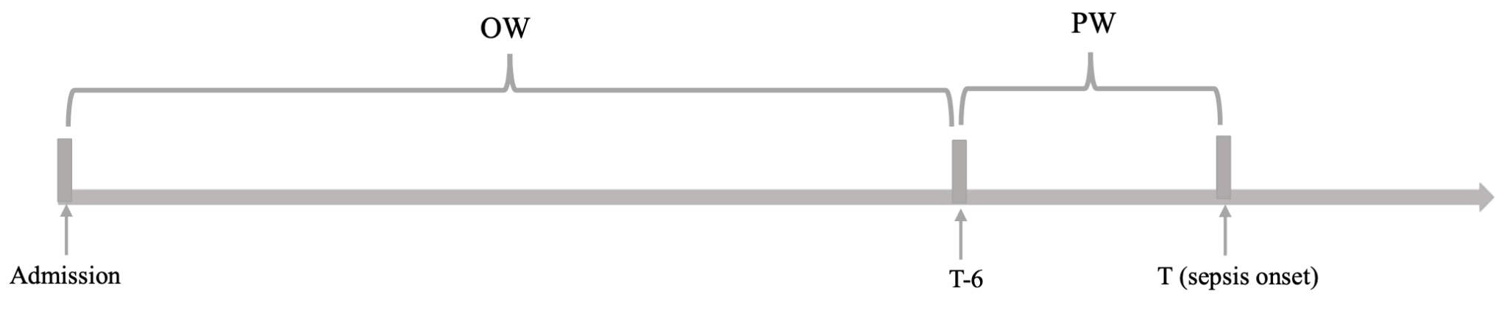

OW: Observational Window (features will be aggregated in OW)
PW: Prediction Window (6 hours)

Note that:
- Cases are patients that are labeled as sepsis. Controls are samples that are not labeled as sepsis.
- The length of OW for controls: if one patient is not discharged during 24 hours, the length of OW is set as a 24-hour time window after admission to the hospital. If a patient is discharged within 24 hours, we consider the entire time window from admission to discharge.
- The length of OW for cases: a OW was selected for the patient as the entire period from admission to 6 hours prior to the onset of sepsis.

Problem 2: Feature extraction:
There are 35 continuous variables (features) including vital signs, laboratory tests, and demographics. Please extract these features from the dataset. More details are shown in the following table.
Table 1: 35 continuous features
# | Variables | Description
1 | HR | Heart rate (beats/min)
2 | O2Sat | Pulse oximetry (%)
3 | Temp | Temperature (ºC)
4 | SBP | Systolic BP (mm Hg)
5 | MAP | Mean arterial pressure (mm Hg)
6 | DBP | Diastolic BP (mm Hg)
7 | Resp | Respiration rate (breaths/min)
8 | Etco2 | End tidal carbon dioxide (mm Hg)
9 | BaseExcess | Excess bicarbonate (mmol/L)
10 | Hco3 | Bicarbonate (mmol/L)
11 | FIO2 | Fraction of inspired oxygen (%)
12 | pH | pH
13 | Paco2 | Partial pressure of carbon dioxide from arterial blood (mm Hg)
14 | Sao2 | Oxygen saturation from arterial blood (%)
15 | AST | Aspartate transaminase (IU/L)
16 | BUN | Blood urea nitrogen (mg/dL)
17 | Alkalinephos | Alkaline phosphatase (IU/L)
18 | Calcium | Calcium (mg/dL)
19 | Chloride | Chloride (mmol/L)
20 | Creatinine | Creatinine (mg/dL)
21 | Bilirubin direct | Direct bilirubin (mg/dL)
22 | Glucose | Serum glucose (mg/dL)
23 | Lactate | Lactic acid (mg/dL)
24 | Magnesium | Magnesium (mmol/dL)
25 | Phosphate | Phosphate (mmol/L)
26 | Potassium | Potassium (mmol/L)
27 | Bilirubin total | Total bilirubin (mg/dL)
28 | TroponinI | Troponin I (ng/mL)
29 | Hct | Hematocrit (%)
30 | Hgb | Hemoglobin (g/dL)
31 | PTT | Partial thromboplastin time (s)
32 | WBC | Leukocyte count (count/L)
33 | Fibrinogen | Fibrinogen concentration (mg/dL)
34 | Platelets | Platelet count (count/mL)
35 | Age | Age (yr)

- Creating prediction matrix for predicting sepsis problem:
  - For each prediction matrix, “Average” the values so that there is a single number per feature per OW. If values are missing for the entire OW, leave the value missing during this step.
  - This will result in an N*M matrix (each row represents the feature value in the OW for a patient, and each column represents one feature. N and M are the number of patients including in the analysis and features, respectively). For each feature, fill missing values using the “median” over patients after average aggregation. Note that, some features can be removed if there are high missing rate (e.g., >30%). Addressing outlier is also necessary.

Problem 3: Building model and result analysis
For predicting sepsis, please do the following:
- Building model: Consider decision tree and random forest. Use 5-Fold cross-validation on the training data to choose optimal hyperparameters.
- Prediction performance: Report the Area under the ROC (receiver operating characteristic curve) Curve (AUC), precision, recall, and F1 score.
- Considering feature importance for result analysis

