Multi-Scanner Burp Extension

Introduction:
Multi-Scanner is an extension to the burp suite. It automates the task of making requests to target websites posing as a variety of devices.
Mobile versions of sites may be different due to
- Different programmers
- Different functionalities (e.g. hover is not possible on a mobile device)
- Compatibility issues (e.g. flash)
Without the extension a penetration tester would have to manually intercept the requests, modify them before forwarding, compare the responses and finally call active scans on each of them. This can be done for a few requests on a few pages but will quickly become a problem when the scale increases. Multi-Scanner provides an efficient and scalable mechanism to carry out these tasks automatically.
Currently it requests the target web pages with the following list of user agents
- Mozilla/5.0 (Macintosh; Intel Mac OS X 10.7; rv:16.0) Gecko/20100101 Firefox/16.0
- Mozilla/5.0 (iPhone; CPU iPhone OS 5_0 like Mac OS X) AppleWebKit/534.46 (KHTML, like Gecko) Version/5.1 Mobile/9A334 Safari/7534.48.3
- Mozilla/5.0 (iPad; CPU OS 5_0 like Mac OS X) AppleWebKit/534.46 (KHTML, like Gecko) Version/5.1 Mobile/9A334 Safari/7534.48.3
- Mozilla/5.0 (Linux; U; Android 4.0.3; ko-kr; LG-L160L Build/IML74K) AppleWebkit/534.30 (KHTML, like Gecko) Version/4.0 Mobile Safari/534.30
- Mozilla/5.0 (compatible; MSIE 9.0; Windows Phone OS 7.5; Trident/5.0; IEMobile/9.0; SAMSUNG; SGH-i917)
- Mozilla/5.0 (compatible; MSIE 10.0; Windows Phone 8.0; Trident/6.0; IEMobile/10.0; ARM; Touch; NOKIA; Lumia 920)
- Mozilla/5.0 (BlackBerry; U; BlackBerry 9900; en) AppleWebKit/534.11+ (KHTML, like Gecko) Version/7.1.0.346 Mobile Safari/534.11+

This list can be easily augmented to include more devices/browsers.
The response is then captured for each user agent. The first user agent is a baseline user agent which all the others (mobile devices) are compared against. If the responses are found to be the same, the extension alerts the user and does no further work. If differences are found, the extension proceeds to do an active scan on all the versions.
https is also supported.

Working:
The Extension is provided as a jar file easily added to the Burp Pro Suite.
On loading the extension, a new item is added to the context menu “Extension: Multi Scanner”. On click, the extension starts executing. The output is shown in the output tab under Extender tab of Burp. It shows information regarding the targets being scanned and the user agents list. On examining the responses, the output pane informs the user if the responses were differing or not and also the response lengths. Depending on that, information is displayed as to whether we are doing multiple scans simultaneously or not.
The user is also alerted to this via the Alerts tab. Finally the results of scanning can be seen in the Scanner tab.
The program’s flow is as follows:
Flow Chart
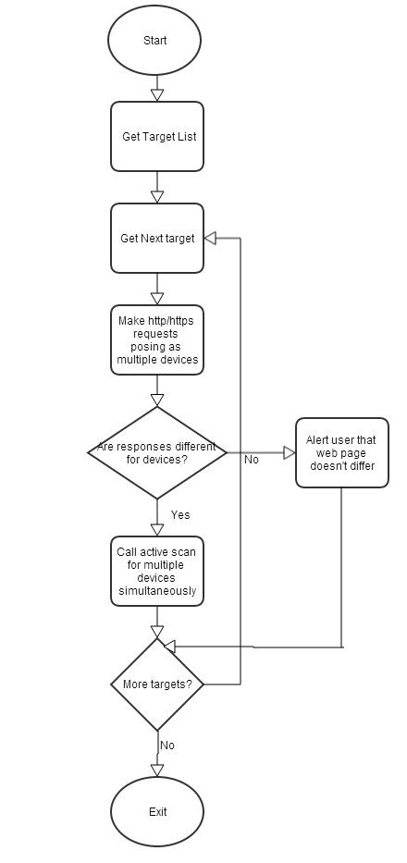
Code Description:
Class BurpExtender is the main class that implements IBurpExtender interface.
It registers the extensions name, prints a message on successful loading and implements the MultiScannerMenuItem.
This menu item’s on click method contains the logic to get the list of target websites, make requests, examine responses and call active scans. Burp’s stdout stream is used for information output.
The callback objects makeHttpRequest, doActiveScan and issueAlert method are used.
Screenshots:
Loading the extension
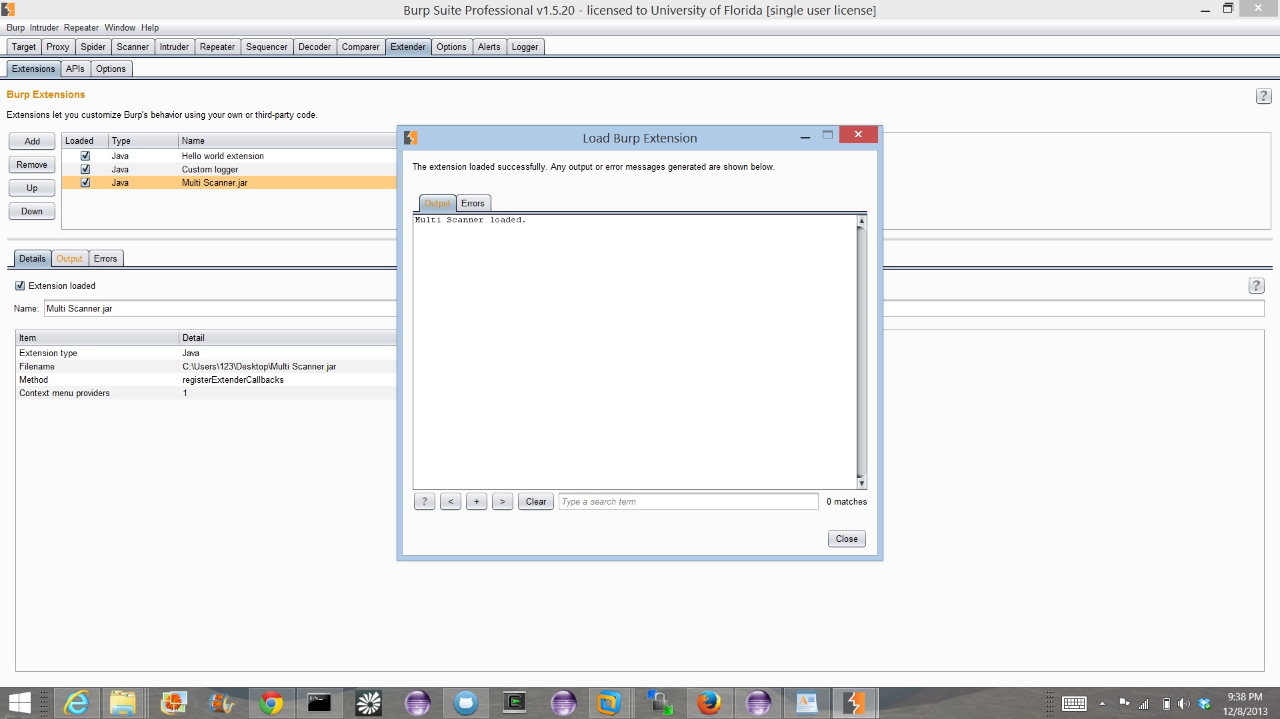

Context Menu Item
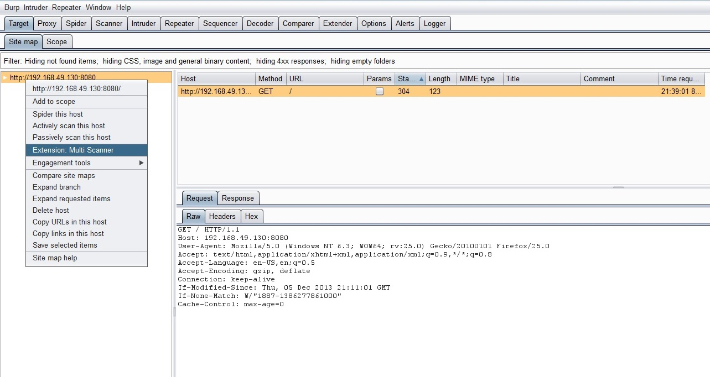
Request and Response Information
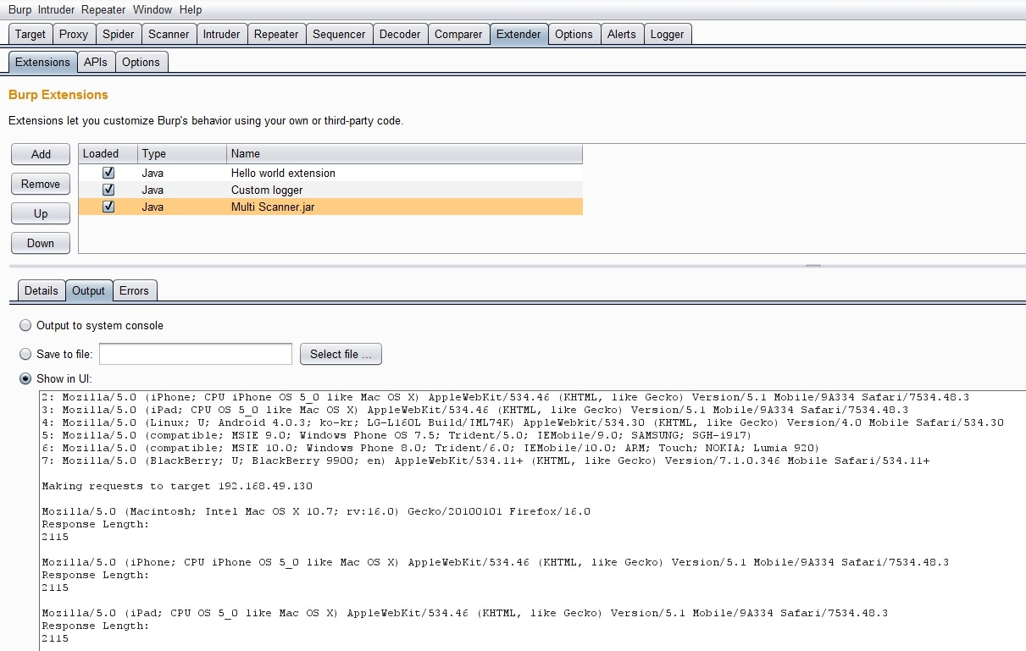

Alerts
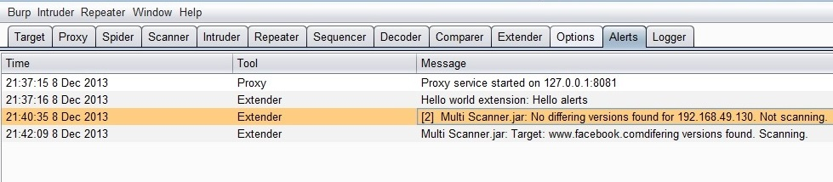

Scanning
