CS 5789 A2 Writeup

Name: Xingze Li NetID: xl834 3/Mar/2023

**Output cost from test_policy:**

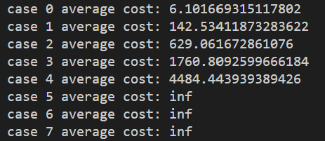

Analysis:

The cost function includes a penalty on the control inputs and the state deviations from a desired setpoint. The cost increase with such a large magnitude may result from the penalty term on state deviations from setpoint while the initial states have increasing deviation of a certain element in vector.

**Comparison:**

The cost of cartpole (LQR): 2.125

The cost of cartpole (PID): 252.723

Obviously, LQR is better than PID.