**Task:**

1) Create the website which will have - create, read, update, delete operations.

2) Using:

* **Front-end** – React
* **Back-end** – Node JS;
* **DB** – PostgreSQL;

3) Use migration for DB. You don’t create the tables before first launch of server. You just set your credentials for empty DB and after migration it should has relevant table with fields.

4) Image using (you can use image link. Without middleware or images upload.)

5) Firstly, use remote DB, it will be comfortably when you will do deploy of project.

6) **Benefits**: Redux: I want to see all actions in browser`s console. Like this (sample actions between tabs of menu):

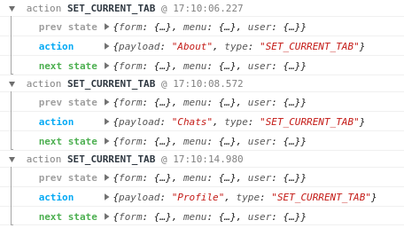

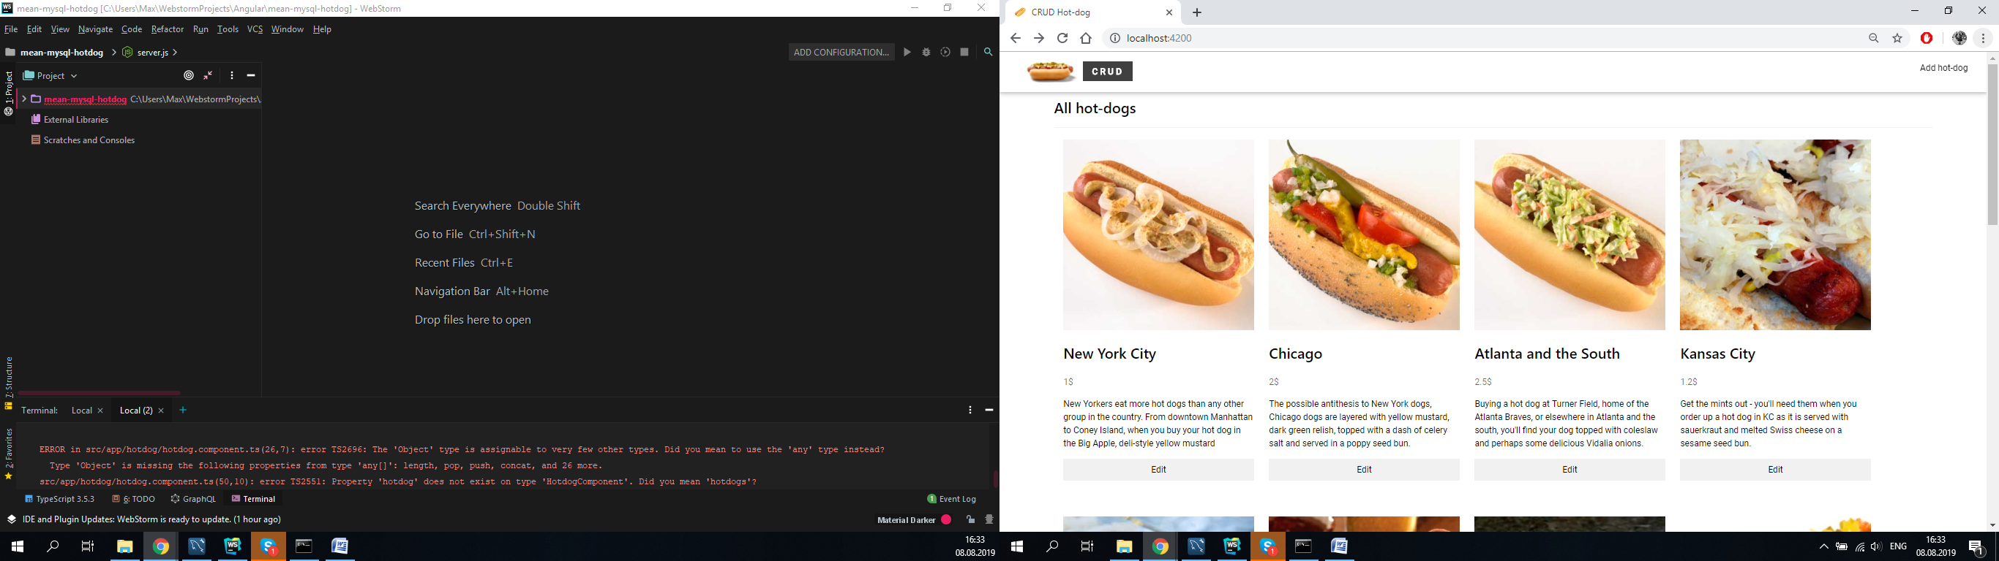

Use redux-form for input field “name” and inform when the name of item (ex: hot-dog) already exist. Without refresh page or send form.

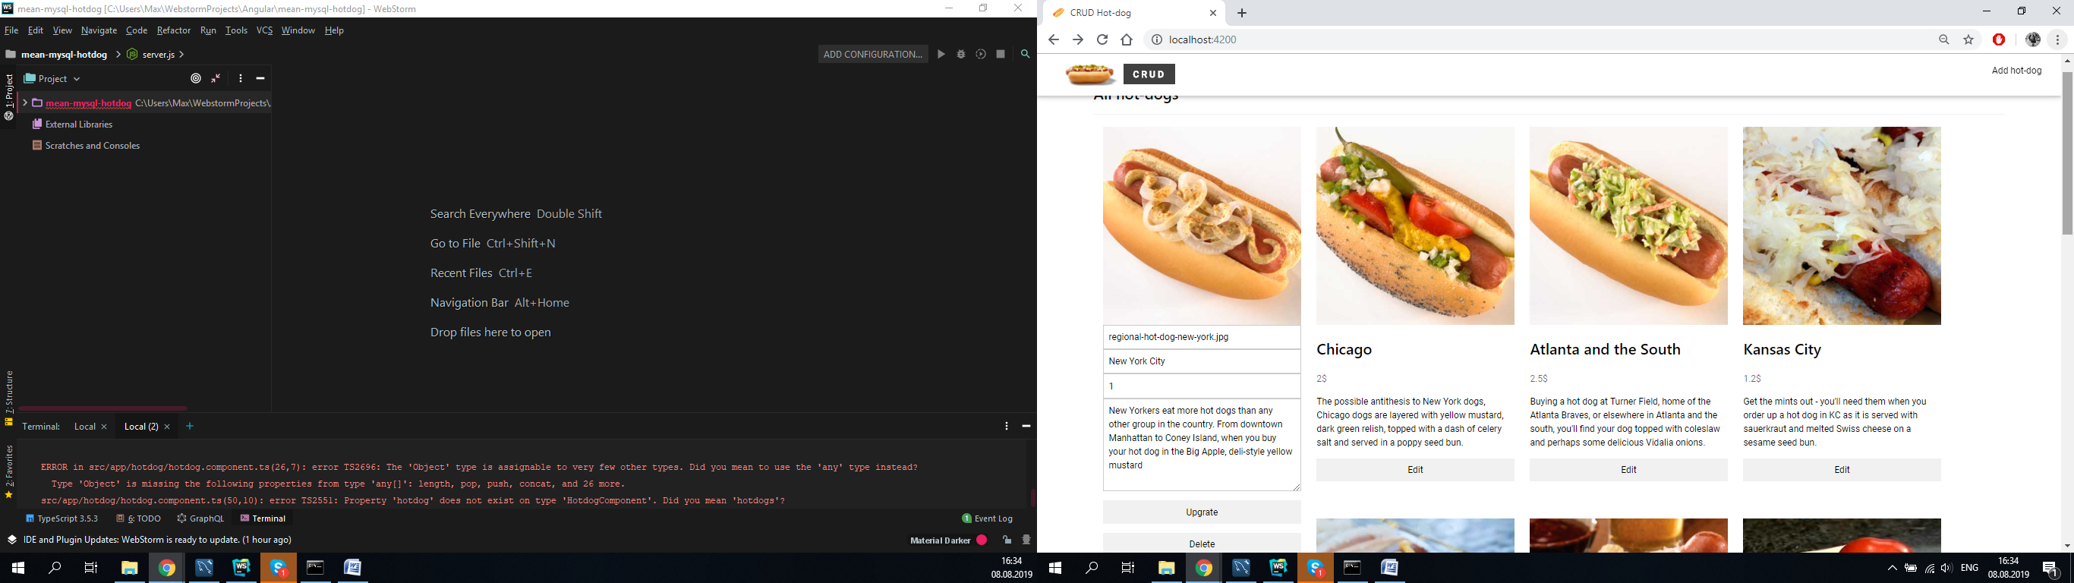When I put **Edit** button:

When I put **Add** button:

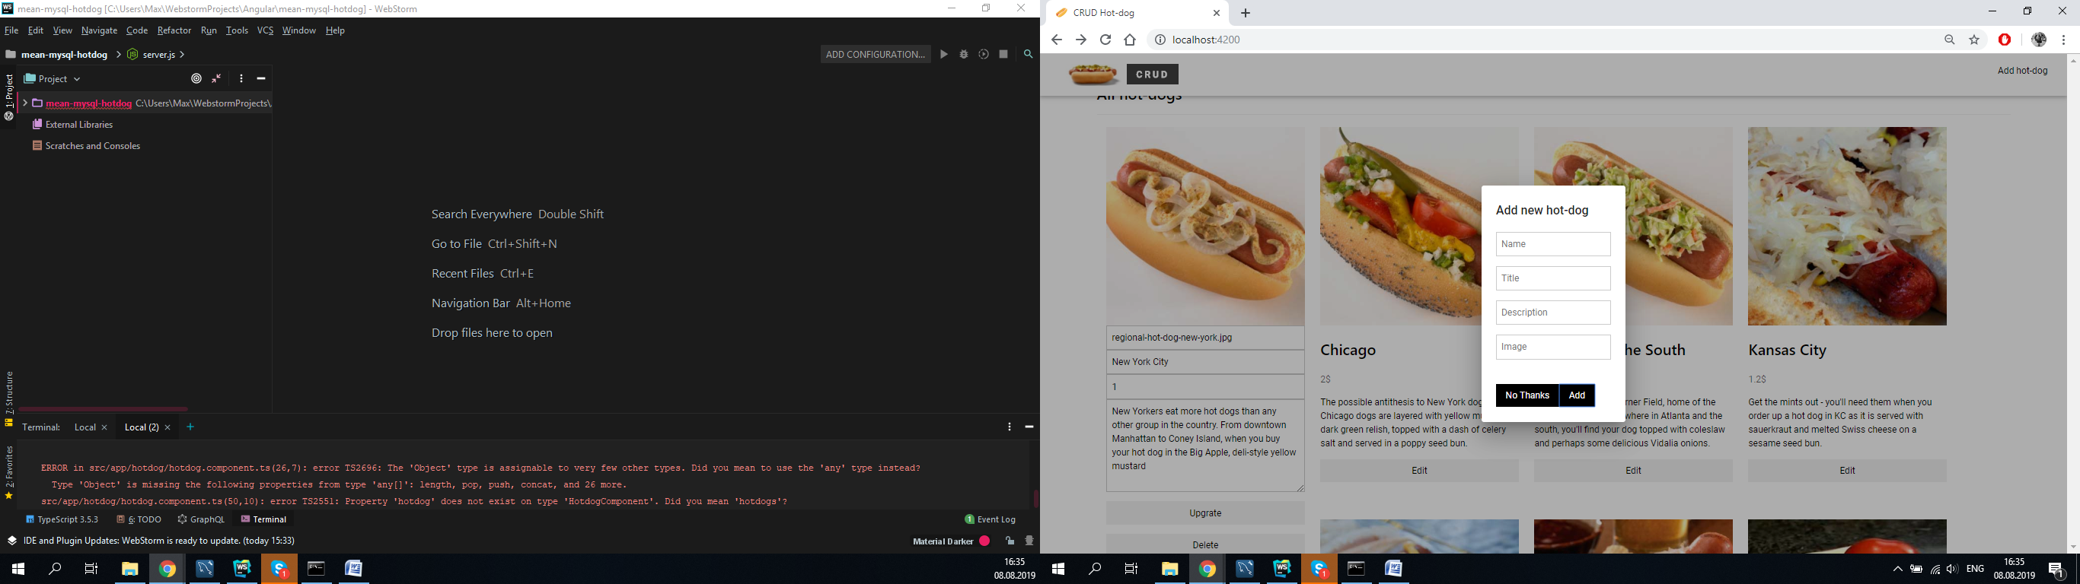

Good luck!