**Description:**

Aim should be to create a user account by authenticating the user with G-Suite / Microsoft active directory and show a simple page of dashboard showing a list of record containing text in a grid with some user details. Clicking on one record should display related text.

Give importance to functionality and code quality, look and feel is not important.

**Practices:**

Create Microservices and REST APIs wherever needed, use a database of Your choice keeping in mind scalability factor. If possible, containerize using Kubernetes. The dashboard should display information from the database.

**Optional**

Multiple users – Upon log in each user should see their own record

Look and feel

**User account creation illustration -just for reference, doesn’t have to look same.**

**You may limit the fields.** (Name, email, password fields are mandatory, others optional)

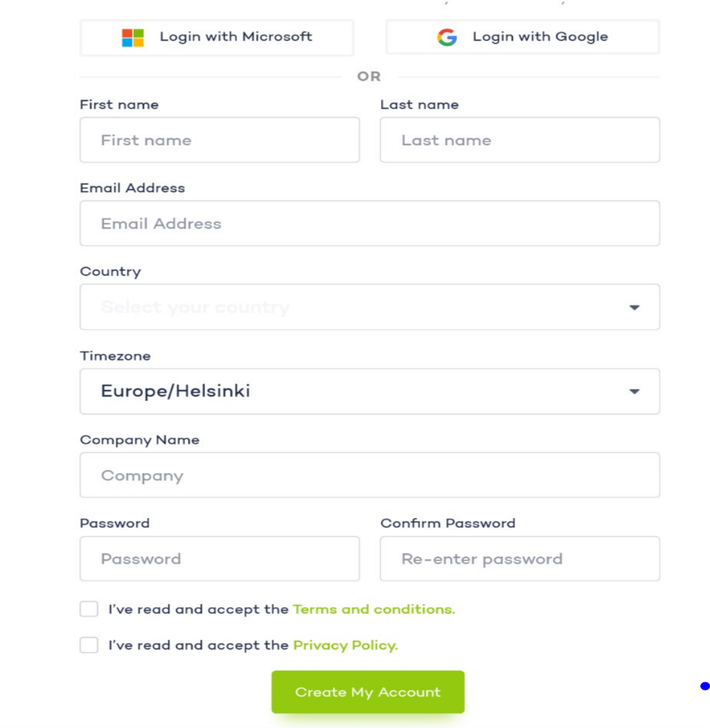

**Dashboard illustration -just for reference, doesn’t have to look same.**

(timestamp and duration can be mocked and stored in database, icons and graphics are not important)

