

Technical Safety Concept Lane Assistance

**Document Version: 1.0**



# Document history

|  |  |  |  |
| --- | --- | --- | --- |
| Date | Version | Editor | Description |
| 15.08.2018 | 1.0 | Reuss | First version |
|  |  |  |  |
|  |  |  |  |
|  |  |  |  |
|  |  |  |  |

# 

# Table of Contents

Document history

Table of Contents

Purpose of the Technical Safety Concept

Inputs to the Technical Safety Concept

Functional Safety Requirements

Refined System Architecture from Functional Safety Concept

Functional overview of architecture elements

Technical Safety Concept

Technical Safety Requirements

Refinement of the System Architecture

Allocation of Technical Safety Requirements to Architecture Elements

Warning and Degradation Concept

# Purpose of the Technical Safety Concept

The purpose of the Technical Safety Concept is to:

* Turning functional safety requirements into technical safety requirements
* Allocating technical safety requirements to the system architecture

# Inputs to the Technical Safety Concept

## Functional Safety Requirements

|  |  |  |  |  |
| --- | --- | --- | --- | --- |
| **ID** | **Functional Safety Requirement** | **ASIL** | **Fault Tolerant Time Interval** | **Safe State** |
| Functional  Safety  Requirement  01-01 | The electronic power steering ECU shall ensure that the lane departure oscillating torque amplitude is below Max_Torque_Amplitude. | C | 50ms | Set vibration torque to zero and shut off system |
| Functional  Safety  Requirement  01-02 | The electronic power steering ECU shall ensure that the lane departure oscillating torque frequency is below Max_Torque_Frequency. | C | 50ms | Set vibration torque to zero and shut off system |
| Functional  Safety  Requirement  02-01 | The electronic power steering ECU shall ensure that the lane keeping assistance torque is applied for only Max_Duration. | B | 500ms | Shut off system |

## Refined System Architecture from Functional Safety Concept

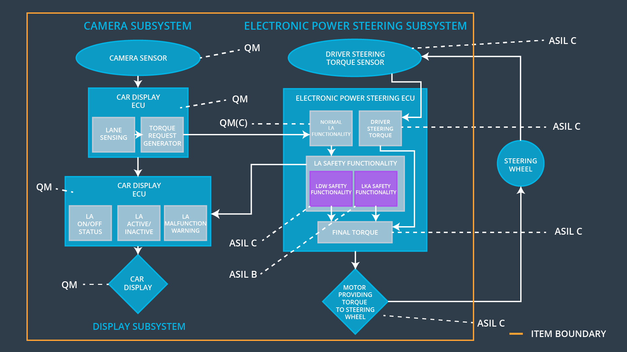

### 

### Functional overview of architecture elements

|  |  |
| --- | --- |
| **Element** | **Description** |
| Camera Sensor | Takes images of the road. |
| Camera Sensor ECU - Lane Sensing | Processes images taken by the camera sensor and identifies lanes. |
| Camera Sensor ECU - Torque request generator | Processes identified lanes together with the cars position and generates a torque request, that is sent to the Electronic power steering ECU. |
| Car Display | Display used to share information with the driver. |
| Car Display ECU - Lane Assistance On/Off Status | Symbol in vehicle display that tells the driver if the lane assistance system is in status On/Off. |
| Car Display ECU - Lane Assistant Active/Inactive | Symbol in vehicle display that tells the driver if the lane assistance system is in status Active/Inactive. |
| Car Display ECU - Lane Assistance malfunction warning | Symbol in vehicle display that warns the driver if the lane assistance system malfunctions. |
| Driver Steering Torque Sensor | Measures torque applied by the driver the steering wheel. |
| Electronic Power Steering (EPS) ECU - Driver Steering Torque | Processes inputs of driver steering torque sensor. |
| EPS ECU - Normal Lane Assistance Functionality | Software block that processes torque request input from camera sensor ECU and outputs a torque request to both safety software blocks LDW safety functionality and LKA safety functionality. |
| EPS ECU - Lane Departure Warning Safety Functionality | Safety software block that validates the requested torque by the normal lane assistance functionality regarding amplitude and frequency.  Generates a torque request as output. |
| EPS ECU - Lane Keeping Assistant Safety Functionality | Safety software block that validates the requested torque by the normal lane assistance functionality regarding duration of lane keep assistance functionality switched on.  Generates a torque request as output. |
| EPS ECU - Final Torque | Resulting final torque request sent to the motor. |
| Motor | Adds additional torque to the steering wheel, if requested. |

# Technical Safety Concept

## Technical Safety Requirements

**Lane Departure Warning (LDW) Requirements:**

Functional Safety Requirement 01-01 with its associated system elements

(derived in the functional safety concept)

|  |  |  |  |  |
| --- | --- | --- | --- | --- |
| **ID** | **Functional Safety Requirement** | **Electronic Power Steering ECU** | **Camera ECU** | **Car Display ECU** |
| Functional  Safety  Requirement  01-01 | The lane keeping item shall ensure that the lane departure oscillating torque amplitude is below Max_Torque_Amplitude | X |  |  |

Technical Safety Requirements related to Functional Safety Requirement 01-01 are:

|  |  |  |  |  |  |
| --- | --- | --- | --- | --- | --- |
| **ID** | **Technical Safety Requirement** | **ASIL** | **Fault Tolerant Time Interval** | **Architecture Allocation** | **Safe State** |
| Technical  Safety  Requirement  01 | The LDW safety component shall ensure that the amplitude of the ‘LDW_Torque_Request’ sent to the ‘Final electronic power steering Torque’ component is below ‘Max_Torque_Amplitude’. | C | 50ms | LDW Safety block | Lane Departure Warning Torque shall be set to zero |
| Technical  Safety  Requirement  02 | The validity and integrity of the data transmission for ‘LDW_Torque_Request’ signal shall be ensured. | C | 50ms | Data Transmission Integrity check | Lane Departure Warning Torque shall be set to zero |
| Technical  Safety  Requirement  03 | As soon as a failure is detected by the LDW function, it shall deactivate the LDW feature and the ‘LDW_Torque_Request’ shall be set to zero. | C | 50ms | LDW Safety block | Lane Departure Warning Torque shall be set to zero |
| Technical  Safety  Requirement  04 | As soon as the LDW function deactivates the LDW feature, the ‘LDW_Safety’ software block shall send a signal to the car display ECU to turn on a warning light. | C | 50ms | LDW Safety block | Lane Departure Warning Torque shall be set to zero |
| Technical  Safety  Requirement  05 | Memory test shall be conducted at start up of the EPS ECU to check for any faults in memory. | A | Ignition cycle | Memory Test | Lane Departure Warning Torque shall be set to zero |

Functional Safety Requirement 01-2 with its associated system elements

(derived in the functional safety concept)

|  |  |  |  |  |
| --- | --- | --- | --- | --- |
| **ID** | **Functional Safety Requirement** | **Electronic Power Steering ECU** | **Camera ECU** | **Car Display ECU** |
| Functional  Safety  Requirement  01-02 | The lane keeping item shall ensure that the lane departure oscillating torque frequency is below Max_Torque_Frequency | X |  |  |

Technical Safety Requirements related to Functional Safety Requirement 01-02 are:

|  |  |  |  |  |  |  |
| --- | --- | --- | --- | --- | --- | --- |
| **ID** | **Technical Safety Requirement** | **ASIL** | **Fault Tolerant Time Interval** | | **Architecture Allocation** | **Safe State** |
| Technical  Safety  Requirement  01 | The LDW safety component shall ensure that the amplitude of the ‘LDW_Torque_Request’ sent to the ‘Final electronic power steering Torque’ component is below ‘Max_Torque_Frequency’. | C | | 50ms | LDW Safety block | Lane Departure Warning Torque shall be set to zero |
| Technical  Safety  Requirement  02 | The validity and integrity of the data transmission for ‘LDW_Torque_Request’ signal shall be ensured. | C | | 50ms | Data Transmission Integrity check | Lane Departure Warning Torque shall be set to zero |
| Technical  Safety  Requirement  03 | As soon as a failure is detected by the LDW function, it shall deactivate the LDW feature and the ‘LDW_Torque_Request’ shall be set to zero. | C | | 50ms | LDW Safety block | Lane Departure Warning Torque shall be set to zero |
| Technical  Safety  Requirement  04 | As soon as the LDW function deactivates the LDW feature, the ‘LDW_Safety’ software block shall send a signal to the car display ECU to turn on a warning light. | C | | 50ms | LDW Safety block | Lane Departure Warning Torque shall be set to zero |
| Technical  Safety  Requirement  05 | Memory test shall be conducted at start up of the EPS ECU to check for any faults in memory. | A | | Ignition cycle | Memory Test | Lane Departure Warning Torque shall be set to zero |

**Lane Departure Warning (LDW) Verification and Validation Acceptance Criteria:**

...

**Lane Keeping Assistance (LKA) Requirements:**

Functional Safety Requirement 02-1 with its associated system elements

(derived in the functional safety concept)

|  |  |  |  |  |
| --- | --- | --- | --- | --- |
| **ID** | **Functional Safety Requirement** | **Electronic Power Steering ECU** | **Camera ECU** | **Car Display ECU** |
| Functional  Safety  Requirement  02-01 | The lane keeping item shall ensure that the lane keeping assistance torque is applied for only Max_Duration | X |  |  |

Technical Safety Requirements related to Functional Safety Requirement 02-01 are:

|  |  |  |  |  |  |
| --- | --- | --- | --- | --- | --- |
| **ID** | **Technical Safety Requirement** | **ASIL** | **Fault Tolerant Time Interval** | **Allocation to Architecture** | **Safe State** |
| Technical  Safety  Requirement  01 | The LKA safety component shall ensure that the time of sending ‘LKA_Torque_Request’ to the ‘Final electronic power steering Torque’ component is below ‘Max_Duration’. | B | 500ms | LKA Safety block | Lane Keep Assistance Torque shall be set to zero |
| Technical  Safety  Requirement  02 | The validity and integrity of the data transmission for ‘LKA_Torque_Request’ signal shall be ensured. | B | 500ms | Data Transmission Integrity check | Lane Keep Assistance Torque shall be set to zero |
| Technical  Safety  Requirement  03 | As soon as a failure is detected by the LKA function, it shall deactivate the LKA feature and the ‘LKA_Torque_Request’ shall be set to zero. | B | 500ms | LKA Safety block | Lane Keep Assistance Torque shall be set to zero |
| Technical  Safety  Requirement  04 | As soon as the LKA function deactivates the LKA feature, the ‘LKA_Safety’ software block shall send a signal to the car display ECU to turn on a warning light. | B | 500ms | LKA Safety block | Lane Keep Assistance Torque shall be set to zero |
| Technical  Safety  Requirement  05 | Memory test shall be conducted at start up of the EPS ECU to check for any faults in memory. | A | Ignition cycle | Memory Test | Lane Keep Assistance Torque shall be set to zero |

**Lane Keeping Assistance (LKA) Verification and Validation Acceptance Criteria:**

...

## Refinement of the System Architecture

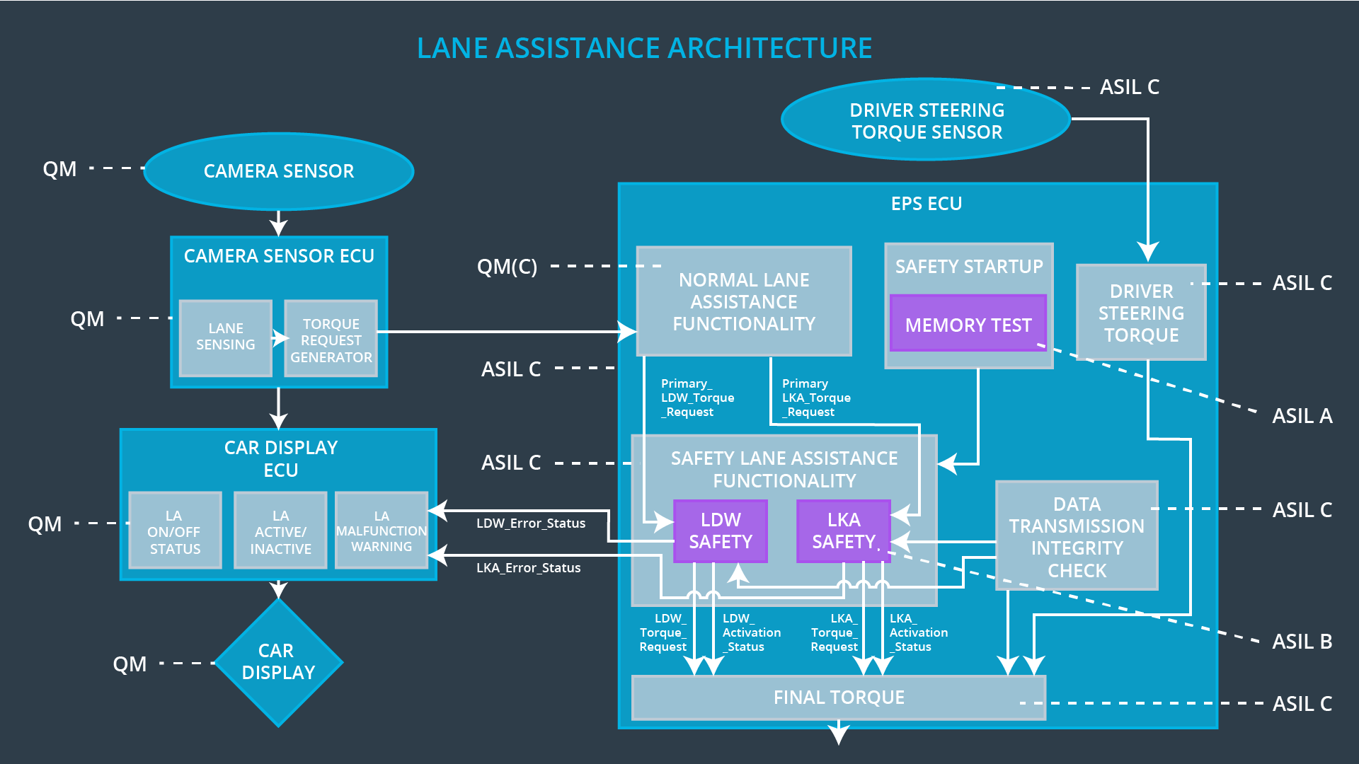

## Allocation of Technical Safety Requirements to Architecture Elements

All technical safety requirements are allocated to the Electronic Power Steering ECU.

## Warning and Degradation Concept

|  |  |  |  |  |
| --- | --- | --- | --- | --- |
| **ID** | **Degradation Mode** | **Trigger for Degradation Mode** | **Safe State invoked?** | **Driver Warning** |
| WDC-01 | Turn off functionality | Torque amplitude over Max_Torque_Amplitude  OR  Torque frequency over Max_Torque_Frequency | Yes | Play alarm sound. Display warning “Lane assistance system is shut off due to malfunction.” |
| WDC-02 | Turn off functionality | Driver did not put hands on the steering wheel for time longer than Max_Duration | Yes | Display warning “Lane assistance system is not designed for autonomous driving. Driver is responsible to control the car at all times. System is shut off.” |