LAB REPORT — Laboratory Work №10
SQL Transactions and Isolation Levels

1. Objective
The purpose of this laboratory work is to study database transactions, understand ACID properties, use COMMIT, ROLLBACK, SAVEPOINT, and explore different transaction isolation levels.

2. Theoretical Background
- Transaction: a sequence of SQL operations executed as a single logical unit.
- ACID:
- Atomicity — all operations succeed or none do.
- Consistency — database stays valid.
- Isolation — transactions do not interfere.
- Durability — committed data survives failures.
Control Statements:
- BEGIN — start transaction
- COMMIT — save changes
- ROLLBACK — undo changes
- SAVEPOINT — rollback partially
Isolation Levels
From strongest → weakest:
- SERIALIZABLE
- REPEATABLE READ
- READ COMMITTED
- READ UNCOMMITTED

3. Practical Tasks

3.1 Task 1 — COMMIT
a)Final balances:
Alice: 900
Bob: 600
b) Why group them into a single transaction?
To ensure that either both updates occur together or none do, preserving integrity during money transfer.
c) What if the system crashed between updates without a transaction?
Alice would lose 100, but Bob wouldn’t get it — data corruption.

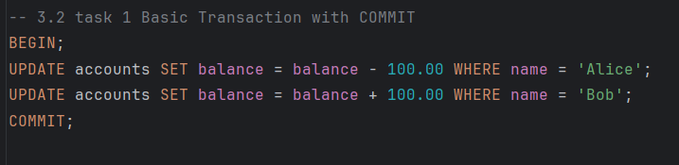
3.2 Task 2 — ROLLBACK
Alice before rollback: 400
Alice after rollback: 900
When use ROLLBACK?
- Wrong data entered
- Unexpected errors
- Constraint violations
- Cancel user action (e.g., failed purchase)
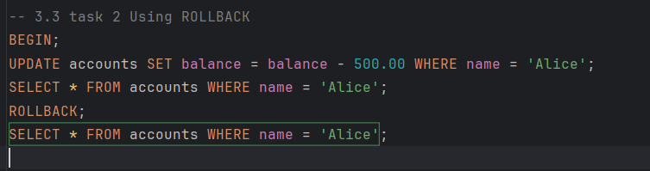

3.3 Task 3 — SAVEPOINT
Final balances:
Alice: 800
Bob: 600
Wally: 850
Was Bob credited?
He was credited temporarily but this was removed by: ROLLBACK TO my_savepoint;
Advantage of SAVEPOINT
Allows partial undo inside one transaction, instead of restarting the whole thing.
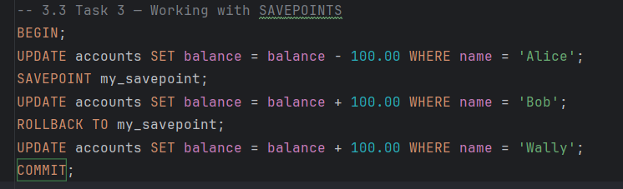
3.4 Task 4 — Isolation Levels
READ COMMITTED: sees updated data after commit.
SERIALIZABLE: sees same snapshot or throws serialization error.

3.5 Task 5 — Phantom Reads
a) No, Terminal 1 does NOT see the new product.
b) Phantom read = new rows appear that match the same WHERE condition.
c) Only SERIALIZABLE prevents phantom reads in standard SQL.
(In PostgreSQL, REPEATABLE READ also prevents phantoms.)

3.6 Task 6 — Dirty Reads
a) Yes, Terminal 1 saw price = 99.99.
This is dangerous because the change was never committed.
b) Dirty read = reading uncommitted data from another transaction.
c) READ UNCOMMITTED is unsafe and almost never used.

4. Independent Exercises
Exercise 1 — Transfer $200 only if Bob has enough money
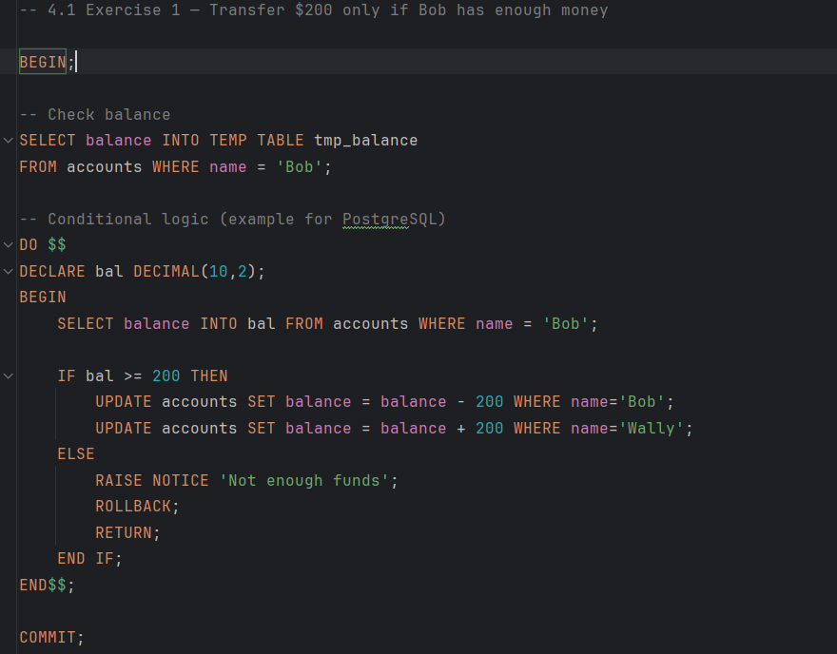
Exercise 2 — Multiple SAVEPOINTs
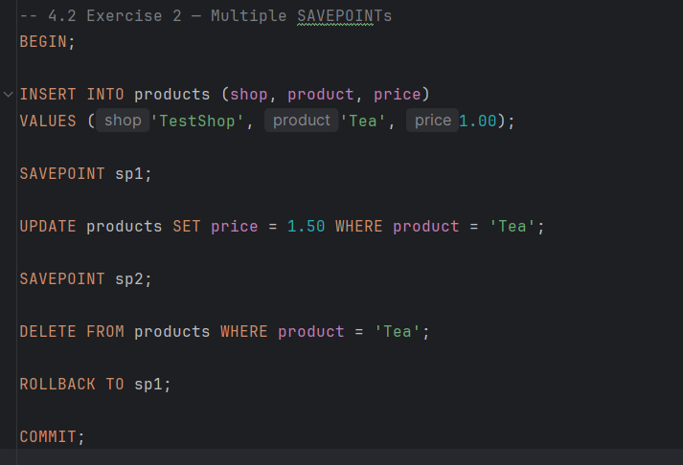
Exercise 3 — Two users withdrawing from the same account
READ COMMITTED
Both users may read the same balance → over-withdraw.
REPEATABLE READ
One transaction waits or restarts to avoid incorrect reads.
SERIALIZABLE
Only one withdrawal succeeds; the second transaction aborts or waits.
Exercise 4 — MAX < MIN anomaly
Bad scenario (no transaction):
User 1: SELECT MAX(price) FROM sells;
User 2 deletes or inserts rows meanwhile
User 1: SELECT MIN(price) FROM sells;
Fix: use transactions
BEGIN TRANSACTION ISOLATION LEVEL SERIALIZABLE;
SELECT MAX(price) FROM sells;
SELECT MIN(price) FROM sells;
COMMIT;

5. Self-Assessment
2. Difference between COMMIT and ROLLBACK
- COMMIT saves changes
- ROLLBACK cancels changes
3. When use SAVEPOINT?
When needing partial undo inside transaction.
4. Compare isolation levels
- SERIALIZABLE — strongest
- REPEATABLE READ — consistent snapshot
- READ COMMITTED — default, sees committed data
- READ UNCOMMITTED — allows dirty reads
5. What is dirty read?
Reading uncommitted changes. Allowed in READ UNCOMMITTED.
6. Non-repeatable read
Same row read twice gives different values.
Occurs in READ COMMITTED.
7. Phantom read
Row set changes (new rows appear).
Prevented by SERIALIZABLE.
8. Why choose READ COMMITTED?
Good performance, avoids unnecessary locks.
9. How transactions maintain consistency?
Atomic operations, isolation, consistency checks.
10. What happens to uncommitted changes after crash?
They are rolled back automatically.

6. Conclusion
During this lab work, we learned how SQL transactions ensure data integrity in multi-user environments. We explored ACID properties, COMMIT, ROLLBACK, SAVEPOINT, and different isolation levels. We demonstrated anomalies such as dirty reads, non-repeatable reads, and phantom reads, and saw how stronger isolation levels prevent them. This knowledge is essential for designing safe financial operations and high-reliability systems.

