# 实验3 JSP与JavaBean

## 实验目的

1. 掌握 JavaBean相关概念
2. 熟悉 JavaBean的使用
3. 在JSP及Servlet中引入JavaBean对象，设置与读取JavaBean属性的方法，以及讨论JavaBean对象的范围。

## 实验内容

### 1. 完成教材【例6-1】Eclipse中编写JavaBean对象的示例。

#### 源代码

package com.xlf.school.bean;  
  
import java.io.Serial;  
import java.io.Serializable;  
  
/**  
 * Goods  
 * <p>  
 * 商品类, 用于存储商品信息  
 *  
 * @version v1.0.0  
 * @since v1.0.0  
 * @author xiao_lfeng  
 */  
public class Goods implements Serializable {  
 @Serial  
 private static final long serialVersionUID = 0;  
 private int gid;  
 private String gname;  
 private double gprice;  
 private int count;  
  
 public int getGid() {  
 return gid;  
 }  
  
 public void setGid(int gid) {  
 this.gid = gid;  
 }  
  
 public String getGname() {  
 return gname;  
 }  
  
 public void setGname(String gname) {  
 this.gname = gname;  
 }  
  
 public double getGprice() {  
 return gprice;  
 }  
  
 public void setGprice(double gprice) {  
 this.gprice = gprice;  
 }  
  
 public int getCount() {  
 return count;  
 }  
  
 public void setCount(int count) {  
 this.count = count;  
 }  
}

### 2. 完成教材的例6-2scope属性使用示例。

<jsp:useBean>标签属性scope，表示JavaBean的作用范围，scope属性的候选值可以是以下四个。

（1） page：表示JavaBean对象作用范围仅限于本页面，在别的页面无法识别。

新建两个JSP页面，分别命名为page1.jsp和page2.jsp。

在page1.jsp的body标签内编写代码，设置1个page范围内的JavaBean对象goods，并设置属性值gname，然后在该页面直接读取，如图6-3所示。

（2） request：表示JavaBean对象除了当前页面可识别外，还可以被request范围内的页面所读取，例如通过forward方式跳转的页面。

（3） session：表示JavaBean对象可以在同一session下所有页面识别。

（4） application：表示只要Web服务器不重启，JavaBean对象能够一直被识别。

#### 源代码

<%@ page contentType="text/html; charset=UTF-8" pageEncoding="UTF-8" %>  
<!doctype html>  
<html lang="zh">  
<head>  
 <meta charset="UTF-8">  
 <meta name="viewport"  
 content="width=device-width, user-scalable=no, initial-scale=1.0, maximum-scale=1.0, minimum-scale=1.0">  
 <meta http-equiv="X-UA-Compatible" content="ie=edge">  
 <title>Document</title>  
</head>  
<body>  
<jsp:useBean id="goods" class="com.xlf.school.bean.Goods" scope="page">  
  
</jsp:useBean>  
  
<jsp:setProperty property="gname" name="goods" value="小米 10"/>  
<jsp:getProperty name="goods" property="gname"/>  
</body>  
</html>

<%@ page contentType="text/html; charset=UTF-8" pageEncoding="UTF-8" %>  
<!doctype html>  
<html lang="zh">  
<head>  
 <meta charset="UTF-8">  
 <meta name="viewport"  
 content="width=device-width, user-scalable=no, initial-scale=1.0, maximum-scale=1.0, minimum-scale=1.0">  
 <meta http-equiv="X-UA-Compatible" content="ie=edge">  
 <title>Document</title>  
</head>  
<body>  
<jsp:useBean id="goods" class="com.xlf.school.bean.Goods" scope="page">  
  
</jsp:useBean>  
  
<jsp:getProperty name="goods" property="gname"/>  
</body>  
</html>

<%@ page contentType="text/html;charset=UTF-8" language="java" %>  
<!doctype html>  
<html lang="zh">  
<head>  
 <meta charset="UTF-8">  
 <meta name="viewport"  
 content="width=device-width, user-scalable=no, initial-scale=1.0, maximum-scale=1.0, minimum-scale=1.0">  
 <meta http-equiv="X-UA-Compatible" content="ie=edge">  
 <title>Document</title>  
</head>  
<body>  
<jsp:useBean id="goods" class="com.xlf.school.bean.Goods" scope="request">  
  
</jsp:useBean>  
  
<jsp:setProperty property="gname" name="goods" value="小米 10"/>  
<jsp:forward page="request2.jsp?gid=1001"/>  
</body>  
</html>

<%@ page contentType="text/html;charset=UTF-8" language="java" %>  
<!doctype html>  
<html lang="zh">  
<head>  
 <meta charset="UTF-8">  
 <meta name="viewport"  
 content="width=device-width, user-scalable=no, initial-scale=1.0, maximum-scale=1.0, minimum-scale=1.0">  
 <meta http-equiv="X-UA-Compatible" content="ie=edge">  
 <title>Document</title>  
</head>  
<body>  
<jsp:useBean id="goods" class="com.xlf.school.bean.Goods" scope="request">  
  
</jsp:useBean>  
  
<jsp:setProperty name="goods" property="gid" param="gid"/>  
<jsp:getProperty name="goods" property="gid"/>  
  
<jsp:getProperty name="goods" property="gname"/>  
</body>  
</html>

<%@ page contentType="text/html;charset=UTF-8" language="java" %>  
<!doctype html>  
<html lang="zh">  
<head>  
 <meta charset="UTF-8">  
 <meta name="viewport"  
 content="width=device-width, user-scalable=no, initial-scale=1.0, maximum-scale=1.0, minimum-scale=1.0">  
 <meta http-equiv="X-UA-Compatible" content="ie=edge">  
 <title>Document</title>  
</head>  
<body>  
<jsp:useBean id="goods" class="com.xlf.school.bean.Goods" scope="session"/>  
<jsp:setProperty property="gname" name="goods" value="小米 10"/>  
</body>  
</html>

<%@ page contentType="text/html;charset=UTF-8" language="java" %>  
<!doctype html>  
<html lang="zh">  
<head>  
 <meta charset="UTF-8">  
 <meta name="viewport"  
 content="width=device-width, user-scalable=no, initial-scale=1.0, maximum-scale=1.0, minimum-scale=1.0">  
 <meta http-equiv="X-UA-Compatible" content="ie=edge">  
 <title>Document</title>  
</head>  
<body>  
<jsp:useBean id="goods" class="com.xlf.school.bean.Goods" scope="session">  
  
</jsp:useBean>  
  
<jsp:getProperty name="goods" property="gname"/>  
</body>  
</html>

#### 截图

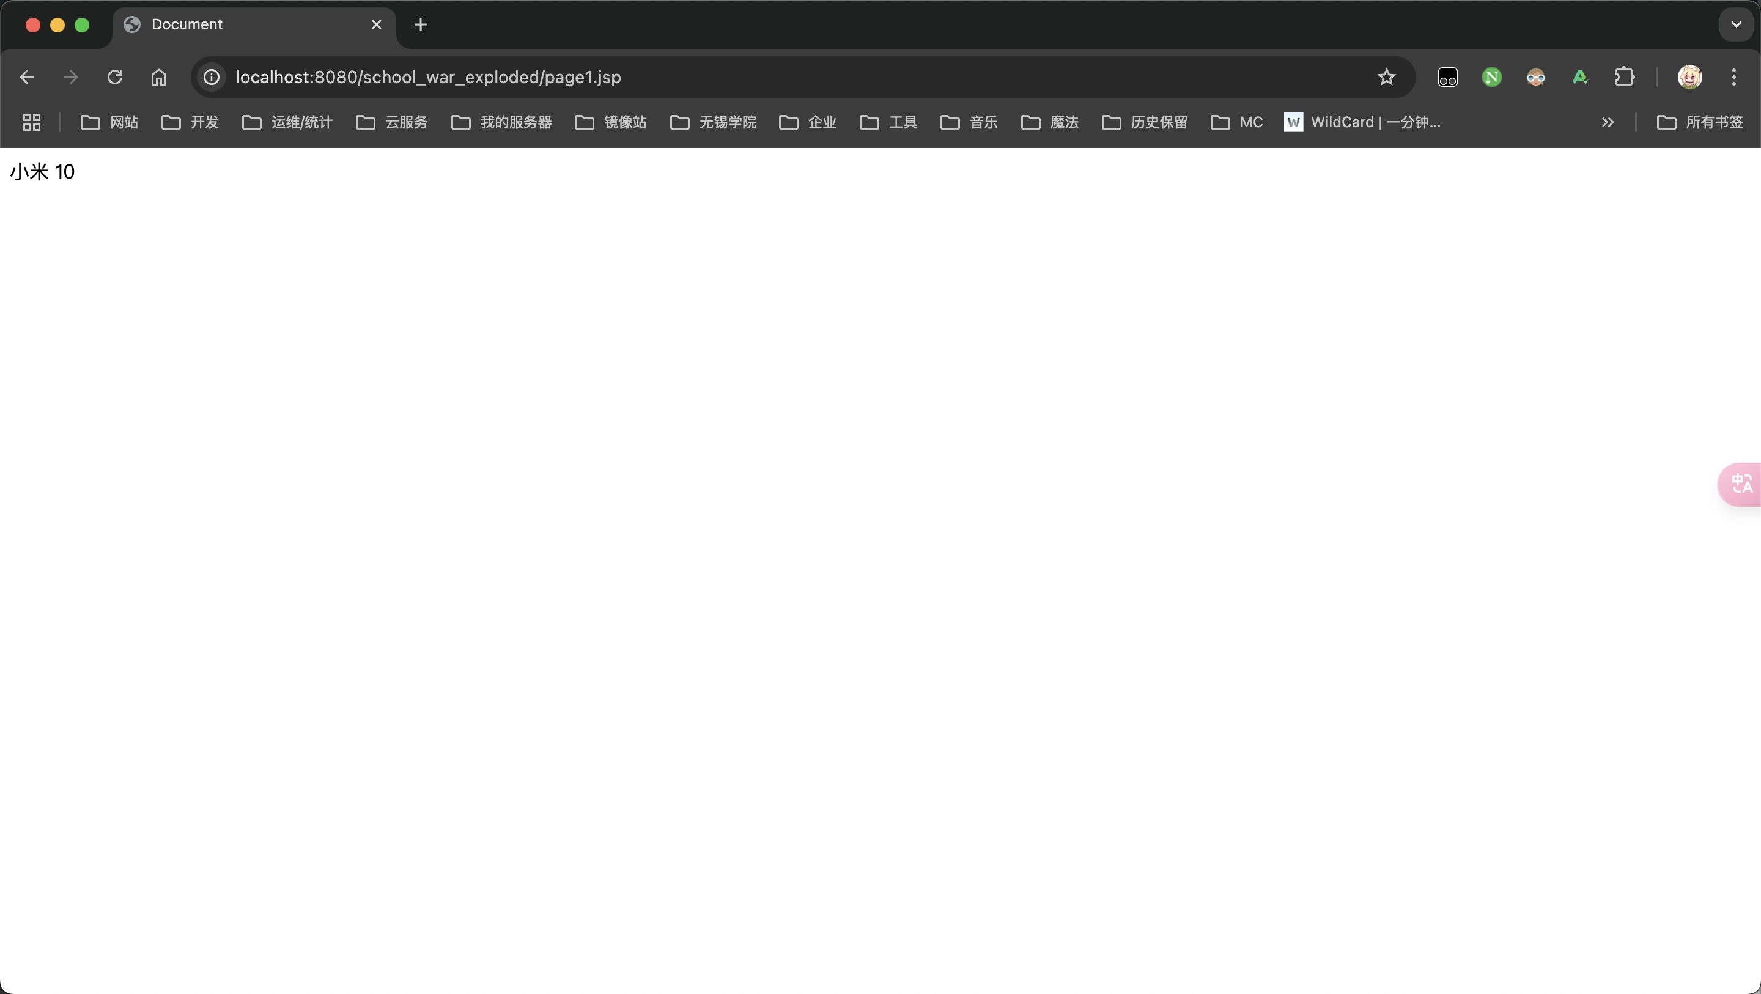

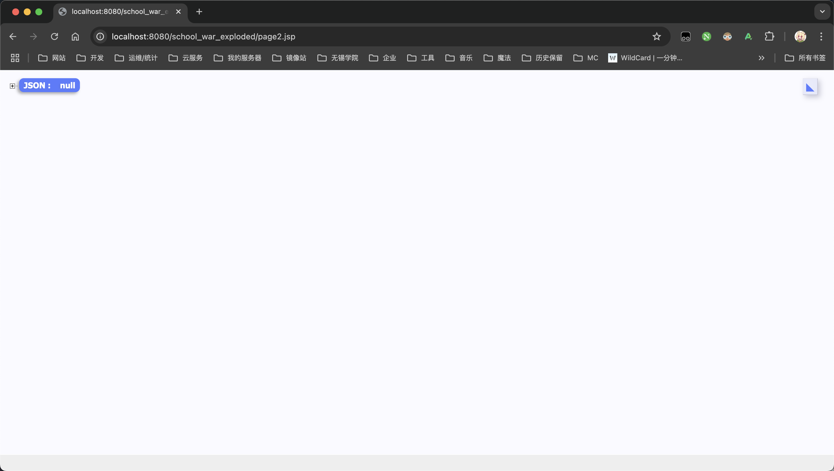

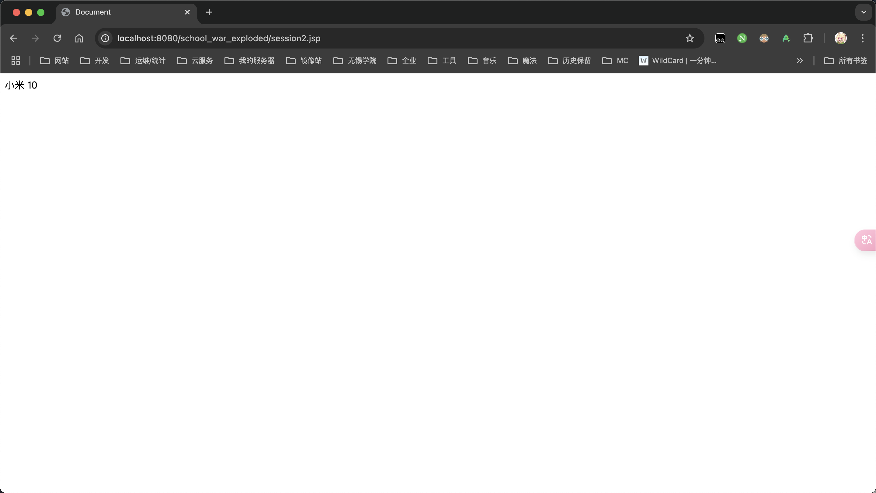

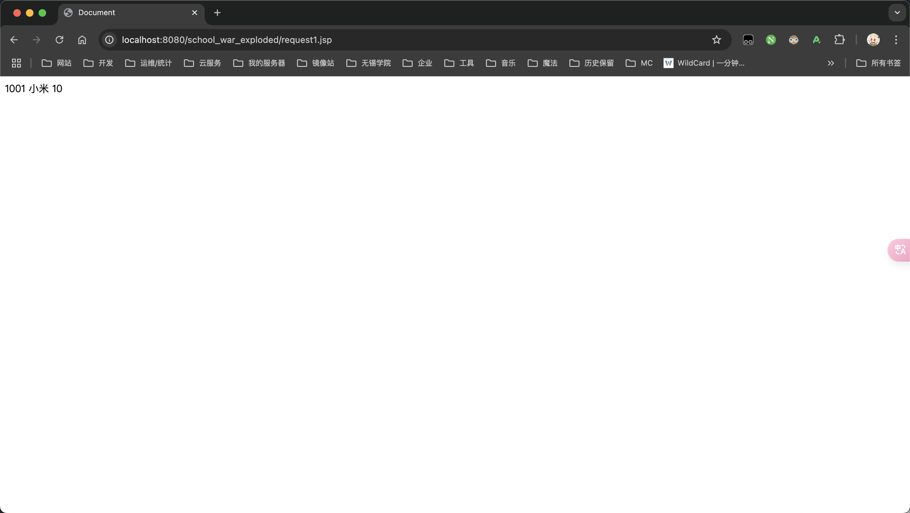

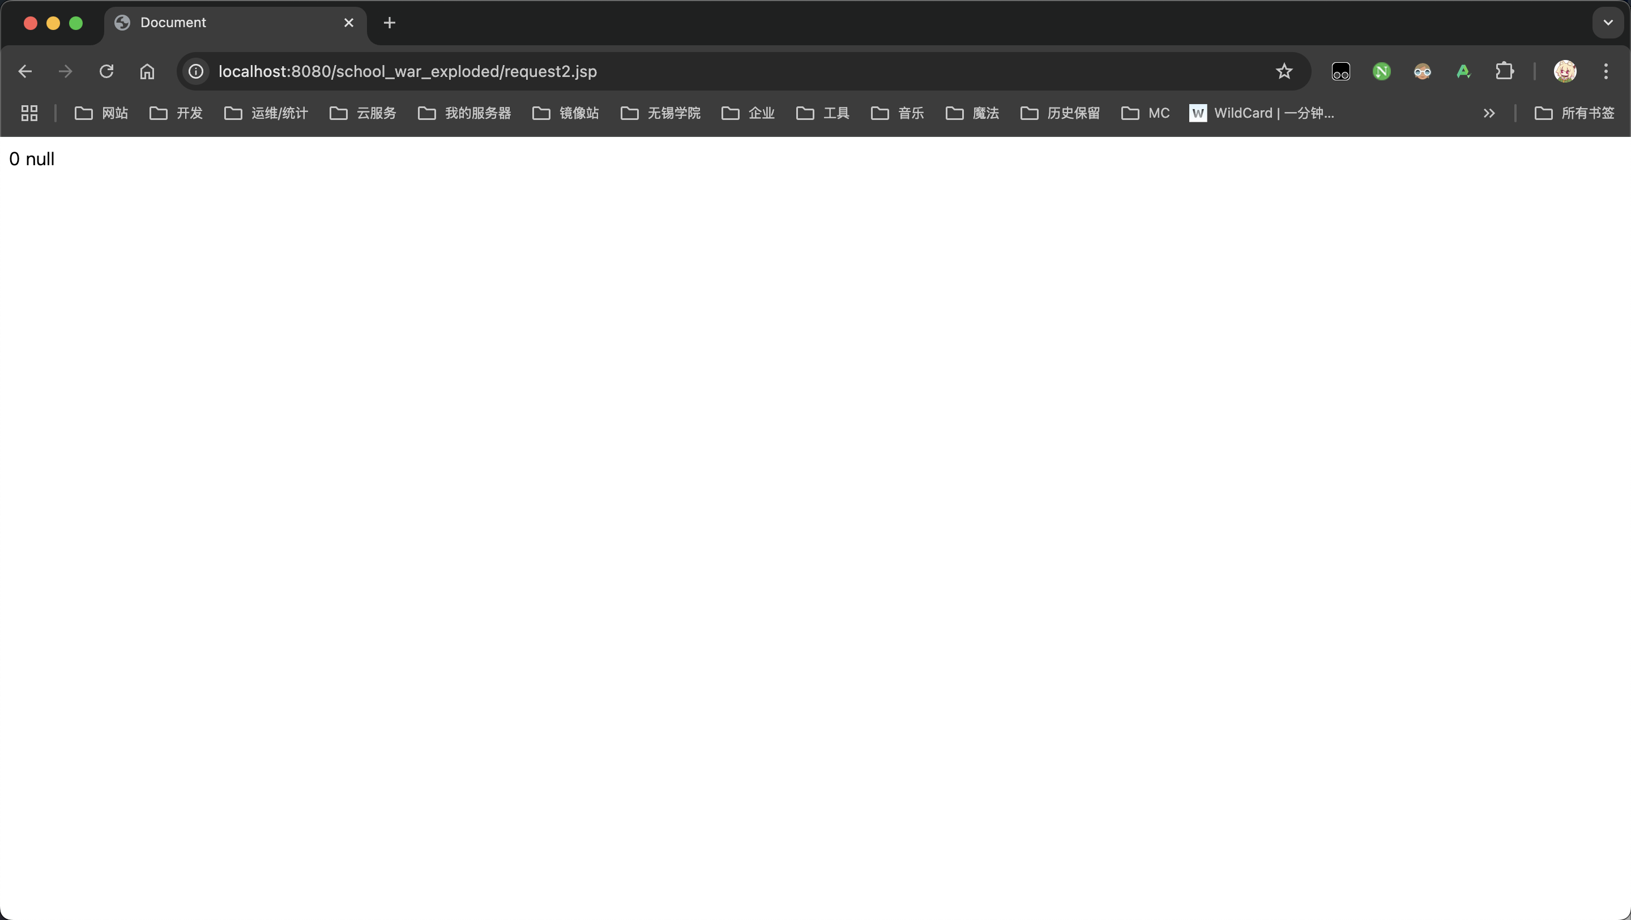

### 3. 下面要求完成JSP项目开发，具体如下

（1）按照JavaBean的编写规范，编写一个User.java的类，含有用户序号userid、用户名username、性别gender、年龄age，并编写对应属性的getter/setter方法。

（2）在上一题编写的User类中，增加一个Boolean类型的属性member，该属性用于判断是否用户为会员，利用Eclipse代码生成编写对应的getter/setter方法。然后在JSP页面中引入User对象，对所有属性进行设置，并利用标签语句输出所有属性值。

（3）在第一个JSP页面中引入User对象，对所有属性进行设置，并将scope取值为application，然后新建第二个JSP页面访问User对象。注意：首先使用一种浏览器访问第一个页面，然后使用另外一种浏览器访问第二个JSP页面，查看其效果。

#### 源代码

package com.xlf.school.bean;  
  
/**  
 * User  
 * <p>  
 * 用户实体类，用于存储用户信息  
 *  
 * @version v1.0.0  
 * @since v1.0.0  
 * @author xiao_lfeng  
 */  
public class User {  
 private int userid;  
 private String username;  
 private String gender;  
 private int age;  
 private Boolean member;  
  
 public int getUserid() {  
 return userid;  
 }  
  
 public void setUserid(int userid) {  
 this.userid = userid;  
 }  
  
 public String getUsername() {  
 return username;  
 }  
  
 public void setUsername(String username) {  
 this.username = username;  
 }  
  
 public String getGender() {  
 return gender;  
 }  
  
 public void setGender(String gender) {  
 this.gender = gender;  
 }  
  
 public int getAge() {  
 return age;  
 }  
  
 public void setAge(int age) {  
 this.age = age;  
 }  
  
 public Boolean getMember() {  
 return member;  
 }  
  
 public void setMember(Boolean member) {  
 this.member = member;  
 }  
}

<%@ page language="java" contentType="text/html; charset=UTF-8" pageEncoding="UTF-8"%>  
<%@ page import="com.xlf.school.bean.User" %>  
<html>  
<head>  
 <title>User Information</title>  
</head>  
<body>  
<%  
 User user = new User();  
 user.setUserid(1);  
 user.setUsername("筱锋");  
 user.setGender("男");  
 user.setAge(21);  
 user.setMember(true);  
  
 application.setAttribute("user", user);  
%>  
  
<h2>User Information:</h2>  
<p>UserID: <%= user.getUserid() %></p>  
<p>Username: <%= user.getUsername() %></p>  
<p>Gender: <%= user.getGender() %></p>  
<p>Age: <%= user.getAge() %></p>  
<p>Member: <%= user.getMember() ? "是" : "否" %></p>  
</body>  
</html>

<%@ page language="java" contentType="text/html; charset=UTF-8" pageEncoding="UTF-8"%>  
<%@ page import="com.xlf.school.bean.User" %>  
<html>  
<head>  
 <title>Display User</title>  
</head>  
<body>  
<%  
 User user = (User) application.getAttribute("user");  
  
 if (user != null) {  
%>  
<h2>User Information from Application Scope:</h2>  
<p>UserID: <%= user.getUserid() %></p>  
<p>Username: <%= user.getUsername() %></p>  
<p>Gender: <%= user.getGender() %></p>  
<p>Age: <%= user.getAge() %></p>  
<p>Member: <%= user.getMember() ? "是" : "否" %></p>  
<%  
} else {  
%>  
<p>No user found in application scope.</p>  
<%  
 }  
%>  
</body>  
</html>

#### 截图

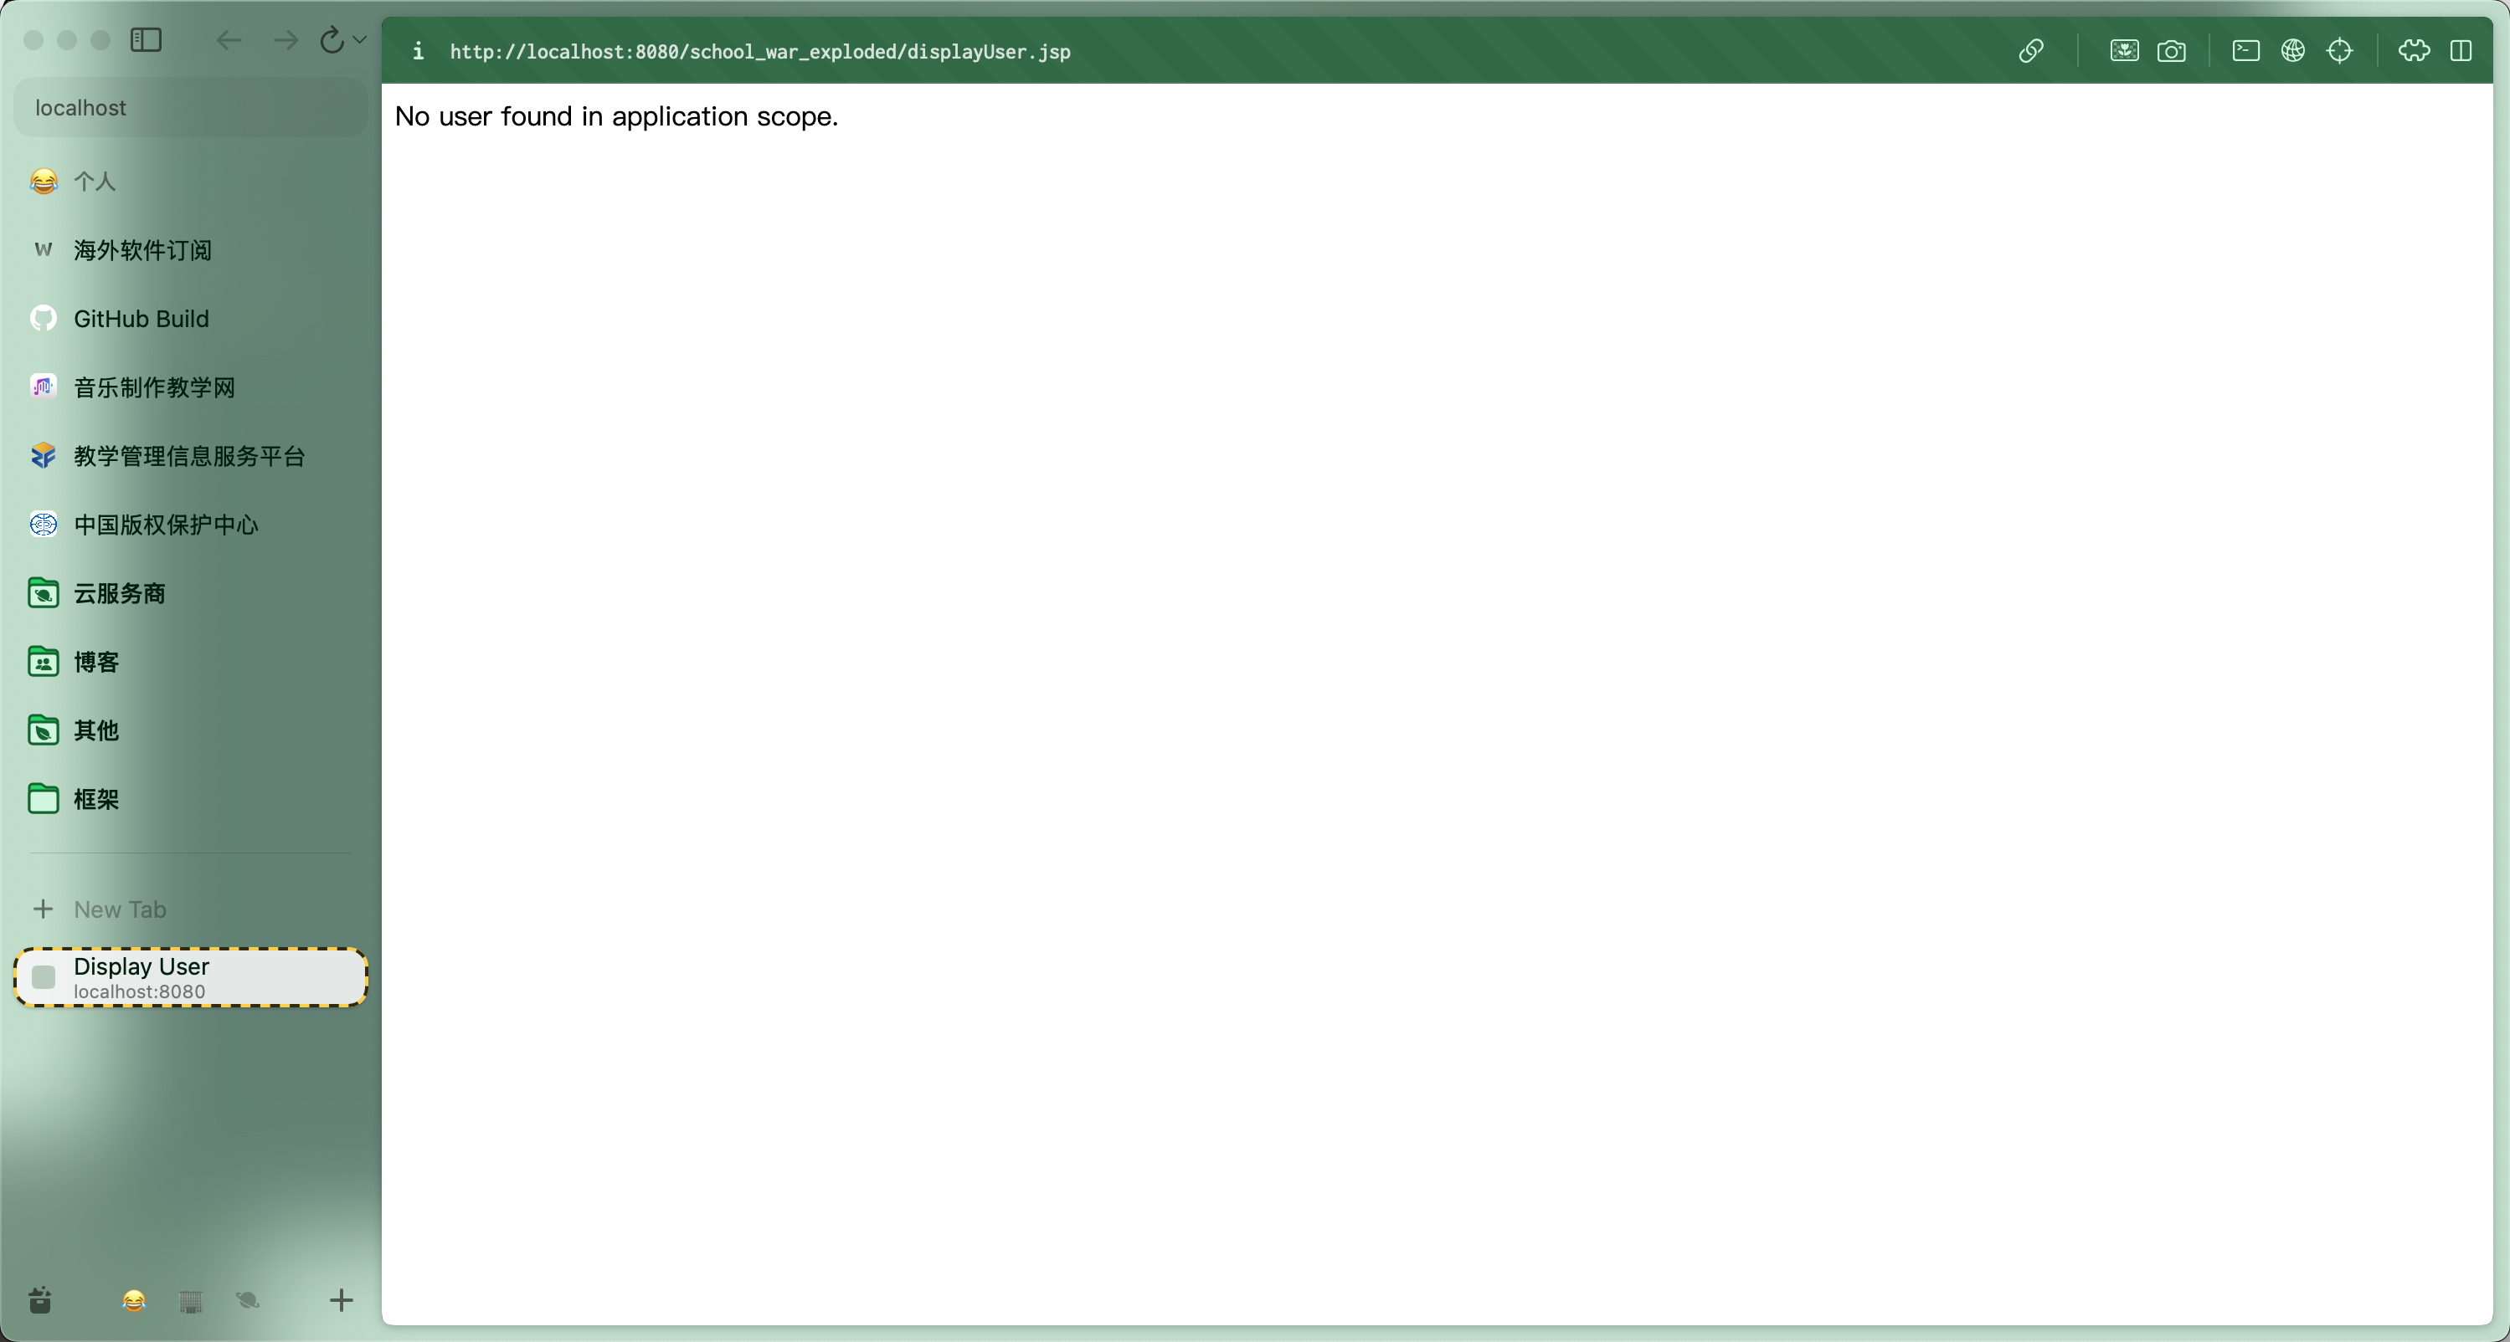

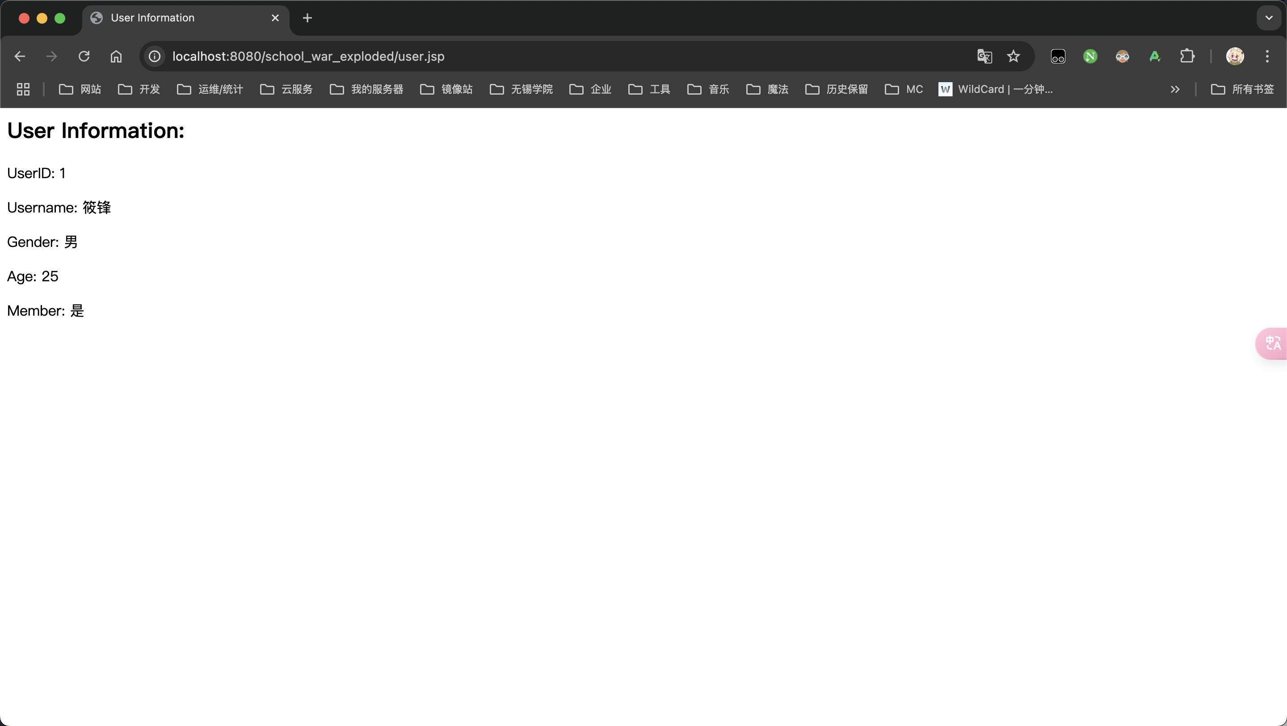

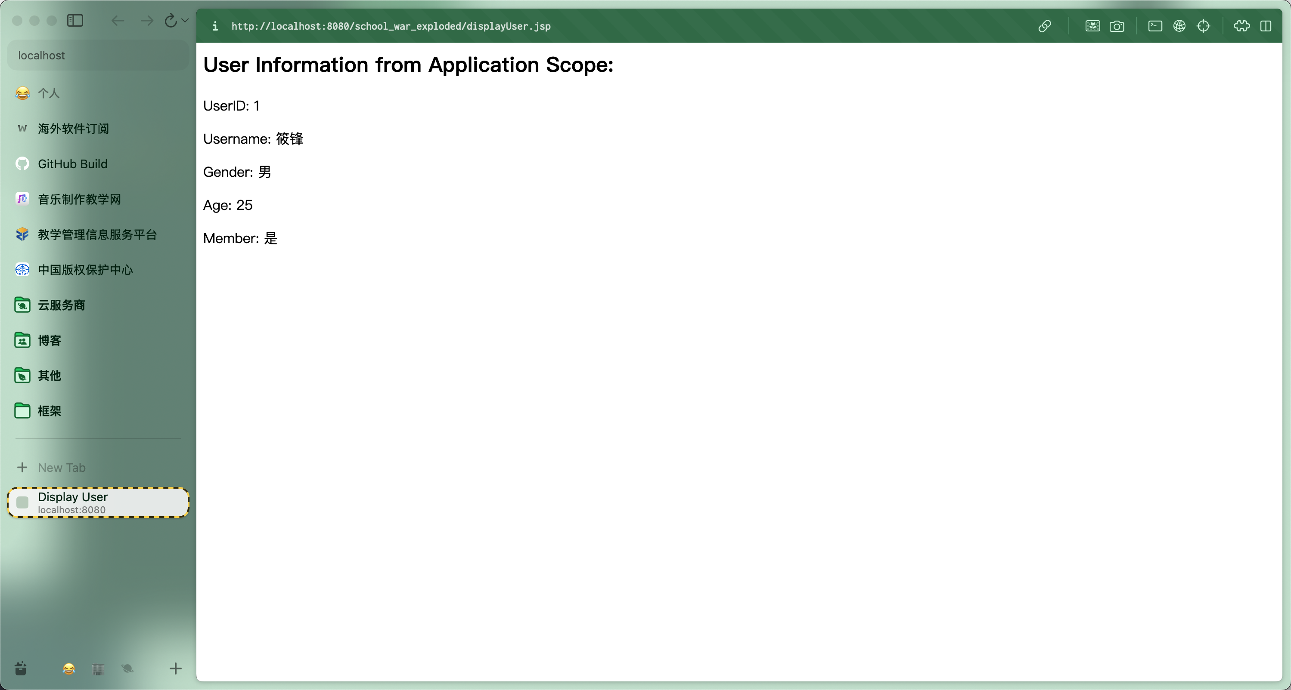

### 4. 完成【例6-3】利用JavaBean开发简易购物车的示例

简易购物车的要求是：网站可以购买不同品牌的手机商品，每个品牌的页面中显示不同型号手机的名称和价格，在商品后面可以选择购买的数量，并显示购买的超链接，单击超链接，可以将商品加入用户的购物车中。在不同的页面下，可以自由挑选商品加入购物车，最终显示购物车内手机商品的数量，每种型号手机的个数、小计价格以及整个购物车商品的价格。

package com.xlf.school.bean;  
  
import java.io.Serial;  
import java.io.Serializable;  
  
/**  
 * Goods  
 * <p>  
 * 商品类, 用于存储商品信息  
 *  
 * @version v1.0.0  
 * @since v1.0.0  
 * @author xiao_lfeng  
 */  
public class Goods implements Serializable {  
 @Serial  
 private static final long serialVersionUID = 0;  
 private int gid;  
 private String gname;  
 private double gprice;  
 private int gcount;  
  
 public int getGid() {  
 return gid;  
 }  
  
 public void setGid(int gid) {  
 this.gid = gid;  
 }  
  
 public String getGname() {  
 return gname;  
 }  
  
 public void setGname(String gname) {  
 this.gname = gname;  
 }  
  
 public double getGprice() {  
 return gprice;  
 }  
  
 public void setGprice(double gprice) {  
 this.gprice = gprice;  
 }  
  
 public int getGcount() {  
 return gcount;  
 }  
  
 public void setGcount(int gcount) {  
 this.gcount = gcount;  
 }  
}

package com.xlf.school;  
  
import com.xlf.school.bean.Goods;  
import jakarta.servlet.ServletException;  
import jakarta.servlet.annotation.WebServlet;  
import jakarta.servlet.http.HttpServlet;  
import jakarta.servlet.http.HttpServletRequest;  
import jakarta.servlet.http.HttpServletResponse;  
import jakarta.servlet.http.HttpSession;  
  
import java.io.IOException;  
  
/**  
 * 添加购物车 Servlet  
 * <p>  
 * 用于处理添加购物车请求  
 *  
 * @author xiao_lfeng  
 * @version v1.0.0  
 * @since v1.0.0  
 */  
@WebServlet(name = "AddCartServlet", urlPatterns = "/AddCartServlet")  
public class AddCartServlet extends HttpServlet {  
 @Override  
 protected void doGet(HttpServletRequest request, HttpServletResponse response)  
 throws ServletException, IOException {  
 response.setCharacterEncoding("UTF-8");  
 response.setHeader("Content-type", "text/html; charset=UTF-8");  
  
 String gid = request.getParameter("gid");  
 String gcount = request.getParameter("gcount");  
  
 if (gid != null && gcount != null) {  
 Goods goods;  
 GoodsDao goodsDao = new GoodsDao();  
  
 goods = goodsDao.setGoods(Integer.parseInt(gid));  
 goods.setGcount(Integer.parseInt(gcount));  
  
 HttpSession session = request.getSession();  
 Cart cart = (Cart) session.getAttribute("cart");  
  
 if (cart != null) {  
 cart.addGoods(goods);  
 } else {  
 cart = new Cart();  
 cart.addGoods(goods);  
 }  
  
 session.setAttribute("cart", cart);  
 response.getWriter().println("添加成功！");  
 response.getWriter().println("<a href='cart.jsp'>查看购物车</a>");  
 response.getWriter().println("<a href='javascript:history.back(-1)'>返回上一页</a>");  
 } else {  
 response.getWriter().println("参数不正确");  
 response.getWriter().println("<a href='javascript:history.back(-1)'>返回上一页</a>");  
 }  
 }  
}

package com.xlf.school;  
  
import com.xlf.school.bean.Goods;  
  
import java.io.Serial;  
import java.util.ArrayList;  
import java.io.Serializable;  
  
/**  
 * 购物车类  
 * <p>  
 * 用于存储用户购物车信息  
 *  
 * @version v1.0.0  
 * @since v1.0.0  
 * @author xiao_lfeng  
 */  
public class Cart implements Serializable {  
 @Serial  
 private static final long serialVersionUID = 44256950914898900L;  
 private ArrayList<Goods> goodslist = new ArrayList<>();  
  
 public ArrayList<Goods> getGoodslist() {  
 return goodslist;  
 }  
  
 public void setGoodslist(ArrayList<Goods> goodslist) {  
 this.goodslist = goodslist;  
 }  
  
 public int getGcount() {  
 int count = 0;  
 for (Goods g : goodslist) {  
 count += g.getGcount();  
 }  
 return count;  
 }  
  
 public double getTotal() {  
 double sum = 0;  
 for (Goods g : goodslist) {  
 sum += g.getGprice() * g.getGcount();  
 }  
 return sum;  
 }  
  
 public int check(int gid) {  
 for (int i = 0; i < goodslist.size(); i++) {  
 if (goodslist.get(i).getGid() == gid) {  
 return i;  
 }  
 }  
 return -1;  
 }  
  
 public void addGoods(Goods goods) {  
 int index = check(goods.getGid());  
 if (index == -1) {  
 goodslist.add(goods);  
 } else {  
 Goods g = goodslist.get(index);  
 g.setGcount(g.getGcount() + goods.getGcount());  
 }  
 }  
}

package com.xlf.school;  
  
import com.xlf.school.bean.Goods;  
  
/**  
 * 商品信息 Dao  
 * <p>  
 * 用于获取商品信息  
 *  
 * @version v1.0.0  
 * @since v1.0.0  
 * @author xiao_lfeng  
 */  
public class GoodsDao {  
 public Goods setGoods(int gid) {  
 Goods goods = new Goods();  
  
 switch (gid) {  
 case 1001:  
 goods.setGid(1001);  
 goods.setGname("小米10");  
 goods.setGprice(3999.00);  
 break;  
 case 1002:  
 goods.setGid(1002);  
 goods.setGname("红米K30");  
 goods.setGprice(1999.00);  
 break;  
 case 1003:  
 goods.setGid(1003);  
 goods.setGname("红米Note8");  
 goods.setGprice(999.00);  
 break;  
 case 1004:  
 goods.setGid(1004);  
 goods.setGname("华为Mate30");  
 goods.setGprice(3699.00);  
 break;  
 case 1005:  
 goods.setGid(1005);  
 goods.setGname("华为P40");  
 goods.setGprice(4188.00);  
 break;  
 case 1006:  
 goods.setGid(1006);  
 goods.setGname("华为Nova6");  
 goods.setGprice(3499.00);  
 break;  
 default:  
 // 可以添加默认处理  
 break;  
 }  
  
 return goods;  
 }  
}

<%@ page language="java" contentType="text/html; charset=UTF-8" pageEncoding="UTF-8"%>  
<%@ include file="header.jsp" %>  
<%@ page import="com.xlf.school.Cart, com.xlf.school.bean.Goods, java.util.ArrayList" %>  
<%@ page import="com.xlf.school.bean.Goods" %>  
<jsp:useBean id="cart" class="com.xlf.school.Cart" scope="session"/>  
<%  
 if (cart == null || cart.getGoodslist().size() == 0) {  
%>  
<p>您的购物车空空如也...</p>  
<%  
} else {  
 ArrayList<Goods> goodslist = cart.getGoodslist();  
 double total = cart.getTotal();  
%>  
<table>  
 <tr>  
 <td>商品编号</td>  
 <td>商品名称</td>  
 <td>商品价格</td>  
 <td>数量</td>  
 <td>小计</td>  
 </tr>  
 <%  
 for (Goods goods : goodslist) {  
 %>  
 <tr>  
 <td><%= goods.getGid() %></td>  
 <td><%= goods.getGname() %></td>  
 <td><%= goods.getGprice() %></td>  
 <td><%= goods.getGcount() %></td>  
 <td><%= goods.getGprice() * goods.getGcount() %></td>  
 </tr>  
 <% } %>  
 <tr>  
 <td colspan="5">总计：<%= total %></td>  
 </tr>  
</table>  
<% } %>

<%@ page language="java" contentType="text/html; charset=UTF-8" pageEncoding="UTF-8"%>  
<%@ include file="header.jsp" %>  
<table>  
 <tr><td>商品号</td><td>商品名称</td><td>商品价格</td><td>数量</td></tr>  
 <tr>  
 <td>1004</td><td>华为Mate30</td><td>3699.00</td>  
 <td><input type="number" name="1004" min="1" value="1" size="5"/></td>  
 <td><a class="link" id="1004">加入购物车</a></td>  
 </tr>  
 <tr>  
 <td>1005</td><td>华为P40</td><td>4188.00</td>  
 <td><input type="number" name="1005" min="1" value="1" size="5"/></td>  
 <td><a class="link" id="1005">加入购物车</a></td>  
 </tr>  
 <tr>  
 <td>1006</td><td>华为Nova6</td><td>3499.00</td>  
 <td><input type="number" name="1006" min="1" value="1" size="5"/></td>  
 <td><a class="link" id="1006">加入购物车</a></td>  
 </tr>  
</table>  
<script src="addcart.js"></script>

<%@ page language="java" contentType="text/html; charset=UTF-8" pageEncoding="UTF-8"%>  
<%@ include file="header.jsp" %>  
<table>  
 <tr><td>商品号</td><td>商品名称</td><td>商品价格</td><td>数量</td></tr>  
 <tr>  
 <td>1001</td><td>小米10</td><td>3999.00</td>  
 <td><input type="number" name="1001" min="1" value="1" size="5"/></td>  
 <td><a class="link" id="1001">加入购物车</a></td>  
 </tr>  
 <tr>  
 <td>1002</td><td>红米K30</td><td>1999.00</td>  
 <td><input type="number" name="1002" min="1" value="1" size="5"/></td>  
 <td><a class="link" id="1002">加入购物车</a></td>  
 </tr>  
 <tr>  
 <td>1003</td><td>红米Note8</td><td>999.00</td>  
 <td><input type="number" name="1003" min="1" value="1" size="5"/></td>  
 <td><a class="link" id="1003">加入购物车</a></td>  
 </tr>  
</table>  
<script src="addcart.js"></script>

<%@ page language="java" contentType="text/html; charset=UTF-8" pageEncoding="UTF-8"%>  
<a href="xiaomi.jsp">小米手机</a> | <a href="huawei.jsp">华为手机</a> | <a href="cart.jsp">查看购物车</a>  
<hr>

var links = document.getElementsByClassName("link");  
for (var i = 0; i < links.length; i++) {  
 links[i].onclick = function() {  
 var gid = this.id;  
 var num = document.getElementsByName(gid)[0].value;  
 window.location.href = "AddCartServlet?gid=" + gid + "&gcount=" + num;  
 };  
}

#### 截图

